CHAPTER TWO
2.1 Literature Review
In theory, solar energy was used by humans as early as the 7th century B.C. when history tells us that humans used sunlight to light fires with magnifying glass materials. Later, in the 3rd century B.C., the Greeks and Romans were known to harness solar power with mirrors to light torches for religious ceremonies. These mirrors became a normalized tool referred to as "burning mirrors." Chinese civilization documented the use of mirrors for the same purpose later in 20 A.D.
Another early use of solar energy that is still popular today was the concept of "sunrooms" in buildings. These sunrooms used massive windows to direct sunlight into one concentrated area. Some of the iconic Roman bathhouses, typically those situated on the south-facing side of buildings, were sunrooms. Later in the 1200s A.D., ancestors to the Pueblo Native Americans known as the Anasazi situated themselves in south-facing abodes on cliffs to capture the sun's warmth during cold winter months.
In the late 1700s and 1800s, researchers and scientists had success using sunlight to power ovens for long voyages. They also leverage the power of the sun to produce solar-powered steamboats. Ultimately, it's clear that even thousands of years before the era of solar panels, the concept of manipulating the power of the sun was a common practice.
Solar energy is the most abundant energy resource on Earth. Each day, it’s harvested as electricity or heat, fueling homes, businesses, and utilities with clean, emission-free power. As the world pivots towards sustainable energy solutions, solar power is crucial in shaping our global energy landscape. But how does it work, exactly? Sun generates an infinite amount of power. Solar energy technologies capture and convert that power into electricity that we can use in our homes and businesses. If you’ve found Energy Sage, you probably already know that solar panels are one way to harness the power of the sun.
But they aren’t the only way. Solar panels, also known as photovoltaics, capture energy from sunlight, while solar thermal systems use the heat from solar radiation for heating, cooling, and large-scale electrical generation.
2.2 Solar Cell
A solar cell or Photo-Voltaic cell (PV cell) is an electronic device that converts the energy of light directly into electricity by means of the photovoltaic effect. It is a form of photoelectric cell, a device whose electrical characteristics (such as current, voltage, or resistance) vary when it is exposed to light. Individual solar cell devices are often the electrical building blocks of photovoltaic modules, known colloquially as "solar panels". Almost all commercial PV cells consist of crystalline silicon, with a market share of 95%. Cadmium telluride thin-film solar cells account for the remainder. The common single-junction silicon solar cell can produce a maximum open-circuit voltage of approximately 0.5 to 0.6 volts. Photovoltaic cells may operate under sunlight or artificial light. In addition to producing energy, they can be used as a photodetector (for example infrared detectors), detecting light or other electromagnetic radiation near the visible range, or measuring light intensity.
The operation of a PV cell requires three basic attributes:
- The absorption of light, generating excitons (bound electron-hole pairs), unbound electron-hole pairs (via excitons), or plasmons.
- The separation of charge carriers of opposite types.
- The separate extraction of those carriers to an external circuit.
In contrast, a solar thermal collector supplies heat by absorbing sunlight, for the purpose of either direct heating or indirect electrical power generation from heat. A "photo-electrolytic cell" (photoelectrochemical cell), on the other hand, refers either to a type of photovoltaic cell (like that developed by Edmond Becquerel and modern dye-sensitized solar cells), or to a device that splits water directly into hydrogen and oxygen using only solar illumination. Photovoltaic cells and solar collectors are the two means of producing solar power. Solar cells were first used in a prominent application when they were proposed and flown on the Vanguard satellite in 1958, as an alternative power source to the primary battery power source. By adding cells to the outside of the body, the mission time could be extended with no major changes to the spacecraft or its power systems. In 1959 the United States launched Explorer 6, featuring large wing-shaped solar arrays, which became a common feature in satellites. These arrays consisted of 9600 Hoffman solar cells.
By the 1960s, solar cells were (and still are) the main power source for most Earth orbiting satellites and a number of probes into the solar system, since they offered the best power-to-weight ratio. However, this success was possible because in the space application, power system costs could be high, because space users had few other power options, and were willing to pay for the best possible cells. The space power market drove the development of higher efficiencies in solar cells up until the National Science Foundation "Research Applied to National Needs" program began to push development of solar cells for terrestrial applications.
In the early 1990s the technology used for space solar cells diverged from the silicon technology used for terrestrial panels, with the spacecraft application shifting to gallium arsenide-based III-V semiconductor materials, which then evolved into the modern III-V multijunction photovoltaic cell used on spacecraft.
2.3 Types of Solar Cell
Solar cells are more complex than many people think, and it is not common knowledge that there are various different types of cells. When we take a closer look at the different types of solar cell available, it makes things simpler, both in terms of understanding them and also choosing the one that suits you best. There are Crystalline cells, Monocrystalline cells, Polycrystalline cells and Thin film solar cells
2.3.1 Crystalline silicon cells
Presently, around 90% of the world’s photovoltaics are based on some variation of silicon, and around the same percentage of the domestic solar panel, systems use the crystalline silicon cells. Crystalline silicon cells also form the basis for mono and polycrystalline cells. The silicon that is in solar cells can take many different forms. However, the thing that matters most is the purity of the silicon. This is because it directly affects its efficiency. What purity means, in this case, is the way in which the silicon molecules have been aligned. The better the alignment, the purer the resulting silicon is.
This, ultimately, leads to better conversion rates of sunlight into electricity. As previously mentioned, the levels of efficiency work alongside the purity of the silicon molecules – and purity can be quite a costly aspect to upgrade. However, it may come as a surprise to learn that efficiency is not the driving force for people who want to invest in solar energy. The cost and the amount of space it takes up tend to be the most important aspects to potential buyers.
2.3.2 Monocrystalline cells
Monocrystalline solar cells are made from single crystalline silicon. They are very distinctive in their appearance as they are often colored, and the cells hold a cylindrical shape. In order to keep the costs low and performance at optimal levels, manufacturers cut out the four sides of the monocrystalline cells. This gives them their recognizable appearance. Here are some of the advantages of monocrystalline solar cells, they have the highest level of efficiency at 15-20%, they require less space compared to other types due to their high efficiency, manufacturers state that this form of solar cell lasts the longest, with most giving them a 25-year warranty and they perform better in low levels of sunlight, making them ideal for cloudy areas.
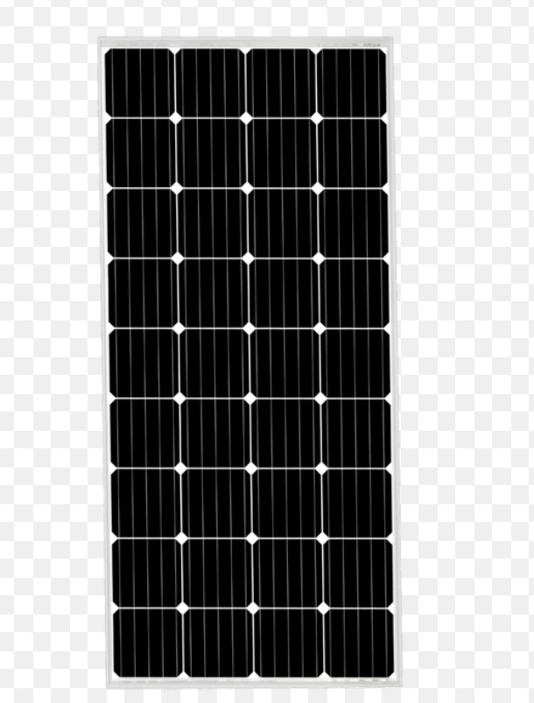
Here are some of the disadvantages to monocrystalline solar cells they are the most expensive solar cells on the market, and so not in everyone’s price range, the performance levels tend to suffer from an increase in temperature. However, it is a small loss when compared to other forms of solar cell, there is a lot of waste material when the silicon is cut during manufacture.
Figure 2.1: Monocrystalline solar panel
2.3.3 Polycrystalline Solar Panel
The polycrystalline solar panels were first introduced to the public in 1981. Unlike the monocrystalline cells, polycrystalline ones do not require each of the four sides to be cut. Instead, the silicon is melted and poured into square moulds. These then form perfectly shaped square cells. Here are some of the advantages of polycrystalline solar cells, the manufacturing process is cheaper and easier than the monocrystalline cells, it avoids silicon waste and high temperatures have less negative effects on efficiency compared with monocrystalline cells, This makes the polycrystalline cells more attractive to people in warmer areas as the price is lower. Here are some of the disadvantages to polycrystalline solar cells, efficiency is only around 13-16% due to low levels of silicon purity. So they are not the most efficient on the market.
- They have lower output rates which make them less space efficient. So more roof space is needed for installation.
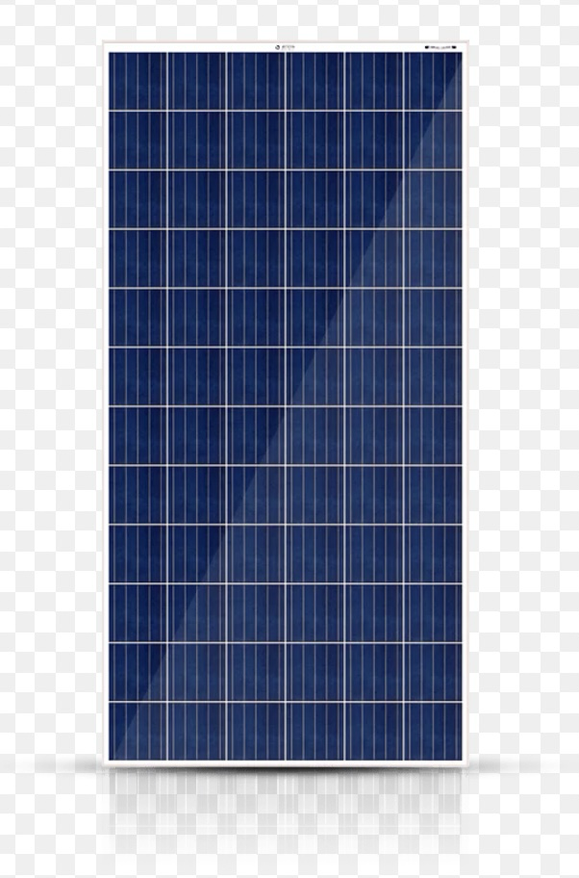
Figure 2.2: Polycrystalline Solar Panel
2.3.4 Thin Film Solar Panel
Thin film solar cells are manufactured by placing several thin layers of photovoltaic on top of each other to creates the module. There are actually a few different types of thin film solar cell, and the way in which they differ from each other comes down to the material used for the PV layers. The types are as follows, amorphous silicon, cadmium telluride, copper indium gallium selenide and organic PV cells.
Depending on the technology that has been used, the efficiency rates for thin film solar cells tends to vary from 7% to 13%. Since 2002, the knowledge levels and popularity for thin film solar cells has risen dramatically, which also means that research and development have been increased. Due to this, we can expect future models to hold efficiency rates of 10-16%. Here are some of the advantages of thin film solar cells, they can be manufactured to be flexible, making them widely applicable to a range of situations and building types, mass production is easy to achieve, making them potentially cheaper to produce than crystalline solar cells and shading has a similar effect on their efficiency
Here are some of the disadvantages of thin film solar cells, they are not ideal for
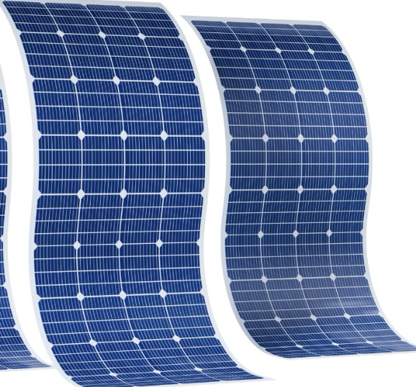
domestic use as thy take up a lot of space, low space efficiency means that they will cause
Figure 2.3: Thin film solar panel
further expenses in the form of enhancers, like cables of support structures and they have a shorter lifespan and so shorter warranty period.
2.4 Rechargeable Fan
Solar rechargeable fans become necessary for a common man. Especially, in summer, the power shortage is more. To overcome from the difficulties caused by power shortage this innovative project is designed.
2.5 Universal Serial Bus (USB)
The development of the Universal Serial Bus (USB) started in 1995 by a group of companies which included Compaq, Digital, IBM, Intel, Microsoft, NEC, and Northern Telecom. These companies have later joined into the USB Implementers Forum, which published the first version of the USB standard. This forum, which has been extended with a large number of companies, continues to update the USB standards for USB controllers and various categories of devices that can be connected to the USB.
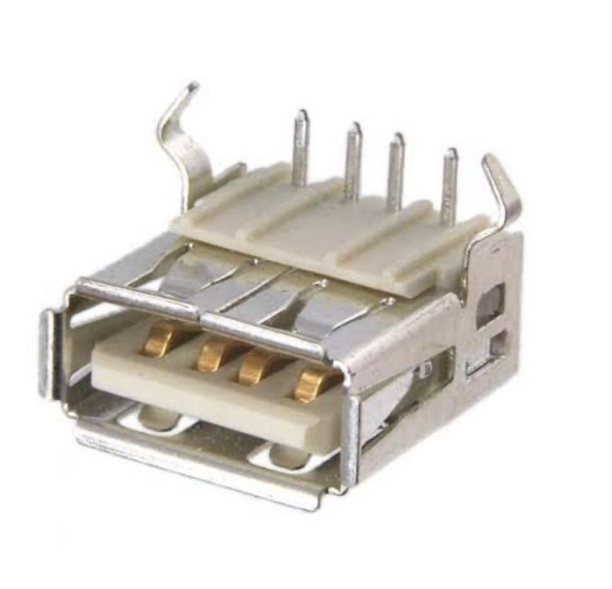
Figure 2.4.: Universal serial bus
USB grew from the requirement for a simple, inexpensive expansion bus for PCs. PCI solved and compatibility problems that existed with the ISA bus. But, the need to take the cover off the PC to add a peripheral was a hassle. And, though PCI made Windows plug-n-play possible, we have all experienced the frequent reality of “plug-n-pray” instead. Universal Serial Bus is a serial protocol (less costly than parallel) and physical layer link. Data is transmitted differentially on one pair of wires, providing relatively good noise immunity. Another pair carries DC power to downstream devices, allowing many low power devices to be bus powered. USB supports a high data rate and ‘hot swap’ connection for PCs without rebooting and provides easy connections to a wide variety of multimedia and network USB devices. Peripherals are simpler and less costly. AUSB master does not have to be a PC, but usually is.

Today, all versions of Windows and Linux support USB. An embedded device is a computer that does not look like a computer. Only sophisticated embedded devices with full operating systems will be USB masters.
Table 2.1: USB Speed USB Protocol Rate Typical Devices
Low speed | USB 1.1, 2.0, 3.0 | 1.5 Mbps | Ice, Keyboards, Joysticks
Full speed | USB 1.1, 2.0, 3.0 | 12 Mbps | Printers, Scanners, Webcams
High speed | USB 2.0, 3.0 | 480 Mbps | Multimedia, Zip drives

Some of the advantages includes, low power consumption, USB is less expensive, each device containing the USB port fits in with the USB and the USB can be of various sizes, and its connections come in several ways. Disadvantages includes, compared with other systems, data transmission is not much quicker, Single messages can only be exchanged between the peripheral and host, and the Universal Serial Bus does not include the broadcast functionality and performance and functionality of USB are within limits.
2.6 Light-Emitting Diode (LED)
Light Emitting Diode (LED) is a semiconductor device that emits light when an electric current flow through it. When current passes through an LED, the electrons recombine with holes emitting light in the process. LEDs allow the current to flow in the forward direction and blocks the current in the reverse direction. Light-emitting diodes are heavily doped p-n junctions. Based on the semiconductor material used and the amount of doping, an LED will emit colored light at a particular spectral wavelength when forward biased. As shown in the figure, an LED is encapsulated with a transparent cover so that emitted light can come out. The LED symbol is the standard symbol for a diode, with the addition of two small arrows denoting the emission of light.
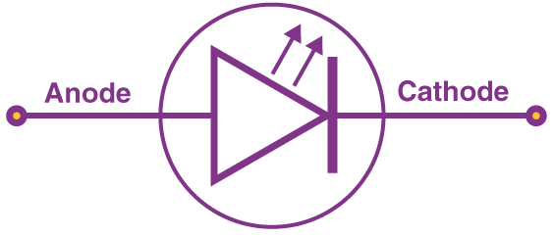
Figure 2.5: LED symbol
The figure below shows a simple LED circuit.
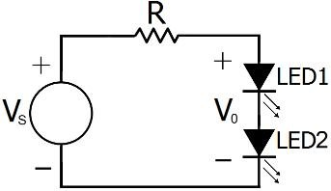
Figure 2.6: Simple LED Circuit
The circuit consists of 2 LED, a voltage supply and a resistor to regulate the current and voltage. When the diode is forward biased, the minority electrons are sent from p → n while the minority holes are sent from n → p. At the junction boundary, the concentration of minority carriers increases. The excess minority carriers at the junction recombine with the majority charges carriers. Classification of LED-based on sizes, miniature characterized with low-current standard and ultra-high output
2.6.1 Different Types of LED (Light-Emitting Diode)
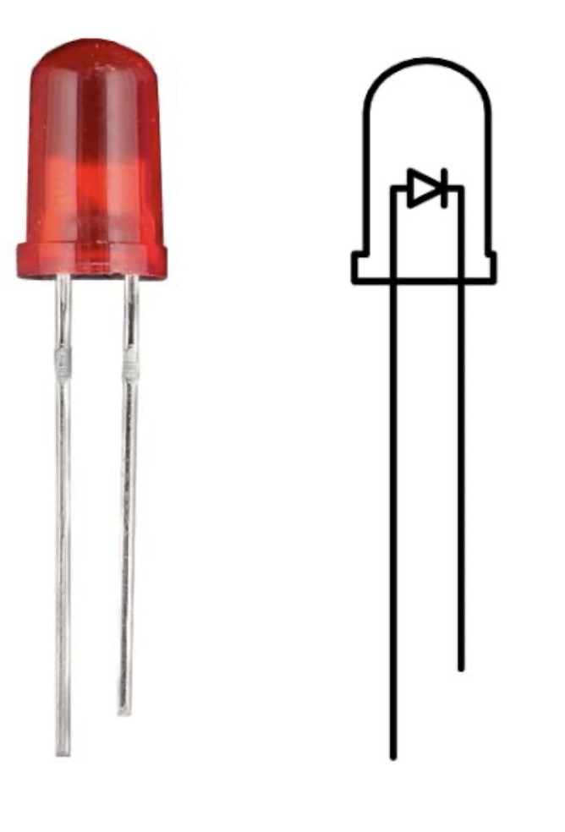
Miniature LED are mostly used now these days. These are available in single shape and color and are available in small sizes. It can be directly placed into a circuit board without the use of a heating or cooling device. These are classified into low-current, standard and ultra-high output depending upon various factors such as voltage, total watts, current, and manufacturer type. Miniature LEDs are used in small appliances such as remote controls, calculators and cell phones.
Figure 2.7: Miniature LED
High-Power LED uses of LED results in high output compared to normal LEDs. The light emitted is measured in terms of lumens. These are again categorized based on luminous intensity, wavelength and voltage.
These have a danger of overheating hence a heat-absorbing material is used to cool it down.
High-Power LEDs are used in high-powered lamps, automobile headlights, in various industrial and mechanical equipment.
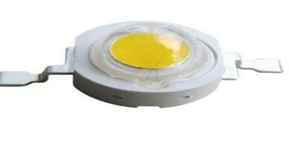
Figure 2.8: High-power LED
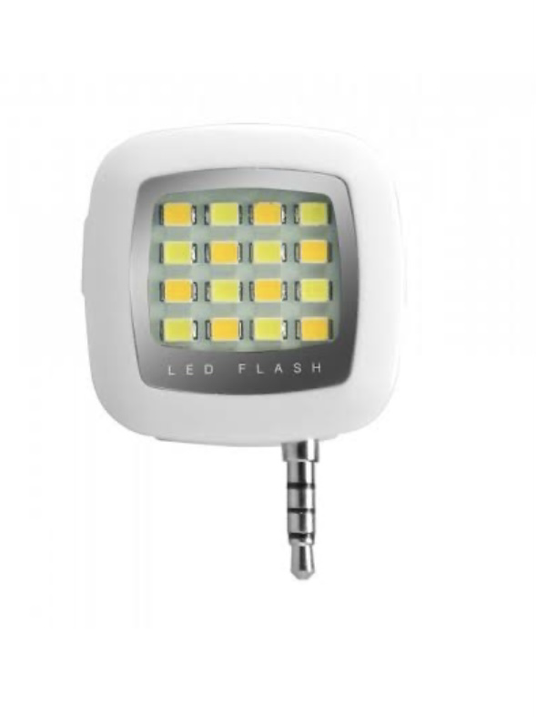
Flash led contains an integrated circuit which flashes the light at a particular frequency. These are directly connected to a power supply without the help of series resistors. It is used in signboards, vehicles etc.
Figure 2.9: Flash LED
Bi and Tri-Color lights consist of two light-emitting dies in a single case. The wiring is inversely parallel which means one is in the forward direction and another in backward which makes one die lit at one time. The flow of current alternates between two dies which results in color variation.
Tri-Color LED lights design lets the two dies to lit separately or together producing a third color. Red Green Blue LEDs, these emit red, green and blue light and also allows to combine these three primary colors and produce a new color. These are used in accent lighting, lights shows and status indicators.
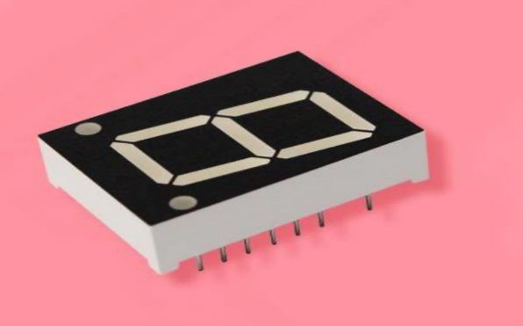
Alphanumeric LED
Figure 2.10: Alphanumeric LED
These consists of segments which offer greater flexibility and lesser power consumption. In it, it has various types of LEDs such as: 14 and 16 segment- they cover full 26 characters of the Roman alphabet in uppercase and with numerals 0-97 segment- covers all numbers and limited set of letters. Matrix segment- covers full alphabets (upper and lower), all number and a full variety of symbols.
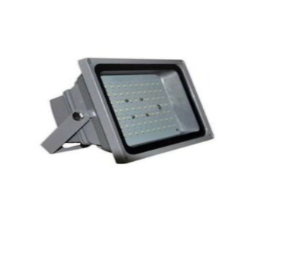
Lighting LED use aluminum/ceramic body which provides heat dissipation. One example is the Edison light bulb design.
Figure 2.11: Lighting LED
2.7 Review of Related Project Work On Solar-Enabled Rechargeable Fans
The increasing need for sustainable and reliable energy solutions, especially in off-grid and rural areas, has driven significant research into developing solar-enabled rechargeable fans. Over the years, various research projects have explored different aspects of solar-powered fans, including design optimization, energy efficiency, and integrated peripheral functions. This section reviews notable past projects to highlight advancements and challenges in the field.
Design and Implementation of Object Detection and Temperature Controlled Solar Powered Fan: This study presented a solar-powered fan integrated with object detection and temperature-based speed control using an Arduino microcontroller. The fan automatically activates when motion is detected and adjusts speed according to the ambient temperature. The system runs on a 12V rechargeable battery charged by a solar panel, designed primarily for domestic use in areas with unstable grid power. The research demonstrated effective energy-saving automation and practical off-grid usability for small spaces. However, it lacked integrated peripheral functions such as mobile charging ports or built-in lighting, limiting its utility in multifunctional household settings. Additionally, the system’s basic sensor setup restricted its adaptability to user-controlled operation (S. A. Akangbe et al., 2024).
Development of a Temperature-Controlled Solar Powered Ventilation System: The paper investigated a solar-powered fan controlled by temperature sensors to provide ventilation in enclosed spaces. An Arduino microcontroller was used to switch the fan on/off depending on ambient temperature, powered by a small solar panel and rechargeable battery. The design aimed at energy-efficient cooling in rural and off-grid locations. While the system proved effective in automatic ventilation control, it did not include additional functionalities like integrated lighting or device charging, restricting its versatility. The design also lacked user override options, limiting adaptability to varying user needs and preferences (N. H. Abdullah et al., 2024).
Solar Driven Prototype Model of Automatic Temperature Controlled Exhauster: This research developed a solar-powered exhaust fan prototype regulated by temperature using analog sensor circuitry instead of a microcontroller. The device offered a low-cost ventilation solution for greenhouses or rural households, utilizing direct solar power with no energy storage. The study showed the feasibility of analog control for temperature-based fan operation. However, the lack of a rechargeable battery limited fan usage to daylight hours only. Additionally, the device’s single-purpose design with no peripheral functions such as lighting or charging limited its applicability for multipurpose off-grid needs (D. Mukherjee, 2022).
A technical report on the construction of two-way powered solar fan: This study designed a 30W DC standing fan powered through an 80W solar panel and a 12V, 75Ah battery, with the capacity to operate continuously for up to 6 hours on a full charge. The dual-input system supported both direct solar charging and stored battery use, improving flexibility in energy sourcing. The design emphasized ease of use in off-grid or low-power areas. However, the system lacked integrated peripheral features such as USB ports or lighting, limiting its functionality beyond basic ventilation. Additionally, the fan operated at a single speed with no interface for adjusting modes or monitoring energy use. The absence of modular features or user customization reduced its practicality for varied user needs and multifunctional home use (A. A. Adediran et al., 2025).
Construction of a 12V standalone solar-powered DC fan for solar energy utilization: This study developed a standalone 12V DC fan powered by a solar PV panel and a 12V battery, aiming to provide ventilation in areas with unreliable electricity. Performance assessments were conducted using variable voltage inputs and airflow measurements. While effective in basic ventilation, the system lacked integrated peripheral functions such as USB charging and LED lighting. Additionally, the fan operated at a fixed speed without user-adjustable settings, and there was no user interface for monitoring or controlling the system. The absence of an energy management system further limited its efficiency and adaptability (M. I. Kolawole & J. Paudel, 2023).
2.8 The Block Diagram of the Project Work.
Solar Panel
Battery Charge Controller
Battery Bank
Dc Fan speed
Control
Integrated
Peripheral
Output

Fan Motor

Figure 2.12 Assembling block diagram
The subsections making up the inverter systems is as shown in the block diagram of Figure 2.12 The diagram shows the interconnection of one unit block to another, starting from the input solar panel to the output loads with various output range.
- ﻿﻿Solar Panels: These photovoltaic (PV) panels are installed to harness sunlight. They convert sunlight into Direct Current (DC) electricity.
- ﻿﻿Charge Controller: The DC electricity from the solar panels passes through a charge controller. This device regulates the voltage and current, preventing the batteries from overcharging.
- ﻿﻿Batteries: The electricity is stored in batteries, usually deep-cycle types, for later use when sunlight is not available, such as during nighttime.
- DC Fan Speed Control: This is a device or circuit that regulates the speed of a dc fan by adjusting the voltage or current supplied to it.
- Fan Motor: This is an electric motor that powers a fan’s blade to create airflow for cooling or ventilation.
- Integrated Peripheral Output: This refers to a built-in output or interface on a device or system that allows it to communicate or interact with external peripheral or devices like the following:
- Universal Serial Bus (USB) charging ports.
- Light Emitting Diode (LED) lightning.
- Battery status indicator.

