CHAPTER FOUR
TESTS, RESULTS AND DISCUSSION
4.1 Introduction
This chapter presents the outcomes obtained from the design and construction of the smart scarecrow system. The analysis of the test results, performance evaluation, and power system behavior is discussed to validate the system objectives and design expectations.
4.2 System Testing and Operation
Tools used for testing the system
- Digital multimeter
- Distance meter
- Stop watch or timer
- Microcontroller programmer/debugger (Arduino IDE)

After assembling the components: solar panel, charge controller, voltage regulator, microcontroller (ATmega328P), PIR sensors, PAM8403 amplifier, and speaker (as shown in the circuit diagram in chapter 3) various functional tests were conducted under real field conditions. The system was evaluated for its detection accuracy, power efficiency, autonomous operation, and sound deterrent response.
The digital multimeter was used to measure the DC voltage levels from the solar panel, battery, adjustable voltage regulator and micro controller power lines. The distance meter is a mobile application that manually validate the motion detection range by measurement of the distance as human walks toward the detection range of the PIR sensors. Finally, the stopwatch was used to record the response time of the system from detection to the sound output.
The device has been built to be waterproof, it can be used in a heavy downpour (As shown in figure 15). The component with the highest risk of damage from moisture is the circuit board that controls the motion sensors and sound system of the scarecrow. However, the entire device can handle light rain, foggy, hot and windy conditions.

4.2.1 Animal Detection Test
The PIR sensors were placed in different directions (N, S, E, W) to provide 360° field monitoring. When movement (such as from goats, birds, or monkeys) was detected within a 6–7 m range, the sensors sent a high signal to the microcontroller, which then activated the amplifier circuit to play a preloaded deterrent sound. Figure 16 and 17 shows the rear and front view of the smart scare crow system.

Sensor | Detection Range | Response Time | Status
PIR 1 | 6.3 m | <1 s | Active
PIR 2 | 6.0 m | <1 s | Active
PIR 3 | 6.2 m | <1 s | Active
PIR 4 | 6.5 mt | <1 s | Active

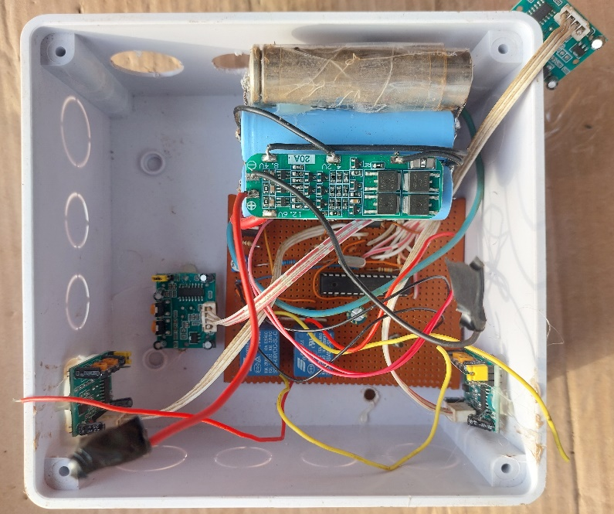
Figure 15: The voltage regulator circuit and PIR sensors connected to the IC
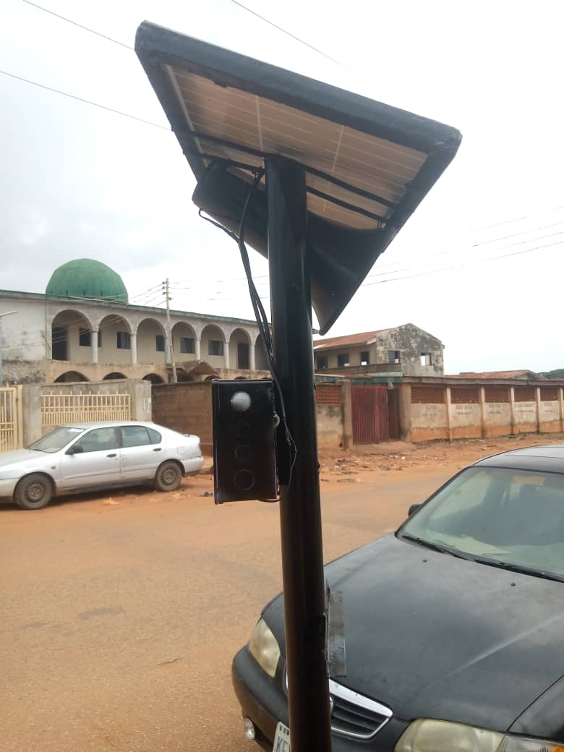
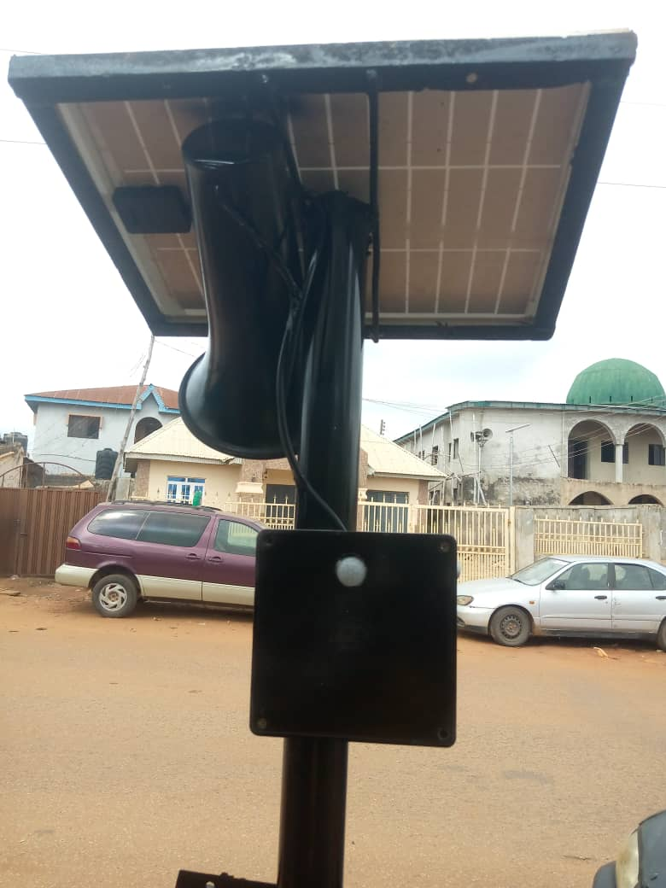
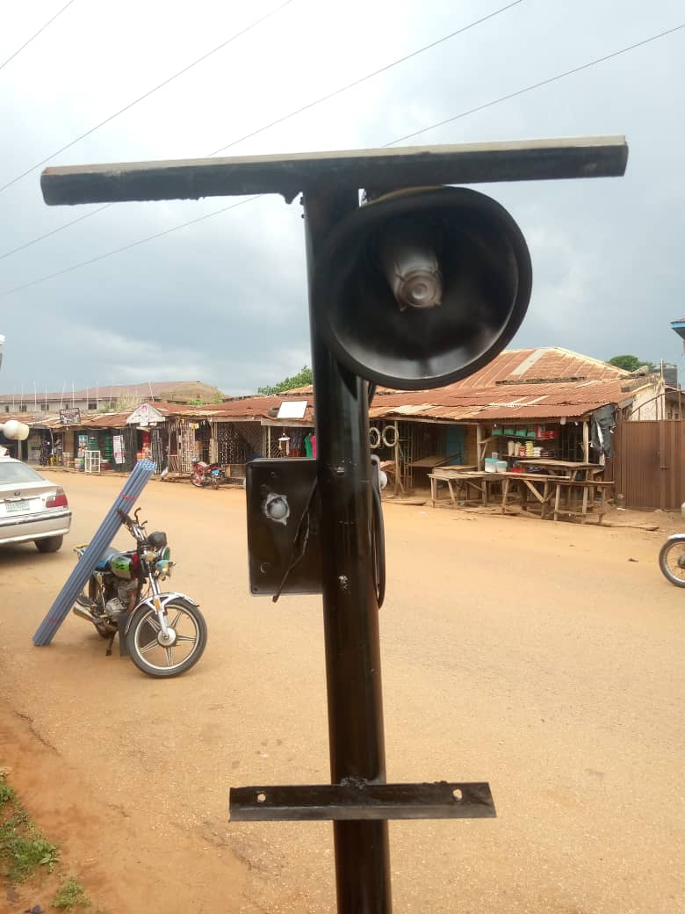
Figure 16: Side views of the smart scarecrow system
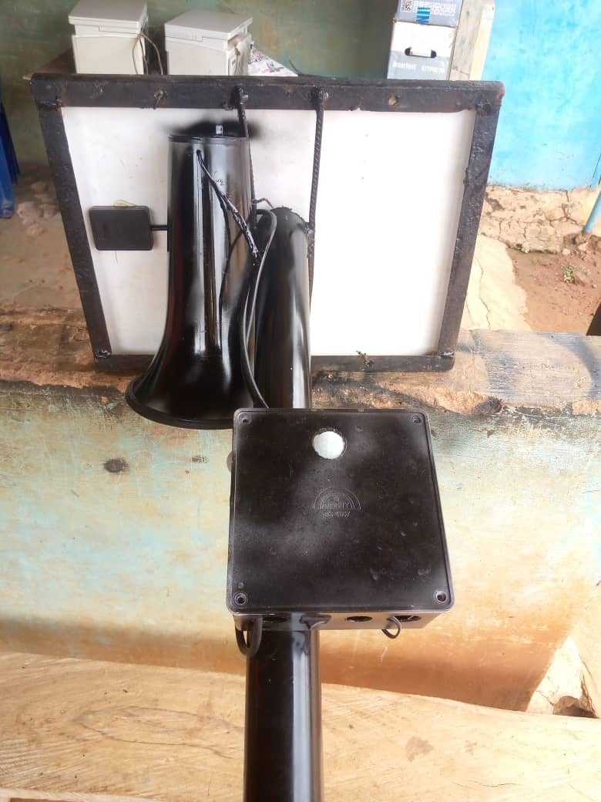
Figure 17: Rear and back view of the smart scarecrow system

4.3 Power System Performance

4.3.1 Solar Charging
A 10 W solar panel provided adequate power to charge the 12 V 7 Ah battery under 4–5 peak sun hours per day. The charge controller regulated overcharge and deep discharge, maintaining battery health.

4.3.2 Battery Endurance Test
The battery supported the system for up to 4 days without sunlight, in line with the calculated autonomy:
Expected runtime: 4 days
Measured runtime: 3.8–4.2 days
Average daily consumption: 10.3 W/h
The battery was not discharged below 11.4 V, protecting against deep cycling damage.

4.4 Voltage Regulation and Efficiency
The adjustable voltage regulator, configured via a resistive divider (R1 = 1 kΩ, R2 = 3 kΩ), stepped down the 12 V battery to 5 V for the microcontroller and sensors. Measurements showed:
Output voltage: 5.01 V (stable)
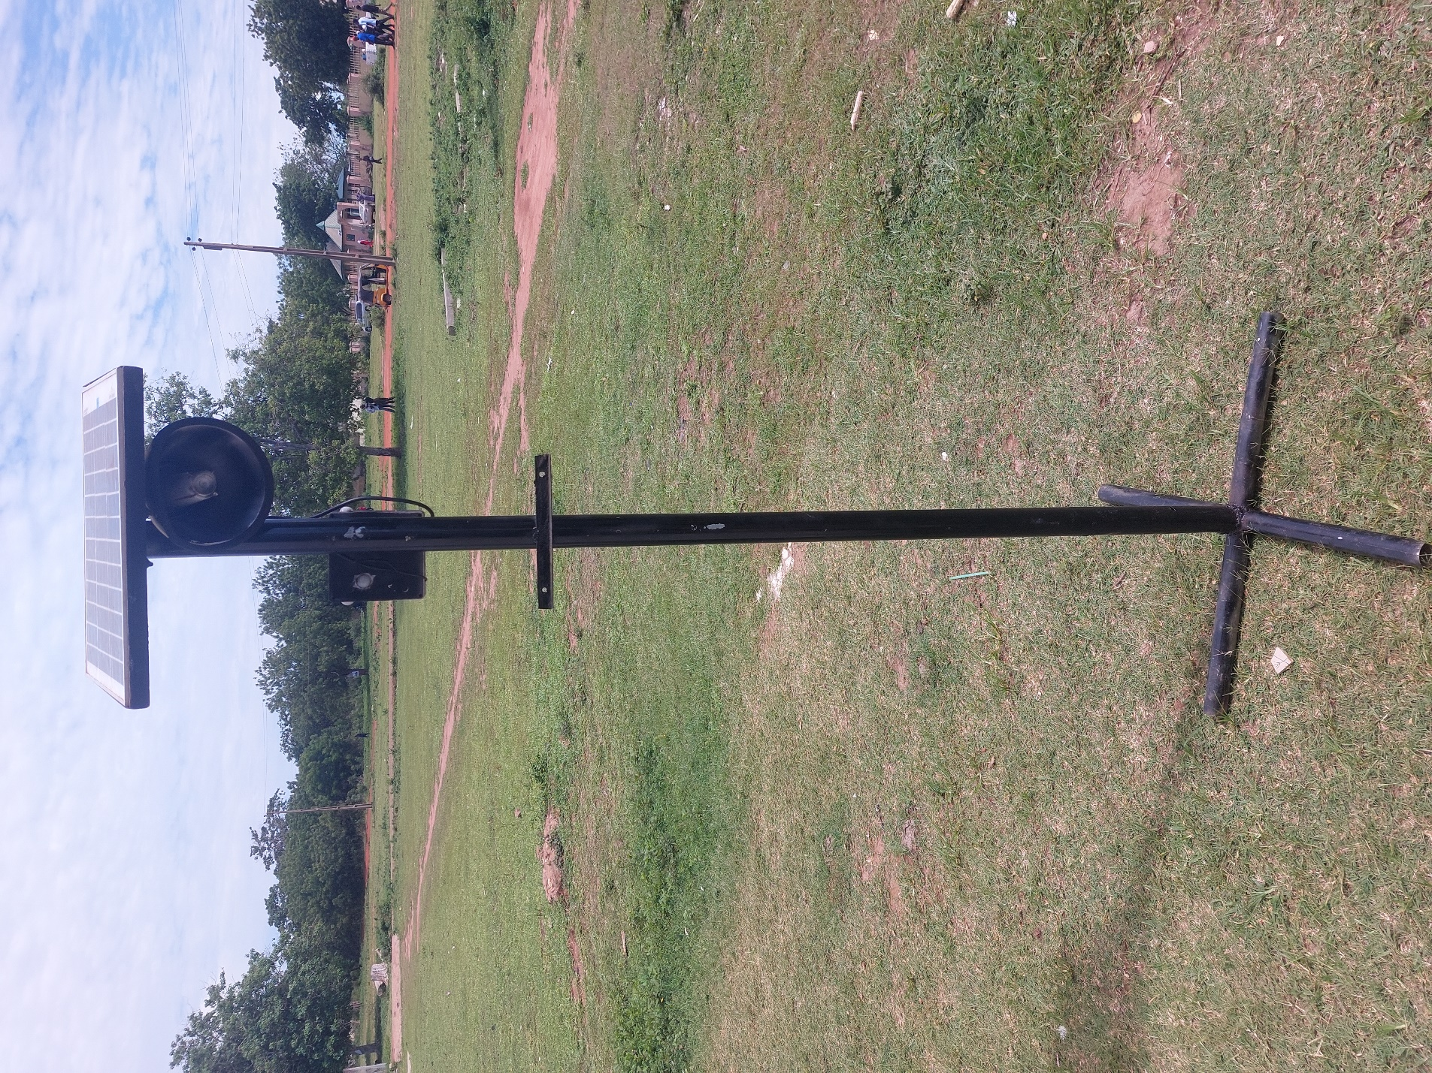Figure 18: The overall view of the smart scarecrow system

