3. METHODOLOGY

3.1. Materials
The primary raw materials used in this study included Portland Limestone Cement (PLC), fine aggregate (sand), hybrid stone dust, water, palm kernel oil (PKO), and sodium lauryl sulfate (SLS). PLC was the primary binder in foam concrete production. Fine aggregates, typically sand, were used in the foam concrete for their particulate properties and to assist in the cohesion of the mix. Water was mixed with the cement in specified proportions to achieve a workable mix consistency. PKO helped to stabilize foam in the concrete mixtures. SLS was used to create air bubbles and reduce the density of the material while maintaining its strength.
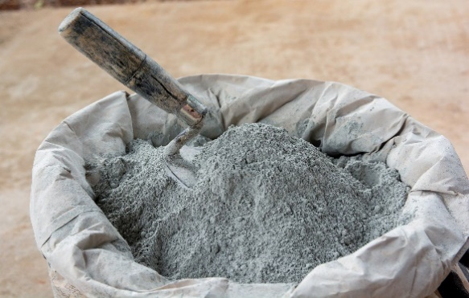 | 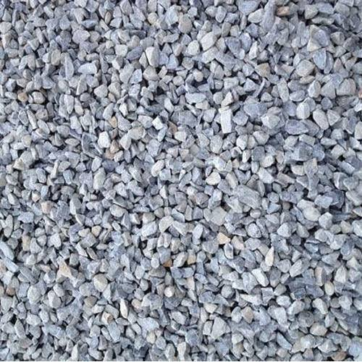
(a) | (b)
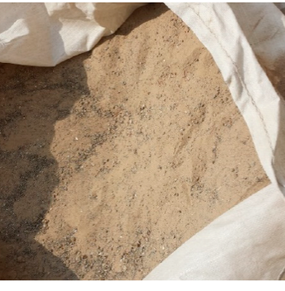 | 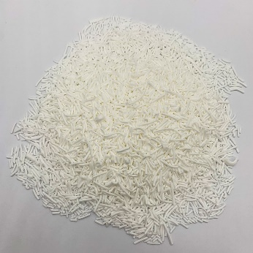
(c) | (d)
Fig. 3.1. Material appearance. (a) Portland limestone cement, (b) hybrid stone dust, (c) fine aggregate, (d) sodium lauryl sulfate.

3.1.1. Binder
The primary binder in foam concrete, known as cement, was sourced from a local supplier and conformed to the ASTM C150 standard for Portland limestone cement. The quality of the cement was checked for consistency in fineness, setting time, and compressive strength before use in the experiments. The physical and mechanical properties of the cement were presented in Table 3.1.
Portland limestone cement is a blend of clinker, limestone, and gypsum. The main chemical reactions during hydration are:
C₃S + H₂O → C-S-H + Ca(OH)₂​
Where:
C₃S (Tricalcium silicate)
C-S-H (Calcium-silicate-hydrate, the binding gel)
Ca(OH)₂ (Calcium hydroxide, also called Portlandite)
Table 3.1. Physical and mechanical properties of cement.
Properties | Results |  | Reference
Initial setting time (minute) | 100 | > 45 minutes | IQS: 5/1984
Final setting time (minute) | 320 | < 600 minutes | IQS: 5/1984
Fineness (Blaine m² /kg) | 300 | > 230 (m² /kg) | IQS: 5/1984
Soundness by Autoclave Method (%) | 0.02 | Not more than 0.8 | IQS: 5/1984
Compressive strength (MPa) |  |  | IQS: 5/1984
3 days | 21 | > 15 | IQS: 5/1984
7 days | 27 | > 2 | IQS: 5/1984

In addition, it is cheaper than other cement types such as high alumina cement, calcium sulfoaluminate cement and magnesium phosphate cement. Its chemical composition is given in Table 3.2.
Table 3.2. Chemical Composition.
Chemical composition of cement (%). | Reference
MgO 2.6 | ASTM C150
SiO₂ 18.7 | ASTM C150
Al₂O₃ 5.48 | ASTM C150
Fe₂O₃ 3.01 | ASTM C150
Na₂O 0.23 | ASTM C150
K₂O 1.22 | ASTM C150
SO₃ 3.25 | ASTM C150
CaO 62.3 | ASTM C150
Cl- 0.001 | ASTM C150
Loss on ignition 2.17 | ASTM C150
Insoluble residue 0.7 | ASTM C150

3.1.2. Fine Aggregates
A locally sourced river sand with particle sizes ranging from 0.075 mm to 4.75 mm was used. The sand was sieved and washed to remove impurities such as clay and organic matter to ensure quality. The grading was confirmed to conform to the requirements of ASTM C33 for fine aggregates.

3.1.3. Palm Kernel Oil
Palm Kernel Oil was used as a natural surfactant in foam concrete. PKO was derived from the seeds of the oil palm and was available from multiple suppliers in both raw and refined forms. The PKO used was sourced from a reputable supplier that provided oil suitable for industrial applications. The oil was filtered and stored in an airtight container to maintain its properties. The PKO was incorporated into the foam mix at varying concentrations to assess its impact on foam stability and concrete properties.

3.1.4. Water
Water used in the mix was potable and clean, sourced from a local supply, and in accordance with ASTM C94 standards for mixing concrete.

3.1.5. Sodium Lauryl Sulfate (foaming agent)
A commercial foaming agent, SLS, depending on the standard mix, was used to generate foam. The foaming agent was purchased from a supplier specializing in concrete additives, and its properties were verified according to ASTM C869 (Standard Specification for Foaming Agents). The foam produced by the agent was used in varying volumes to create foam concrete.

3.2. Methods
The methodology involved preparing foam concrete with varying concentrations of palm kernel oil and evaluating its properties. The experiments focused on assessing the impact of PKO on the foam stability, mechanical properties, and physical properties of foam concrete. The following outlined the key experimental procedures.

3.2.1. Mix Design Preparation
The first step in the experiment was preparing the foam concrete mix design. The mixes were prepared according to the following steps:
- The cement was weighed and mixed with fine aggregates (sand) at a specified weight ratio, typically 1:2 by weight of cement to sand, depending on the target density.
- Water was added in the amount necessary to achieve suitable workability for the mix. A water-to-cement ratio of 0.8 to 1.5 was used.
- The palm kernel oil was incorporated into the foaming agent at concentrations of 0%, 1%, and 1.5% by weight of cement. The PKO was mixed into the water phase of the foam concrete mix to ensure uniform distribution.
- The foaming agent was added in the correct amount to generate foam, which was then mixed with the slurry. The amount of foam was adjusted to achieve a target density (typically between 800 kg/m³ and 1,600 kg/m³) for the foam concrete.

3.2.2. Preparation of Foam
There are two primary techniques used in foam concreting: the pre-foaming method and the mix-foaming method. Both approaches regulate the mixing process and influence the quality of foamed concrete.
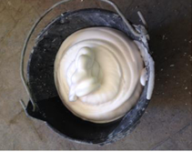
Fig. 3.2. Photograph of the foam generated.
The pre-foaming method was used and it involved separately producing the base mix and stabilizing the preformed aqueous foam before thoroughly integrating the foam into the base mix. The pre-formed foam was generated using wet method. The wet method generated foam by spraying the foaming agent solution through a fine mesh, producing bubbles typically ranging from 2 to 5 mm in size. However, wet foam was comparatively less stable than dry foam.

3.2.3. Mixing and Casting
Once the foam was prepared, it was carefully incorporated into the cement-sand-water mixture. The following procedure was used for mixing and casting:
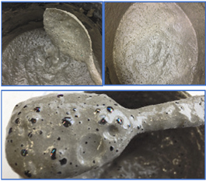
Fig. 3.3. Pictures depicting foam concretes incorporating foaming agent (SLS).
- The foam was gently folded into the wet mix to avoid collapsing the air bubbles in the foam.
- This step was critical to maintain the desired air content and stability of the foam. The resulting foam concrete was poured into molds of standard size (e.g., 150 mm × 150 mm × 150 mm for cube samples) and vibrated to ensure uniform distribution and minimal air pockets.
- The foam concrete was left to cure under standard conditions (ambient temperature of 20–25°C, with 60% humidity) for 24 hours before being demolded. The specimens were further cured in water for up to 28 days.

3.2.4. Testing of Foam Concrete
The various properties tests were carried out in the fresh state and after the foam concrete had been cured.

3.2.4.1. Slump Test
- Standard Code: ASTM C143 – The slump test was conducted in accordance with the Standard Test Method for Slump of Hydraulic-Cement Concrete.
- Procedure:
- A slump cone (base diameter: 200 mm, top diameter: 100 mm, height: 300 mm) was placed on a flat, non-absorbent surface.
- The cone was filled with foam concrete in three layers, each tamped 25 times with a standard tamping rod.
- After filling, the cone was carefully lifted vertically, allowing the concrete to slump under its own weight.
- The height difference between the original cone height and the highest point of the slumped concrete was measured to determine the slump value.

3.2.4.2. Thermal insulation Properties Test
The thermal insulation test was conducted under the following environmental conditions:
- Date of Test: 22th April 2025.
- Time of Exposure: 12:00 PM to 2:00 PM
- Location: I.O.T yard, Kwara State Polytechnic, Ilorin, Nigeria.
- Weather Condition: Clear skies with direct sunlight.
- Ambient Temperature: Ranged between 38°C and 42°C during the test.
To assess the thermal performance of the foam concrete, a cube specimen was exposed to direct sunlight under ambient outdoor conditions. The specimen was positioned on a flat, non-conductive surface to minimize heat loss through conduction to the ground. Temperature readings were taken at both the front (sun-exposed) and rear surfaces of the cube at regular intervals of 30 minutes using a digital infrared thermometer. This procedure was continued over a specified duration to monitor the progression of heat transfer through the material. The recorded data provided insight into the thermal insulating properties of the foam concrete and the influence of its composition on heat resistance.

3.2.4.3. Compressive Strength Test
- Standard Code: ASTM C39 – The compressive strength test was conducted in accordance with the Standard Test Method for Compressive Strength of Cylindrical Concrete Specimens.
- Procedure: Cube samples (150 mm x 150 mm x 150 mm) of foam concrete was tested for compressive strength after 7, 14, and 28 days of curing.
- The specimen was placed in a universal testing machine, and the load was applied gradually at a rate of 0.25 MPa/s until failure occurs. The compressive strength was calculated by dividing the maximum load by the cross-sectional area of the specimen.

3.3. Selected image of workplace moment

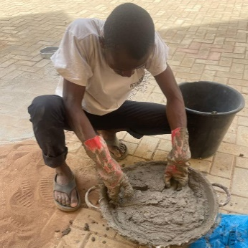 | 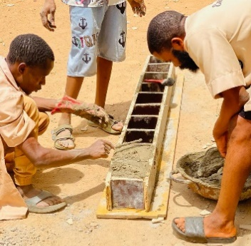 | 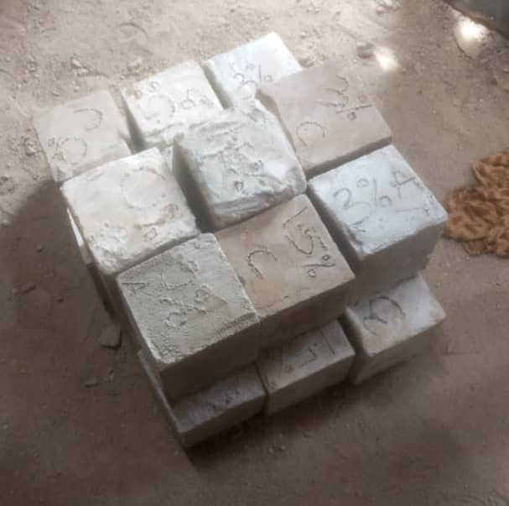
(a) | (b) | (c)
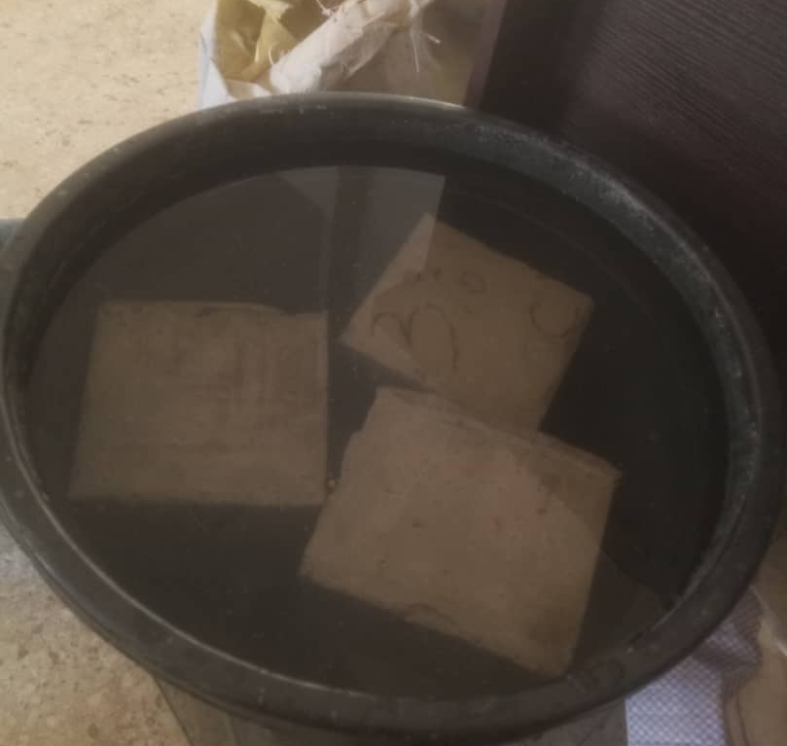 | 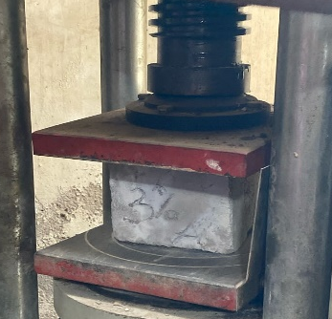 | 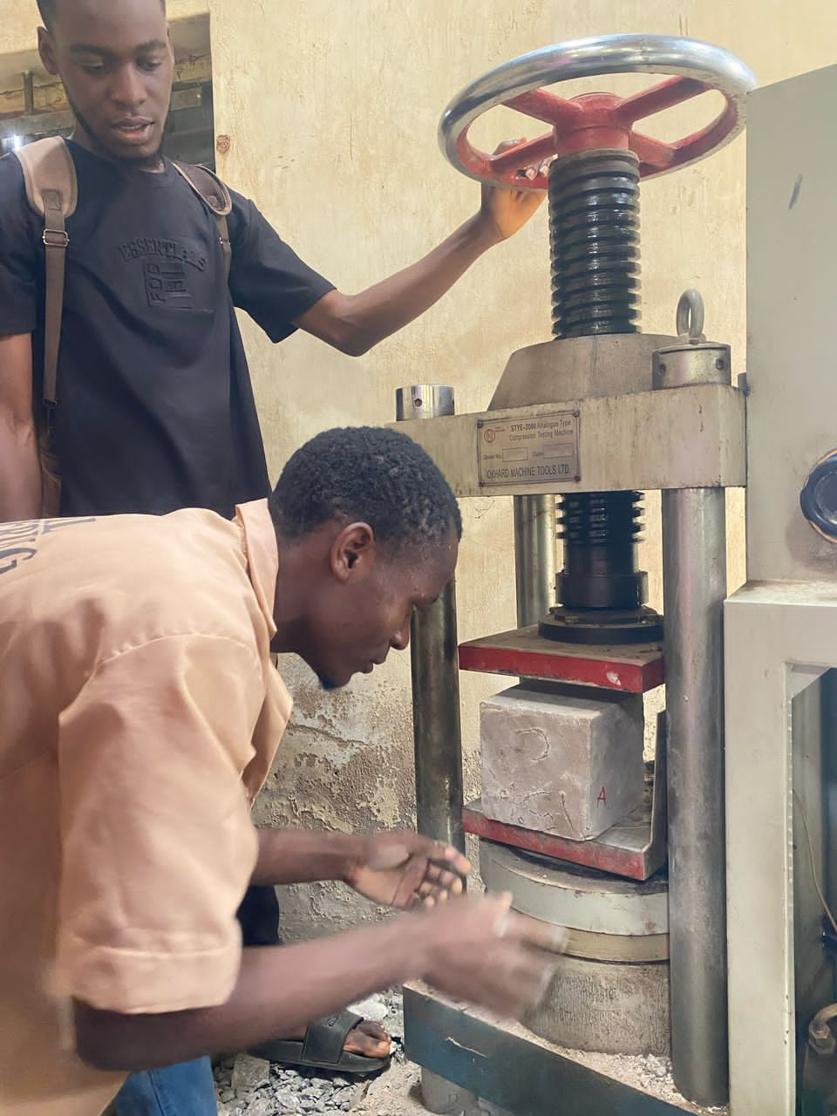  (g)
(d) | (e)
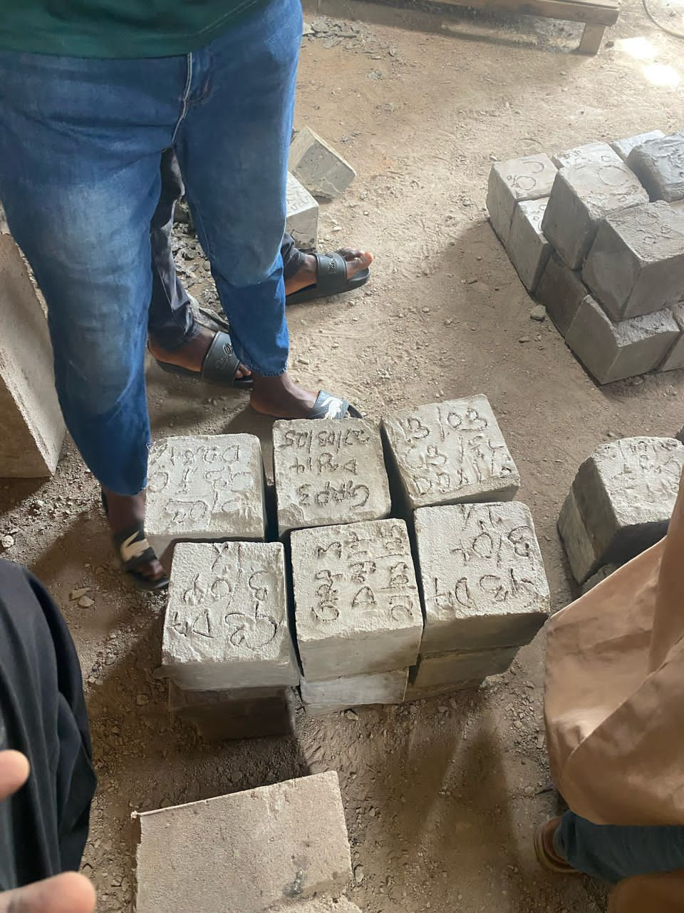
(f)
Fig. 3.4. Photographs (in alphabetical order from top left to bottom right) of the FC preparation, casting, curing and testing phases in cubic

