CHAPTER THREE
3.0 METHODOLOGY
This is the process where we determine the method to use , instrument to use when to go and how to carry out the project to have a successful work done at the end.
It explains the steps by step procedure equipment and technique in executing the perimeter and detailed survey of federal staff school, Adewole Kano road Ilorin. (Data processing, accuracy check and final map production.
- Working from whole to the part.
- The principle of choosing the method of survey most appropriate to meet the desired result.
- The principle of provision for adequate checks to meet the required accuracy
- Planning is divided into two stages:
- Office planning
- Field planning
3.1 OFFICE PLANNING: Office planning which could be termed as preparation,analyze and organized in the office reconnaissance involved knowing the type of instruments, purpose, specification and accuracy require of the survey to be carried out. These led to the choosing of appropriate equipment and method to be employed, also costing of the survey operation was done in the office. Information related to the give project was collected from various sources the coordinate (x, y, and z) of the initial and that of the three choosing controls used for orientation.
Tab. 3.1shows the value of Controls
Station | Northing | Easting
SC/KWI.334R | 938052.240 | 675605.928
SC/KWI.333R | 9377797.689 | 675548.031
SC/KWI.332R | 937809.422 | 675500.648

3.1.1FIELD RECONNAISSANCE
The project site was visited by all the group members to have the true picture of the site for the better planning. The recce diagram was drawn alongside the carrying out and the reasonable artificial features were fixed along and within the traverse lines, the traverse was fixed to maintain perfect indivisibility.
3.2 INSTRUMENT USED
Selection of instrument to be used is:
Total station
- Tripod
- Linear tape
- Steal tape
- Field book
- Pencil
- Targets and their tripod
- Reflectors stand and target
- Nails
- Pegs
- HARDWARE USED
- Total station
- Computer system
- SOFTWARE USED
- ArcGIS
- Ms Excel
- Google earth
- Ms word
INSTRUMENT TEST
All instrument used for the executive of the project were tested before the commencement of the field observation in order to ascertain the efficiency and reliability of the instrument.
3.3 CHECKING OF INSTRUMENT ERROR (TOTAL STATION)
The total station was tested for horizontal and vertical collimination error and the instrument was mouned on a good condition before being used at the point mark (A) with the necessary adjustment. A target was set up on another point and bisect with the cross hair if the total station telescope recording the angles (i.e. horizontal and vertical).
This is where we exercise for any controls to be used for orientation; the control was checked by observation on the control pillars as to ascertained stability and reliability both linear and angular.
The check was carried out as follows:-
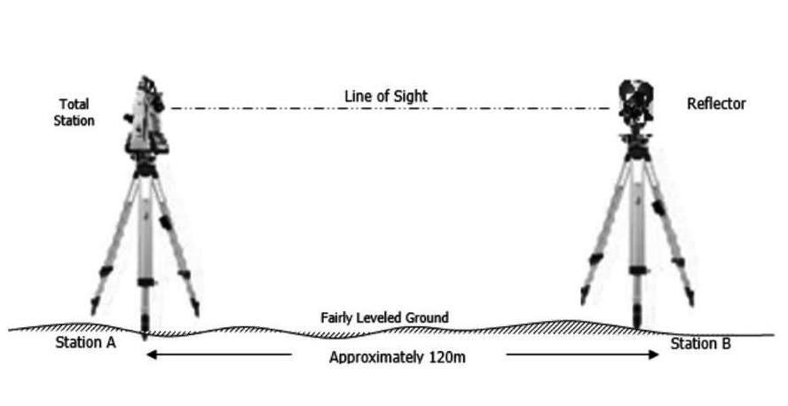
The total station was set on a pillar, temporary adjustment include centering, leveling, and focusing.

Fig. 3.1: show the instrument test.
Tab. 3.2: Show the result of instrument test
Inst Stn. | Sight (Reflector) | Face | Hor. Circle Reading | Ver. Circle Reading
 | B | L | 87º 35’ 10’’ | 88º 26’ 15’’
A | B | R | 267º 35’ 12’’ | 271º 33’ 46’’
 |  |  | Diff= 180º 00’ 02’’ | Sum= 360º 00’ 01’

Horizontal Collimation = [(FR – FL) - 180º]/2
= [(180º 00’ 02’ - 180º 00’ 00’’) /2]
= 00º 00’ 02’’/2
= 00° 00’ 01’’
Vertical Collimation = [(FR – FL) - 360º]/2
= [(360º 00’ 01’’ - 360º 00’ 00’’)/2]
= 00º 00’ 01’’/2
= 00° 00’ 0.5"
3.4 MONUMENTATION
This is the process where we established and do physical marking of control point on the ground to serve as reference position. These control point are for ensuring accurate and consistency throughout digital Mapping project. The digital Mapping of federal staff school Adewole Kano road Ilorin monumentation formed the foundational frame works of the entire survey
PUROSE OF MONUMENTATION.
It serves as the origin point for horizontal and vertical measurements
It is a reference point for instrument set up
It provide permanent marker for future survey
To facilitate proper geo reference and coordinate
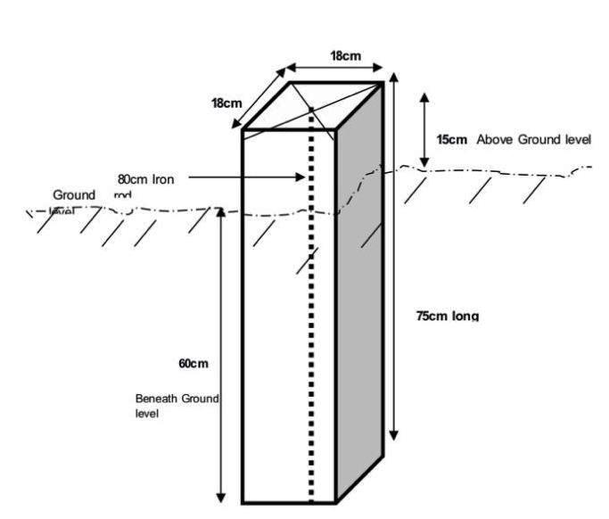

Fig.3.2 typical third order survey beacon
3.5 DATA ACQUISITION
Data acquisition is the next stage after we ave done reconnaissance, this was done on the field and it includes the determination of point’s geometry and attribute value i.e. linear measurement and the coordinating of each station using total station.
INSTRUMENT CHECK
Before carrying out the survey operation, the working condition of the instrument was checked to see if the instrument was tested. This was done by setting the instrument such as centering and parallax elimination were applied measurements was carried out by sighting a target on another station to determine both collimination and vertical error.
During the data acquisition we carry total station instrument to mount it on a tripod and level it by operating the levelling screw within the range so dat we can do temporary adjustment on the level position. We bisect the horizontal, vertical, slope and height of the land. The processor target point and compute the data of the point and display it on screen,It is stored in the electronic book. During the process of data acquisition we carry out perimeter traverse.
3.5.1 GEOMETRIC DATA ACQUISITION
Geometric data acquisitionwere obtained using total station ie combination of electromagnetic theodolite as and the electronic distance measurement (EDM). Geometric data are positional data i.e. (X,Y,Z) coordinate which make it easy to locate their actual position of features on the earth surface.
Detail is a referred to as man made and natural features on the ground with in the project site which are determined and obtained by using total station and are finally represened with a suitable scale on a plan..
3.5.2 PERIMETER TRAVERSE AND GEOMETRY POINTS GENERATION
Traverse may be defined as sequence of connected straight lines whose direction and distance has been measured, that is, it involved the determination of the bearings and distance of series of connected straight line from known coordinated point so as to obtain coordinates of the newly established station, this include the following: -
Linear measurement
Angular measurement
STATION | EASTING (m) | NORTHING (m) | REMARKS
PT1 | 675945.300 | 940823.730 | Established
PT2 | 676048.460 | 940788.200 | Established
PT3 | 675981.000 | 940628.000 | Established
PT4 | 676020.620 | 940593.770 | Established

3.6 DATA PROCESSING
This is the method in retrieving, downloading, sorting, and analysis of the acquired data (field data), the data is being downloaded from the total station to a computer system and processed into information using the appropriate method and software.
This simply refers to the graphical representation i.e. plotting of plan. it was plotted using AutoCAD and Ms-word software in a computer system and a suitable scale was used to have the hard copy format. Presented information includes; boundary, details and pegs. Conventional signs and symbols were also used to represent features of the plan accordingly. The digital map was produced using AutoCAD software and following the under listed procedures;
- Switch on the computer and it was allowed to boot
- Start menu was clicked
- Select programs was clicked
- From the notepad, a script files for the coordinate as p-line easting, northing, was structured
- File was saved with the extension. scr.
- AutoCAD was launched
- File menu was clicked
- Sub menu [news] was clicked and the name was saved
- Format was clicked and all necessary settings were carried out [i.e. units, direction etc.]
- Then ‘ok’ was clicked to aspect the parameters settings
- Tools were selected
- Run script was clicked on
- Escape key was clicked, z enter and e enter were pressed one after the other in order to zoom The extent of the plan being drawn and the plotted plan was displayed
- Text was clicked
- Escape key was pressed, Z then E enter key
- Text writing and other necessary editing were done
- Coordinates of the details were all typed
- Coordinates were pasted and then the points were all displayed
- With polyline the points were joined as they were sketched.

