CHAPTER THREE
3.0 SYSTEM DESIGN AND IMPLEMENTATION
3.1 Introduction
This chapter outlines the practical steps taken in designing and constructing the electrical extension box. It describes the major system blocks, their connection, the function of each component, and how they work together to produce a functional and safe device. The goal was to develop a reliable, user-friendly extension box using affordable materials while observing all safety precautions.
3.2 Block Diagram of the System
The system is designed using simple and safe electrical components arranged in the following logical sequence: Power Plug → Fuse → Control Switch → Indicator Lamp → Socket Outlets
Each section plays a critical role in managing and distributing power safely to the connected appliances.
Power Plug → Fuse → Control Switch → Indicator Lamp → Socket Outlets
3.3 Description of the System
The extension box receives AC power (220V) from a wall socket through a three-pin plug and cable.
The live wire is first passed through a fuse which serves as protection against excess current.
From the fuse, it goes to a control switch that allows the user to manually turn ON or OFF the entire system.
An indicator lamp is connected in parallel with the switch to show power availability.
Finally, the output is distributed evenly to four sockets arranged within the casing.
3.4 Components Used and Their Functions
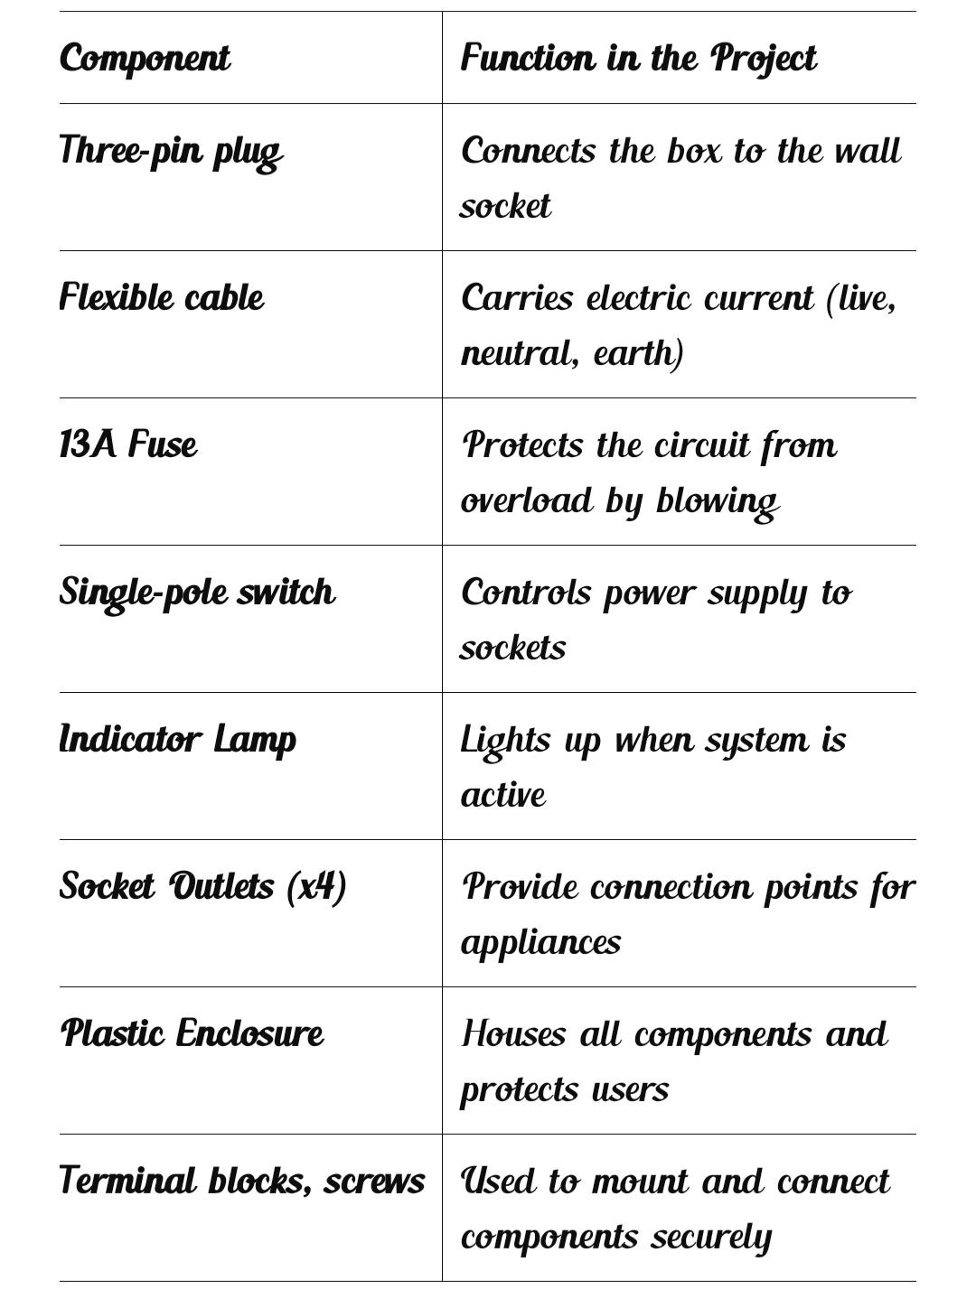

All wires used are 1.5mm² copper, which is standard for low-load power distribution.

3.5 Circuit Design and Explanation
Live wire goes from the plug to the fuse, then to the switch, then to all sockets.
Neutral and Earth wires are split from the plug and sent directly to all sockets.

The indicator lamp is connected across the live and neutral to light up when power flows.
When the switch is ON and the fuse is intact, current flows through the system.
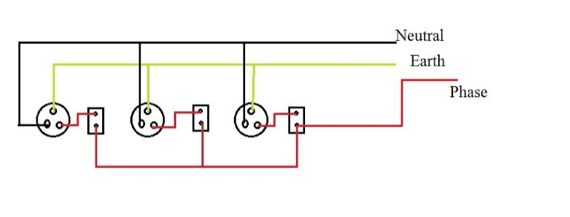
CIRCUIT DIAGRAM OF ELECTRICAL EXTENSION BOX

3.6 Construction Procedure
- Measured and cut openings in the plastic box for sockets, switch, and indicator.
- Connected all internal wiring as per the design, using terminal blocks and clips.
- Soldered where necessary for solid connections.
- Installed components into the box and screwed them in place.
- Tested for continuity, insulation, and load performance before sealing the box.
3.7 Safety Considerations
All wires were neatly arranged and insulated to avoid contact and shock.
Fuse rating matched the expected maximum current draw.
Earth wire was properly connected to all sockets and the plug.
Casing is made of flame-retardant plastic to prevent fire hazard.
All terminals were tightened and checked to avoid sparking.

