TECHNICAL REPORT ON

STUDENT INDUSTRIAL WORK EXPERIENCE SCHEME (SIWES)

OBSERVED AT

SOLA AKINRINDE CENTER LIBRARY, OSUN STATE
(AUGUST, 2024 – NOVEMBER, 2024)
BY
ADELEKE ANTHONIA ADEDOYIN
(ND/23/LIS/FT/00140)

SUBMITTED TO

THE DEPARTMENT OF LIBRARY AND INFORMATION SCIENCE, INSTITUTE OF INFORMATION COMMUNICATION TECHNOLOGY, KWARA STATE POLYTECHNIC, ILORIN

FEBRUARY, 2025

TABLE OF CONTENT
Title Page 1
Tableof 2
ReportOver-view 3
CHAPTER ONE: 4
  - Background 4
1:2 Objectives of SIWES 5
CHAPTER 6
2:1 Description of the Establishment of Attachment 6
2:2 Location andBriefHistoryoftheEstablishment 6
2:3 Objective of the Establishment 7
2:4 Organization Structure of the Establishment 8
2:5 Various Department/Unit and their Functions 9
CHAPTERTHREE: 11
3:1 Summary of Actual Work Done with a Clear Statement of the 11
Experience Gained During SIWES 14
CHAPTERFOUR: 16
4:1 Description of Equipment Used and their Functions 16
CHAPTERFIVE: 17
5:1 Summary
5:2 Conclusion
5:3

REPORT OVERVIEW
This report showcases the experience I gained during my Students’ Industrial Work Experience Scheme (SIWES). SIWES is an Industrial Training program that assists in making students gathers practical experience in their various fields of study. Students are to get attachments in institutions where they can undergo their training. This report entails the experience I gathered as well as information pertaining to where I carried out my Students’ Industrial Work Experience Scheme. It contains, also some valuable and important information and description of the establishment/institution of my attachment. Some of this information in this report includes the location and brief history of the establishment, the objectives of the establishment of my attachment, the organisational structure/hierarchy of the establishment and the various departments/sections in the establishment and their functions. Finally, the report contains some challenges I encountered or took notice of during the period of my attachment and some recommendations that could help improve the Scheme in the future.

Chapter one
Introduction
1.1 Background
The Students' Industrial Work Experience Scheme (SIWES) is a system imbued with the ability to provide tertiary-level students with the opportunity of gaining practical-based work experience in relation and addition to what they have learnt in school within the time framework of their undergraduate academic tutelage. It is designed to prepare students for the industrial working situation they will likely face after graduation by bridging the gap between theory and practice. Akerejola (2004) opines that in an effort to bridge this identified gap between theory and practical in our tertiary institutions, the ITF initiated the Students' Industrial Work Experience Scheme (SIWES) in 1974. The scheme was designed to provide the much needed on the job practical experience for students undergoing all courses that required exposure in industrial activities during the school program. It was planned as a cooperation industrial inter-relationship between institutions of higher learning and industry/commerce in the country.
The student industrial work scheme is an integral part of the curriculum for students of engineering, applied sciences and environmental studies. The student Industrial work experience scheme exposes them to real life work environment which cannot be obtained in the classroom. SIWES will also enable students to learn how to apply theories learnt in classroom to real life situation. It also allows students to be familiar with modern equipments and state of the art practice in the industry.
1.2 Aims of Students Industrial Work Experience Scheme
The Students Industrial Work Experience Scheme (SIWES) Aims at:
- Enhancing the industrial skill acquisition and work experience of students thus augmenting their theoretical knowledge to make them efficient at solving the practical problems of the work environment.
- Ensuring the involvement of the related industries and organizations in the training, education, exposure and development process of the students which they will in turn recruit as their staffers after their academic experience.
- Exposing students to different categories and classes of people to improve their people skills, interactional abilities and team spirit and enhance their abilities to build positive working relationships with a wide range of individuals and organizations.
- Increasing the marketability and entrepreneurial skills of students by exposing them to the odds of fieldwork and the challenges of meeting personal and organizational expectations by preparing students for the industrial situation they will likely meet after graduation.
- Affording students the additional opportunity of learning how to write field reports.
- Contributing to the quality and size of the nation's manpower, technological development and overall skill levels.

Chapter two
Description AND BRIEF HISTORY of SOLA AKINRINDE CENTER LIBRARY
2.1 Description and History AKINRINDE CENTER LIBRARY
Sola Akinrinde Center Library, often call UNIOSUN main library was named after the first vice-chancellor of the institution, Professor Sola Akinrinade and was completed on November 2016. The library was built and completed from the Internally Generated Revenue (IGR) of the institution. It is a two storey building with different units/sections, headed by unit or sectional heads. The Library is built on the capability of having a strong foundation in terms of infrastructural development, addresses challenges and looks forward to future opportunities to serve the community better. Aforesaid, the Osun State University Library supports and supplements the teaching-learning programme of the institution at all levels. It performs this function by providing information resources in various formats. As the custodian of knowledge, the library serves as an institutional repository.
The University Librarian is the overall head of the library. Considering the mission and vision of the university community which is to create a unique institution committed to the pursuit of academic innovation, research, skills-based training and a tradition of excellence in teaching and community service; the library has been well positioned (UNIOSUN News-Spring, 2010). The library at the main campus, Osogbo, Osun State, Nigeria was moved from the old library building to the magnificent two storey new library building on February 2017. This new library could accommodate more significant library resources in all formats: print and e-resources as well as human resources, it could accommodate more than 500 library users/readers at a time. The reading rooms are spacious, well aerated, and with air conditioners, comfortable reading chairs and tables. Some of the reading rooms are set aside for group reading. In these rooms, readers are encouraged to discuss. Similarly, adequate shelves and shelving spacing that allows for easy movement are provided. More so, reading carrels are reserved for staff members.

2.2 OPERATIONS OF OSUN STATE UNIVERSITY LIBRARY
Osun State University is set up to extend services beyond its physical walls, provide materials accessible by electronic means and at the same time to provide unrestricted access to information.
Opening Hours:
The libraries open to readers as follows:
During Session Time Monday – Friday 8.00 am - 6.00 pm
Saturday 8.00 am - 1.00 pm
Environmental Sanitation (Saturday) 10.00 am - 4.00 pm
Sunday and Public Holidays closed
2.3 STRUCTURE/ORGANOFRAM OF SOLA AKINRINDE CENTER LIBRARY
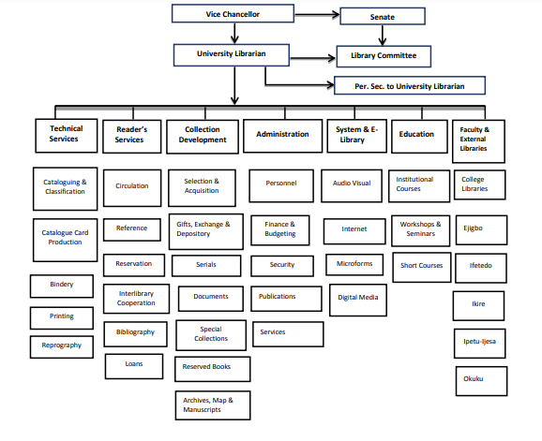

2.4 Division /section
- Technical services
- Readers services
- Electronic support services
Collection Development Unit
Acquisition of library books and other literary materials: This Unit is headed by a Collection/Acquisition Librarian. In Osun State University Library, the nature of acquisitions has continued to illustrate the shift from print material to electronic media. More investments are in both digital content and technology infrastructure. The library acquires its resources in all formats, such as subscription to locally produced books and journal, association journals, subscription to current journals both print and electronic, large scale acquisition of books in print and subscription to international databases. Acquisitions in the library could also be through gifts and exchanges, inter-library loan and bequeath. Every new resources/item coming into the library passes through the Acquisitions Department which ensures that proper records have been kept concerning the item acquired before being out for further processing and use.
Technical Services Unit
The Technical Unit of UNIOSUN Library is headed by a Technical Services Librarian. It processes all library resources. The following resources are made available in this unit:
- Library of Congress (LC) Subject Headings and Schedule
- Internet Connectivity to check online resources
- Cataloguers’ desktop.
This Unit is responsible for the cataloguing and classification of all library materials. Cataloguing has to do with description of library materials such as books to point out important bibliographic features like author, title, place of publication, publisher, edition, date of publication and subject of each book. In classification, all materials that have similar subject contents are grouped together and are assigned class marks or numbers. The class mark or number identifies each item as a member of a group. The ultimate purpose of cataloguing and classification is to ensure that library materials are systematically organized. With cataloguing and classification, it becomes possible to put all materials on a specific discipline in one area of the library shelves. Library and classification save the time of the library user/clientele.
Serials Unit
The Serials Unit is headed by a Serials Librarian. It stocks primary sources of information, for example periodicals, newspapers and magazines, academic journals on various subjects. The materials in this Unit are restricted and cannot be taken out of the Osun-ana
Reference Unit
The Reference Unit is headed by a Reference Librarian. She/he performs the following services:
- Conducts an extensive literature search for readers with research/project proposal;
- Provides answers to specific queries;
- Instructs users on the use of the library, catalogues, abstracts, and indexes etc;
- Guides users/clienteles in locating materials;
- Renders photocopying services to readers;
- Provides inter-library loan services.
The materials in the Reference Unit are for in-house use only. They are not for loan. Readers are supposed to consult or refer to them only. However, it is not only the materials that are consulted in this Unit, but also the Reference Librarian and his supportive staff are consulted. These staff constitutes the human resources of this Unit and can answer questions from the users to satisfy their information needs. In addition, this Unit of the library assists users to release information very quickly through compilation of reading lists, bibliographies and making of abstracts and indexes.

Readers Service Unit
This Unit is headed by a Readers’ Services Librarian. In Osun State University Library, this Unit serves as public relation unit. It is the point where books are charged out and discharged. The Unit registers users and generates the library tickets that admit users/patrons into the library. All library users with or without borrowing privileges, must register and be issued a library ticket before they can make use of the library. The purpose of every library is to provide literature support and general information services to users. It will be a complete failure if a library cannot provide the needed readers’ services. This library provides readers’ services in two main divisions:
- Circulation division
- Reference division.
Digitization Unit
This Unit is headed by a System Librarian/Analyst. In this unit of UNIOSUN Library, critical library resources, particularly thesis and dissertation known as Red publications are digitized and uploaded for wider circulation. The library management needs to invest more in modern digitization equipment in this unit. The library will in future publish the Abstract of Theses and Dissertations accepted by the Post Graduate School.
Institutional Repository Unit (IR)
This Unit is headed by an Institutional Repository Librarian. The Unit is an archive for collecting, preserving and disseminating digital copies of the intellectual output of an institution, particularly a research institution. The services here are rendered to the members of the university community in the management and dissemination of digital materials created by this institution and its community members. Materials such as monographs, e-prints of academic journal articles, electronic thesis and dissertation, course notes, learning objects or conference proceeding are rendered or provided for the university. The main objective of having this Unit is to provide open access to institutional research output in an open access repository, to create global visibility for institutional scholarly research.
The Electronic Library Unit Similarly, This Unit is as well headed by a System Librarian/Analyst. The Unit is an essential part of the library. The Unit is equipped with adequate number of computers. It has unlimited access to internet, provision of adequate bandwidth, and there is an alternative energy backup in the library considering the energy situation in Nigeria. The library has subscribed to the following e-resources:
Law Pavilion, Law Companion,
African E-Journal, Biokemistri,
Bioscience, ARDI,
OARE, Hein online,
AJOL, Agora,
Ebscohost, Hinari,
Nigerian virtual Library, Lexis/Nexis.

Chapter three
Description of work done and experience gained.
During my SIWES, I was introduced to various departments, section and staff of the Sola Akinrinde Center Library. I was exposed to the opening hours of the library, the divisions and sections under each divisions. I was also put through on how the library carries out their functions such as user registration, discharging of books, stamping of books, etc. I was posted to the following sections in Sola Akinrinde Center Library.
- Circulation section: I was exposed to how library materials are shelved and re-shelved, how library materials are discharged, how borrowers slip is being filed until the user has returned the borrowed items. The borrowers slip contains three copies which is white and pink. The white is filled according to the accession number of the book, pink according to borrower’s number. The pink copy is the users copy. We were also introduced to the book bank where newly materials and processed materials are kept before shelving. It also contains up to date materials and are used during accreditation.
Experience gained
- I was taught the Charging and discharging of library materials.
- I took part in the Library statistics done at regular intervals of 4 hours, at 10 am and 1 pm.
- Shelving and shelf reading of library materials on daily basis.
- I engaged in the arrangements of newly acquired library materials on the shelf
- Registering of new library users who wants to make use of the information materials in the library.
- I received processed materials from the cataloging and classification section.
- I weeded out dated materials as well as torn materials.
- I engaged in recording of books that are recieved from the catalogue and classification section.
Acquisition section: I was put through on how library materials are acquired. They acquire books, serial materials, newspapers, magazines and non-books. Acquisition is done by the polytechnic management and TETFUND. Acquisition is done by purchase or donation. TETFUND materials are purchased by TETFUND, and the polytechnic committee's also pay for materials being purchased by the polytechnic Stamping and accessioning of library materials is also done by the acquisition section. The stamp used in this section is of 6 as shown and explained in the above diagram. As well as a sample of accessioning register. Accessioning is done by following the previous number in the accession register. I.e. 097962-03 the next number will be 097964- followed by the number of copies of the material acquired by the university. They ensure books bear the necessary stamp before they are moved to the shelf. The register is used to keep information of books as shown below. 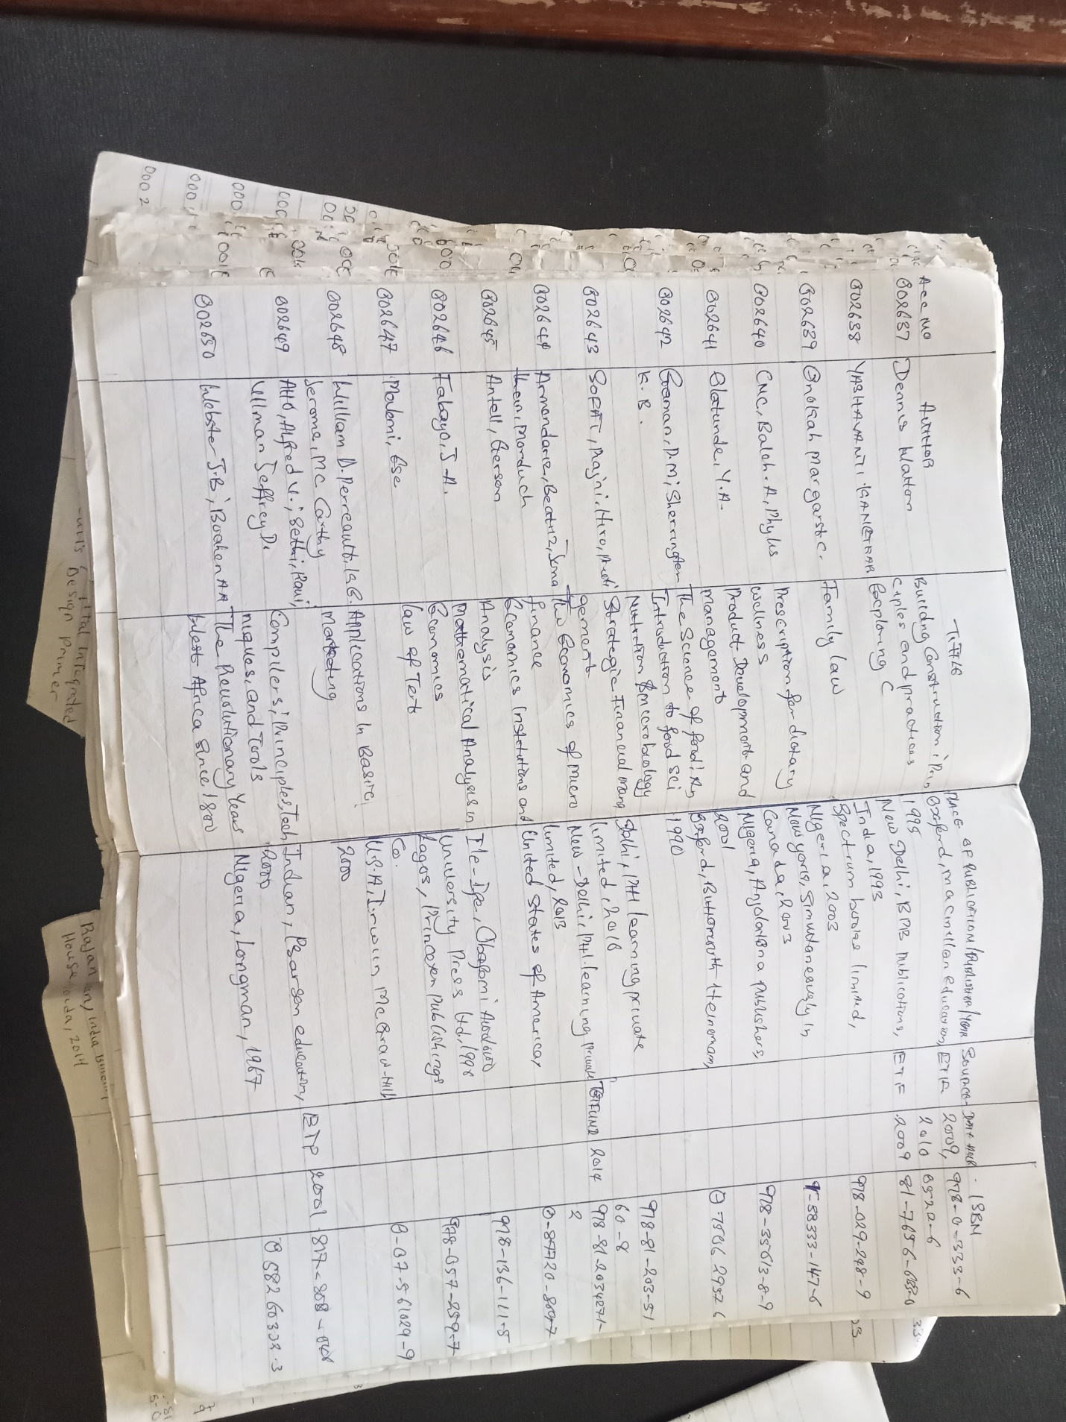Experience gained
- I have learnt the different stamps and their uses.
- I now know how to use the accessioning register to keep bibliographic details of acquired materials.
- The selection of library materials and evaluation is done here.
- Different approaches are used to acquire different materials such as serial materials which is acquired through subscription, books through purchase or donation, etc.
- I administer accession number to newly acquired books.
- Dispatching of processed material to the cataloguing and classification section for further processing.
- Cataloguing and classification section: I was taught on how to catalogue and classify library materials. We were put through on how to describe library materials on the catalogue cards in order for easy retrieval. The University use the library of Congress classification scheme to classify materials and the AACR2 to describe the library materials. Library of Congress (LC), divide knowledge into the 25 alphabets, (a-z) excluding I,O,X,W and Y for future expansion. Catalogue provides the physical description of library materials which is prepared in the following entry: main/author entry, subject or title entry. Example of a card catalogue is shown below.

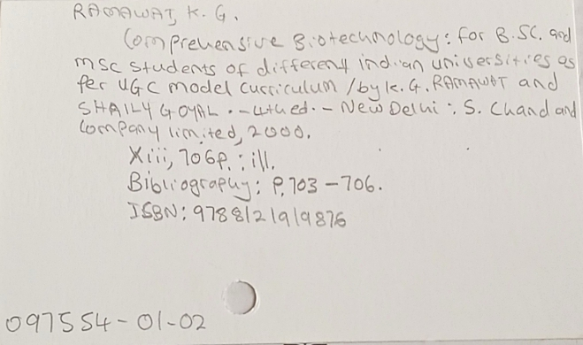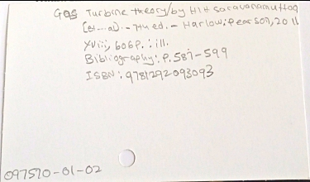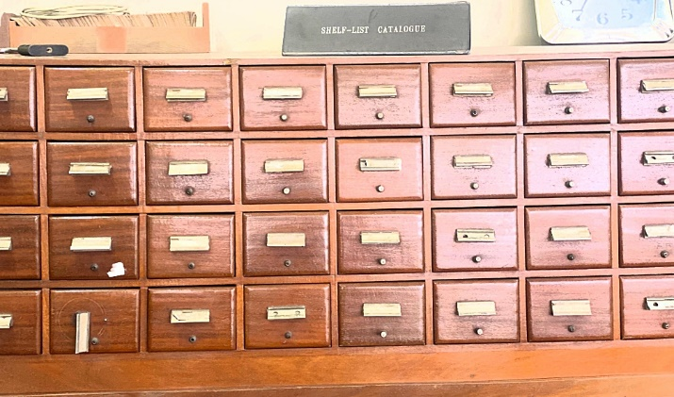
Experience gained
- Classify materials using LC.
- Cataloguing of library materials on the catalogue card.
- Use the AACR2 to describe materials in order of name of author, place of publication, year of publication, etc. for easy retrieval of information materials.
- I engaged in online cataloguing of library materials using the library integrated software KOHA. It is used to input the information on a catalogue card to the online public access catalogue OPAC.
- The different types of catalogue such as descriptive catalogue, subject catalogue and online catalogue practical are learnt in this section.
5. Serial section: I was introduced to the activities carried out in this section. I was taught on how to record newspapers, stamping, stapling, and dispatching of newspaper to the required places. I learnt the different between journal and books as well as the type of journals we have which can either be local or foreign journals. Serials are issued in successive part and are also in volumes. The local journals include; Nigeria journal of social work education, Nigeria journals of clinical and counseling psychology. While the foreign journals include; Canadian journal of economics, senri ethnological studies, etc. .
Experience gained
- Journals are assigned ISSN and are always in volumes. Such as Nigeria journal of clinical and counseling psychology (ISSN : 1118-4035) (vol. 26, may 2018).
- Stamping the necessary pages on the journals.
- Recording of newspaper and other journals.
- Materials here can only be consulted in the library and cannot be loaned out.
- Statistics of users who consult the materials are taken.
6. E- library: I was introduced to the databases that are available in the library which are of two categories, subscribed and non-subscribed databases. I learned how to catalogue inline using the library software KOHA. The operations and activities carried out in this section is to support the patron in order to have free access to any information via the internet. I also have a deep understand on the different between automation and digitization. The subscribed databases are PROQUEST, JSTOR, and the non-subscribed databases are AGORA, HINARI, JSTOR, OARE.
experience gained
- The difference between automation and digitization.
- The difference between subscribed and non-subscribed databases.
- How to assist student search for needed information using that subscribed and non-subscribed databases.

Chapter four
- Equipment used and the details of their usage
- Computers: computers are used for easy accessing of information and are used to enter the information on the card catalogue to the library software Computers can be use in a Library to keep records of books and number of books that are available in the book stalk. It is used to access the databases of the library.
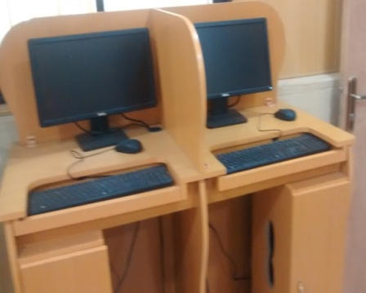
- Card catalogue cabinet: This is used to keep the catalogue cards which entails the details of all the material that has been processed in the library.
- Ups: It is used in the library because of power failure. It enables the operator to save documents before the computer system shut down to avoid loose of data and effort.
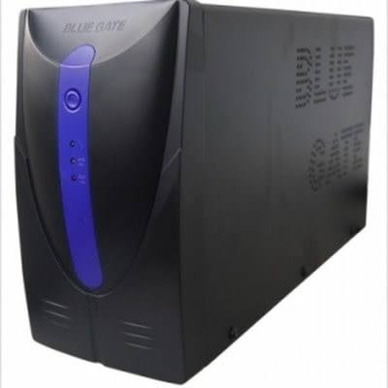

- Library shelf's: This allows the material to be arranged properly in order for easy access by the users and the library staffs.
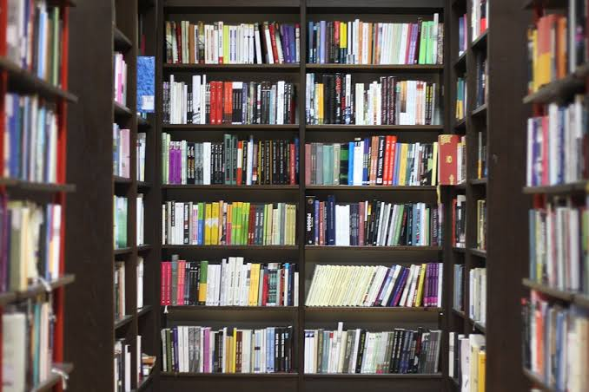
- 3 by 5 Card: this is the card used when cataloguing a book and it is used in cataloguing section by writing the descriptive details of a material in an orderly manner for easy access. After been used to catalogue the material they are kept in a drawer for record use.
- Book End: it used between books to ensure they are well arranged by putting one at the beginning and other at the end of the book on the shelf.
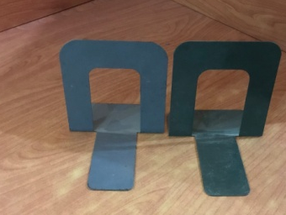
- Stamps: they are used on the information materials that are aquired in the library. It comprises of different stamp such as the date stamp, Security stamp, Edge stamp, identification stamp, Gift stamp, accession stamp and Ownership stamp, stamped on the information material. Accession stamp is for inserting the accession number, Edge stamp display library name and it is stamped on the edge of book, Ownership is to display the means of acquiring the material and Gift stamp is used when the material are donated to the library so the name of the donor can be written on it.
- Library of Congress subject heading and schedule: it list knowledge in an alphabetical order a-z. It is a comprehensive list of all the terms used by the library of congress to describe materials in their collections. It is used at cataloguing and classification section of the library to determine the subject and classify the library materials.
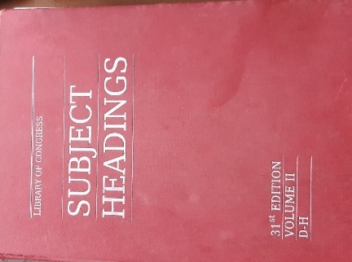

- Cutter table: it is used to determine the author name after a book has been catalogued and classified.

Chapter five
Summary, conclusion and recommendation
5.1 summary
In the course of my attachment at Sola Akinrinde Center Library, I have been taught on how to shelve, re-shelve, catalogue, discharge, acquire, stamping, etc. of library materials. During my course of learning, I observed that the class lectures are theory and are not complete without the SIWES training. There is need to balance the scale between the school system, and the industry in raising the technical literature of the students. I have gained a profound knowledge, practical skills, and understanding partaking to my profession.
5.2 Conclusion
This report covers the experience gathered during the students’ industrial work experience scheme SIWES programme held at Sola Akinrinde Center Library popularly known as LAUTECH Library. I learnt the basic practical and theoretical knowledge that I may not have gotten from the lecture room. It also gives me a feel of what it would be like after graduation, when I start working in a library organization. It is therefore an understatement to conclude that SIWES is of great benefit to students of tertiary institutions. Proper and effective administration of the scheme will go a long way in boosting and enhancing the competencies of the work force of the country.
5.3 Recommendations
Base on my experience during the four months SIWES training, I hereby recommend the following;
- There should be alternative power supply in the library so as to not hinder the study of the student currently studying in the library.
- Experienced staff should be assigned to the students.
- The SIWES coordinator should provide Scheme of what the organization are to teach the students.
- The bindery section should be provided for to enhance the protection of materials.
- There should be proper maintenance of the ICT facilities and training of staff and also back up of data for further use.
- The SIWES officials should invigilate the students at their respective place of attachment to ensure discipline.
- Organization should accept student in order to gain the expected experience.
- Materials should be processed, checked, and dispatched immediately to ensure that the materials are available on the shelf at the needed time.

