CHAPTER TWO
2.1 LITERATURE REVIEW
This chapter explains the literature review of the previous project work on electrical extension box, its relevance and the detailed explanation of each of the major components that is used to achieve the results.

2.3 COMPONENTS USED FOR THE PROJECT
For this project to be complete, there is a need to know the components used in the design. In electronics, the power system is designed in such a way that the equipment always has power so that it can function effectively. These components include:

- Resistor
- Transistor
- Transformer
- Switch
- Fuse
- Liquid crystal display (LCD)
- 13A sockets
- Rectifier
- Capacitor

2.3.1 CAPACITORS
Capacitor is a passive component that consists of two conducting surfaces separated by a layer of an insulating medium called di-electric. They are usually used to store electric charges.
2.3.2 CERAMIC CAPACITORS
Ceramic capacitor are the common types of capacitors used in most of the electrical instruments, as they are more reliable and cheaper manufacture.
These capacitors consist of ceramic or porcelain discs and are said to exist in a non-polarized from which is used in various types of industries. Ceramic material is known to be an excellent dielectric because of its poor conductivity and an efficient of the electrostatic fields.
2.3.3 ELECTROLYTIC CAPACITOR
An electrolytic capacitor is a type of capacitor that uses an electrolyte to achieve a larger capacitance than capacitor other capacitor types. An electrolyte is a liquid or gel containing a high concentration. Almost all-electrolytic capacitor are polarized, which means that the voltage on the positive terminal must always be greater than the voltage on the negative terminal.
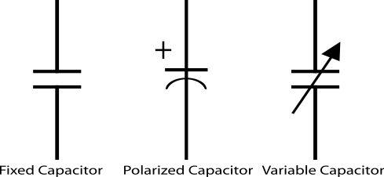
Fig.2.1 symbols of a capacitor
2.3.4 REGULATORS
A LM79805 regulator is a three terminal positive regulator with 5V fixed output voltage. The fixed regulator provides a local regulation, internal current limiting, thermal shut-down control, and safe area protection. Atypical diagram of a Regulator is shown in Fig. 2.3.
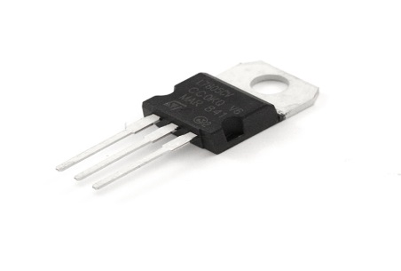
Fig. 2.2 A Regulator
2.3.5 RESISTORS
Resistors are passive elements used to oppose the flow of electricity in a circuit. The resistance of a resistor is measured in ohms. They are used to limit the current in the circuit and as a potential divider to achieve a specific value of voltage across a terminal. Resistors are either fixed or variable. A typical symbol of a resistor is shown in Fig. 2.3

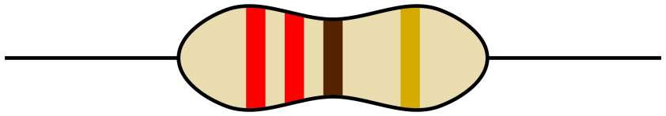
Fig. 2.3 Resistor

2.3.7 CRYSTAL OSCILLATOR
A crystal oscillator is an electronic circuit that uses the mechanical resonance vibrating crystal of piezoelectric material to create an electric signal with a precise frequency. This is often used to stabilize frequencies for radio transmitters and receivers. A typical diagram of crystal oscillator is shown in Fig. 2.4
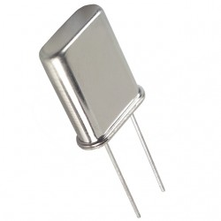
Fig. 2.4 Crystal Oscillator

2.3.8 TRANSFORMER
A current is a passive component that transfers electrical energy from one electrical circuit to another circuit, or multiple circuit. A varying current in any one coil of the transformer produces a varying magnetic flux in the transformer’s core, which induces a varying electromotive force across any other coils wound around the same core.
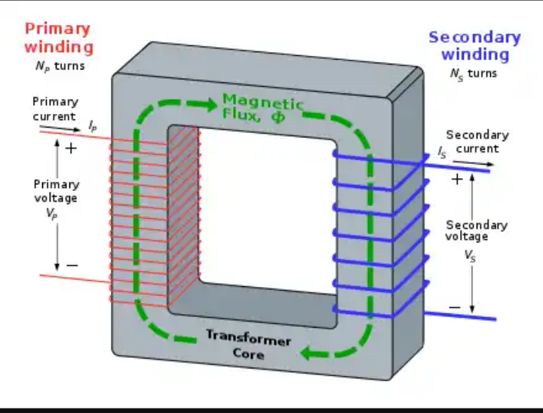
Fig. 2.5 Transformer winding
2.3.9 SWITCH
This electrical component can disconnect or connect the conducting path in an electrical circuit interrupting the electric current or diverting it from one conductor to another. The most common type of switch is an electromechanically device consisting of one or more sets of movable electrical contacts connected t external circuits, when a pair of contacts is touching current can pass between them, while when the contacts are separated, no current flow.
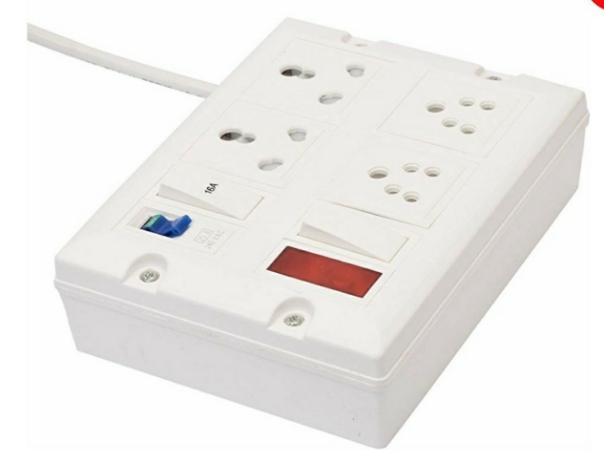
Fig.2.6 A typical switched socket

2.3.10 FUSE
This is an electrical safety device that operates to provide overcurrent protection of an electrical circuit. Its essential component is a metal wire or strip that melts when too much current flows through it, thereby stopping or interrupting the current.

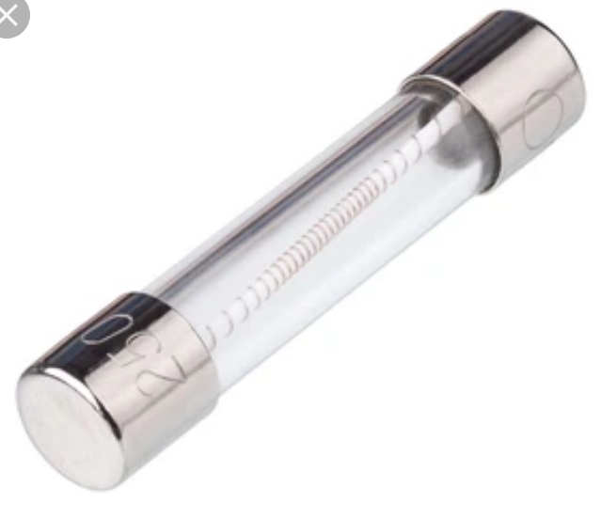
Fig.2.7 A fuse

2.3.11 LIQUID CRYSTAL DISPLAY
This is a flat panel display or electronically modulate optical device that uses the light – modulating properties of a liquid crystals combined with polarizers. Liquid crystals do not emit light directly, instead using a backlight or reflector to produce images in colour or monochrome.
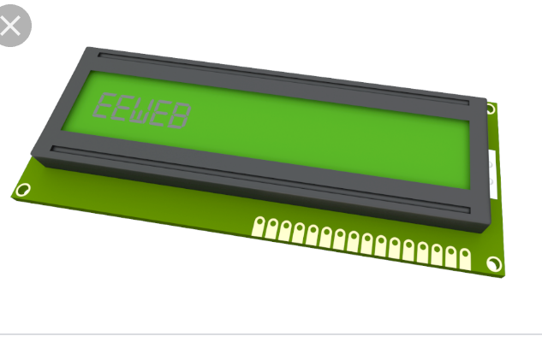
Fig.2.8 Liquid crystal display
2.3.12 13A SOCKET
This is a three (3) outlet with a (live, Neutral and Earth), it accommodates different electrical devices and aid their connections to the electricity before they can function properly. It helps in the connection of appliances rated between 700W and 3000W e.g dishwasher, micro wave, kettle, toaster machine, Iron e.t.c
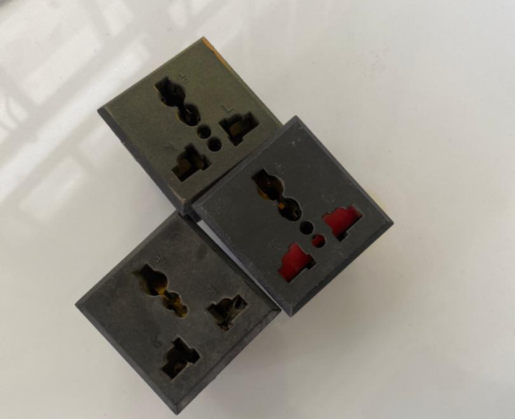
Fig.2.9 A typical 13A sockets
2.3.13 UNIVERSAL SERIAL BUS (PORT)
USB connectors have become the standard connection method for devices such as keyboards, game pads & joysticks, scanners, digital cameras, printers and external hard drives.
Although designed for personal computers USB has become commonplace on other devices such as mobile phones, tablets, video game consoles, AC power adaptors, memory sticks and mobile internet access dongles
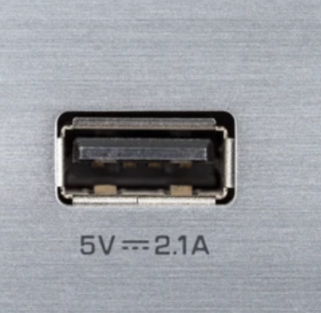
Fig.2.10 USB port

2.3.14 LITHIUM BATTERY
A lithium battery or a Li-ion battery is a type of rechargeable battery composed of cells in which lithium ions move from the negative electrode through an electrolyte to the positive electrode during discharge and when charging. The figure below shows a lithium battery
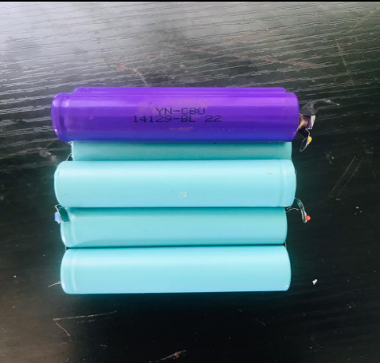
Fig.2.11 A lithium battery
2.3.15 RELAY
A relay is an electrically operated or electromechanical switch composed of an electromagnet, an armature, a spring and a set of electrical constants. The electromagnetic switch is operated by a small electrical current that turns a larger current on or off by either releasing or retracting the armature constant, thereby cutting or completing the circuit.
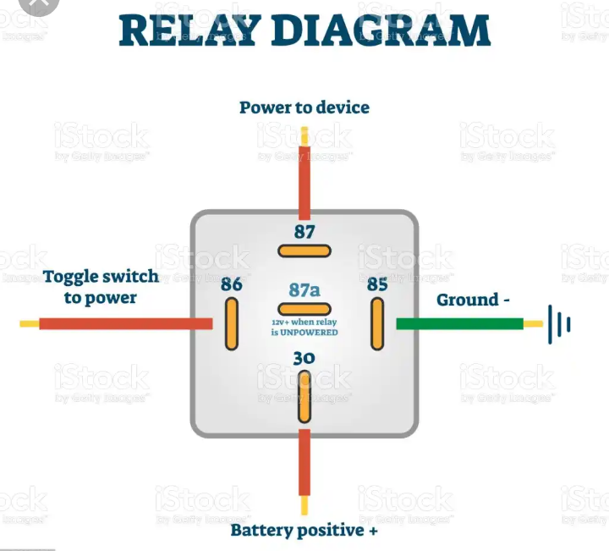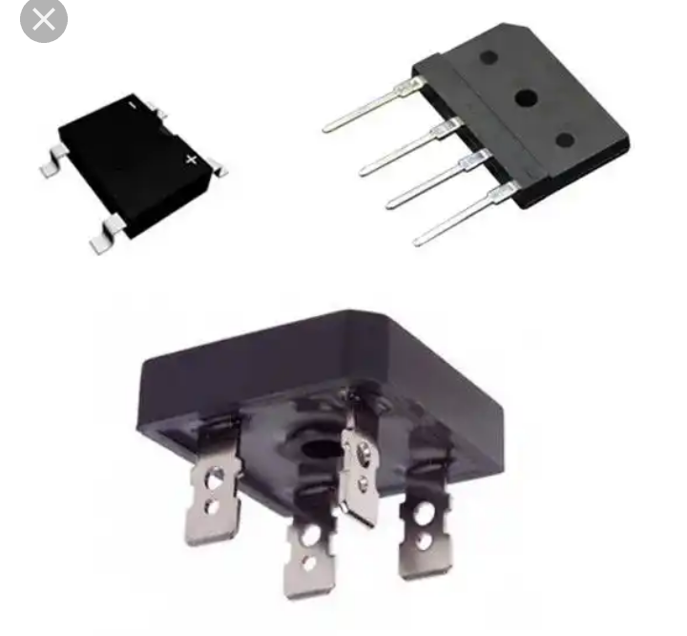
Fig.2.12 Relay
2.3.16 TRANSISTOR
Transistor are active component of integrated circuits, or ‘microchips,’ which often contain billions of these minuscule devices etched into their shiny surfaces. Deeply embedded in almost everything electronic, transistors have become the nerve cells of the information Age.
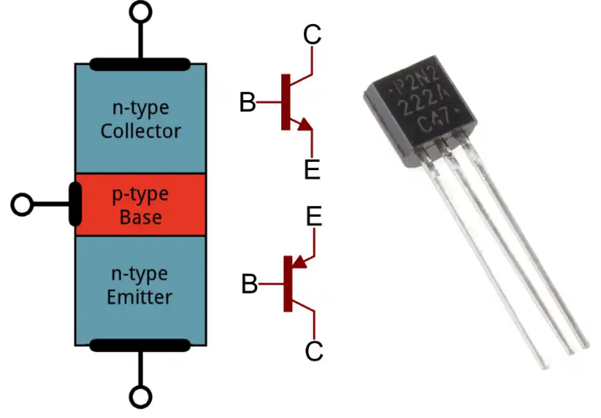 Fig.2.13 Transistor
    - RECTIFIER
A rectifier is a device that converts an oscillating two-directional alternating current (AC) into a single-directional direct current (DC). AC power is available at low cost. DC power is more expensive to produce. Therefore, a method of changing ac to dc is needed as an inexpensive dc source. AC power can be converted to DC power using rectifiers When ac power is converted to dc power using rectifiers, dc output contains un wanted alternating current components known as ripple. Many rectifier applications need that the ripple do not exceed a specified value. If the ripple exceeds the specified value, different unwanted effects appear in the system. Some of the unwanted effects are stray heating and audible noise. The ripple can be reduced using an output filter.

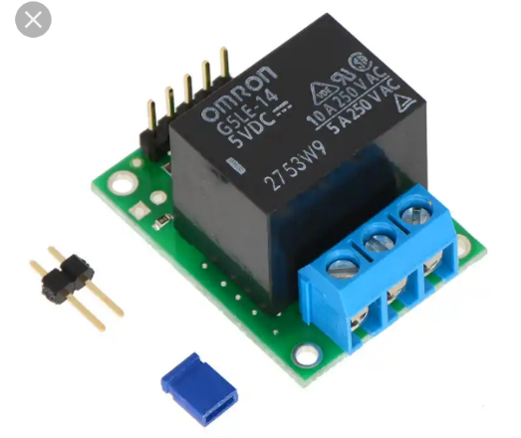Fig.2.15 Rectifier

