CHAPTER THREE
3.0 System Design and Methodology
3.1.0 System Requirements
3.1.1 Safety Components
- DC circuit breakers/fuses between charge controller and batteries
- AC circuit breakers/fuses for inverter output
- Grounding for all metallic enclosures
3.1.2 Monitoring
- Basic LCD/LED display on charge controller for real-time voltage, current, and SOC (state of charge)
- Option for future upgrade to remote monitoring
3.1.3 Environmental Condition
- Operating temperature range: 0°C – 50°C
- Indoor installation, protected from rain and direct sunlight

3.2 Block Diagram
Figure 3.2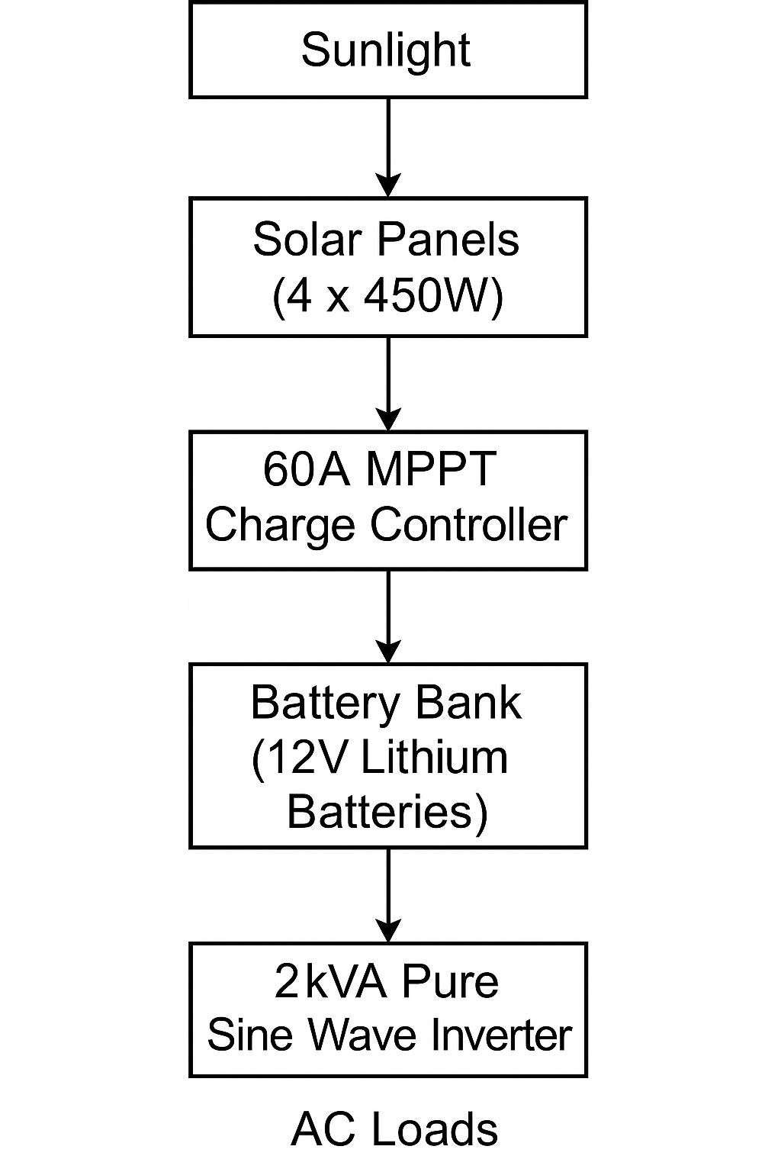
3.3.0 Component Selection
3.3.1 System Capacity
- Rated Power Output: 2kVA (2000VA)
- AC Output Voltage: 220V ± 10%, 50Hz (standard for residential and office appliances)
- DC Input Voltage: 24V (battery bank voltage)

3.3.2 Solar Panels
- Type: Monocrystalline solar panels
- Number of Panels: 4
- Individual Power Rating: 450W per panel
- Total Solar Array Capacity: 1800W (4 × 450W)
- Operating Voltage: ~37-40V per panel
- Series/Parallel Configuration: Configured to charge a 24V battery bank efficiently via MPPT

3.3.3 Batery Bank
- Type: Lithium-ion batteries
- Number of Batteries: 4
- Individual Voltage: 12V
- Total Configuration: 24V (two 12V batteries in series, paralleled with another series pair)
- Total Capacity: ~200Ah (depending on the specific battery amp-hour rating)
- Depth of Discharge (DoD): Up to 80-90% (typical for lithium batteries)

3.3.4 Charge Controller
- Type: MPPT (Maximum Power Point Tracking)
- Current Rating: 60A
- Input Voltage Range: Compatible with solar panel array voltage (typically 30-100V)
- Output Voltage: 24V for charging the battery bank
- Features: Overcharge, over-discharge, and short circuit protection

3.3.5 Inverter Specification
- Type: Pure Sine Wave Inverter
- Output Power: 2kVA continuous, with short-term surge capability
- Efficiency: 85-90% (typical for modern inverters)
- Cooling: Forced-air cooling (internal fan)
- Protections: Short-circuit, over-temperature, overload, and low/high voltage shutdown

3.4.0 Circuit Diagram
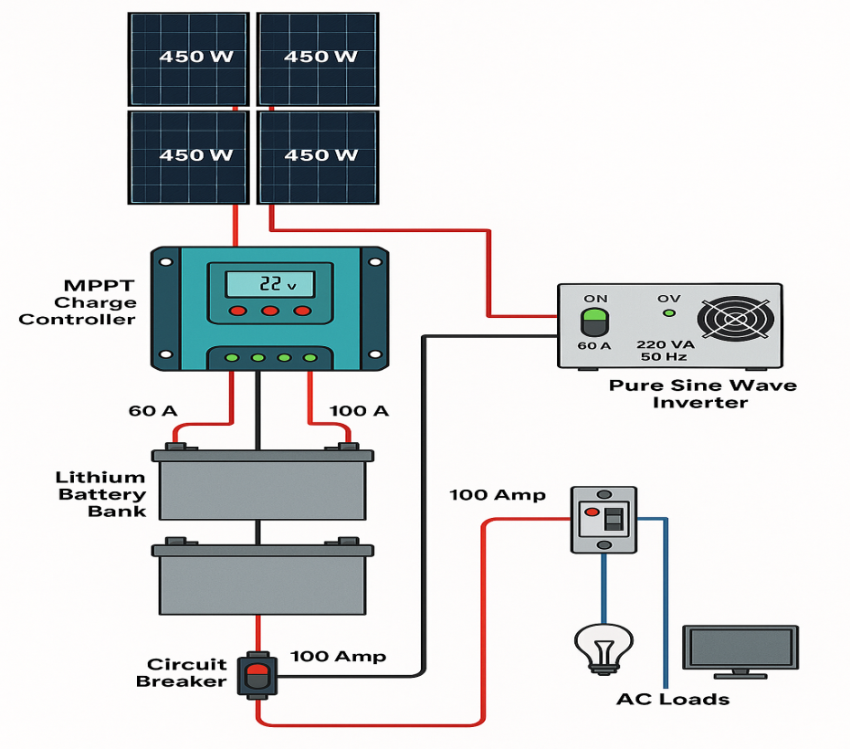
Figure 3.4
3.4.1 Explanation of the Circuit Diagram
3.4.1.2 Solar Panels
- 4 pieces of 450W panels convert solar radiation into DC electrical energy.

3.4.1.3 MPPT Charge Controller (60A)
- It tracks the maximum power point to regulate the charging voltage and current to the battery bank.
- It also prevents overcharging and prolongs battery life.
3.4.1.4 Lithium Battery Bank (24V)
- 4 lithium batteries configured to produce a nominal 24V storage system.
- Provides backup power when solar generation is low.
3.4.1.5 2kVA Pure Sine Wave Inverter
- Converts DC from the batteries into 220V AC (50Hz) for household appliances.
- Pure sine wave output ensures safe and reliable power for sensitive loads.
3.4.1.6 AC Loads
- Lights, fans, TVs, and other typical household devices powered from the inverter AC output.
3.5.0 Software Tools
Here’s a short overview of the software that was used in the completed solar-powered inverter system project for simulation and design purposes:
- Proteus Design Suite
Used for simulating and testing DC and AC electrical circuits, including inverter control circuits.
- MATLAB/Simulink
Useful for modeling and simulating the overall behavior of renewable energy systems, MPPT algorithms, and battery management.

- PVsyst
A powerful tool for simulating solar energy systems to estimate solar energy yield and performance.
- AutoCAD Electrical
Ideal for drawing detailed electrical schematics, wiring diagrams, and panel layouts.
- ETAP
Often used for advanced load flow analysis, short circuit calculations, and system protection.
3.6.0 Safety Considerations
Ensuring the safety and reliability of the solar-powered inverter system is paramount. The following measures were implemented during design and construction:
- Proper Component Selection
- Certified components were chosen (solar panels, charge controller, lithium batteries, inverter) to ensure high-quality and reliability.
- Overcurrent ratings and compatibility checks were conducted to prevent system overloading.
- Circuit Protection Devices
- DC and AC Fuses/Circuit Breakers were installed:
  - Between the solar panels and charge controller
  - Between the charge controller and battery bank
  - Between the inverter and AC loads
- These protect against short circuits, overcurrent, and potential electrical fires.
- Battery Protection
The lithium batteries include a Battery Management System (BMS), which:
- Prevents overcharge and deep discharge
- Monitors cell temperature and voltage
- Balances cells during charging
- Grounding and Earthing
- All metal parts of the system (e.g., inverter casing, control panel enclosures) were properly grounded to prevent electric shocks.

- Proper Cable Sizing and Termination
- Cables were selected based on load current with proper insulation to reduce overheating and energy losses.
- Crimped terminals and lugs were used for secure connections, reducing the risk of loose connections.
- Environmental Protection
- Indoor installation in a well-ventilated area to protect against rain and direct sunlight.
- The inverter and batteries were placed in enclosures to prevent accidental contact.
- Load Management
- The system was designed with load estimation to avoid overloading the inverter and batteries.
- A load schedule can be implemented to prioritize critical loads during low solar input.
- Periodic Maintenance
Recommendations for regular inspection of:
- Battery voltage and condition
- Cable connections and fuse conditions
- Inverter operation (fan, temperature, alarms)

