
TECHNICAL REPORT ON THE STUDENT INDUSTRIAL WORK EXPERIENCE
SCHEME (SIWES)

UNDERTAKEN AT
Kwara State Ministry of Works and Transportation.
AHMADU BELLO WAY
POPOOLA MALEEK ISHOLA
ND/23/CEC/PT/0203

SUBMITTED TO
THE DEPAERTMENT OF CIVIL ENGINEERING,
INSTITUTION OF TECHNOLOGY (IOT) KWARA STATE POLYTECHNIC, PMB 1375 ILORIN KWARA STATE.
IN PARTIAL FULFILMENT OF THE REQUIREMENT FOR THE AWARD OF NATIONAL DIPLOMA (ND) CERTIFICATE IN CIVIL ENGINEERING DEPARTMENT

AUGUST – NOVEMBER, 2024.

DEDICATION
This report is dedicated to Almighty God for His infinite grace, protection, and guidance throughout the duration of my Industrial Training. I also dedicate this work to my beloved parents, family, and mentors whose support and encouragement have been my source of strength.

ACKNOWLEDGEMENT
I sincerely express my gratitude to God for the success of my SIWES program. My appreciation goes to the Kwara State Ministry of Works and Transportation for the opportunity to undergo my training and for providing a conducive environment for learning.
I extend my gratitude to the Honourable Commissioner, Permanent Secretary, Directors, and all Engineers in the Ministry for their guidance and support. Special thanks to my industrial supervisor, for his mentorship and valuable advice throughout the training.
I also thank my academic supervisor and the entire management of civil engineering for making the SIWES program a reality. Lastly, my heartfelt thanks to my family and friends for their endless encouragement.

PREFACE
The Students’ Industrial Work Experience Scheme (SIWES) is an essential part of the academic curriculum designed to bridge the gap between theoretical knowledge and practical experience. This report presents the activities, skills acquired, and observations made during my six-month industrial training at the Kwara State Ministry of Works and Transportation.
It covers the general overview of the Ministry’s operations, specific tasks carried out, projects handled, and lessons learned. The training provided an opportunity to apply engineering principles in real-life situations, thereby enhancing my understanding of civil and transportation engineering.

REPORT OVERVIEW
The purpose of this report is to document my industrial attachment at the Kwara State Ministry of Works and Transportation, where I was posted as a student trainee. This training was undertaken to fulfill the requirements of the Student Industrial Work Experience Scheme (SIWES).
The report is organized into five chapters:
- Chapter One: Introduction
- Chapter Two: Organizational Structure and Background
- Chapter Three: Weekly Summary of Activities
- Chapter Four: Challenges Faced and Solutions
- Chapter Five: Conclusion and Recommendations

Table of Contents
- Title Page
- Certification
- Dedication
- Acknowledgement
- Abstract
- Table of Contents

Chapter One: Introduction
1.1 Background of the Study
1.2 Objectives of the SIWES Program
1.3 Scope of the Report

Chapter Two: Organization Profile
2.1 History and Background of the Ministry
2.2 Mission and Vision
2.3 Departments in the Ministry
2.4 Organizational Structure

Chapter Three: Training Activities and Experiences
3.1 Weekly Summary of Activities
3.2 Tools and Equipment Used
3.3 Software Used

Chapter Four: Skills Acquired and Lessons Learned
4.1 Technical Skills Acquired
4.2 Soft Skills Acquired
4.3 Challenges Faced
4.4 Solutions Applied

Chapter Five: Conclusion and Recommendations
5.1 Conclusion
5.2 Recommendations

CHAPTER ONE

INTRODUCTION

1.1 Background of the Study
The Student Industrial Work Experience Scheme (SIWES) is a mandatory industrial training program designed to bridge the gap between theoretical knowledge acquired in academic institutions and practical experience in real working environments. The scheme is a collaborative effort between tertiary institutions, the Industrial Training Fund (ITF), and industries, aimed at equipping students with relevant skills for the labor market.
As part of the requirements for the completion of my undergraduate program, I undertook my industrial training at the Kwara State Ministry of Works and Transportation, located along Ahmadu Way, Ilorin, Kwara State. The ministry is primarily responsible for the construction, rehabilitation, and maintenance of roads and public infrastructures, as well as overseeing the transport policies and regulations in the state.

1.2 Objectives of the SIWES Program
- To expose students to the industrial environment and enable them to apply theoretical knowledge in practical settings.
- To develop students’ technical competencies and hands-on skills.
- To foster professional discipline, ethics, and communication skills.
- To gain insights into engineering operations and public sector infrastructure development.
- To prepare students for future career paths and enhance their employability.

1.3 Scope of the Report
This report covers all activities, observations, and tasks performed during the six-month SIWES program at the Kwara State Ministry of Works and Transportation. It includes construction supervision, site inspections, road maintenance, project planning, and administrative documentation.
CHAPTER TWO
ORGANIZATION PROFILE

2.1 History and Background of the Ministry
The Kwara State Ministry of Works and Transportation was established to provide a comprehensive framework for infrastructure development and maintenance in the state. The ministry plays a pivotal role in road network expansion, maintenance of public buildings, and implementation of government transport policies.

2.2 Mission and Vision
- Mission: To deliver durable and sustainable infrastructure and transportation systems that enhance socio-economic growth.
- Vision: To be a leading ministry in the provision of quality infrastructure and efficient transport services in Nigeria.

2.3 Departments in the Ministry
The ministry is structured into various departments including:
- Civil Engineering Department: Responsible for road construction and maintenance.
- Mechanical/Electrical Department: Handles installation and maintenance of electrical systems and mechanical services.
- Transportation Department: Manages public transportation systems and regulations.
- Planning and Design Department: Engages in road design, planning, and feasibility studies.
- Administration and Finance Department: Oversees personnel management, budgeting, and general administration.

2.4 Organizational Structure
The ministry is headed by the Honourable Commissioner for Works and Transportation, supported by a Permanent Secretary and departmental directors who manage the day-to-day activities.

CHAPTER THREE

TRAINING ACTIVITIES AND EXPERIENCES

3.1 Weekly Summary of Activities
Week 1-2: Orientation and introduction to the ministry’s departments, safety procedures, and ongoing projects.
Week 3-4: Site visits to road construction projects within Ilorin metropolis
Week 5-6: Assisted in the preparation of Bill of Quantities (BOQ) and cost estimation under the supervision of quantity surveyors.
Week 7-10: Participated in the supervision of drainage construction, laying of laterite, and asphalt paving.
Week 11-14: Monitoring of culvert installation and shoulder dressing on rural roads in Kwara South.
Week 15-18: Gained exposure to road marking, signage installation, and traffic control strategies.
Week 19-22: Attended project meetings and contributed to progress report writing and documentation.
Week 23-24: Final report compilation and review of acquired skills.

3.2 Tools and Equipment Used
- Total Station and Leveling Instrument
- Measuring Tape and Survey Rods
- Asphalt Spreader and Compactor
- Concrete Mixer
- Personal Protective Equipment (PPE)
- Tape
- Excavator
- Pay loader
- Sand truck
- Water tanker
- Road roller machine
- Demolition crane icon machine
  - Total Station and Leveling Instrument
- Total Station: A modern surveying instrument that combines an electronic theodolite with an electronic distance meter (EDM). It is used to measure angles and distances, and it helps in mapping and construction layout.
- Leveling Instrument: A tool used in surveying to determine the height of points and ensure level surfaces. It helps in creating accurate horizontal planes (e.g., for roads and buildings).
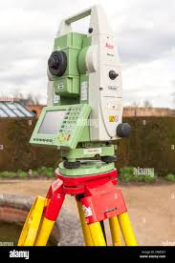

- Measuring Tape: A flexible ruler used to measure distance. In construction, long tapes (usually 30m, 50m, or 100m) are used for ground measurements.

- Survey Rods (Leveling Rods or Staffs): Graduated rods used with leveling instruments to determine the height difference between points on the ground.
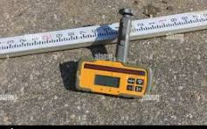
Construction Equipment:
  - Asphalt Spreader and Compactor
- Asphalt Spreader: Also known as an asphalt paver, it lays asphalt on roads and ensures a smooth, even surface before compaction.
- Compactor: A machine used to compress and stabilize soil, asphalt, or other materials to remove air gaps and increase density.

  - Concrete Mixer
- A machine that combines cement, sand/gravel (aggregate), and water to form concrete. It ensures a consistent mix and is essential for building foundations, slabs, and other structures.
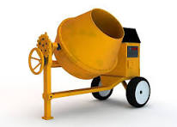

  - Excavator
- A heavy construction machine with a bucket, arm, rotating cab, and movable tracks. It's used for digging, trenching, and material handling.
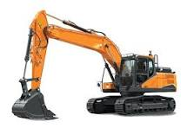

  - Pay Loader
- Also known as a wheel loader, it’s used for moving materials like sand, gravel, or debris. It has a front-mounted bucket that can scoop and load materials into trucks.
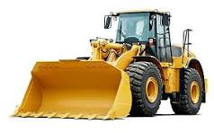

  - Sand Truck
- A dump truck specifically used to transport sand to and from construction sites.
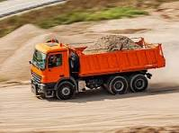

  - Water Tanker
- A truck with a large tank used to supply water to construction sites. It’s essential for dust control, concrete mixing, and general water supply.
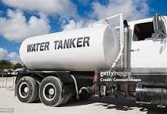
  - Road Roller Machine
- A heavy machine with large drum rollers used to compact soil, gravel, concrete, or asphalt in road construction and foundations.
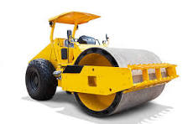

  - Demolition Crane Icon Machine
- Likely referring to a demolition crane or wrecking crane, which is a heavy-duty machine equipped with a large boom and attachments like wrecking balls or hydraulic breakers used for tearing down buildings or structures.
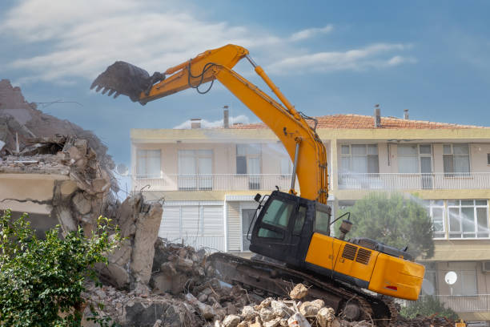

3.3 Software Used
- AutoCAD for road design schematics
- Microsoft Excel for cost estimation and data analysis

CHAPTER FOUR

SKILLS ACQUIRED AND LESSONS LEARNED

4.1 Technical Skills Acquired
- Interpretation of engineering drawings and schematics
- Road construction and pavement techniques
- Cost estimation and bill preparation
- Use of surveying instruments for alignment and leveling
- Concrete mixing ratio and testing procedures

4.2 Soft Skills Acquired
- Team collaboration and communication
- Time management and punctuality
- Problem-solving on site
- Documentation and report writing
- Adaptability to workplace challenges

4.3 Challenges Faced
- Limited access to heavy machinery for personal use due to safety policies
- Weather conditions delaying outdoor activities
- Logistics and transportation to remote sites

4.4 Solutions Applied
- Observational learning and documentation when practical use was restricted
- Planning and scheduling to align with weather conditions
- Teaming with other interns and staff for transportation

CHAPTER FIVE

CONCLUSION AND RECOMMENDATIONS

5.1 Conclusion
The SIWES program at the Kwara State Ministry of Works and Transportation was a highly beneficial and enlightening experience. It provided practical exposure to engineering projects and deepened my understanding of infrastructural development in the public sector. The knowledge and skills acquired have significantly enriched my academic knowledge and career readiness.

5.2 Recommendations
- The Ministry should create a dedicated internship schedule for students to ensure hands-on engagement.
- Students should be encouraged to take documentation seriously for future reference.
- Tertiary institutions should collaborate more with ministries for technical seminars during the SIWES period.
- Interns should be given access to simulation tools to complement physical training when direct machinery use is limited.

