CHAPTER TWO
2.0 LITERATURE REVIEW
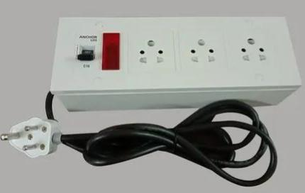
Electrical extension boxes have become essential components in both domestic and industrial environments, as they provide additional power outlets beyond what is built into a space. In this chapter, we examine the concept, historical background, development, and design standards of extension boxes. We also look into similar works, components used, and the safety regulations governing their use

2.1 Concept of Electrical Extension Box
An electrical extension box is a portable electrical device designed to provide multiple outlets from a single power source. It is commonly used where multiple appliances need to be powered but limited wall sockets are available. The box consists of sockets, wires, fuse, switches, indicator lamps, and sometimes USB ports. Its major functions include safe power distribution, circuit protection, and mobility.

2.2 Historical Background
The history of power extension devices* traces back to the era of rapid industrialization in the late 19th and early 20th centuries, when electricity began to power homes, factories, and offices. As electrical infrastructure spread, so did the demand for multiple power outlets to operate various appliances and machinery.
In the early days, extension devices were basic—consisting of simple wires and plugs used to extend power from one point to another. These early models lacked safety features and were often bulky and exposed.
Over time, as electrical devices became more diverse and safety standards improved, power extensions evolved significantly. Manufacturers began designing compact, insulated units with multiple outlets, built-in fuses, and individual switches. These additions not only enhanced safety but also improved convenience and energy control.
Today, modern power extension units may include surge protection, USB ports, circuit breakers, and smart controls, reflecting a long journey from basic wire extensions to multifunctional, safe, and user-friendly devices.
2.3 Review of Similar Projects
Several student and commercial projects have focused on developing extension boxes with added safety and convenience. Some designs include surge protection, in-built meters, and USB charging ports. Others are made with smart features that can cut off supply when the current exceeds a set limit.
This project focuses on a manually operated, fused four-outlet box, specifically built for affordability, safety, and practical learning.

2.4 Components and Their Functions
Sockets – Serve as the connection point for plugging appliances.
Switches – Used to control power supply to each outlet.
Fuse – Protects the circuit from overload or short circuit by breaking the circuit when current exceeds the rated value.
Indicator Lamp – Shows when the unit is powered.
Cables – Used for internal and external wiring, usually copper-insulated cables.
Casing – Encloses and protects all internal components.
2.5 Safety Considerations
When designing an extension box, safety is paramount. Standards such as wiring color codes (e.g., brown for live, blue for neutral, and green/yellow for earth) must be followed. All joints should be soldered or properly clipped. The fuse should be rated to match the load capacity (typically 13A or 15A). Enclosures must be made from non-conductive and heat-resistant materials such as plastic or rubber.
2.6 Summary of Review
The literature has shown that extension boxes play a critical role in safe power distribution. They have evolved from basic wire extensions to intelligent, fuse-protected, and user-friendly devices. This project builds upon the knowledge from previous designs while focusing on simplicity, affordability, and user safety

