

A TECHNICAL REPORT ON
STUDENT INDUSTRIAL WORK EXPERIENCE SCHEME (S.I.W.E.S)

UNDERTAKEN AT:

DIAMOND STANDARD LIMITED
NO, 20, ORO ROAD, OFF STASIUM ROAD , ILORIN KWARA STATE

BY:
OJO OPEYEMI EMMANUEL
(ND/23/PAD/PT/0707)

DEPARTMENT OF PUBLIC ADMINISTRATION, KWARA STATE POLYTECHNIC, ILORIN

SUBMITTED IN PARTIAL FUFILMENT OF THE AWARD OF NATIONAL DIPLOMA (ND) IN PUBLIC ADMINISTRATION FROM:
AUGUST TO DECEMBER, 2024

DEDICATION
This report is dedicated foremost to God Almighty for his favor, mercy and grace upon my life especially during my 4 months SIWES program at DIAMOND STANDARD LIMITED
I would also like to dedicate it to my parents and siblings for their love and support and everyone else that contributed towards making my SIWES training a fun and successful one.

ACKNOWLEDGEMENT
My appreciation goes to the Industrial Training Fund (ITF) for their foresight in putting this program in place and also to the Kwara State Polytechnic, for providing a platform on which I was engaged on the training. I appreciate the siwes Coordinator, Many thanks to my supervisor for taking time to supervise me during my training. I also express my profound gratitude to all members and staff of DIAMOND STANDARD LIMITED who gave me training an exciting and blissful one. Also to my parents and siblings thank you all for your moral and financial support.
I am deeply indebted to God Almighty, the giver of all wisdom, knowledge and understanding without whom I would have achieved nothing at all.
Finally to my Industrial based supervisor Mr. Afolayan Opeyemi Seun for his support and to my other friends and colleagues. Thank you all I am highly grateful.

TABLE OF CONTENTS
Front Page
Dedication
Acknowledgement
Table of Content
CHAPTER ONE
Introduction1.
1 Purpose of Working at the Organization
1.2 Definition of terms
DESCRIPTION OF THE ESTABLISHMENT OF ATTACHMENT
CHAPTER THREE
Instrument for monogram
CHAPTER FOUR
PURPOSE OF WORKING AT THE ORGANIZATION
Chapter five
Conclusion,
Challenges
Recommendations.

CHAPTER ONE
INTRODUCTION
1.1 Background of Study
Student Industrial Work Experience Scheme (SIWES) is one of the Industrial Training Fund (ITF) programs which were introduced in 1974 due to the inability of students in Nigeria universities and polytechnics to meet the practical aspects of their training. That is, the needs to enable students match their theoretical school knowledge with the practical aspect of their training in industry.
The program was designed for students of tertiary institutions with the aim of exposing students that have acquired theoretical knowledge in the classrooms to the practical exposure and experience. The scheme is a tripartite program, involving the student, the university and the industry (Employer of labor). It is funded by the Federal Government of Nigeria and jointly coordinated by the Industrial Training Fund (ITF) and the National Universities Commission (NUC).
1.2 Brief history of SIWES
In recognition of the shortcomings and weakness in the formation of graduates, particularly with respect to acquisition of relevant production skills (RPSs), the Industrial Training Fund (which was itself established in 1971 by decree 47) initiated the Students’ Industrial Work-experience Scheme (SIWES) in 1973. The scheme was designed to expose students to the industrial environment and enable them develop occupational competencies so that they can readily contribute their quota to national economic and technological development after graduation. Consequently, SIWES is a planned and structured program based on stated and specific career objectives which are geared toward developing the occupational competencies of participants. Participation in SIWES has become a necessary condition for the award of degrees and diplomas
The main thrust of ITF program and services is to stimulate human performance, improve productivity, and induce value-added production in industry and commerce. Through its SIWES and Vocational and Apprentice Training Program, the Fund also builds capacity for graduates and youth self-employment, in the context of Small Scale Industrialization, in the economy.
1.3 AIMS AND OBJECTIVES OF SIWES
The program was specially designed to carry out the following;
- Bridge the gap between theory and practical thereby giving students the opportunity to apply their knowledge accurately.
- Expose students to what their professions entail.
- Improve inter-personal relationship skills of the students.
- Develop skills on practical knowledge

CHAPTER TWO
2.1. DESCRIPTION OF THE ESTABLISHMENT OF ATTACHMENT

Brief History of Diamond Standard Limited
Diamond Standard Limited was established in the year 2012, and the office situated at NO, 20, ORO ROAD, OFF STASIUM ROAD , ILORIN KWARA STATE. And the main branch is situated at Kwara State Polytechnic, Ilorin. The Company is made up of Chief Executive Officer, who is responsible for the day to day running of the organization. It was charged with the broad function of Monogram and customizing.

2.3.2 Vision
To make Nigeria one of the acknowledged leaders of the scientifically and technologically developed nations of the world.

2.4 Major Activities of the Organization/Company
Diamond Standard Limited was majorly established for monogram, customizing T-shirt etc

2.5 Organization Chart of Diamond Standard Limited

OUR VISION
- To move with re-positioning agenda of the present administration
- To bring the dividend of democracy closer to the students of the grassroots level of the institution.
- Making sure that policies and plans of institution are properly implemented
- To empower the youths and the women
- To build capacity for small and medium scale enterprises
- To ensure market sanitation and street cleanliness
- To secure the life and properties of the citizens of the country
- Improving access to quality knowledge service delivery

CHAPTER THREE
  - Monogram as a Viable Means of Empowerment for the Undergraduates
Monogram is a skill-oriented study which is also considered to be a lucrative vocation as a result of its ever existing demand. Monograms are special designs made on cloths as a means of branding; usually for identification, beautification, uniformity, et.al. It is made not only on wears, but other essential items like bags, caps, industrial equipment, household items, and other varieties classified as souvenirs.
Monogramming as an art can be classified under both textile and graphic designs. Although its production and finishing involves textile design. Based on the scope of disciplines, graphic designer does the design and the form work while the finishing can be handled by a textile designer or anyone who has the experience. But, fortunately, the monogramming is very easy that anyone can do it; irrespective of discipline or level of education.
  - Different Approaches of Executing Monogram

There are several ways through which monogram can be executed. The purpose of monogram is to add an identity to any item be it clothing related, stationary, not excluding other objects such as doors, ceilings, floors, industrial equipment, household items, etc. Most times, the identity added is usually for identification, to indicate uniformity, create an awareness, et.al. There are several ways through which an item can be customized or monogrammed but whichever way it is executed, all forms of monogramming usually come in either typographic approach or pictorial approach.

Examples: MONOGRAM -capital, block or uppercase letters
monogram - small or lowercase letters.
MoNogRam Is gOoD –toggle approach.

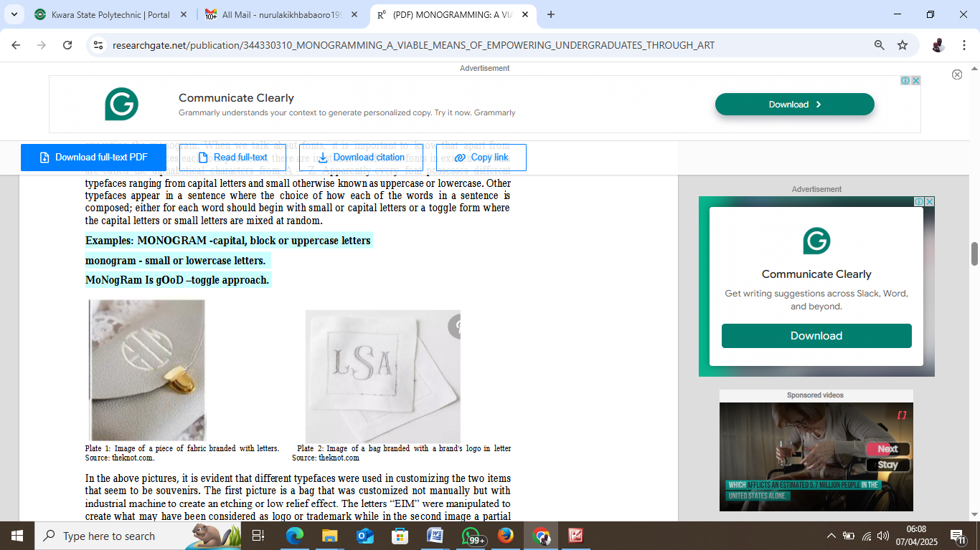
In the above pictures, it is evident that different typefaces were used in customizing the two items that seem to be souvenirs. The first picture is a bag that was customized not manually but with industrial machine to create an etching or low relief effect. The letters “EIM” were manipulated to create what may have been considered as logo or trademark while in the second image a partial cursive font was used to also create an identity on the table mat using embroidery. Embroidery is a process of creating an image, letter, etc. by repeatedly running thread and needle on a portion of the fabric, leather, etc. either manually with the use of hand or technologically by using the sewing machine or other industrial equipment invented to further foster embroidery.

Pictorial Approach: It is not only letters or numbers that can be transferred or printed on wears or objects, images can also be used. The image sometimes range from the logo of an entity comprising individual, church, group, society, company, et.al, image of an individual, symbols, etc. Other varieties that could be categorized as pictorial approach is geometric shapes, lines,

Plate 3: A shirt branded with an abstract image. Plate 4: A shirt branded with a
portrait and text
Source: polo.jinekologdr.com Source: Pinterest.com

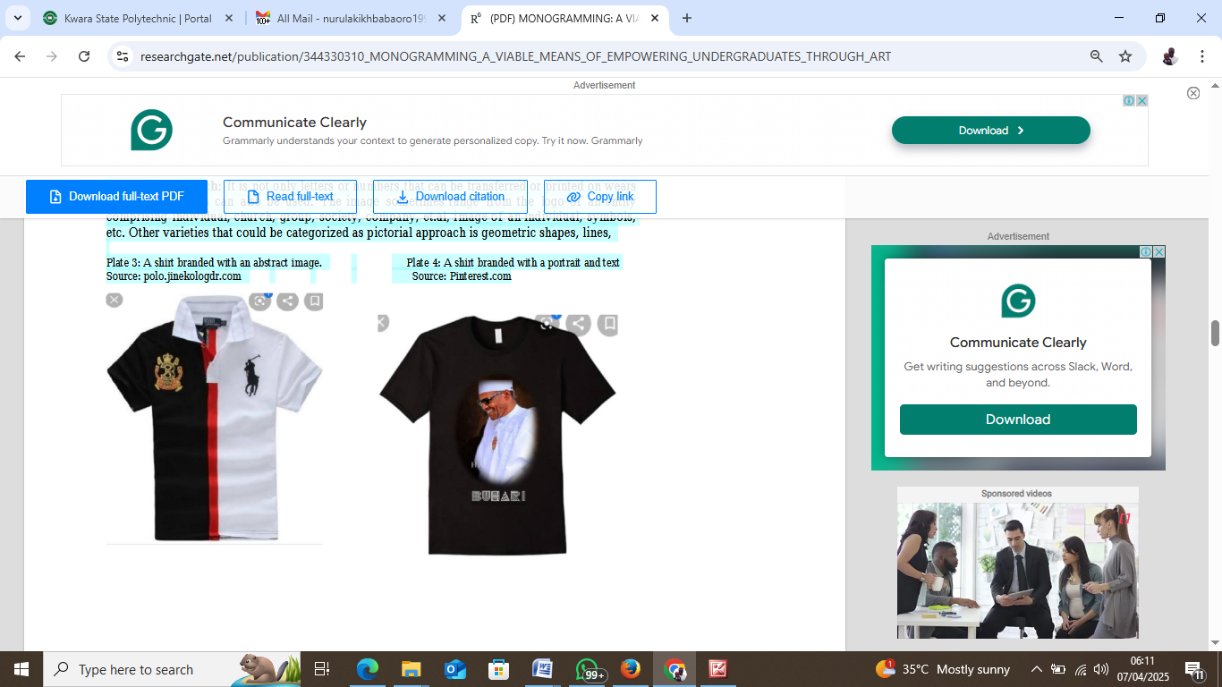

CHAPTER FOUR

4.1 The Different Techniques of Branding/Customizing
There are several techniques employable in adding embellishment on fabric cum other items. The techniques range from Stenciling, Direct application with hands, stitching, embroidery, direct printing with printers, screen printing, among others.

4.2 Stenciling
This technique is an ancient way of adorning an item or textile materials with an embellishment through dabbing of paints with foam or brush on a cutouts of paper or similar materials. This technique traced its root back in almost 37000 years ago in one of the caves in Spain where a shape of hand was traced on the cave wall. However, the paper stenciling came into existence through the Chinese around 105AD. Since then it has been adopted as one of the most effective techniques of embellishment.
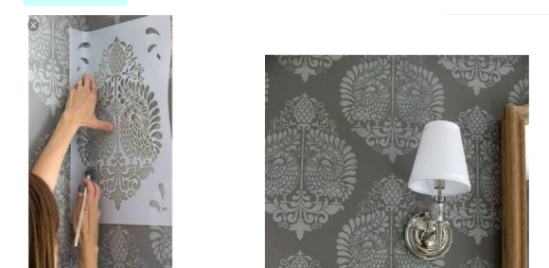

4.3 Materials Needed for Stenciling Technique

The materials needed for Stenciling method are not much, they range from Paper, pencil to write the letter(s), figure(s) or word(s), paint, razor blade/craft knife, a piece of foam, masking tape, etc.

4.4 PAINTS
Paint is derived from the combination of chemical solutions such as resins, solvents, pigment including other various additives. The pigment is what bring about colour for the paint; solvents allow the paint to relate well when applying to a surface; the drying is being fostered by resins; while other additives ranging from antifungicidal agents to fillers contribute to the workability of the paint.

Types of Paints for Customizing/Branding Items
There exist several paints that could be used for executing a monogram. However, as a result of various supplies of inferior quality of most of the paints available in the present market in the country, we hereby avail many a quality monogram paint that are of good quality, even though they are seemingly a bit costly, yet quality paint is really worth having. The following are the recommended fabric paints for monogram based on the recommendations of the editors of thesJacquard Textile Color Fabric Paint, Set of 8. Tulip Slick Fabric Paint. Others are: tulip soft fabric paint 4oz matte, delta creative textile medium, best glow in the Dark: neon nights fluorescent glow Fabric and Textile Paint, other similar paints were enlisted on the editors’ recommendations, kindly refer to the website for more information on them and how to purchase them. However, as a result of its fast drying, affordability, flexibility, availability, etc. the universally acceptable paint
for monogram is acrylic but because of the wide spread of fake products, the above listed paints are hereby suggested for quality result.

Why Acrylic?
From experience, acrylic is commonly used because of its fast drying feat; its ability to maintain its intensity/value for a good period of time and its ability to fade very slowly unlike other water based paints like water colour, emulsion, poster colour, etc.

Precautions during the Production
• While sponging the stencils do not be carried away to allow the foam stained with paint to go beyond the boundary of the paper, lest it stains other part of the fabric or materials
• Do not allow the ink/paint to be watery lest it smears and spoil the whole designs or the material itself.
• Be conscious while using the blade or craft knife as a single mistake can be very severe.
From experience, a slight mistake while using the craft knife or blade could be fatal and treating it will be far costlier than the amount charged for the job. Employ full concentration while using the tool

• Ensure you choose a readable font for your characters; except you are restricted to use a font given by your client.
• Avoid using oil based paints to brand especially shirts, face caps, etc. Reason being that, it might be smelly and feel choky. Asides, from experience, any mistake will only be corrected by using strong liquids, like bleaching chemicals, petrol, kerosene, et.al to adjust and apart from the liquids being smelly on the fabric, they could also be harmful on the fabric unlike using water to adjust any err committed while using acrylic paint.
• Do not allow the characters to be too big; always ensure moderate sizes which should be determined by the size of the item you wish to brand/customize.

Market Prospects for Monogram
Since the core target of this study is the youth especially Nigerian undergraduates, therefore we would be concentrating on the market prospects that youths, secondary school students notwithstanding, could explore.
There is no doubt that monogram is lucrative, as clothing is one of the indispensable needs of man, hence the need for adding creativity to some of the wears is paramount as people’s wants are in diversity, stirring endless competitions in the textile industry.
The first market prospect is students’ community; especially the higher education students in all the 3 tiers of tertiary education. Why? On a yearly basis, that is the end of every academic session, it has always been the students' culture especially the final year students to adorn themselves in beautifully customized wears ranging from caps, footwear, neck warmers, pullovers, shirts, trousers, et.al which they usually clad in most especially when it’s the time for their final paper(s). For example, very recently, during the course of executing the interview part of the methodology, several final year students of the Federal Polytechnic, Ilaro were found cladded in a fully diversified customized pullover shirts and other traditional attires during the last day of the 2018/2019 Second semester examination. About five students from different department yet each
from the 5 schools in the polytechnic were approached because of their outfits being customized unlike other conventional attires. They were asked how much was paid for the wears? Three of the students from school of environmental studies, school of engineering and school of communication and information technology respectively responded N4, 000 each while the 2 other students from
the school of management and school of Applied Sciences respectively said a sum of N3,500 each was paid.
Then cross examining the cost implication that will execute the making of the wear it was nearly N2500 as against the paid N3,500 and N4000. Therefore, for example, picking one of the students responses, the students said it was done for all her course mates in her department and neighboring departments, hence, assuming 200 students paid N3500 each and N2500 was spent on each branded shirt, it means there will be a profit of N1000 x 200 which is equaled to N200, 000.00. If this amount got into the wallet of a student, if kind-hearted, he/she will end up sending money home in lieu of the existing trend of calling his/her parents every 48hours to remind the parents of the N1000 they promised to send. Hence, it will ease the parents of some financial responsibilities, the parents would be able to save, improve their standard of living, invest and/or engage in some other activities that would in turn be in favour of the country’s economy. In
contrast, it will also stem down the intensity of cybercrime, popularly known as “yahoo, yahoo” among the youths.prucecrafts.com.

Challenges
The possible challenges connected to monogram are the supply of inferior materials ranging from the paints, shirts, fabrics and other materials. This is the main reason why the researchers suggested that the paints be ordered online or if they were to be purchased in the local markets, the buyers should be vigilant of what to buy. The inferior paints usually have poor value/intensity/hues of colour making the embellishment dull and monotonous. Asides, the inferior acrylic paints usually crack after a short period of time on the fabric.
Another, possible challenge is level of patronage, however, the best panacea to that is to start by customizing wears for yourself from there those who love it would ask questions in form of enquiry and from there you’d automatically be nearing to hit the ever demanding service in textile industry.

Conclusion and Recommendations
This study has been able to explore insightful information centered on eradicating the joblessness of about 55% youths in the country and the incessant rate of unemployment by leaning on youth empowerment. It proposed monogram which is a sub-course in Textile and Graphic Design as another possible and viable means of empowering the youths. This research has also been able to validate Monogram as a lucrative business for youth/undergraduate empowerment in a country like Nigeria that has almost half of its over 200 million population as youths. It explored the market prospects and challenges connected to monogramming as an empowerment program for the undergraduates. This study has also added to the few existing literature on the topic.
Eventually, the study was able to justify monogram as an entrepreneurship course which, if included in the school curriculum and various vocational programs, is a viable means for self-employment and sustainable business that can also perform the role of internally generated revenue
for institutions, organizations, schools, et.al ready to invest in it. The study also expatiated various techniques of monograms, prospects and challenges of monogramming To further curtail the fast rising growth of unemployment, it is imperative for governments and other parastatals to inject more vocational courses like the proposed Monogram and its equals into the entrepreneurship education. The parents also have an essential role to play in curtailing the rate of unemployment. Parents should rather look for a mini trade that their children can start while in school to fend for themselves; with that, after graduating from school, they would have been so used to the trade and may be triggered to embark on birthing a business/venture for themselves.

CHAPTER FIVE

5.1 My Personal Impression About the Organization
Diamond Standard Limited, a very friendly organization which addresses issues in a polite manner and equally encourages both the SIWES students and apprentices to be self-dependent and motivated. I can say that the organization as a bright/promising future if she will not change the way she operates.

5.2 Experience Gained
Working as a student Trainee at Diamond Standard Limited has given me the opportunity of getting a firsthand appreciation of Computer Business Center, learning its fundamentals, learning to work with the various equipment used. I was able to apply some of the theoretical knowledge gained during my study at the Polytechnic to real work situations thereby bridging the gap between school work and actual practice.
My general experiences concerning Business Administration are as follow:
- I was able to understand what Business Administration generally was all about.
- I was made to understand how to use some Computer equipment and their general maintenances
- I learnt how to do online registration.
- I learnt how to use mouse, keyboard and photocopies machine.
- Finally, I learnt how difficult tasks are handled to ensure smooth progress of a project work in conjunction to the time frame for a given project.

5.3 Recommendation to the Organization and to the Polytechnic Concerning the SIWES Program
In view of the relevance of the SIWES program, it is important that it is sustained by the government through the industrial training fund (ITF) as it exposes the student to work tools, facilities and equipment that may not be available in their respective institutions in relation to their course of study.
- To this end, I recommend that the following under-listed points should be implemented.
- Students’ Industrial work Experience Scheme (SIWES) needs to be strengthened by all concerned stakeholders in order for its objective to be full realized.
- Regular monthly allowances for students on attachment should be paid promptly.
- Organizations should always accept students for SIWES and subsequently assign them to relevant jobs.
- It will be of great benefit if the institution can create a platform whereby student can obtain Pre-SIWES knowledge or excursion programs, before the student embark for general 4-Months Industrial Training Programme.

5.4 Interpersonal Relationship
My four (4) month SIWES programme Diamond Standard Limited was much educational because their staff was always ready to entertain every question and to provide reasonable answers to them. In other words, the workers there were hard working, reasonable and also good at clearing doubt.

5.5 Conclusion
This report has been able to X-ray an account of the entire work-experience garnered by me during my SIWES program at Diamond Standard Limited which is a core scheme in ITF and which is saddled with the responsibility of strengthening the effective teaching and learning skill-based course such as Business Administration. I therefore concluded that SIWES is of great benefit to students in tertiary institutions. It therefore implies that the proper and effective administration of SIWES will go a long way in boosting and enhancing the competencies of the workforce of the country. I also that SIWES is confronted with series of challenges and this may have hindered the realization of the goals and objectives of the scheme and it therefore needs to be given attention by all concerned stakeholders.

