CHAPTER FOUR

4.0 TESTING, RESULTS AND DISCUSSION
In the process of design and construction of single-phase transformer trainer, there are four major stages involved. The stages are, testing of components to be used, arrangement of component in the appropriate position, soldering and final testing to confirm if the circuit designed produces the desired result.

4.1 TESTING OF THE COMPONENTS
The components used for the construction were purchased according to the design specification and tested to ascertain its performance. The polarity and pin arrangement of some of the components were noted.
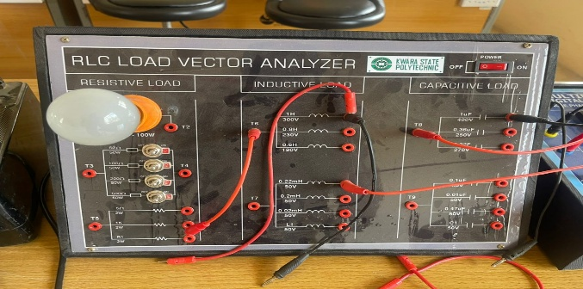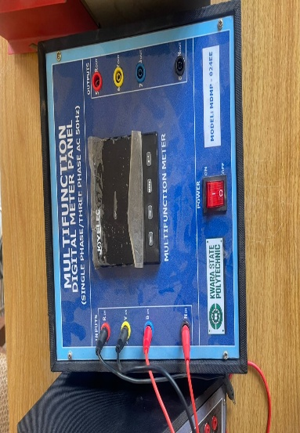Figure 4.1a:RLC Trainer Figure 4.1b:Multipurpose Meter
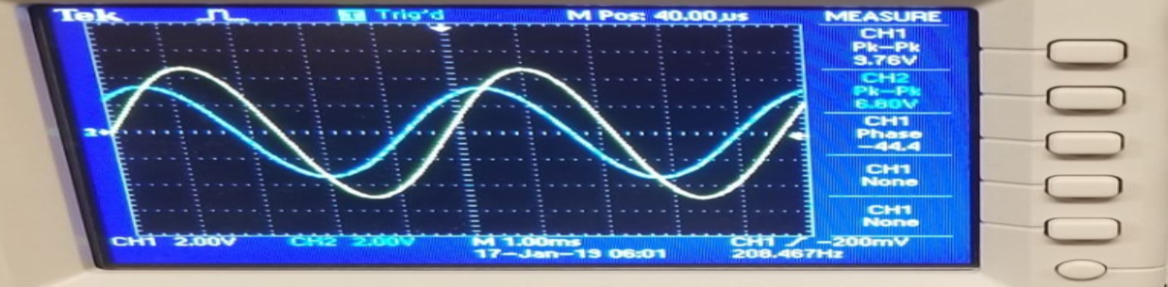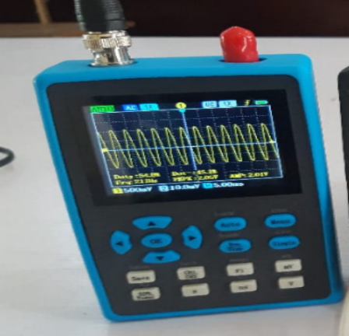

Figure 4.1b: Oscilloscope

- The Variac supplies adjustable AC voltage.
- The Digital Multifunction Meter measures all key parameters: Voltage (V), Current (I), Power (P), Apparent Power (S), Power Factor (PF), etc.
- Loads can be resistive, inductive, capacitive, or a combination (RLC).
- Power factor is calculated directly or with formula:
- The function generator injects an AC signal of varying frequency.
- The resistor, inductor, and capacitor are connected in series.
- Channel 1 of the oscilloscope is placed across the resistor to observe current (since V_R ∝ I).
- Channel 2 is placed across the whole circuit to observe total voltage.
- At resonance, you'll see:
  - Maximum voltage across resistor
  - Phase difference = 0°
  - Voltage across L and C individually spike (voltage magnification)

4.2 SOLDERING ARRANGEMENT OF COMPONENTS
Soldering is a process of joining two or more metals together by application of heat and solder to join the components. Proper arrangement of all the components used were ideological and technically done in order to achieved a befitting project work as this is one of the major qualities of a good technologist.

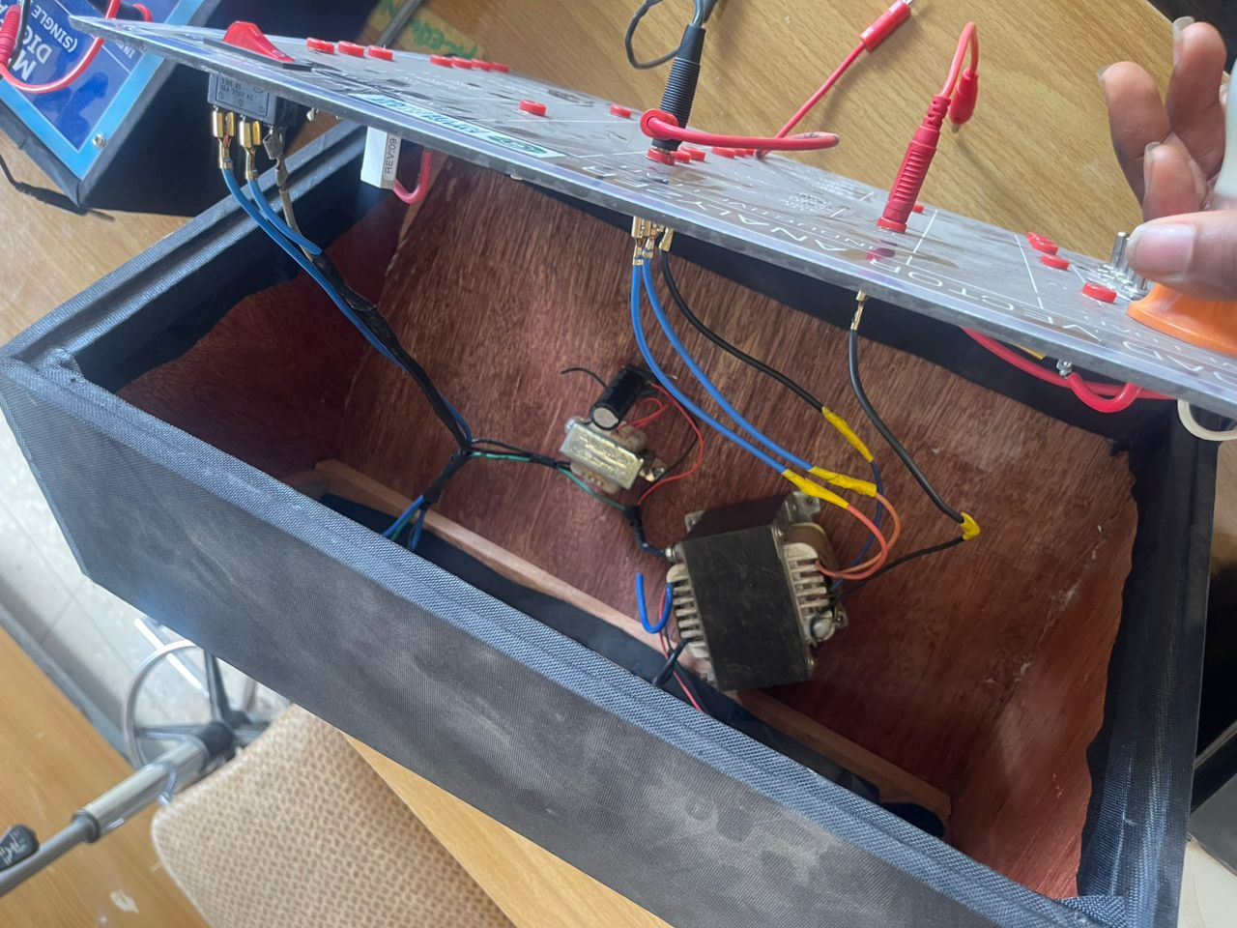
Figure 4.2: RLC Trainer inner components

4.3 TESTING AND RESULT
Experiment 1: Measurement of Power Factor
Calculation:
Power factor may be defined by three definitions and formals as follow.
1). The Cosine of angle between Current and Voltage is called Power Factor.
- P = VI Cos θ OR (4.1)
- Cos θ = P ÷ V I OR (4.2)
- Cos θ = kW ÷ kVA OR (4.3)
- Cos θ = True Power ÷ Apparent Power (4.4)
Where:
- P = Power in Watts
- V = Voltages in Volts
- I = Current in Amperes
- W = Real Power in Watts
- VA = Apparent Power in Volt-Amperes or kVA
- Cos θ = Power factor

4.4 OBSERVATION TABLE:
Table 4.1: Measurement of Power Factor
Load Type | Voltage  (V) | Current  (I) (A) | Apparent power  (S) = (VxI) VA | Active  Power (P) W | Power  Factor (PF) Cos θ
Resistive  (R)(100w bulb) | 195 | 0.34 | 66.3 | 66 | 0.995
Inductive (L)  (0.8H) | 198 | 0.089 | 17.6 | 6 | 0.34
Capacitive (C)  (1uF) | 197 | 0.124 | 24.4 | 0.000 | 0.000
Mixed (RL) (100w, 0.8H) | 198 | 0.38 | 75.2 | 73 | 0.971
Mixed (RLC) (100w,0.8H,0.36uF) | 195.7 | 0.38 | 74.3 | 73 | 0.983

Table 4.2: Voltage Across Resistor (V_R) vs. Frequency
Constants: Vin = 5V, R = 100Ω, L = 10mH, C = 0.1µF, Theoretical fᵣ = 1591.5 Hz
Frequency (Hz) | V_R (Volts) | Current (I = V_R / R, mA) | Phase Shift (θ) | Observations
500 | 1.2 | 12.0 | Lagging (θ > 0°) | Dominated by inductive reactance (Xₗ).
1000 | 3.0 | 30.0 | Slight lag | Approaching resonance.
1400 | 4.2 | 42.0 | Near 0° | Lower cutoff frequency (f₁).
1600 (fᵣ) | 5.0 | 50.0 (max) | 0° | Resonance: Z = R, I = max.
1800 | 4.2 | 42.0 | Near 0° | Upper cutoff frequency (f₂).
2000 | 2.8 | 28.0 | Leading (θ < 0°) | Dominated by capacitive reactance (X𝒸).
2500 | 1.5 | 15.0 | Leading | Far from resonance.

4.4.1 Observations and Discussion:
- Peak Voltage/Current:
  - At fᵣ = 1600 Hz, V_R = Vin = 5V (maximum current, 50 mA).
  - Confirms resonance condition: X_{L}=X_{C}
- Bandwidth (BW):
  - BW = f₂ - f₁ = 1800 - 1400 = 400 Hz
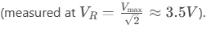
- Phase Behavior:
  - Below fᵣ: Current lags voltage (inductive dominance).
  - At fᵣ: In phase (θ = 0°).
  - Above fᵣ: Current leads voltage (capacitive dominance).
- Voltage Magnification:
  - V_L and V_C reached ~50V at resonance (Q = 10), though not shown in the table.

Table 4.3: Voltages at Resonance (fᵣ = 1600 Hz)
Parameter | Theoretical Value | Experimental Value | Remarks
Input Voltage (Vin) | 5 V (constant) | 5 V | Set by function generator.
Voltage across R (V_R) | 5 V | 5 V | Matches V_in (Z = R at resonance).
Voltage across L (V_L) | 50 V | 49.8 V | Magnified due to Q-factor (Q = 10).
Voltage across C (V_C) | 50 V | 50.2 V | Equal and opposite to V_L (phasor).
Phase Angle (θ) | 0° | ~0° (observed) | V_in and I in phase at resonance.

Observations and Discussion:
  - V_L and V_C exceed V_in due to the quality factor (Q) of the circuit
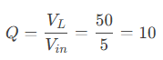
  - Experimental values may slightly differ from theory due to:
  - Component tolerances (L, C, R).
  - Oscilloscope/probe calibration errors.
  - Phase relationship: At resonance, V_L and V_C cancel out (180° phase difference), leaving V_R = Vin.

