CHAPTER FOUR

SYSTEM IMPLEMENTATION AND TESTING

4.1 Introduction
This chapter presents the actual implementation of the system developed for the remote monitoring of solar energy using an IoT-based framework. It outlines the system development environment, step-by-step implementation procedure, challenges encountered during the build-up, testing approach, performance evaluation, and the system's limitations. Diagrams and pictures of key components are also included to enhance understanding.

4.2 System Development Environment
- Hardware Environment
The hardware components used in the development of the system include:
- ESP8266 NodeMCU Wi-Fi Microcontroller
- Lithium-ion Battery (3.7V)
- Battery Management System (BMS)
- Solar Panel (6V – 12V)
- Voltage Sensor (e.g., INA219)
- Current Sensor
- Relay Module
- USB to Micro USB Cable
- Jumper Wires
- Breadboard
- 5V Regulator (if needed)
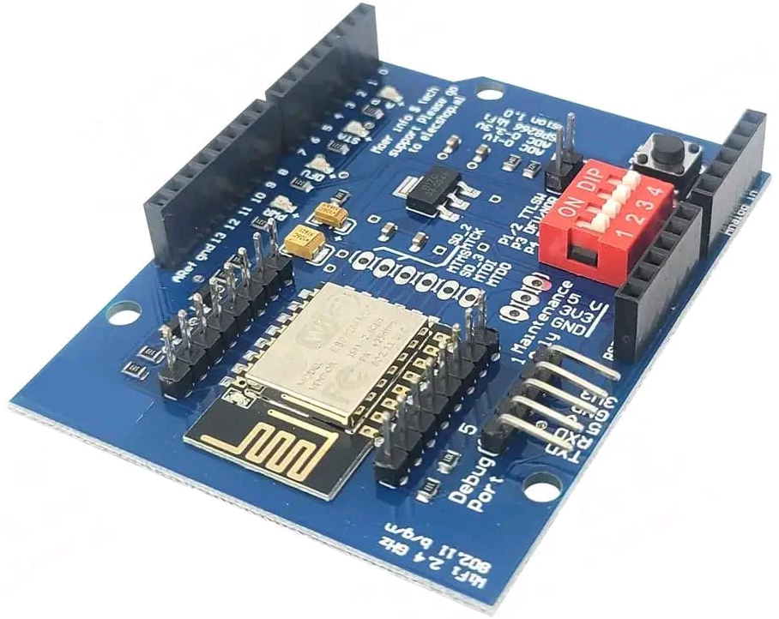
Figure 4.2: ESP8266 NodeMCU Microcontroller

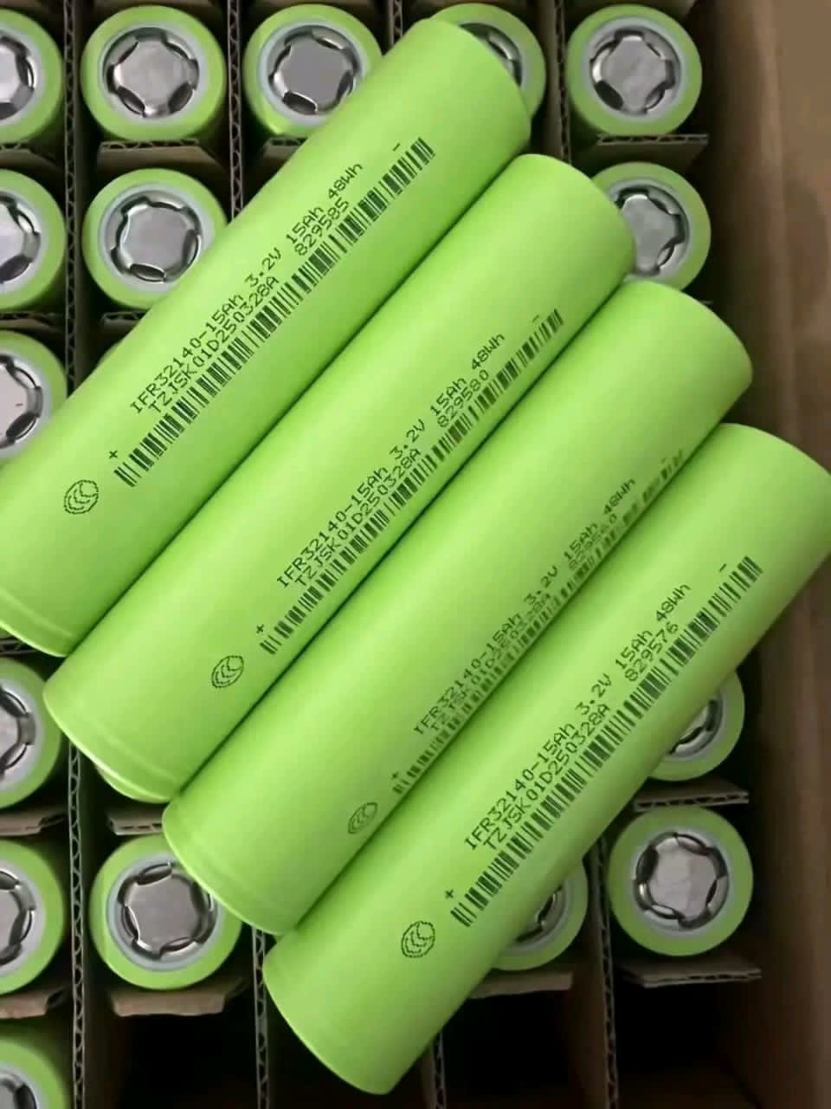
Lithium Ion Battery
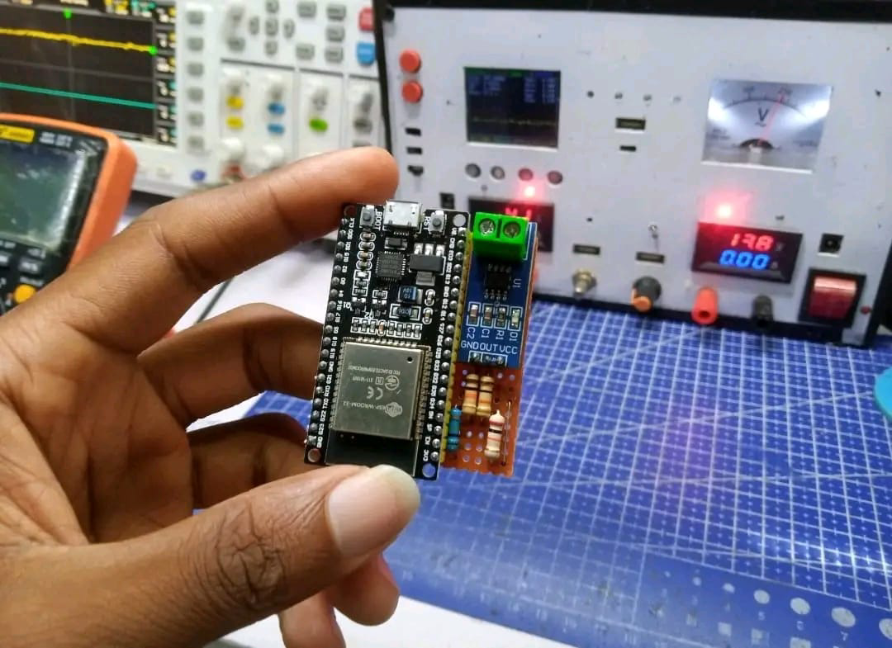
BMS Integrated Circuit

- SOFTWARE ENVIRONMENT
The system uses the following software tools:
- Arduino IDE – used to write and upload code to the ESP8266
- Blynk Application (mobile platform) – used for remote monitoring of system performance
- Blynk Cloud – to store and retrieve IoT data
- Serial Monitor – for debugging the microcontroller’s output
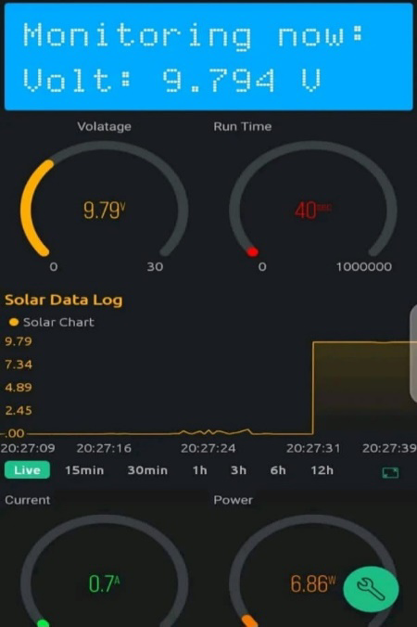
Blynk interface

4.3 System Implementation Procedure
The implementation of the IoT-based remote monitoring system involved the following steps:
- Circuit Design and Connection All hardware components were assembled and interconnected on a breadboard based on the designed schematic. The ESP8266 served as the central unit, receiving input from the voltage and current sensors and transmitting data to Blynk.
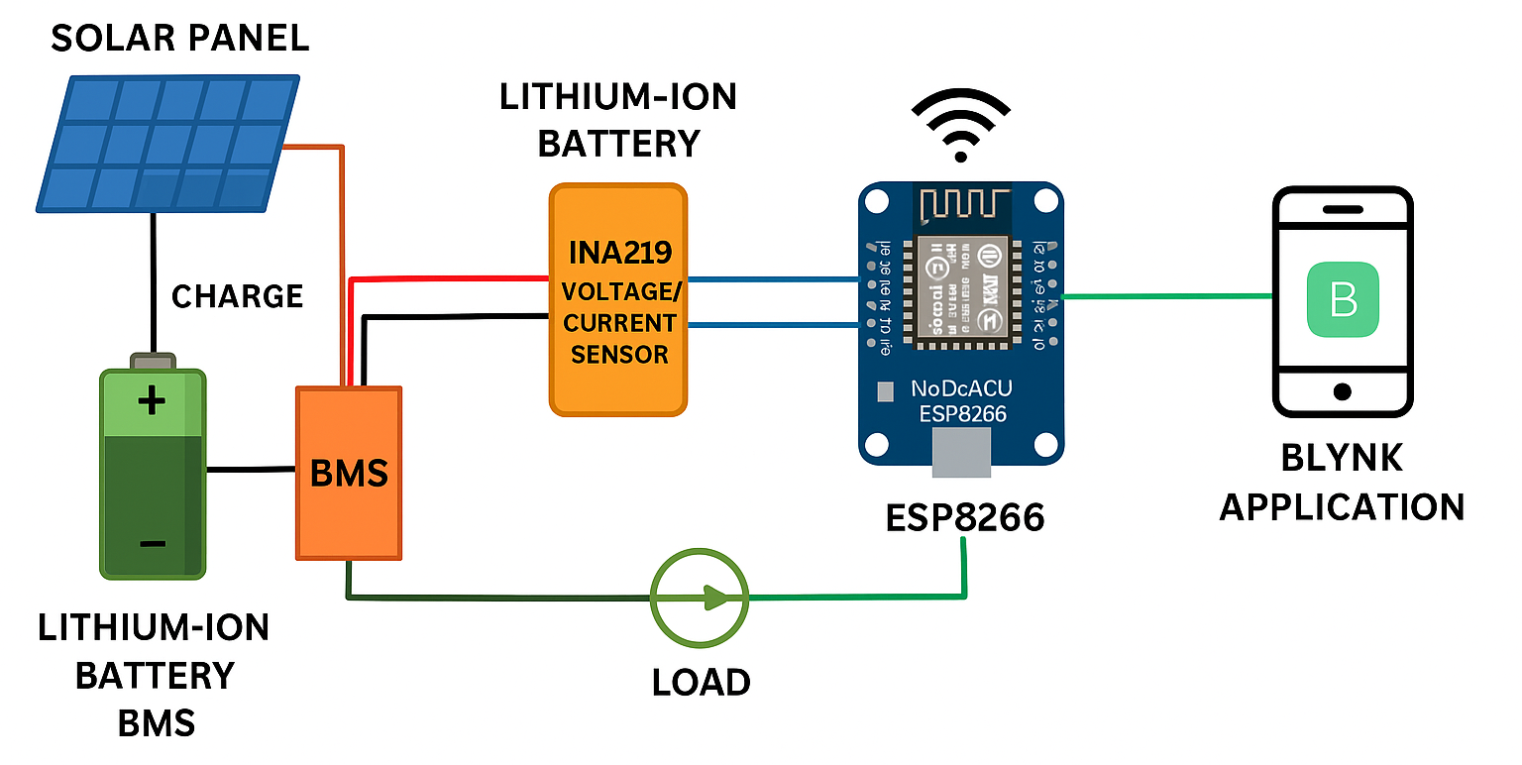
Figure 4.3: Circuit Diagram of the Monitoring System
- Sensor Integration The INA219 current sensor was connected in series with the load to measure current and in parallel to the battery to measure voltage. Readings were calibrated in the Arduino code.
- Power Management Setup A BMS was installed with the lithium-ion battery to prevent overcharging and over-discharging. The solar panel was connected through a diode to prevent backflow of current.
- ESP8266 Configuration and Code Upload The Arduino IDE was configured with the ESP8266 board, and necessary libraries (e.g., Wire.h, Adafruit_INA219, BlynkSimpleEsp8266.h) were installed. The code was uploaded via a USB cable.
- Blynk Interface Setup A Blynk project was created on the mobile app. Virtual pins were mapped to sensor values, and gauges, graphs, and status indicators were added.
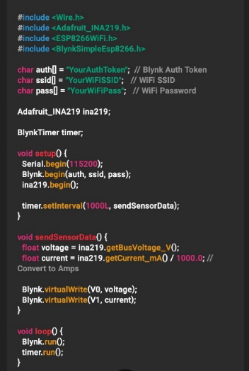
Figure 4.3: Code Segment for Data Transmission via ESP8266

4.4 Challenges Encountered During Implementation
Several challenges were faced during implementation:
- Wi-Fi Instability: The ESP8266 sometimes disconnected from the router.
- Power Fluctuations: The voltage from the solar panel was inconsistent in poor weather.
- Sensor Noise: Sensor values occasionally fluctuated due to poor wire connections.
- Overheating: The ESP8266 heated up when exposed to high voltage without regulation.

4.5 Testing and Evaluation
Each module was tested individually and as an integrated system:
Component | Test Method | Expected Output | Result
ESP8266 | Serial monitor via Arduino IDE | Wi-Fi connection | Successful
Voltage Sensor | Measured voltage at terminals | 3.7V – 12V | Accurate
Current Sensor | Measured current in loop | 0A – 3A | Stable
Blynk Dashboard | Live data on mobile | Real-time updates | Responsive
The system was also tested under load conditions to evaluate battery performance and power consumption. Data logging on Blynk showed consistent readings with minimal delay.

4.6 System Performance Analysis
The system performed optimally under stable lighting conditions. Key performance insights include:
- Latency: Less than 2 seconds for sensor data to appear on Blynk.
- Battery Runtime: Depended on solar charging hours; the BMS helped maintain safety.
- Accuracy: Sensor readings had an error margin of ±0.1V.
- User Interface: The Blynk app provided an intuitive dashboard with easy-to-read gauges and logs.

