CHAPTER THREE

METHODOLOGY AND ANALYSIS OF THE SYSTEM

3.1 Introduction
This chapter outlines the step-by-step process adopted in the design and implementation of a cost-effective IoT framework for remote monitoring of solar energy systems. The methodology integrates both hardware and software components to enable real-time data collection, processing, and remote monitoring via a mobile interface. The framework is developed using an ESP8266 NodeMCU microcontroller for data processing and Wi-Fi communication, a BMS for battery protection, current and voltage sensors for data acquisition, and the Blynk IoT platform for remote monitoring.

3.2 Research Design
The research adopts a prototyping approach, combining system analysis, component selection, system design, implementation, and testing. The goal is to create a working prototype that is cost-effective and practical for solar energy monitoring in off-grid or rural areas. Emphasis is placed on low-cost and energy-efficient components to ensure affordability and sustainability
The design-and-build approach is central to this research because it facilitates the exploration of affordable hardware components and open-source platforms, aligned with the goal of creating a low-cost yet effective IoT solution.

3.3 System Design and Components
System Architecture
The system architecture comprises the following components:
- A solar panel that generates electricity.
- A lithium-ion battery for energy storage.
- A BMS (Battery Management System) for battery protection and regulation.
- Sensors (ACS712 current sensor and voltage divider circuit) for measuring the electrical parameters.
- ESP8266 NodeMCU microcontroller for data processing and transmission.
- Blynk mobile app for real-time remote monitoring via the internet.
- This structure ensures seamless interaction between physical hardware and a cloud-based interface, allowing the user to monitor system status from anywhere with internet access
- BLOCK DIAGRAM
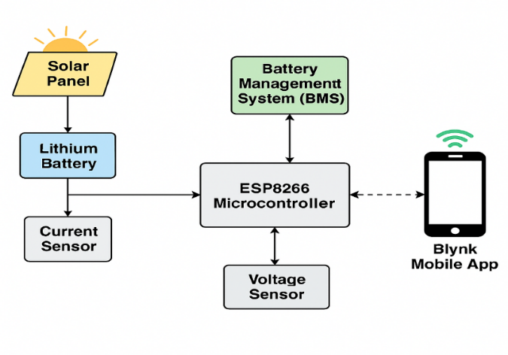
Figure 3.3: Block Diagram of the IoT-Based Solar Monitoring System

3.4 Hardware Components
Several affordable and accessible hardware components were used in this project. They include:
- Solar Panel
The solar panel is the source of renewable energy, converting sunlight into electrical energy. It supplies power to the battery for storage and directly powers the system when available.
- Lithium-ion battery
This rechargeable battery stores energy generated by the solar panel. It supplies power during periods of low sunlight or nighttime.
- Battery Management System (BMS)
The BMS protects the lithium-ion battery from overcharging, over-discharging, short circuits, and overheating. It ensures the longevity and safety of the battery.
- ACS712 Current Sensor
This sensor measures the current flowing from the solar panel and the battery. It provides analog data that is interpreted by the ESP8266.
- Voltage Divider Circuit
The voltage divider reduces the voltage level from the battery or panel to a safe level that the ESP8266 can read (usually below 3.3V).
- ESP8266 NODEMCU
The ESP8266 is a low-cost microcontroller with built-in Wi-Fi. It reads sensor data, processes it, and transmits it to the cloud. It serves as the brain of the monitoring system.

- Blynk IOT Platform
Blynk is a cloud-based mobile platform used for real-time monitoring and visualization. It enables users to view voltage, current, and battery status remotely using a smartphone app.
- Relay module:
Enables the control of connected devices remotely.

3.5 Software Tools and Platforms
The following software platforms and tools were used:
- Blynk IoT Platform: Used to display real-time data on a mobile interface. It provides features such as widgets for graphs, gauges, and notifications.
- Arduino IDE: Used to write and upload firmware to the ESP8266.
- Blynk Library and ESP8266WiFi Library: Enables connectivity between the ESP8266 and Blynk server.

3.6 Circuit Schematic Design
The circuit schematic below illustrates the interconnection of the ESP8266 NodeMCU with voltage and current sensors, the lithium-ion battery, and the Battery Management System (BMS). Each sensor provides analog inputs to the microcontroller, which processes the data and transmits it to the cloud using the integrated Wi-Fi module.
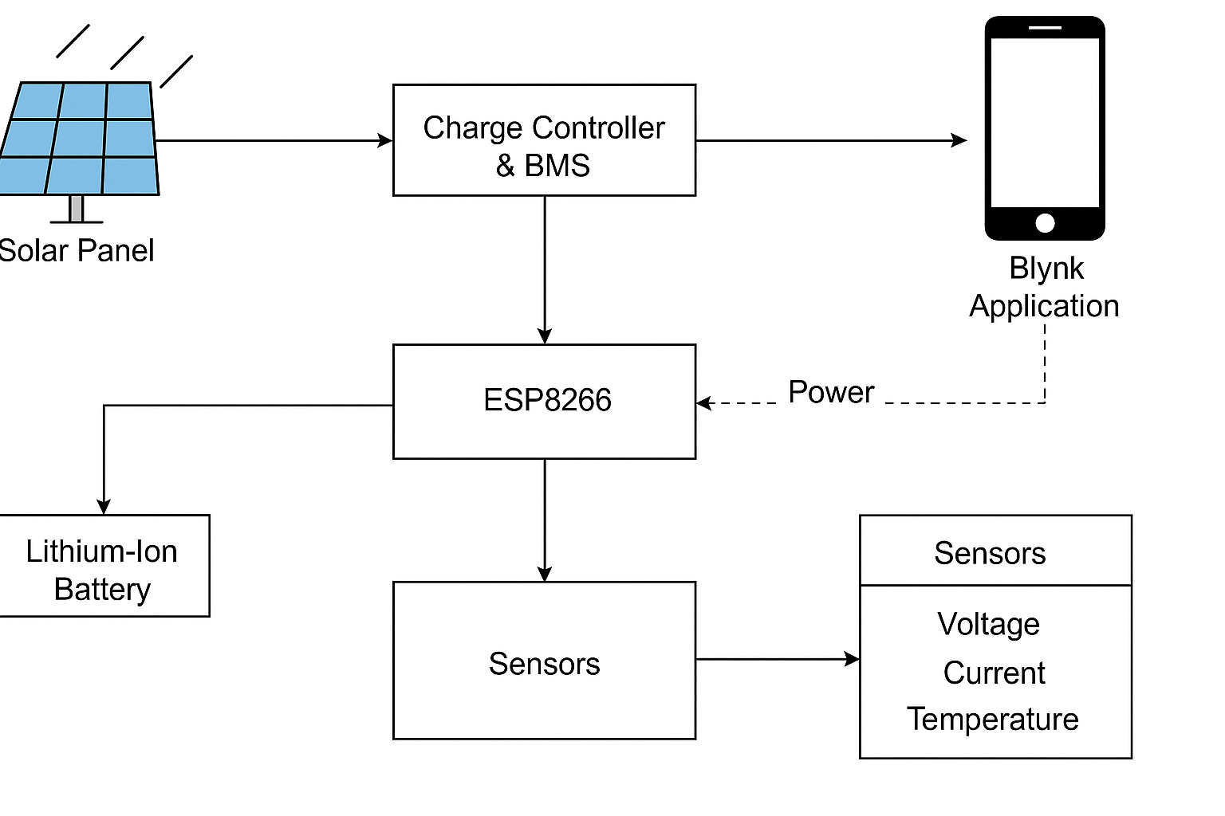
Figure 3.6: Circuit Schematic of the IoT-Based Solar Energy Monitoring System

3.7 System Operation
The system begins with the solar panel converting solar energy into electrical energy. This energy is stored in a lithium-ion battery protected by the BMS. The ACS712 current sensor and voltage divider measure the current and voltage, respectively, and feed these readings to the ESP8266 NodeMCU. The ESP8266 processes the data and uses its Wi-Fi capability to send the data to the Blynk mobile app, where the user can observe battery voltage, charging current, and overall solar performance.
The data is updated in real time, enabling proactive monitoring and maintenance. Alerts can also be configured in the Blynk app to notify the user in case of abnormal values.

3.8 Implementation Procedure
- Hardware Setup: All components were connected on a breadboard and tested. The ESP8266 was connected to the voltage and current sensors and powered using the lithium battery via the BMS.
- Firmware Development: Code was written in Arduino IDE using Blynk and sensor libraries.
- Wi-Fi Configuration: The ESP8266 was configured to connect to the local Wi-Fi and communicate with the Blynk cloud server.
- Mobile App Setup: A custom dashboard was created on the Blynk mobile app to display real-time voltage, current, and battery status.
- System Integration: The complete system was assembled on a custom PCB and housed in a protective casing.

3.9 Summary
This chapter presented a detailed account of the methodology used in designing and implementing the IoT-based solar energy monitoring system. It highlighted the hardware and software components, system architecture, implementation procedures, testing, and limitations. The system effectively demonstrates how cost-effective components and cloud platforms like Blynk can be used to monitor energy systems remotely in real time

