CHAPTER TWO

LITERATURE REVIEW

2.1 REVIEW OF RELATED WORK
The rapid global shift towards renewable energy sources has brought solar energy systems into the forefront of sustainable power solutions. As the demand for efficient and intelligent energy management grows, integrating the Internet of Things (IoT) into solar energy systems has become a major research focus. This chapter reviews existing literature relevant to the development of cost-effective IoT frameworks for remote monitoring of solar energy systems. It explores the theoretical underpinnings, key concepts, related technologies, real-world implementations, and identifies gaps in the literature that this project aims to address. The structure of this chapter is designed to provide a comprehensive understanding of the research landscape and justify the need for the proposed system.
Several researchers have contributed to the development of IoT-based monitoring systems for solar energy applications. These works highlight various approaches, tools, and challenges in designing low-cost, real-time solutions.

[1] Bhattacharya & Singh (2020) implemented an IoT-based system to compare traditional solar monitoring methods. Their findings revealed that smart monitoring significantly reduced maintenance delays and improved energy usage accuracy.

[2] Gandhi et al. (2019) developed a real-time solar energy monitoring prototype using NodeMCU and sensors. The system achieved accurate voltage and current readings with minimal latency, making it suitable for rural deployment.

[3] Dela Cruz & Tadle (2022) designed a solar monitoring solution for Philippine communities using ThingSpeak. Their system improved accessibility to solar data and helped local users manage energy usage more effectively.

[4] Alam et al. (2020) focused on cost-effectiveness by using ESP8266 and the Blynk platform. Their model demonstrated that with minimal hardware, users could monitor and receive alerts via mobile in real-time.

[5] Ibrahim & Okonkwo (2020) proposed a Firebase-integrated monitoring system for Nigeria. Their solution emphasized local relevance, affordability, and ease of installation for small-scale solar users.
These studies validate the potential of IoT in enhancing solar energy management and highlight the need for scalable, user-friendly frameworks — particularly in developing countries like Nigeria. This project builds on their contributions by offering a low-cost, ESP8266-based framework integrated with Blynk and real-time sensor data transmission

2.2 Theoretical Framework
The development of IoT-based monitoring systems is grounded in several theoretical frameworks, including cyber-physical systems, embedded systems theory, and energy management frameworks.
- Cyber-Physical Systems Theory
Cyber-Physical Systems (CPS) refer to mechanisms that integrate computation, networking, and physical processes. In the context of solar energy, CPS enables real-time data acquisition and feedback loops between sensors (physical components) and cloud-based data analytics (cyber components). According to Lee, CPS is foundational for systems that require automation, monitoring, and intelligent decision-making.
- Embedded Systems Theory
Embedded systems are at the core of IoT technology. These are computer systems designed for specific control functions within a larger system, often with real-time computing constraints. For solar monitoring, embedded microcontrollers (e.g., ESP8266, Arduino, Raspberry Pi collect and transmit data from solar panels, charge controllers, and batteries (Gandhi et al).
- Energy Management Theories
Energy management theories focus on optimizing the generation, distribution, and usage of energy. Concepts such as load balancing, demand-side management, and renewable integration are crucial for building intelligent solar systems. These frameworks guide the design of efficient and scalable IoT monitoring solutions (Mekki et al).

2.3 Conceptual Review
- Internet of Things (Iot)
The Internet of Things (IoT) is a concept that describes a network of interconnected physical devices embedded with sensors, software, and other technologies to exchange data over the internet. These devices collect real-time data from their environment and use it for decision-making, automation, and optimization. In the context of solar energy systems, IoT facilitates the remote monitoring of parameters such as voltage, current, energy output, temperature, and battery health (Aazam et al).

IoT architecture typically includes four layers:
- Perception Layer: Responsible for capturing physical data via sensors.
- Network Layer: Transmits collected data through communication technologies like Wi-Fi, GSM
- Processing Layer: Consists of microcontrollers or embedded processors that handle data preprocessing.
- Application Layer: Provides services to users such as dashboards, alerts, and reports (Gubbi et al).
- Solar Energy Systems
Solar energy systems are technologies designed to harness energy from the sun. These systems usually consist of solar panels (photovoltaic cells), charge controllers, inverters, and energy storage systems like batteries. Standalone (off-grid) and grid-tied systems are the two major categories. Effective operation requires consistent monitoring to avoid inefficiencies caused by dust, shading, overcharging, or component failures (Rahman et al)
- Remote Monitoring Systems
Remote monitoring refers to the ability to track, control, and analyze a system's performance from a distance. IoT-based solar monitoring systems use sensors and wireless communication to transmit performance metrics to a cloud platform or mobile app. This allows users to detect faults, optimize system performance, and make data-driven decisions without physical inspection (Al-Fuqaha et al).
- Cost-Effective Solutions
The notion of cost-effectiveness in technology deployment implies achieving optimal functionality at minimal expense. In IoT for solar energy systems, this involves selecting affordable hardware (e.g., ESP8266), open-source platforms (e.g. Blynk), and energy-efficient components. The aim is to develop solutions that are not only functional and scalable but also accessible to low-income or rural users.
- Sustainability and Scalability
Sustainable IoT solar systems are designed with energy efficiency, environmental friendliness, and long-term usability in mind. Scalability refers to the system’s ability to expand to accommodate more panels, sensors, or monitoring locations with minimal additional cost. These factors are essential when developing solutions intended for deployment in communities, small businesses, or developing regions (Georgiou et al).

2.4 Empirical Review
The empirical review section examines past studies and practical applications of IoT in solar energy systems, drawing from global case studies, academic research, and industry reports. This section also highlights methodologies, findings, and limitations in existing works that support the rationale for this research.
- Global Studies On IoT-Based Solar Monitoring Systems
A study by Alam et al. presented an IoT-based monitoring system for solar PV systems using Blynk. Their system enabled real-time visualization of solar voltage, current, and temperature on a mobile app. The major strength of their work was the low cost and simplicity, though scalability and cloud integration were limited.
In India, a project by Rathore et al. developed an Arduino-based remote monitoring system for solar panels installed in rural areas. They used GSM technology for data communication, enabling monitoring in regions without internet access. While the system was robust and localized, it lacked advanced data analytics features that cloud-based platforms offer.
In Kenya, Mwangi et al. deployed a solar energy IoT solution for off-grid villages using Raspberry Pi, sensors, and SMS alert systems. Their solution improved system uptime by 35% through early fault detection. However, they noted that cost and technical skill requirements hindered wide-scale adoption.
A study in the Philippines by Dela Cruz & Tadle explored using cloud IoT platforms like ThingSpeak to manage community solar energy systems. Their system allowed data logging and threshold alerts for battery overcharge protection, and successfully prevented four potential battery failures over a month.
- Nigerian Context and Challenges
In Nigeria, electricity supply remains unreliable, especially in rural and semi-urban areas. Solar energy systems have gained traction as alternatives. However, maintenance and system monitoring remain challenges due to limited technical support and poor accessibility.
Adegboye et al. designed a low-cost solar PV monitoring system for use in Nigeria, focusing on real-time monitoring of panel output and battery level. Their research identified cost, maintenance, and component availability as major barriers to system effectiveness. They recommended the use of widely available microcontrollers and open-source software.
Another Nigerian study by Ibrahim and Okonkwo emphasized the lack of local research in the integration of IoT for renewable energy systems. Their work tested a remote monitoring prototype using Wi-Fi modules and cloud logging. They found the solution to be functional, but security and power consumption remained concerns.

2.5 Summary of Gaps Identified
The review of both global and local literature reveals several gaps that this research seeks to address:
- Cost Constraints: Most advanced IoT solar monitoring systems are cost-prohibitive for individuals in developing regions. Many studies fail to fully implement cost-effective solutions using locally available materials or open-source technologies.
- Limited Scalability: Many existing prototypes are tailored to small, fixed-scale installations. There is a lack of scalable frameworks that can adapt to larger or community-based solar projects without substantial reengineering.
- Insufficient Localization: Very few studies account for the unique environmental and infrastructural contexts of rural or semi-urban Nigeria. For instance, GSM or Wi-Fi coverage and power reliability greatly influence system effectiveness.
- Real-Time Analytics: While several projects can track metrics like voltage or current, most do not integrate real-time alerts, intelligent analytics, or fault diagnosis, which are vital for proactive maintenance and system optimization.
- Energy Efficiency: Some IoT monitoring systems inadvertently consume more power than ideal for off-grid setups. Solutions must be optimized to ensure they don’t significantly drain energy meant for critical loads.
- Security and Data Privacy: Only a few works have considered the security of IoT data transmissions, leaving systems vulnerable to intrusion or data loss.
This study aims to fill these gaps by proposing and developing a cost-effective, scalable, energy-efficient IoT-based monitoring framework suitable for rural solar energy installations in Nigeria, utilizing affordable microcontrollers, efficient data logging, and user-friendly interfaces.

2.6 Theoretical and Conceptual Model
- THEORETICAL MODEL
This study is grounded in two major theories:
Diffusion of Innovation Theory (Rogers): This theory explains how new technologies are adopted within societies. The adoption of IoT in solar systems depends on perceived advantages, ease of use, trialability, and observability—factors this research addresses through simplicity, cost-efficiency, and usability.
Systems Theory: This posits that a system's performance is dependent on the proper interaction of its components. A solar monitoring system is an integration of hardware (sensors, microcontrollers), communication channels (Wi-Fi, GSM), and software (apps, cloud platforms), and any inefficiency in one affects the whole.
- CONCEPTUAL MODEL
The conceptual framework of this study includes:
- Input Layer: Solar parameters (voltage, current, temperature) captured by sensors.
- Processing Layer: Microcontroller (e.g. ESP8266) handling data formatting.
- Transmission Layer: Wireless communication to the cloud via Wi-Fi or GSM.
- Cloud Layer: Data storage and visualization on platforms like ThingSpeak or Firebase.
- User Interface Layer: Dashboard for users to access real-time data and receive alerts.
This layered approach ensures that the system is modular, scalable, and adaptable to varied use-cases, especially in resource-constrained environments.
The conceptual model is illustrated in figure 2.6 below
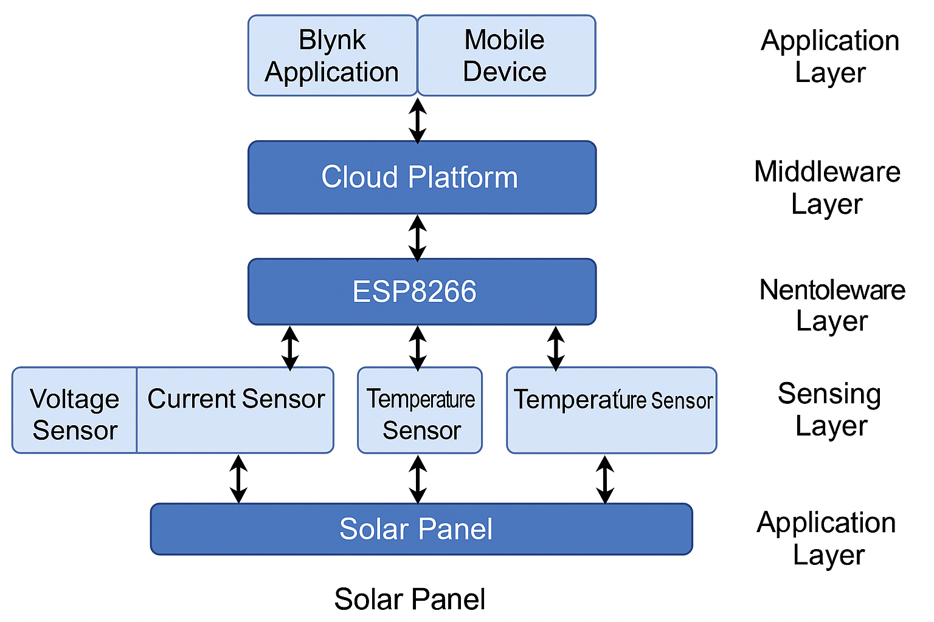
Figure:2.6 conceptual model of the IoT-Based Solar Monitoring System

