CHAPTER FOUR
4.0 Implementation and Testing
This chapter details the implementation and testing processes involved in developing the RLC circuit trainer. It includes systematic documentation of prototype development, testing and validation procedures, presentation of results, and methods of troubleshooting.
4.1 Prototype Development
The development of the RLC circuit trainer prototype was carried out through the following phases:
- Requirements Gathering and Analysis: The process began by identifying user and educational needs through informal interviews, curriculum analysis, and review of existing training kits. Key requirements included real-time circuit measurement, ease of circuit reconfiguration, visual feedback for waveforms, and a guided user interface.
- Preliminary Design: A high-level block diagram was drafted to outline the trainer’s subsystems: RLC circuit board (with plug-and-play capability), measurement terminals, and software interface. This initial blueprint facilitated early identification of system dependencies and critical design constraints.
- Prototype Construction: The actual trainer was built using a breadboard setup for flexibility. It housed discrete resistors, inductors, and capacitors, and was connected to:
- A signal generator for test inputs,
- Oscilloscope probes for waveform analysis,
- A digital multimeter for voltage, current, and resistance readings.
The user interface was created using a PC-based GUI platform (e.g., Python with Tkinter or LabVIEW), enabling users to configure component values, simulate signals, and observe results.
- Initial User Evaluation: A small group of students and instructors tested the prototype. Their feedback helped refine the layout, interface, and instruction manual. Early user involvement ensured that the trainer was educationally effective and intuitive to use.

4.2 LABORATORY MANUAL ON RLC CIRCUIT TRAINER
DEPARTMENT OF ELECTRICAL ELECTRONICS ENGINEERING,
FACULTY OF ENGINEERING, KWARA STATE POLYTECHNIC

STUDENT’S LABORATORY MANUAL ON RLC VECTOR ANALYZER TRAINER
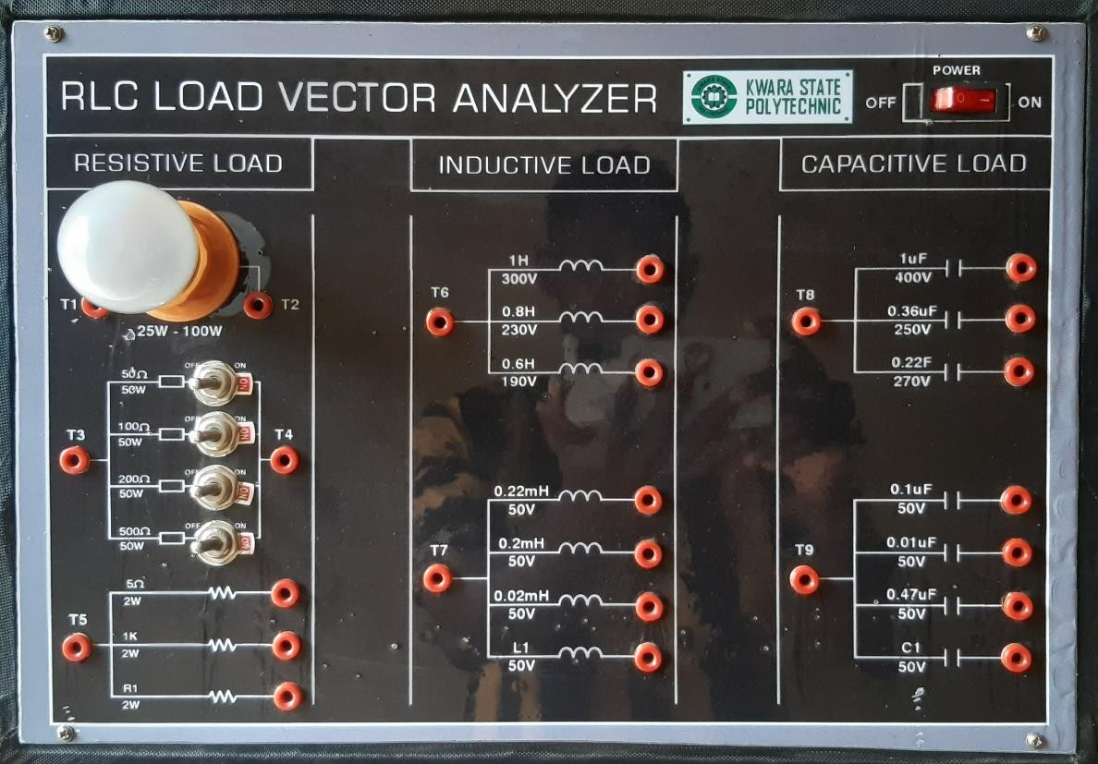

STUDENT’S IDENTIFICATION

NAME: ……………………………………………………………………………………..
REG.NUMBER:………………………………………………………………………….. SEMESTER/SESSION: …………………………………………………………………..

CONCEPT OF POWER FACTOR IN AC CIRCUITS
Power Factor (PF) is a measure of how effectively electrical power is converted into useful work output. It is the ratio of real power (measured in watts, P) to apparent power (measured in volt-amperes, S) in an AC circuit:

Power Factor = cosθ = Real Power (P)/Apparent Power (S)
Where θ is the phase angle between the voltage and current waveforms.

Components of Power:

Real Power (P):
  - Power used to perform actual work (e.g., running machines, lighting lamps).
  - Measured in watts (W).
  - Depends on the resistive component of the circuit.

Reactive Power (Q):
  - Power used to establish magnetic and electric fields in inductive or capacitive components (e.g., motors, transformers).
  - Does not perform useful work but is necessary for the operation of reactive loads.
  - Measured in reactive volt-amperes (VAR).

Apparent Power (S):
  - The total power supplied by the source, a combination of real and reactive power.
  - Measured in volt-amperes (VA).
  - Given by: S = sqrt(P² + Q²)

Power Triangle:
The relationship between P, Q, and S can be represented by a right triangle: Cosθ = P/S
- Real Power (P) is the adjacent side.
- Reactive Power (Q) is the opposite side.
- Apparent Power (S) is the hypotenuse.
- Power Factor Cosθ is the cosine of the angle between P and S.

Importance of Power Factor:

Efficiency:
  - A high power factor (≈1, approx 1) indicates efficient utilization of electrical power.
  - A low power factor means more current is required to deliver the same amount of real power, leading to energy losses.

Phase Relationship:
  - In purely resistive loads, voltage and current are in phase (θ= 0∘, and PF=1).
  - In inductive loads, current lags voltage (θ>0∘, and PF<1).
  - In capacitive loads, current leads voltage (θ<0∘, and PF<1).

Impact on Electrical Systems:
  - A low power factor increases the current drawn by the circuit, causing;
  - Increased losses in transmission lines.
    - Higher demand on generation and distribution systems.
    - Larger equipment sizing for the same power delivery.

Example:
If a motor draws 1000 VA of apparent power but only delivers 800 W of real power, the power factor is:

PF=800/1000=0.8

This indicates that 80% of the power is used for useful work, while the rest is reactive.

Improving Power Factor:

Capacitor Banks:
  - Used to offset inductive reactance in the circuit.
  - Improves lagging power factor.

Synchronous Condensers:
  - Large machines that operate as capacitors to improve power factor dynamically.

Power Electronics:
  - Devices such as active power factor correction circuits.

By maintaining a high power factor, efficiency is improved, energy costs are reduced, and electrical infrastructure operates more effectively.

Experiment 1:

MEASUREMENT OF POWER FACTOR:

Objective:
To understand the concept of power factor and measure the power factor of different types of loads.

Apparatus Required:
- Voltmeter, Ammeter, Wattmeter. (MULTIFUNCTION DIGITAL METER PANEL)
- AC power source.
- Load banks: (RLC LOAD VECTOR ANALYZER)
  - Resistive load (e.g., incandescent bulbs or resistive heaters).
  - Inductive load (e.g., coil or induction motor).
  - Capacitive load (e.g., capacitor bank).
- Connecting wires.

Circuit Diagram:
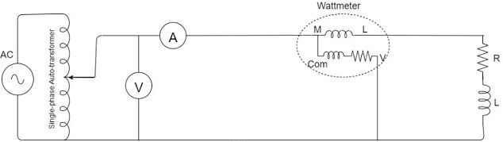

Carry out the following connections:

  - Connect the MULTIFUNCTIONAL DIGITAL METER PANEL (MDMP) to power supply and turn it ON. At this point you will observe the multifunction digital meter display on the screen. This digital meter would measure:

Voltage as V

Current as A

Real Power (P) as Kw Reactive Power (Q) as KVar Apparent Power (S) as KVA Power Factor as Cosθ

Note : the K is kilo

You should access these parameters above using the left and right arrow keys on the multimeter

  - Also connect the RLC LOAD VECTOR ANALYZER to the power supply, turn it ON and observe the cooling fan behind spin.

Procedure:

Step 1: Resistive Load

- Connect the resistive load (100w incandescent bulb to Rout and Nout of the MDMP
OUTPOUTS.
- Connect the inputs of MDMP Rin and Nin using patch chords to the power supply source through a variac transformer.
- Measure and record:
  - Voltage (V) using a voltmeter.
  - Current (I) using an ammeter.
  - Active power (P) using a wattmeter.
- Calculate the power factor using the formula: Power Factor (PF)=P/V×I Note : VxI = apparent power (S). Calculate and compare it. Is this true? Therefore PF = Active or Real power / apparent power = P/S = Cosθ
- Observe that the power factor is close to 1 for a purely resistive load.

Step 2: Inductive Load

- Replace the resistive load with an inductive load.(either 1H, 0.8H, 0.6H only)
- Repeat the measurements of voltage, current, and active power.
- Calculate the power factor using the same formula.
- Observe that the power factor is less than 1 due to the lagging phase difference between voltage and current.

Step 3: Capacitive Load

- Replace the inductive load with a capacitive load.(either 1uF, 0.36uF, 0.22uF only)
- Repeat the measurements of voltage, current, and active power.
- Calculate the power factor.
- Observe that the power factor is less than 1 due to the leading phase difference between voltage and current.

Step 4: Mixed Loads (RESISTIVE and INDUCTIVE)

- Combine resistive and inductive.( 100w incandescent bulb and 0.8H inductor)
- Repeat the measurements and calculations.
- Observe how the combination affects the overall power factor.

Step 5: Mixed Loads (RESISTIVE, INDUCTIVE and CAPACITIVE)

- Combine resistive, inductive, and capacitive loads.( 100w incandescent bulb and 0.8H inductor 0.36uF)
- Repeat the measurements and calculations.
- Observe how the combination affects the overall power factor.

Observations:
Record the measured values of V, I, P, and the calculated power factor for each type of load in a table.

Load Type | Voltage  (V) (V) | Current  (I) (A) | Apparent  power(S) = (VxI) VA | Active  Power (P) W | Power  Factor (PF) Cosθ
Resistive  (R)(100w bulb) | 195 | 0.34 | 66.3 | 66 | 0.995
Inductive (L)  (0.8H) | 198 | 0.089 | 17.6 | 6 | 0.34
Capacitive (C)  (1uF) | 197 | 0.124 | 24.4 | 0.000 | 0.000
Mixed (RL)(100w,  0.8H) | 198 | 0.38 | 75.2 | 73 | 0.971
Mixed (RLC)(100w,  0.8H, 0.36uF) | 195.7 | 0.38 | 74.3 | 73 | 0.983

Note : the values on the table are converted to standard values. KVA is converted to VA, Kw is converted to w from the meter display.
Compare the calculated values to the measured values

Results:
Compare the power factors of different loads and observe the phase relationships between voltage and current.

Conclusion:
Discuss how the power factor varies with load type and its implications in real-world applications.

Experiment 2:
Investigating RLC Resonance

Introduction
The study of resonance in RLC circuits (comprising resistors, inductors, and capacitors) is fundamental to understanding the behavior of alternating current (AC) systems. This experiment focuses on the resonance phenomenon that occurs in series and parallel RLC circuits when the inductive reactance (XL) and capacitive reactance (XC) become equal in magnitude but opposite in phase, resulting in a significant change in the circuit's impedance.

In an RLC series circuit, the total impedance is minimized at resonance, leading to maximum current flow, while in a parallel RLC circuit, the total impedance is maximized at resonance, resulting in minimal current flow through the branch. The experiment explores how varying the frequency of an AC signal affects the behavior of both types of RLC circuits, providing insights into the resonance frequency and the impact of component values (resistance, inductance, and capacitance) on circuit performance.

By conducting this experiment, students will observe the effects of resonance on the voltage and current waveforms, power factor, and impedance characteristics of RLC circuits. The knowledge gained will be essential for understanding real-world applications in communication systems, power distribution, and signal processing, where resonance plays a critical role in the design and operation of filters, oscillators, and tuning circuits.

This experiment allows students to directly measure and analyze resonance conditions, providing hands-on experience with oscilloscopes, frequency generators, and the fundamental principles of AC circuit analysis.

Objective
To study the resonance phenomenon in RLC circuits, determine the resonance frequency, and analyze the behavior of voltage, current, and phase relationships using an oscilloscope.

Apparatus Required
- Function generator
- Oscilloscope (dual-channel)
- RLC VECTOR ANALYZER

Theory
An RLC circuit exhibits resonance when the inductive reactance (XL) equals the capacitive reactance (XC). At resonance:

- Series RLC Circuit: Impedance is minimum, and current is maximum.
- Parallel RLC Circuit: Impedance is maximum, and current is minimum. The resonance frequency (f0) is given by:

f0=1/(2π.sqrt(LC))

Using the provided values: f0 = 1/(2π.sqrt((221×10⁻³)(0.1×10⁻⁶)))s = 1,072.77 Hz

Experimental Procedure

Part 1: Setup the Circuit

Series RLC Circuit:
  - Connect a resistor (R), inductor (L), and capacitor (C) in series with the function generator.
  - Connect Channel 1 of the oscilloscope across the resistor to measure current indirectly.
  - Connect Channel 2 of the oscilloscope across the entire circuit to measure input voltage.

Part 2: Frequency Sweep and Data Collection
- Set the function generator to produce a sinusoidal signal with a small amplitude (e.g., 1V peak-to-peak).
- Start at a low frequency (∼500 Hz) and gradually increase the frequency while observing the waveforms on the oscilloscope.
- For each frequency, record:
  - Voltage amplitude across the resistor.
  - Phase difference between input voltage and current (via the resistor).
  - Shape of the Lissajous figure in XY mode.

Table of Experiments
Given 1k resistor, 0.22mH inductor, 0.01uF capacitor f0 = 107,650.86 Hz

S/N | Frequency(Hz) | Resistance Voltage (V) | Phase difference  (Degrees) | Observation (Lissajous  shape)
1 | 70,000 | 1.01 | 13.10 | ellipse
2 | 115,000.0(f0) | 1.02 | 0 | Straight line
3 | 200,000 | 1.03 | 14.4 | ellipse

Given 1k resistor, 0.22mH inductor, 0.1uF capacitor f0 = 33,978.9 Hz

S/N | Frequency(Hz) | Resistance Voltage (V) | Phase  difference (Degrees) | Observation  (Lissajous shape)
1 | 10,000 | 0.604 | 0.014 | ellipse
2 | 37,900.0(f0) | 0.624 | 0 | Straight line
3 | 50,000 | 0.634 | 9.09 | ellipse

Key Observations and Parameters

Maximum Voltage Across Resistor (Series RLC)

  - Identify the frequency at which the voltage amplitude across the resistor is maximum. This frequency corresponds to the resonance frequency (f0).

Phase Relationship
  - Use the dual-channel display:
    - At resonance: Voltage and current are in phase (ϕ=0).
    - Below resonance: Voltage lags current.
    - Above resonance: Voltage leads current.

Lissajous Figure Analysis
  - In XY mode:
    - At resonance: The figure is a straight line.
    - Below or above resonance: The figure forms an ellipse.

Calculations
- Resonance Frequency:
  - From maximum voltage or minimum current measurements.
  - Theoretical value: f0=1/(2π.sqrt(LC))
- Phase Difference:
  - Measure time difference (Δt) between voltage and current waveforms on the oscilloscope.
  - Calculate phase difference (ϕ): Φ = (Δt/T)⋅360∘
Here’s the explanation:

- Δt is the time difference (or time shift).
- T is the time period of the signal.
- Φ is the phase shift in degrees

Analysis Questions
- How does changing the values of RR, LL, and CC affect the resonance frequency?
- Why is the voltage amplitude maximum at resonance in a series RLC circuit?
- What is the significance of the phase difference observed at and away from resonance?
- How does the Q-factor change with resistance, and what does this indicate about the sharpness of resonance?

Precautions
- Ensure all connections are secure to avoid noise or signal distortion.
- Ensure all connections are secure to avoid noise or signal distortion.
- Start with low amplitude signals to prevent damage to components.
- Gradually increase the frequency to avoid skipping the resonance point.

Conclusion
In this experiment, the resonance frequency of the RLC circuit is determined experimentally and compared with the theoretical value. The behavior of the circuit at resonance, including maximum current or voltage, zero phase difference, and Lissajous figures, confirms the principles of resonance.

4.3 Testing and Validation Procedures
To ensure the reliability and accuracy of the trainer, rigorous testing and validation were conducted:
- Functional Testing: Each module (circuit, interface, and tools) was tested to ensure individual and integrated performance. This included checks for:
- Correct voltage and current display,
- Responsiveness of the GUI,
- Stability of signals during operation.
- Performance Testing: Sample RLC configurations were set up to evaluate real-time behavior under different frequencies and component combinations. Measurements were taken for:
- Resonant frequency verification,
- Voltage amplitude changes with frequency,
- Current variation in series/parallel RLC arrangements.
- Validation Against Theoretical Values: Experimental data were compared with calculated results using standard RLC formulas. For instance:
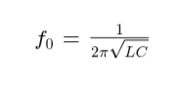

4.4 Results and Discussion
The findings from the prototype testing were as follows:
- Measurement Accuracy: The trainer produced accurate readings of voltage, current, and frequency. Most values matched theoretical predictions within a 5% margin of error, confirming the effectiveness of the measurement tools.
- Analysis of Circuit Behavior: The trainer effectively demonstrated the core characteristics of RLC circuits—resonance peaks, phase shifts, and frequency-dependent impedance changes. The transition from inductive to capacitive behavior near resonance was observable and measurable.
- User Experience: Test users appreciated the hands-on interaction. The GUI was found intuitive, although recommendations were made to include:
- Auto-calculation of resonance frequency,
- Step-by-step guidance for beginners,
- Graphical plots of impedance vs. frequency.
These insights guided subsequent iterations and refinements of the system.
4.5 Troubleshooting and Debugging
Challenges faced during development were systematically addressed:
- Common Issues Identified:
Inconsistent readings due to poor breadboard contacts,
GUI lag during data refresh,
Signal noise affecting oscilloscope output.
2. Debugging Steps:
Connections were reinforced using banana plug terminals,
Code optimization reduced GUI response time,
Signal integrity was improved using shielded wires and proper grounding.
3. Verification of Fixes: All fixes were re-evaluated using the same test cases. The trainer’s performance remained consistent after debugging, validating the reliability of the final prototype.

The successful implementation and testing of the RLC circuit trainer confirmed that the design met its technical and educational objectives. It offers a practical and interactive way to learn fundamental RLC concepts with sufficient accuracy, robustness, and user engagement for classroom and lab use.

