CHAPTER THREE

3.0 DESIGN AND DEVELOPMENT
This chapter presents the systematic process undertaken in the design and development of the RLC circuit trainer. It covers the system architecture, detailed circuit design, component selection criteria, development of the trainer module, integration of measurement tools, and user interface functionalities. The goal of this chapter is to describe how the conceptual design was translated into a functional and educational circuit training platform.

3.1 System Architecture and Block Diagram
The RLC circuit trainer system is built with modularity and educational utility as its core objectives. Its architecture is composed of three interdependent subsystems:
- Trainer Module
This is the core platform where users construct various RLC circuits using interchangeable components. It includes plug-and-play sockets for resistors, inductors, and capacitors to allow for easy reconfiguration of the circuits. The trainer module supports both series and parallel RLC connections, providing flexibility in experimentation.
- Measurement Tools
Measurement tools integrated with the trainer include multimeters, oscilloscopes, and signal generators. These devices are used to observe and analyze circuit behavior such as voltage levels, current flow, phase differences, and resonance characteristics.
- User Interface
The user interface (UI) is designed to be simple and educational, aiding in circuit configuration, parameter monitoring, and data visualization. It bridges the gap between the physical trainer and analytical tools by facilitating parameter input and real-time data observation.

Block Diagram
The block diagram illustrates the overall system architecture, showing the interconnections between the trainer module, measurement tools, and user interface.
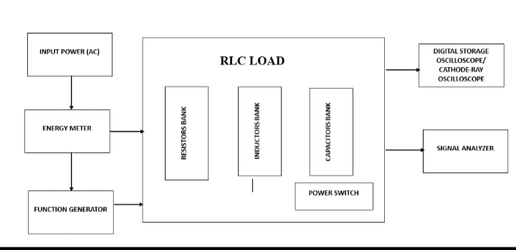
3.2 Circuit Design and Component Selection
Designing an effective RLC circuit trainer requires the use of standardized and robust components that ensure both accuracy and safety.
Resistors
Resistors were selected based on the expected current and voltage range in the learning environment. Typical values such as 100 Ω, 1 kΩ, and 10 kΩ with 5% tolerance were chosen to cover a wide range of circuit configurations. Metal film resistors are preferred for their accuracy and thermal stability.
Inductors
Inductors were chosen to represent realistic values used in common AC circuit applications. Values like 1 mH, 10 mH, and 100 mH are selected, with current ratings above 500 mA to prevent saturation or overheating
Capacitors
Capacitor selection includes values like 100 nF, 470 nF, and 1 µF with voltage ratings of at least 50V to ensure safety during testing.
Component List
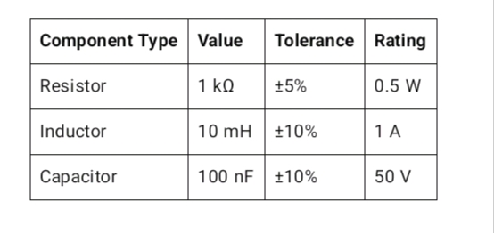
3.3 Trainer Module Development
The physical trainer module is designed for ease of use, modularity, and robustness. It includes the following key features:
- Breadboard or PCB Interface
A high-quality solderless breadboard is integrated to enable users to construct circuits quickly without permanent soldering.
- Component Sockets
Dedicated sockets are provided for inserting components such as resistors, inductors, and capacitors. These sockets are color-coded and labeled for clarity, helping users distinguish components and correctly place them in the circuit.
- Connectors and Terminals
Standard banana jacks and pin headers are used to connect the trainer to external instruments like signal generators or oscilloscopes.
These connectors ensure secure, low-resistance connections and are designed to withstand frequent use.

3.4 Measurement Tool Integration
Accurate measurement is crucial for analyzing RLC circuit behavior. The trainer integrates or interfaces with the following instruments:
- Oscilloscopes
Digital oscilloscopes are used to visualize voltage waveforms across components and observe phase relationships. They help students identify the effects of resonance and frequency response.
- Multimeters
Multimeters are used to measure DC/AC voltage, current, and resistance. They serve both as diagnostic tools and verification instruments during experiments.
- Signal Generators
Function generators provide sinusoidal, square, or triangular waveforms at various frequencies and amplitudes. They allow users to study circuit response under different input conditions, such as sweep frequency testing for identifying resonant peaks.

3.5 User Interface and Data Analysis Capabilities
To bridge theory and practice, the user interface enables interaction with the system while simplifying complex tasks.

- Parameter Input and Control
Users can input component values, adjust signal frequency and amplitude, or switch circuit configurations using knobs, switches, or a graphical UI (e.g., on an LCD or PC). This modularity encourages experimentation and active learning.
- Circuit Monitoring
Real-time visualization of voltage, current, and phase data allows users to understand circuit behavior. Oscilloscopes, digital displays, or PC software can be used for monitoring.
- Data Analysis Features
Analysis of data, including frequency response, impedance, and resonance. The user interface provides tools and features for data analysis, allowing users to gain insights into circuit behavior and performance.The user interface also includes data analysis capabilities, such as:
- Data Visualization: Visualizing data, including plots and charts, to facilitate understanding and analysis. The data visualization tools provide a clear and concise representation of the data, allowing users to quickly understand circuit behavior.
- Data Export: Exporting data for further analysis and processing. The data export feature allows users to transfer data to other tools and software, facilitating further analysis and processing.
4. Data Export Capability
Measurement data can be exported as CSV or Excel files for further analysis in MATLAB, Excel, or Python. This feature supports laboratory reporting and post-experiment analysis.

