

TECHNICAL REPORT
ON
STUDENT INDUSTRIAL WORKING EXPERIENCE
SCHEME (SIWES)

HELD AT

RALPH DIGITAL CONCEPT
ADJACENT NEWLAND POLYTECHNIC SANGO ROAD ILORIN KWARA STATE

PRESENTED BY

KOLAWOLE NAFISAT OLAMIDE
ND/23/MKT/PT/0271
SUBMITTED TO

DEPARTMENT OF MARKETING
INSTITUTE OF FINANCE AND MANAGEMENT STUDIES
(IFMS)
KWARA STATE POLYTECHNIC, ILORIN
IN PARTIAL FULFILLMENT OF THE AWARD OF THE REQUIREMENT
FOR THE AWARD OF NATIONAL DIPLOMA IN MARKETING
OCT-NOV 2024

DEDICATION
I dedicate this technical report to the Almighty God, the giver of knowledge, wisdom and who is rich in mercy.
ACKNOWLEDGEMENTS
I appreciate the Almighty God for the knowledge, endurance, safety, and courage upon throughout the period of my Industrial attachment and kwara state polytechnic for the
Lastly, I wish to express my sincere regards to the school’s Board of Trustees and the entire staff of the marketing department for their dedication and support. Once again, a big thank you to everyone who contributed to making this experience a memorable and successful one.
privilege of this siwes program

TABLE OF CONTENT
Title page
Dedication Acknowledgement

Chapter 1
1.1 Introduction
1.2 Aims and objectives of SIWES (Definition of SIWES)
1.3 organization chart
Chapter 2
2.1 Historical background of the organization
2.2 Major activities of the organization

Chapter 3
3.1 student involvement at various section /unit
3.2 communication in organization
3.3 Digital marketing consultancy
3.4 Relevance experience gained to the student field study

Chapter 4
4.1 Conclusion
4.2 Personal Impression about the organization
4.3 Recommendation

Chapter one
1.1 INTRODUCTION
This program called (SIWES) student industrial work experience scheme is compulsory to all ND1 student who offer science course or any other practicable course. It enables student to have the experience of the aspect which have been taught in school. It is a program that takes up to four month in which student are expected to be able practices what they are taught.
1.2 AIMS AND OBJECTIVES OF SIWES
The student industrial work experience scheme (SIWES) can be define as a technical skills and acquisition of knowledge from the organization, industrial sector. It is also serving as the complement the learning which student have acquired in the classroom or theoretically.

1.3 organization chart

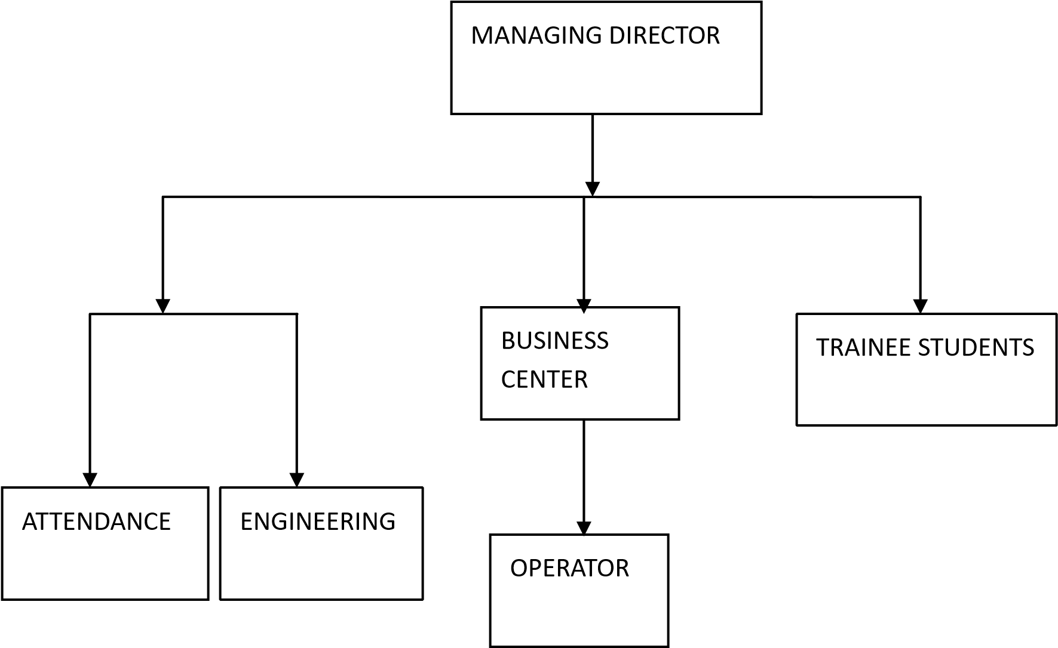

CHAPTER TWO
2.1 HISTORICAL BACKGROUND OF THE ORGANIZATION
Ralph digital concept provider, operates as an offshoot of Excellent World Technology Ventures. The parent company's original mandate was to mitigate various ICT challenges faced by individuals and businesses.
Ralph digital concept built upon this foundation, establishing itself as a purveyor of diverse digital solutions. These include facilitating the purchase of e-registration pins, result checkers for academic use, data and airtime bundles, cable TV subscriptions, and bill payment services. A key operational pillar is its platform, a virtual top-up system. Beyond direct consumer transactions, also empowers resellers by offering vital tools like sales tracking, automated delivery, and dedicated customer support, ensuring consistent operational uptime.

2.2 MAJOR ACTIVITIES OF THE ORGANIZATION
The major activity of the organization is operating digital marketing The organization also accommodate SIWES student and individual.
Other activities performed by the organization are:
1. The organization based on digital marketing
2 . Data analysis interpretation digital marketing
3. Digital marketing marketing consultancy

Chapter 3

3.1 student involvement at various section /unit
Ralph digital concept actively involves students, providing practical experience across several areas:
- Practical Internships: Students gain hands-on experience by assisting with marketing and content creation, supporting customer service, and learning the intricacies of digital service platforms (e.g., airtime/data sales, bill payments, educational pin distribution).
- Sales & Outreach: Students can become campus ambassadors or reseller agents, actively promoting services like exam result checker pins, discounted airtime/data bundles, and cable TV subscriptions directly within their university communities.
- Market Insights: Students contribute by conducting surveys among their peers, gathering vital feedback on service usability and pricing, and suggesting improvements based on current student technology trends.
- Social Media Amplification: Leveraging their digital savviness, students help manage social media pages, create engaging youth-focused content, and boost brand visibility among student populations.
- Tech Support & Development: Tech-oriented students can get involved in testing new digital tools.

3.2 COMMUNICATION IN ORGANIZATION
Effective communication is crucial in an organization, especially in the field of digital marketing, where teamwork, collaboration, and stakeholder engagement are essential. Here are some key aspects of communication in an organization in the field study of digital marketing:

Types of Communication:
- Internal Communication : Communication among team members, departments, and stakeholders within the organization.
- External Communication : Communication with customers, clients, partners, and other external stakeholders.
Channels of Communication:
- Email: Official communication, updates, and notifications.
- Team Collaboration Tools: Slack, Trello, Asana, and other project management tools.
- Meetings: Regular team meetings, brainstorming sessions, and progress updates.
- Video Conferencing : Remote meetings, training sessions, and client calls.
- Instant Messaging: Informal communication, quick updates, and feedback.

Communication Skills:
- Clear and Concise Writing: Ability to write effective emails, reports, and proposals.
- Effective Listening: Ability to listen attentively, understand, and respond appropriately.
- Presentation Skills : Ability to deliver engaging, informative presentations.
- Conflict Resolution: Ability to manage and resolve conflicts, disagreements, and misunderstandings.
- Cultural Competence: Ability to communicate effectively with diverse teams, clients, and stakeholders.

Communication Challenges:
- Information Overload : Managing the sheer volume of data, emails, and messages.
- Miscommunication: Avoiding misunderstandings, misinterpretations, and miscommunications.
- Language Barriers: Communicating effectively with team members, clients, or stakeholders who speak different languages.
- Technical Issues : Overcoming technical challenges, such as email deliverability issues, software glitches, or connectivity problems.

Best Practices:
- Establish Clear Communication Channels*: Define official communication channels, protocols, and expectations.
- Set Clear Goals and Objectives : Align communication efforts with organizational goals, objectives, and key performance indicators (KPIs).
- Foster Open Communication : Encourage transparency, feedback, and open communication among team members, departments, and stakeholders.
Use Collaboration Tools : Leverage team collaboration tools, project management software, and communication platforms to facilitate teamwork, productivity, and efficiency.
- Provide Training and Development: Offer training, workshops, and coaching to enhance communication skills, conflict resolution, and cultural competence.

3.3 Digital marketing consultancy
Digital marketing consultancy is a service that provides expert advice and guidance to businesses and organizations on how to improve their online presence, reach their target audience, and achieve their digital marketing goals.

Services Offered:
- Digital Marketing Strategy: Developing a comprehensive digital marketing strategy aligned with business objectives.
- Website Optimization: Improving website design, user experience, and conversion rates.
- Search Engine Optimization (SEO): Enhancing website visibility, ranking, and organic traffic.
- Pay-Per-Click (PPC) Advertising: Managing and optimizing PPC campaigns for maximum ROI.
- Social Media Marketing: Creating and implementing social media strategies to engage with target audiences.
- Content Marketing: Developing and distributing valuable, relevant, and consistent content to attract and retain a clearly defined audience.
- Email Marketing: Building and executing email marketing campaigns to nurture leads and drive conversions.
- Analytics and Reporting: Providing regular analysis and reporting on digital marketing performance, including metrics such as website traffic, engagement, and conversion rates.

Benefits:
- Improved Online Visibility : Increased website traffic, search engine rankings, and social media presence.
- Enhanced Brand Awareness: Stronger brand reputation, recognition, and loyalty.
- Increased Conversions: More leads, sales, and revenue generated from digital marketing efforts.
- Data-Driven Decision Making Informed decisions based on accurate data analysis and insights.
- Cost Savings: Optimized digital marketing budgets and reduced waste.

Types of Digital Marketing Consultancy:
- Full-Service Digital Marketing Consultancy: Comprehensive services covering all aspects of digital marketing.
- Specialized Digital Marketing Consultancy: Expertise in specific areas, such as SEO, PPC, or social media marketing.
- Freelance Digital Marketing Consultancy: Independent consultants offering flexible, projectbased services.

Qualities of a Good Digital Marketing Consultant:
- Expertise: Proven experience and knowledge in digital marketing.
- Strategic Thinking: Ability to develop and implement effective digital marketing strategies.
- Analytical Skills: Strong data analysis and interpretation abilities.
- Communication Skills: Clear, concise, and engaging communication style.
- Adaptability: Ability to adapt to changing digital marketing trends and technologies.
Digital marketing consultancy is a service that provides expert advice and guidance to businesses and organizations on how to improve their online presence, reach their target audience, and achieve their digital marketing goals.

Services:
- Digital Marketing Strategy: Developing a comprehensive digital marketing strategy.
- Website Optimization: Improving website design, user experience, and conversion rates.
- SEO: Enhancing website visibility and ranking.
- PPC Advertising: Managing and optimizing PPC campaigns.
- Social Media Marketing: Creating and implementing social media strategies.
- Content Marketing: Developing and distributing valuable content.
- Email Marketing: Building and executing email marketing campaigns.
- Analytics and Reporting: Providing regular analysis and reporting.

Benefits:
- Improved Online Visibility: Increased website traffic and search engine rankings.
- Enhanced Brand Awareness: Stronger brand reputation and recognition.
- Increased Conversions: More leads, sales, and revenue.
- Data-Driven Decision Making: Informed decisions based on accurate data analysis.
- Cost Savings: Optimized digital marketing budgets.

Types of Consultancy:
- Full-Service Consultancy: Comprehensive services covering all aspects of digital marketing.
- Specialized Consultancy: Expertise in specific areas, such as SEO or social media marketing.
- Freelance Consultancy: Independent consultants offering flexible services.

Qualities of a Good Consultant:
- Expertise: Proven experience and knowledge in digital marketing.
Strategic Thinking: Ability to develop effective digital marketing strategies.
- Analytical Skills Strong data analysis and interpretation abilities.
- Communication Skills Clear and concise communication style.
- Adaptability Ability to adapt to changing digital marketing trends.

3.4 RELEVANCE EXPERINCE GAINED IN STUDYING FIELD
Here's how the experience i gained from studying digital marketing can be relevant
- Research Design: Understanding of research methodologies, data collection, and analysis.
- Data Analysis: Familiarity with data analysis tools, metrics, and methodologies.
- Literature Review: Ability to conduct a comprehensive literature review on digital marketing topics.

Relevance to Practical Applications:
- Digital Marketing Campaigns: Understanding of how to plan, execute, and measure digital marketing campaigns.
- Social Media Management: Familiarity with social media platforms, content creation, and community engagement.
- Content Creation: Ability to create high-quality, engaging content for various digital channels.
Relevance to Career Development:
- Digital Marketing Career Paths: Understanding of various digital marketing career paths, including SEO, social media, email marketing, and content marketing.
- Industry Trends: Familiarity with current digital marketing trends, challenges, and opportunities.
- Professional Networking: Ability to connect with professionals in the digital marketing industry.
Relevance to Soft Skills:
- Communication: Ability to communicate complex digital marketing concepts effectively.
- Teamwork: Understanding of how to work collaboratively with cross-functional teams.
- Time Management: Ability to manage multiple projects and deadlines in a fast-paced digital marketing environment.

Chapter 4
4.1conclusion, student industrial work experience
scheme program (SIWES)
Student industrial work experience scheme program has given the opportunity to have at least some knowledge about my course of study and program has provided me an abridgement of gap.

4.2 PERSONAL IMPERSSION ABOUT THE ORGANIZATION
Though the organization is a growing firm, yet it is of standard. It is standard enough to impact great and immeasurable knowledge i have chosen marketing as a field of study.
4.3 RECOMMENDATION

SIWES experience, future interns are advised to:
• Be Proactive: Take initiative in seeking out learning opportunities and engaging in diverse projects.
• Embrace Challenges: View challenges as learning opportunities and approach them with a problem-solving mindset.
• Network Effectively: Build professional relationships within and outside the organization to enhance learning and career prospects.
• Reflect and Adapt: Regularly reflect on experiences to identify areas for improvement and adapt accordingly

