CHAPTER THREE

3.0 MATERIALS AND METHODS

3.1 Materials
Flame Atomic AbsorptionSpectrophotometer, Nitric Acid, Chlorate, Kjeldahl distillation glass, Sample bottle, Distilled water.

3.2 Method

3.2.1 Digestion of sample
One gram of sample was weighed in a 250 mlKjeldahl distillation glass and was wet digested using 20 ml of HNO₃-HClO₄acid solution (2:1 volume) on a hot digestion system,heated until the samples turn colorless solution.

3.2.2 Mineral analysis
After digestion was complete, the solution of eachsample was transferred into a 100 ml calibrated samplebottle and the solution was diluted to the mark withdistilled water. Minerals in the samples weredetermined by flame Atomic AbsorptionSpectrophotometer (VARIAN model AA240FS,United State).
3.3 Proximate Analysis
Proximate analysis was carried out according to AOAC methods to determine moisture, crude fibre, ash, crude protein, crude fat and carbohydrate.
3.3.1 Determination of Moisture Contents
A glass petri-dish was accurately weighed, after which 5.0g of the sample was added and reweighed and the weight was recorded as (W₁). This was kept in a drying oven for 4 hours at 100oc to determine the actual moisture of the standardized foods, the dish was removed from the oven, cooled in a desiccator and re-weighed and was recorded as (W₂). This process was repeated until a constant weight is attained. This process was repeated for all the samples, and the moisture content was calculated in percentage as follows:
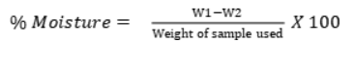
3.3.2. Determination of Ash Content
2.0g of sample was accurately weighed in a platinum crucible and was recorded as W₁, this was transferred to muffle furnace at the temperature of 550oc for 5 hours or until a white ash was obtained. The platinum crucible was removed and place in a dedicator to cool and weighed, this was recorded as W₂.
Calculation:
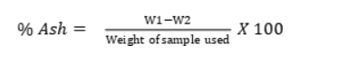
3.3.3. Determination of Crude Fibre
2.0g of standardized food was digested in 200ml of 1.25% H2SO4, the mixture was boiled for 30minutes on heating mantle, filtered and washed with hot water to reduce the acidity, and this was tested with pH paper indicator. The residue was again transferred and digested in 200ml of 1.25% NaOH. The mixture was heated for 30 minutes. Filtered using buncherfunnel under pressure and washed with hot water and the filter paper and its content was placed in a drying oven, this was then transferred to a platinum crucible and weighed (W1). The crucible was heated in a muffle furnace at 550oc to ash and weighed again as (W2). Percentage crude fibre is calculated as:
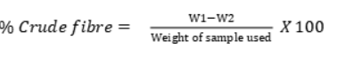
3.3.4. Determination of Crude Fat
2.0g of the sample was weighed and placed in a different paper. The filtered paper and its content was transferred in a soxhlet apparatus extractor. The flask was filled with 300ml petroleum ether (40-600c) and allowed to boil. The soxhletapparatus was allowed to reflux for about 4 hours. The filter paper was removed and the petroleum ether was recovered and re-use. When the flask was free of petroleum ether, the flask was removed and dried at 1050c for 1 hour. The dried flask was then transferred to a desiccator to cool and weighed.
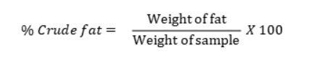
3.3.5. Determination of Crude Protein
The protein nitrogen in 0.5g of dried samples was converted to ammonium sulphate by digestion with 20ml of concentrated H2SO4 and 5g of kjehdal catalyst (Cu2SO4, K2SO4 and Selenium dioxide). This was heated on a digestion heater and the ammonia involved was steam distilled into 4% boric acid solution, the nitrogen from ammonia was deduced from the titration of the trapped ammonia with 0.1N HCl with methyl red and bromocresol green indicator until a green colouration was observed, which indicate the end point of titration. Protein was calculated by multiplying the deduced value of nitrogen by a protein constant 6.25mg.
Percentage Nitrogen
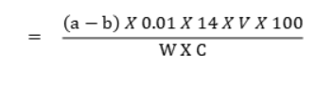
Where:
a = Titre value of the digested sample
b = Titre value of blank sample
v = Volume after dilution (100ml)
W = Weight of dried sample (mg)
C. = Aliquot of the sample used (5ml)
14. = Nitrogen constant in mg.
3.3.6. Determination of Carbohydrate
The carbohydrate content of the foods was estimated as the difference obtained after subtracting the values of crude protein, ash content, fat or oil, crude fibre, and moisture content from 100. That is 100- (protein + ash + oil + crude fibre + moisture content).

