

TECHNICAL REPORT ON

STUDENT INDUSTRIAL WORK EXPERIENCE SCHEME (SIWES)

HELD AT

OPERAH WORLD INTERNATIONAL
(NO 175, OPPOSITE SANRAB FILLING STATION TANKE)

BY:

YUNUS HAMZAT ALASIELE
ND/23/BAM/PT/0211

SUBMITTED TO:

DEPARTMENT OF BUSINESS ADMINISTRATION AND MANAGEMENT,
INSTITUTE OF FINANCE AND MANAGEMENT STUDIES (IFMS) KWARA STATE POLYTECHNIC, ILORIN.

IN PARTIAL FULFILMENT FOR THE AWARD OF NATIONAL DIPLOMA (ND) IN BUSINESS ADMINISTRATION AND MANAGEMENT, KWARA STATE POLYTECHNIC, ILORIN

2024/2025 SESSION

PREFACE
The Student Industrial Work Experience Scheme (SIWES) was established by the Industrial Training Fund (ITF) to enable student of tertiary institution to have basic technical knowledge of industrial work basic on their courses of study before the completion of their program in their various institutions.
In the early stage, student are graduating into institution without any technical knowledge of working experience, this make them to undergo further training after servicing an employment with the reason.
I did my Siwes programme at Operah World International , located at No 175, Opposite Sanrab Filling Station Tanke. In the course of my SIWES programme, I was exposed and I learnt how to run Microsoft Office Programs i.e. MSWord, MS-PowerPoint, MS-Excel and PowerPoint

DEDICATION
This report is dedicated to God Almighty for His blessings, and mercies bestowed on me right from womb till this very moment and for always been there for me and got my back always and ever. And special thanks to my parent and departmental lecturers as well.

ACKNOWLEDGEMENT
I really thank God Almighty for making this vision a reality. The foundation of everything in life is of utmost importance. Therefore, I give credit and kudos to all Mentors at Operah World International . I also thank the Director of the center for his leadership attitude which provides a conducive and uninterrupted academic Centre for which students can acquire knowledge in different kind of field of study.
A report of this magnitude definitely involved more than just my hand work alone. In consequence to that, it is important that effort of my people who contributed to the success of this programme should be acknowledge.
I sincerely appreciate the effort of all the lecturers of Business Administration and Management Department and also to the non-teaching staffs, who have contributed in one way or the other towards the successful completion of this programme, may the Lord give them his infinite mercy and blessing. Bless you and your entire family. (Amen).

TABLE OF CONTENTS
Title page i
Preface ii
Dedication iii
Acknowledgement iv
Table Of Contents v
Chapter One 1
1.1 Introduction 1
1.2 Objectives Of Siwes 2
Chapter Two 3
2.0 Location And Brief History Of Establishment 3
2.1 About The Company 3
2.1.1 Mission 3
2.1.2 Vision 3
2.1.3 Our Core Values 3
2.2 Organization Chart 4
Chapter Two 5
3.0 Work Done 5
3.1 Introduction To Microsoft Word 5
3.1.1 Steps Require To Activate Microsoft Word 5
3.1.2 Creating A Document 5
3.1.3 How To Format A Text 5
3.1.4 How To Save A Document 6
3.1.5 Zooming In And Out 7
3.1.6 Printing Of File 7
3.1.7 Spelling And Grammer Checking 7
3.1.8 To Create Table 8
3.1.9 Exiting Microsoft Word 8
3.1.10 To Insert Word Art 8
3.1.11 To Insert Symbol 8
3.2 Microsoft Powerpoint 9
3.3 Microsoft Excel 12
3.3.1 Microsoft Excel Tools 12
Chapter Four 15
4.1 Experience Gained 15
Chapter Five 16
5.1 Conclusion 16
5.2 Personal Impression About The Organization 16
5.3 Suggestions/Recommendation To The Organization And The Polytechnic Concerning The Siwes Programme 16

CHAPTER ONE

1.1 INTRODUCTION
SIWES was established by ITF in 1973 to solve the problem of lack of adequate practical skills preparatory for employment in industries by Nigerian graduates of tertiary institutions.
The Scheme exposes students to industry-based skills necessary for a smooth transition from the classroom to the world of work. It affords students of tertiary institutions the opportunity of being familiarized and exposed to the needed experience in handling machinery and equipment which are usually not available in the educational institutions.
Participation in Industrial Training is a well-known educational strategy. Classroom studies are integrated with learning through hands-on work experiences in a field related to the student’s academic major and career goals. Successful internships foster an experiential learning process that not only promotes career preparation but provides opportunities for learners to develop skills necessary to become leaders in their chosen professions.
One of the primary goals of the SIWES is to help students integrate leadership development into the experiential learning process. Students are expected to learn and develop basic non-profit leadership skills through a mentoring relationship with innovative non-profit leaders.
By integrating leadership development activities into the Industrial Training experience, we hope to encourage students to actively engage in non-profit management as a professional career objective. However, the effectiveness of the SIWES experience will have varying outcomes based upon the individual student, the work assignment, and the supervisor/mentor requirements. It is vital that each internship position description includes specific, written learning objectives to ensure leadership skill development is incorporated.
Participation in SIWES has become a necessary pre-condition for the award of Diploma and Degree certificates in specific disciplines in most institutions of higher learning in the country, in accordance with the education policy of government.
Operators - The ITF, the coordinating agencies (NUC, NCCE, NBTE), employers of labour and the institutions.
Funding - The Federal Government of Nigeria
Beneficiaries - Undergraduate students of the following: Agriculture, Engineering, Technology, Environmental, Science, Education, Medical Science and Pure and Applied Sciences.
Duration - Four months for Polytechnics and Colleges of Education, and Six months for the Universities.

1.2 OBJECTIVES OF SIWES
The following are some of the objectives of SIWES:
- SIWES will provide students the opportunity to test their interest in a particular career before permanent commitments are made.
- SIWES students will develop skills in the application of theory to practical work situations.
- SIWES will provide students the opportunity to test their aptitude for a particular career before permanent commitments are made.
- SIWES students will develop skills and techniques directly applicable to their careers.
- SIWES will aid students in adjusting from college to full-time employment.
- SIWES will provide students the opportunity to develop attitudes conducive to effective interpersonal relationships.
- SIWES will increase a student's sense of responsibility.
- SIWES students will be prepared to enter into full-time employment in their area of specialization upon graduation.
- SIWES students will acquire good work habits.
- SIWES students will develop employment records/references that will enhance employment opportunities.
- SIWES will provide students the opportunity to understand informal organizational interrelationships.
- SIWES will reduce student dropouts.

CHAPTER TWO

2.0 LOCATION AND BRIEF HISTORY OF ESTABLISHMENT

2.1 ABOUT THE COMPANY
Operah World International is a dynamic and fast-growing company dedicated to delivering top-quality solutions for all computer-related needs. From automation to project execution, we specialize in providing reliable and efficient ICT services.
Founded in 2016 by Mr. Unique Johnson, our company has been a leader in ICT solutions and consultancy, serving businesses, government agencies, and organizations of all sizes. We manage critical ICT systems and offer innovative products, services, and solutions tailored to meet the needs of both the public and private sectors worldwide.

2.1.1 Mission
We are committed to providing cutting-edge, user-friendly ICT products, services, and solutions that make technology more accessible and efficient.

2.1.2 Vision
To establish ourselves as a world-class ICT company, driving technological advancement in Nigeria and beyond.

2.1.3 Our Core Values
- Teamwork, Honesty, and Integrity – We believe in collaboration and transparency.
- Excellence, Efficiency, and Effectiveness – We strive for top-quality results.
- Service and Delivery – Ensuring customer satisfaction is our priority.
- Customer-Centric Approach – Tailoring solutions to meet unique client needs.
- Vendor Neutrality – Offering unbiased and flexible ICT solutions.
At Operah World International , we are committed to empowering businesses through technology, ensuring they stay ahead in a fast-evolving digital world.

2.2 ORGANIZATION CHART

Figure 1.1: Organogram of the Company

CHAPTER TWO

3.0 WORK DONE

3.1 INTRODUCTION TO MICROSOFT WORD
The chapter include information about how to boot the system, formatting of text, what we can find when we start our window and some other important things in word processor. Microsoft word is the word processing software which can be use in writing of text, placing of text in column inserting of clip art, creating of text.

3.1.1 STEPS REQUIRE TO ACTIVATE MICROSOFT WORD
- Step 1 Boot the system
- Step 2 Click start button ( or press window on keyboard)
- Step 3 Click on all program
- Step 4 Click on Microsoft office ( from the program submenus)
- Step 5 point Microsoft word

3.1.2 CREATING A DOCUMENT
When Microsoft word is started, a basic sheet of electronic paper is displayed on which you can type and text appear in the document and editing occurs.

3.1.3 HOW TO FORMAT A TEXT
Formatting is when you want to change the characters of your text such a font type, size and the thickness. Color or the position which could be superscript or subscript does as following.
- Step 1 Highlight the, it is compulsory to highlight the text you want to modify either by the mouse or keyboard before the operation.
- Step 2 click format
- Step 3 click font
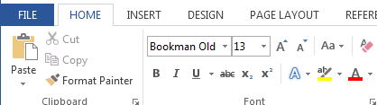

3.1.4 HOW TO SAVE A DOCUMENT
Saving a document can be done in two ways:
To save a new document
- Click file from menu bar
- Click save as
- Type a file your document
- Click on save
To save subsequent document after the first saving
- Then Click file the menu bar
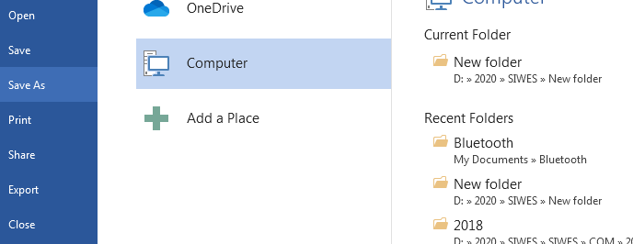
- Click save or use shortcut key from keyboard “Ctrl + S”

3.1.5 ZOOMING IN AND OUT
- Select zoom tool from the tool-box
- Hold the mouse button down to access to zoom fly –out, and then select the first option
- Move your cursor, which has changed ‘above or below of the object, press the mouse button.
- Release the mouse button, the object will now take up most the screen

3.1.6 PRINTING OF FILE
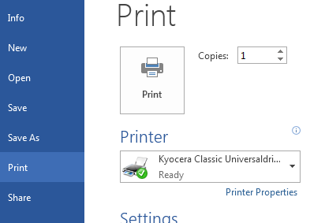
- Open the file you want to print
- Click file from the menu bar
- Select print from the file menu
- Click print.

3.1.7 SPELLING AND GRAMMER CHECKING
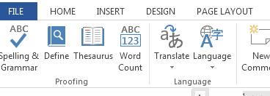
- At the beginning of the document click review tab
- Select spelling and grammar from the proofing
- Select the correct word from the suggestion list bar
- Click change.

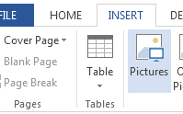
3.1.8 TO CREATE TABLE
- Position the cursor to where you want the table
- Click insert tab and click table button
- Select insert table from the dialog box.
- Type the number of column in the column box and the number of rows in the rows box
- Select the desired width for each column or select auto
- Click ok.

3.1.9 EXITING MICROSOFT WORD
- Select the file command from the main menu
- Select exit and click it take you back to the window menu

3.1.10 TO INSERT WORD ART
- From the menu, click insert.
- Highlight function and click word art from the sub menu
- Select the desire word art and click it
- Type the text using the desired font and click ok.

3.1.11 TO INSERT SYMBOL
- Select insert from the main menu
- Select symbol from the sub menu
- Click the desired symbol
- Select close
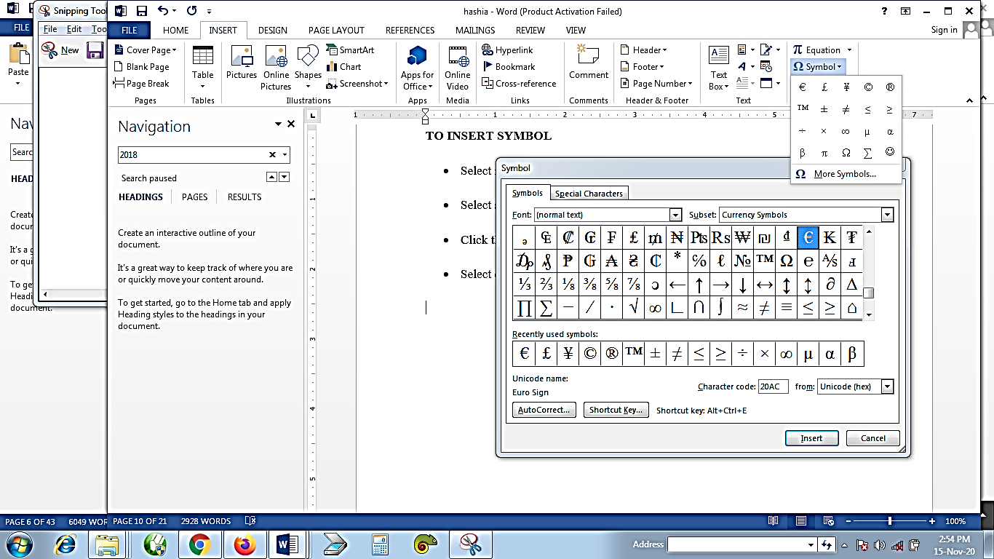

3.2 MICROSOFT POWERPOINT
This is a presentation software package that uses a graphical approach to present it file in the form of slide show.
Arrangement of Tools in Power Point
- Microsoft Button: This contains the main file functions. Example: New, open, save, save as, print preview etc.
- Quick Access Tool Bar: Contains shortcut to save, undo and redo or repeat.
- Ribbon: Is used to issue command.
- Title Bar: Displays the name of current working presentation.
- Ruler: Is used to determine where to place object.
Slides, Placeholder and Notes
- Slides: Appears in the center of the window where you create your presentation.
- Status Bar: Displays the name of slide your are working on.
- Outline Bar/Tab: Displays the text command in presentation.
- View Button: Is used to change between normal view slider sorter view and the slide show view.
- Zoom: This allows you to zoom in and out on the window.
- Minimize Button: Used to remove a window from view.
- Maximize Button: Used to cause a window to fill the screen.
- Close Button: Used to exit the window and close program.
- To Create a New Presentation: <>Click on MS-Office button<>Choose “Blank Document”<>Click on “Create”.
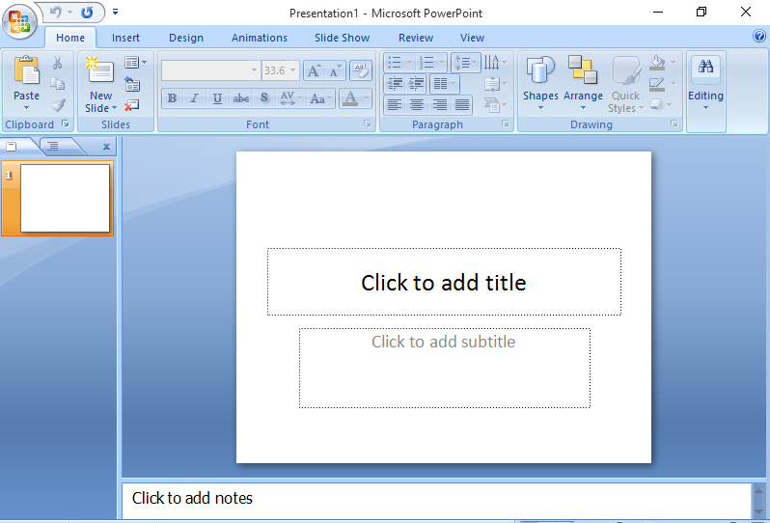
- To Open an Existing Presentation: <>Click on MS-office bottom<>Click on open <>Find your presentation file in the open window.
- To Add a Background: <>Click on design tab <>Click the background style button <>Click on the background of your choice.
- To Add Animation: <>Select the object you want to laminate <>Click on the animation tab <>Click on custom animation button <>Click on the add effect menu <>Choose your desire effect type <>Click on the effect and apply.
- To Save Slide Document: <>Click on MS-Office Button <>Select save <>Specify a name for the file <>Select file extension <>Click on save.
- To Add Image from a File: <>Click on insert tab on ribbon <>Click on illustration <>Click on picture <>Find the picture file you want <>Click on OK.
- To Add Bullets/Numbering: <>Click on ribbon <>Click on bullet or number <>Click on your preferred format.
- To Add Table:<>Click insert table icon on the menu bar <>Select the number of row and column you want.
- Transitions between Slide: <>Click on Animation <>Click on the bottom button in the column of 3 to the right palette <>Click on transition of your choice.
- Make Changes to Slide: <>Place the mouse pointer at the point at which you would like to add text <>Type the information you want to add.
- To Print Out Slide: <>Click on the MS-office button <>Choose print <>Click on print preview <>Do the necessary set-up <>Click print to print out the document.
Navigating the Slide Show
Task | Procedure
Go to the next slide | Pres the right arrow, enter or page down key
Go to the previous slide | Press the left arrow, backspace or the page up key
End the slide show and return to the PowerPoint | Press the Esc (Escape key)
To run your slide | Press the F5 key
To cut your slide | Press the CTRL + X key
To duplicate your slide | Press the CTRL + D key

3.3 MICROSOFT EXCEL
Excel Microsoft office also known as spreadsheet or worksheet program is used to store and retrieved numerical data in a grid format of rows and columns. It is also used for entering calculation and analyzing data.
- To Start or Launch the Program: <>Click the start button <>Select all programs <>Select Microsoft office <>Click on Microsoft Excel.

3.3.1 Microsoft Excel Tools
- Title Bar: Displays the name of the current program and worksheet you are working on in the computer system.
- Menu Bar: Displays the name of the excel menu.
- Standard Bar: Displays the buttons of the most frequently used functions.
- Name Box: Displays the coordinates of the active cell.
- Formula Bar: Displays the contents of the active cell.
- Status Bar: Displays information about a selected command as well as the status of certain keys. Example: cap-lock, number lock.
- Scroll Bar: Used to move through the worksheet.
- Selected All Button: This selects every cell in a worksheet.
- Sheet Tabs: Displays the names of the worksheet within a workbook.
- Tab Scrolling Button: Used to scroll through the worksheet in a workshops.
- Worksheet: This is a single page in a workbook, which is divided into rows and columns.
- Active Cells: This is the cell surrounded by a border where you enter and edit data.
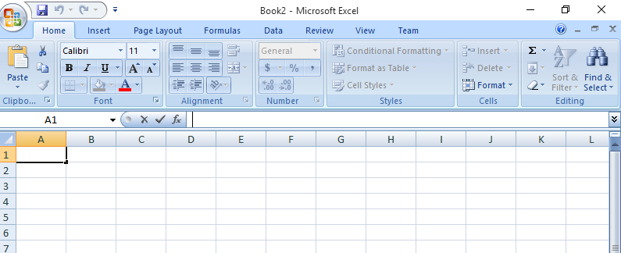
- Creating A Worksheet
- Entering Data:<>Select a cell<>Enter the data <>Click on Ok.
- Entering a Range of Data: <>Select the cell <>Enter the data<>Click on enter <>Continue until the entire cell is filled.
- Editing Data: <>Double click on the cell or click on it.
- Saving A Document on Microsoft Excel: <>Click on the file menu <>Click on save as <>Click on the save in drop down list to select the specific drive <>Name your document <>Select “MS-Excel workbook from the file type <>Click on OK.
- Inserting, Deleting and Merging of Cells
- Inserting Cell: <>Select the cell <>Click on the insert menu <>Click on cells <>Click on OK.
- Inserting Rows and Columns: <>Select the cell <>Click on the insert menu <>Click on columns and rows.
- Deleting Cells: <>Select cells to delete <>Click on edit <>Click on delete <>Click on OK.
- Deleting Rows and Columns: <>Select at least on cell <>Click on the edit menu <>Click on delete <>Click on OK.
- Merging Cells: <>Select the cells you want to merge <>Click on merger and center button on the tools bar.
- Adding Header and Footer: <>Click on the view menu <>Click on header and footer <>Click on OK.
- Changing Margin: <>Click on the file <>Click on page set-up <>Click on margin tab, change it to your preferred choice <>Click on OK.
- Printing Worksheet and Workbook
- Printing: <>Click on the file menu<>Click on print, a dialogue box will appear<>Select the option you wish to change (i.e. page name, name of printer etc)<>Select the number of copies<>Click on OK.

CHAPTER FOUR

4.1 EXPERIENCE GAINED
- I learnt how to create and work with PowerPoint slides
- I was able to practice all the theoretical aspect have been learning from class before
- I was able to develop research using online and apply different effect
- I was able to use MS-Excel to solve calculations by myself
- I was able to learn how I can apply formula to excel spreadsheet with different forms of calculations
- I can now use and print data of varies from both MS word, excel and PowerPoint level
- I was able to add and develop my typing skills
- I was able to know what each menu on Microsoft office are working for
- I understand the concept of hyperlink, paging, merging etc.

CHAPTER FIVE

5.1 CONCLUSION
SIWES (Student Industrial Work Experience Scheme) is design to show student greatly equipped with technical knowledge based work experience scheme in each student scheme of work. As a student who has pass through this program, I have acquired more knowledge on computer operating and the different why operating system varies. The program has been an avenue of multiplication to my knowledge in the field of Business Administration and Management.

5.2 PERSONAL IMPRESSION ABOUT THE ORGANIZATION
I was highly impressed with the performance of the entire staffs of the company. The environment are so conducive and close to my place, their staffs are friendly and ready to listen to any complaint from their customer. And the way they conduct their meeting every Monday before any service at the company.

5.3 SUGGESTIONS/RECOMMENDATION TO THE ORGANIZATION AND THE POLYTECHNIC CONCERNING THE SIWES PROGRAMME
To the numerous and immensely contributions of SIWES to my personal life and my career in computer, I hereby suggested that, this great opportunity should be given to generation yet unborn. Every technical school and polytechnic in Nigeria should re strength their effort with the federal government to make sure that, this great opportunity should have a lifespan. Henceforth, the school should be orienting the student on what they are likely to face and experience they are likely to acquired during the program. So as to prepare their mind for the great challenge.
Finally, the organization should understand the important of this program, they should have it at back of their mind that, this is an opportunity for them to contribute to the development of this country by building manpower and developing human resource. So their interest should be taken aside. They should stop requesting for some amount before admitting student for the program.

