

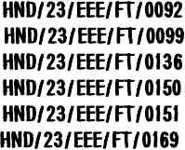
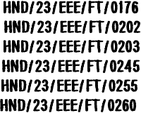
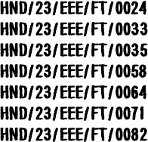


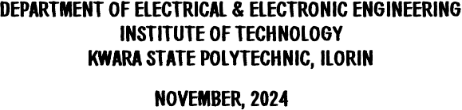

















口 口 口 口 口

6/28/2025 Proposal Seminar 2



Power systems operations rely on the Optimal Power Flow (OPF)
problem, which determines generators’ most cost-eﬀective dispatch to satisfy power demands while accounting for technical and physical constraints throughout the power network . The Optimal Power Flow (OPF) problem serves as the cornerstone for a range of power system studies, addressing both short-term concerns such as unit commitment, security-constrained economic dispatch, market clearin g , transmission network congestion management, voltage control , and optimal transmission switching, as well as long-term considerations like transmission expansion planning.

6/28/2025 Proposal Seminar 3



Through extensive research, scholars have sought to ﬁ nd fast and eﬃcient solutions to the non convex nonlinear Alternating Current OPF (AC-OPF) problem for many years. Centered on short-term
considerations, ﬁ nding a quick and eﬀective solution to the OPF problem is of utmost importance for grid operators, particularly given the heightened ﬂuctuations in power supply and demand.

6/28/2025 Proposal Seminar 4



The increasing complexity of modern power systems, driven by the integration of renewable energy sources and the need for real- time operational efficiency, presents significant challenges in maintaining optimal power flow (OPF) and voltage stability . Traditional optimization methods often struggle with the non- convex and nonlinear nature of the OPF problem, leading to inefficiencies and potential instability in power delivery (Donnot & Guyon; 2017).

6/28/2025 Proposal Seminar 5



Aim:
The aim of this project is to leverage advanced machine learning techniques to enhance the optimization of power flow while ensuring voltage stability across electrical grids.

6/28/2025 Proposal Seminar 6


The objectives are to:
i. develop machine learning models that can predict optimal generator settings and operational levels in real-time.
ii. create predictive algorithms that assess voltage stability risks and provide actionable insights for grid operators, thereby minimizing the likelihood of voltage collapse or instability during peak loads or unexpected disruptions.
iii. address the challenges posed by intermittent renewable energy sources by employing hybrid models that combine deep reinforcement learning with other optimization techniques, improving the adaptability and robustness of power systems under uncertainty.

6/28/2025 Proposal Seminar 7



√ Collect extensive historical data from power systems, including load profiles,

generation outputs, voltage levels, and operational constraints.

√ Develop neural network models to predict optimal generator settings

directly from input features such as load demand and renewable generation forecasts.
√ Implement machine learning models that predict which constraints are active in the optimal solution.
√ Combine machine learning with physics-based models to ensure compliance with physical laws governing power systems, enhancing model reliability and accuracy

6/28/2025 Proposal Seminar 8



Donnot, B., Guyon, I., Schoenauer, M., Panciatici, P., & Marot, A. (2017). Introducing machine learning for power system operation support.
Frank, S . & Rebennack, S . (2016) . An introduction to optimal power flow: Theory, formulation, and examples. IIE Transactions, 48(12):1172–1197
Misra, S., Roald, L ., & Ng, Y . (2018) Learning for constrained optimization: Identifying optimal active constraint sets. arXiv preprint arXiv:1802.09639
Krishnaram, K., Suresh Padmanabhan, T. & Alsaif, F. (2023). Performance optimization of interleaved boost converter with ANN supported adaptable stepped-scaled P&O based MPPT for solar powered applications.
Senthilkumar, S., Kavitha, M., Arunkumar, P., Pushpa, G., Ramanan, R. & Anbazhagan, L.(2024). Optimized maximum power point tracking algorithm for solar photovoltaic with dissimilar environmental conditions.

6/28/2025 Proposal Seminar 9

