CHAPTER THREE

3.0 METHODOLOGY
This section outlines the research approach used in this study to investigate the effectiveness of solar charge controllers in off-grid applications. The study utilizes a mixed-methods approach combining both qualitative and quantitative data to ensure a comprehensive understanding of the topic.

3.1 PWM CIRCUITRY
PWM is a technique used to control the amount of power delivered to a load by adjusting the width of the pulses in a signal. PWM is widely used in applications like motor control, light dimming, and power regulation in circuits such as solar charge controllers, DC-DC converters, and more. Below, we will explain the basic working principle, circuitry, and steps involved in generating PWM signals.
Figure 2 describes the schematic diagram of a PWM solar charge controller consists of several key blocks, including a microcontroller or control circuitry, a MOSFET for switching, a battery voltage sensing circuit, and a solar panel input interface.

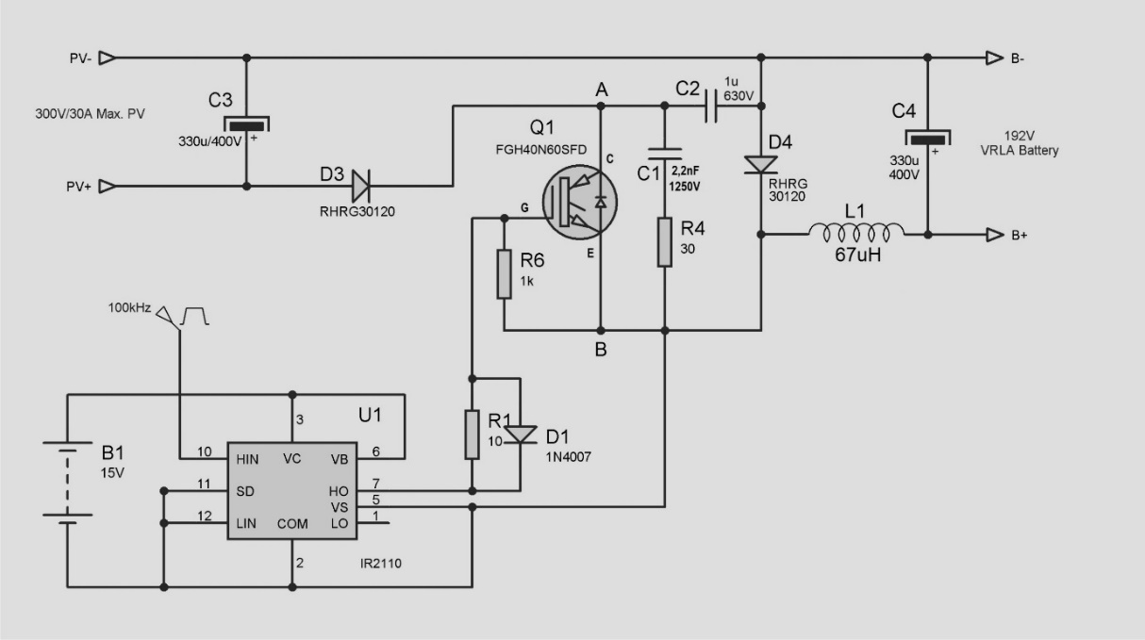
Figure 2 : Schematic diagram of PWM solar charge controller (Acharya & Aithal, 2020)

3.1.1 Basic Components:
- Solar Panel Input: Provides DC power (typically 12V or 24V, depending on the system design).
- Battery: Stores the energy from the solar panel.
- PWM Controller (Microcontroller/IC): Controls the duty cycle to regulate power delivery to the battery.
- MOSFET: Acts as a switch to regulate the connection between the solar panel and the battery.
- Voltage Sensing Circuit: Monitors the battery voltage to adjust the PWM signal accordingly.
- Current Sense Circuit: Measures the current to ensure proper charging.
- Protection Circuit: Includes features like over-voltage, under-voltage, and over-temperature protection.

3.1.2 Steps Involved in PWM Solar Charge Controller Operation:

Solar Panel Provides Power

Voltage and Current Sensing

PWM Control and Duty Cycle Adjustment

Mosfet Switching

Battery Charging Regulation

3.2 MPPT CIRCUITRY
MPPT is a technique used in solar charge controllers to maximize the power output from solar panels. Unlike a PWM controller, which simply regulates the voltage to prevent overcharging, an MPPT controller dynamically adjusts the operating point of the solar panel to extract the maximum power available. MPPT algorithms track the maximum power point (MPP) of the solar panel, which varies with temperature, light intensity, and panel characteristics, and then adjust the load to match this point for optimal power transfer.
Figure 3 describes the schematic diagram of an MPPT solar charge controller consists of several key blocks, including a microcontroller or control circuitry, a MOSFET for switching, a battery voltage sensing circuit, and a solar panel input interface.

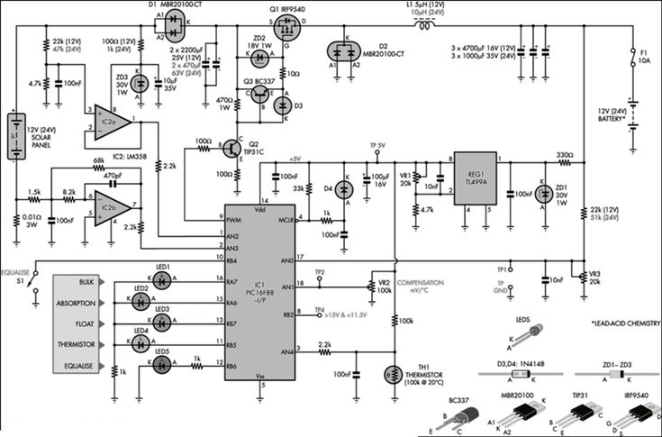
Figure 3: Schematic diagram of MPPT solar charge controller (Y.-H. Liu et al., 2005) (Acharya & Aithal, 2020).
MPPT-based charge controllers typically consist of the following components:
- Solar Panel Input: A PV array that generates power.
- MPPT Algorithm (Control Circuit): A microcontroller or specialized IC that runs the MPPT algorithm to compute the optimal power point.
- DC-DC Converter: A step-up (boost) or step-down (buck) converter, typically using a switching transistor (MOSFET), to adjust the voltage and current to match the battery charging requirements.
- Battery Storage: The battery or battery bank that stores the energy harvested from the solar panel.
- Voltage and Current Sensing: Measurement circuits that monitor the battery voltage, solar panel voltage, and current to optimize the system’s operation.
- Feedback Loop: A system that continuously monitors the solar panel’s performance and adjusts the operation of the DC-DC converter to ensure maximum power transfer.

3.2.1 Steps Involved in MPPT Operation

3.2.1.1 Solar Panel Voltage and Current Measurement
- The MPPT controller continuously monitors both the voltage (V) and current (I) of the solar panel.
- These measurements are used to calculate the power (P) being generated by the panel at any given time. Power is calculated as: P=V×I, P =IV

3.2.1.2 Determining the Maximum Power Point (MPP)
- The MPPT algorithm tracks the point at which the solar panel produces the maximum power. This point is often referred to as the maximum power point (MPP) and is the combination of voltage and current where the panel is most efficient.
Two common MPPT algorithms are:
  - Perturb and Observe (P&O): This method perturbs (slightly changes) the operating voltage and observes the resulting change in power. If power increases, it continues in that direction; if it decreases, it switches direction.
  - Incremental Conductance (IncCond): This algorithm compares the incremental changes in voltage and current to find the point where the derivative of power with respect to voltage is zero (indicating maximum power).
- The MPP is dynamic and changes based on environmental conditions such as sunlight intensity and temperature.

Adjusting the Operating Point Using a DC-DC Converter
- The MPPT controller uses the determined MPP (voltage and current values) to adjust the voltage at which the solar panel operates.
- The DC-DC converter adjusts the output from the solar panel to match the optimal voltage required by the battery. This can involve:
  - Step-down (buck) converters if the panel voltage is higher than the battery voltage.
  - Step-up (boost) converters if the panel voltage is lower than the battery voltage.
- The converter typically uses a MOSFET (Metal-Oxide-Semiconductor Field-Effect Transistor) as a switch, controlled by the MPPT algorithm.

Charging the Battery
- The DC-DC converter's output is used to charge the battery. The MPPT controller ensures that the battery receives the right voltage and current for efficient and safe charging.
- The charging process may consist of different stages:
  - Bulk Charge: High current charging until the battery reaches a certain voltage.
  - Absorption Charge: The current is reduced as the battery reaches its full charge voltage.
  - Float Charge: A low current is used to maintain the battery charge without overcharging.

3.3 SYSTEM CONFIGURATION
The basic block diagram in figure 4 consists of a PV cell, charge controllers, change over switch, battery, inverter, and load.
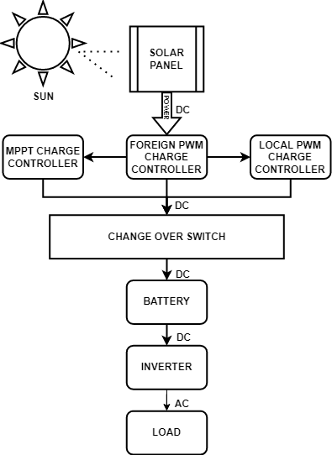
Figure 4: Schematic diagram of MPPT solar charge controller (Y.-H. Liu et al., 2005) (Acharya & Aithal, 2020).

3.3.1 SOLAR PANEL
Solar panels, also known as PV panels, are devices that convert sunlight directly into electricity through a process called the photovoltaic effect. These panels are a cornerstone of renewable energy technology, providing a clean, sustainable source of power for homes, businesses, and even large-scale power plants.
Solar panels consist of multiple solar cells made from semiconductor materials, typically silicon. When sunlight hits these cells, it excites electrons in the material, causing them to move and generate an electric current. This current is then captured and used as electricity.

3.3.1.1 Types of Solar Panels:
There are three main types of solar panels:
- Mono-crystalline Solar Panels: Made from a single continuous crystal structure. These are highly efficient and long-lasting but are generally more expensive.
- Polycrystalline Solar Panels: Made from silicon crystals that are melted together. These are slightly less efficient than mono-crystalline but more affordable.
- Thin-Film Solar Panels: Made from layers of photovoltaic material. These are flexible, lightweight, and can be used in a variety of applications, though they are generally less efficient than crystalline panels.
The table below shows the description of the solar panel used in the system configuration:
Table 2: Description of the solar panel used
Parameters | Value
Manufacturer | Sunshine solar
MODEL | POLYCRYSTALLINE
AM | 1.5
E | 1000w/m²
TC | 25⁰C
MAXIMUM POWER (PMAX) | 100W
OUTPUT TOLERANCE | $±$5%
CURRENT AT PMAX (IMP) | 5.15A
VOLTAGE AT PMAX (VMP) | 19.43V
SHORT CIRCUIT CURRENT (ISC) | 5.51A
OPEN CIRCUIT VOLTAGE (VOC) | 23.3V
MAXIMUM SYSTEM VOLTAGE | DC 1500V
MAXIMUM SERIES FUSE RATING | 20A

Figure 5 describes the pictorial view of 100W solar panel used in system configuration.
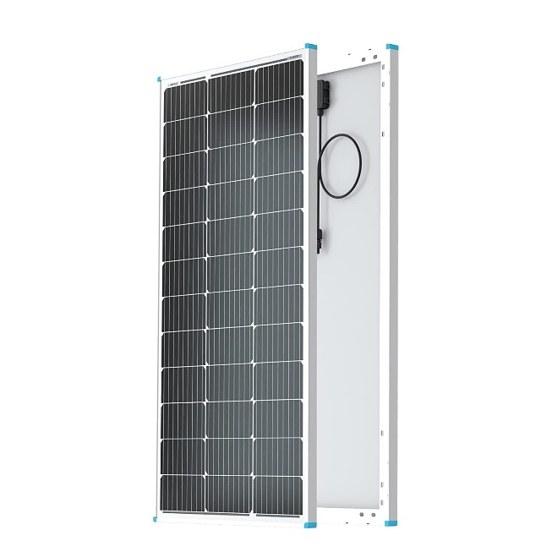
Figure 5: Solar panel (Belkaid et al., 2016)

3.3.2 MPPT SOLAR CHARGE CONTROLLER
A MPPT charge controller is an advanced type of solar charge controller that optimizes the power output from solar panels to charge a battery efficiently. It does this by constantly adjusting the voltage and current to find the maximum power point (MPP), where the combination of voltage and current delivers the most energy to the battery. MPPT technology maximizes the efficiency of the system, improving the charging speed and making better use of the available solar energy.
Table 3 shows the description of the MPPT charge controller used:
Table 3: Description of MPPT charge controller used
Parameters | Value
Rated voltage | 12V/24V
Rated current | 40A
Maximum PV voltage | 100V
Maximum PV input power | 520W(12V), 1040W(24V)

Figure 6 describes the pictorial view of a 40A MPPT controller used in the system configuration.

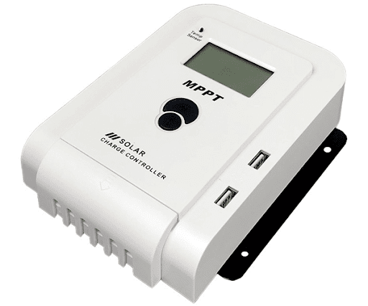
Figure 6: MPPT solar charge controller.

3.3.3 PWM SOLAR CHARGE CONTROLLER
A PWM Charge Controller is a crucial component in solar power systems, especially for managing the charging of batteries. It regulates the voltage and current from solar panels to the battery, ensuring optimal charging performance, safety, and longevity of the battery.
A PWM charge controller works by switching the connection between the solar panel and the battery on and off at a high frequency, thus controlling the amount of power going into the battery. The key here is the pulse width, the amount of time the controller is “on” (allowing power to pass to the battery) compared to when it is “off.”
- Pulse Width: The “on” time of the controller determines how much power is delivered to the battery. As the battery charges and its voltage rises, the controller adjusts the pulse width to lower the charge rate, ensuring that the battery is charged efficiently without being overcharged.
- Voltage Regulation: The controller ensures that the battery doesn’t receive too much voltage (which could damage it) by controlling the amount of energy that goes through based on the battery’s state of charge.
Table 4: Description of the PWM charge controller used.
Parameters | Value
Model | W88-B
Rated voltage | 12v/24v
Rated current | 30A
Maximum PV voltage | 50v
Maximum PV input power | 260W(12v)520W(24v)

Figure 7 describes the pictorial view of the 30A PWM solar charge controller used in the system configuration.

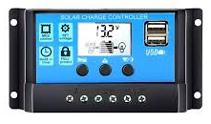
Figure 7: PWM charge controller.

3.3.4 LOCAL MADE PWM CHARGE CONTROLLER
Figure 8 describes the circuit diagram of a local made PWM solar charge controller consists of several key blocks, including a microcontroller or control circuitry, a MOSFET for switching, a battery voltage sensing circuit, and a solar panel input interface.

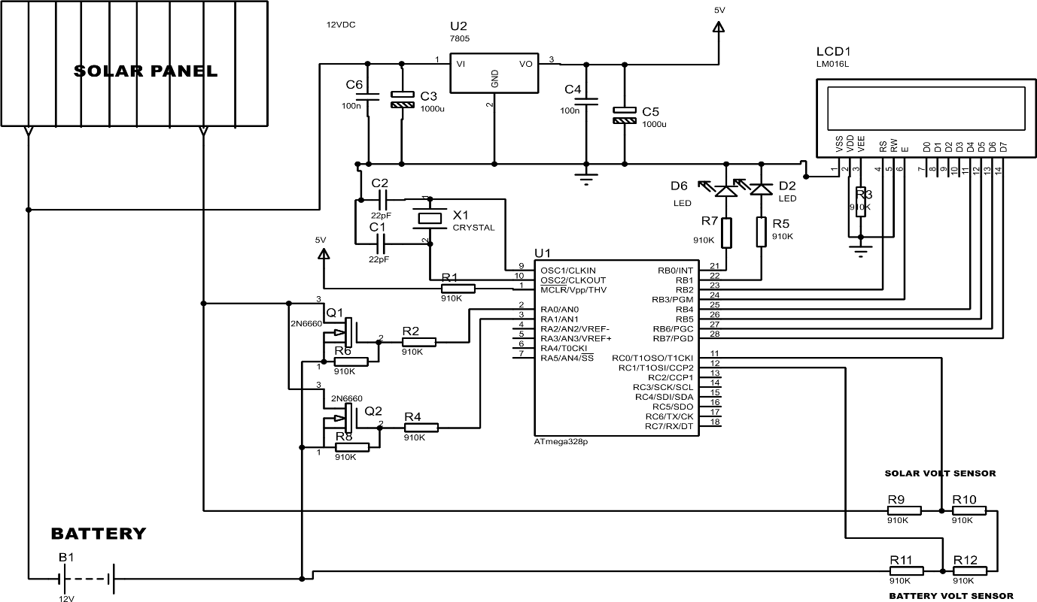
Figure 8: Locally made PWM charge controller circuit diagram.

Below is a detailed explanation of all the components in the schematic diagram and their functions:

Power Components

Solar Panel Input
- Function: Converts sunlight into DC electricity.
- Voltage Output: Typically 12V.
- Connection: Provides power to both the battery and the circuit.

Battery (B1 – 12V) Input
- Function: Stores energy from the solar panel.
- Usage: Supplies power when sunlight is unavailable.
- Connection: Powers the microcontroller and other circuit components through a voltage regulator.

Voltage Regulator (U2 – 7805)
- Function: Converts 12V DC from the solar panel/battery down to a stable 5V DC.
- Connections:
  - Input (Vin): Connected to 12V from the battery/solar panel.
  - Ground (GND): Common ground.
  - Output (Vout): Supplies 5V DC to the microcontroller and other low-voltage components.
- Capacitors (C3, C4, C5, C6):
  - C3 (10µF): Smooths input voltage.
  - C4 (0.1µF): Reduces noise.
  - C5 (100µF): Stabilizes output voltage.
  - C6 (100µF): Additional filtering.

Microcontroller Section

Microcontroller (U1 – Atmega328P)
- Function: The brain of the system. It processes voltage readings and displays them on the LCD.
- Key Pins:
  - VCC & GND: Power supply (5V).
  - Oscillator Pins (XTAL1, XTAL2): Connected to a 16MHz crystal oscillator (X1) for timing.
  - Analog Pins (ADC0, ADC1, etc.): Used to read voltages from sensors.
  - Digital Pins: Control LCD and LED indicators.

Crystal Oscillator (X1 – 16MHz)
- Function: Provides a stable clock signal for microcontroller operation.
- Capacitors (C1, C2 – 22pF): Used for frequency stability.

Sensor Section

a. Voltage Sensors (Resistor Dividers)
Used to measure voltages from the solar panel and battery.
- Solar Voltage Sensor (R9, R10):
  - Scales down the solar panel voltage for safe microcontroller input.
  - Example: If solar panel voltage is 12V, the divider reduces it to a range suitable for ADC (e.g., 0-5V).
- Battery Voltage Sensor (R11, R12):
  - Similar function for battery voltage monitoring.

Display Section

LCD Display (LCD1 – 16x2)
- Function: Displays real-time battery and solar voltage data.
- Connection:
  - Data Pins (D4-D7): Receive data from the microcontroller.
  - Control Pins (RS, EN): Used for LCD operation.
  - Power (VCC, GND): 5V supply.

LED Indicators

LED (D6, D2)
- Function: Status indicators.
- Current Limiting Resistor (R7 – 330Ω): Limits current to LEDs.

Transistor Circuit

Transistors (Q1, Q2 – 2N3904)
- Function: Likely used as electronic switches to control power flow or load connection.
- Resistors (R1, R2, R3, R4 – 1KΩ):
  - Used as pull-down or base resistors for transistors.

Working Principle Summary
- Power Flow:
  - The solar panel charges the battery.
  - The voltage regulator (7805) converts 12V to 5V.
  - The microcontroller and LCD operate at 5V.
- Voltage Sensing:
  - Voltage dividers reduce solar panel and battery voltage for safe ADC input.
  - The microcontroller reads the values.
- Data Display:
  - The LCD shows real-time voltage readings.
  - LEDs indicate system status.
- Transistor Switching:
  - Used for battery protection or load control.
Figure 9 and figure 10 describes the inner and outer view of the local made PWM solar charge controller, showing the main components and soldering processes involved.
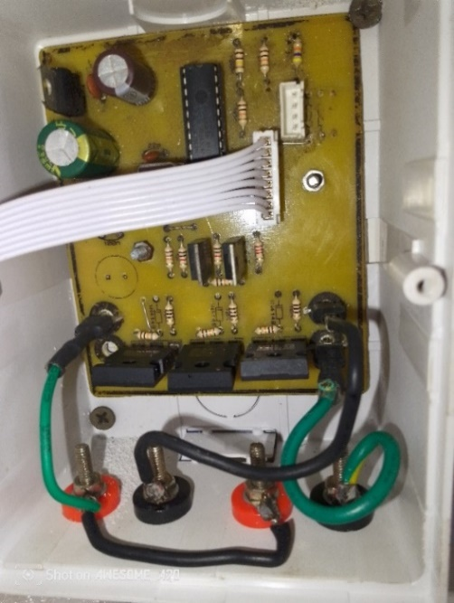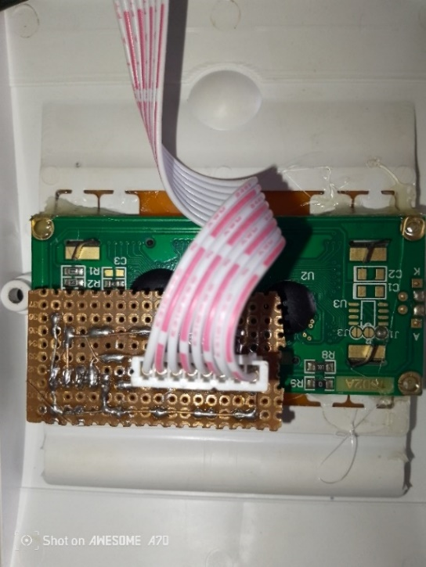
Figure 9: Inner view of the locally made charge controller.
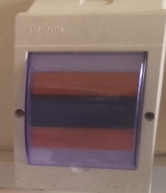
Figure 10: Outer view of the locally made charge controller

3.3.5 KNIFE SWITCH CHANGE OVER
A knife switch change-over is a manually operated electrical switch used to transfer power between two different sources or circuits. It consists of a metal blade (the “knife”) that pivots into or out of contact with stationary terminals to make or break a connection. This type of switch is commonly used in power distribution systems, laboratories, and industrial settings for isolating and switching circuits.
The knife switch change over allows switching between two power sources (such as a main supply and a generator) by manually shifting the blade between two sets of terminals. When the blade is in one position, power flows from the corresponding source. Moving it to the other position transfers power to the second source. In the situation of this project, an 100A knife switch change-over was used to switch power between the foreign MPPT, foreign PWM and locally made PWM charge controllers which would be supplied to the battery.
The figure 11 describes the pictorial view of 100A knife switch change over, showing the switching operations from one source to another.
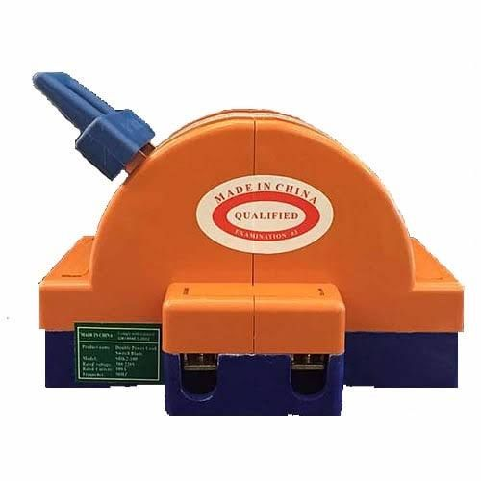
Figure 11: knife switch changeover (Amrouche et al., 2000)

3.3.6 LITHIUM BATTERY
A lithium-ion (Li-ion) battery is a type of rechargeable battery that uses lithium ions to store and transfer energy. It is widely used in consumer electronics, electric vehicles, renewable energy systems, and industrial applications due to its high energy density, long lifespan, and lightweight design. A lithium-ion battery consists of three main components:
- Anode (Negative Electrode): Usually made of graphite, it stores lithium ions when the battery is charged.
- Cathode (Positive Electrode): Typically made of lithium metal oxides (like lithium cobalt oxide or lithium iron phosphate), it releases lithium ions during discharge.
- Electrolyte: A liquid or solid substance that allows lithium ions to move between the anode and cathode.
During charging, lithium ions move from the cathode to the anode through the electrolyte, storing energy.
During discharging, the ions move back to the cathode, releasing stored energy to power devices.

Types of Lithium Batteries
- Lithium Cobalt Oxide (LiCoO₂) – Used in smartphones, laptops, and cameras.
- Lithium Iron Phosphate (LiFePO₄) – Safer, with a longer lifespan, used in power tools and electric vehicles.
- Lithium Manganese Oxide (LiMn₂O₄) – Common in medical devices and power tools.
- Lithium Nickel Manganese Cobalt Oxide (LiNiMnCoO₂ or NMC) – Popular in EVs and energy storage.
- Lithium Titanate (Li₄Ti₅O₁₂ or LTO) – Ultra-fast charging and long lifespan, used in specialized applications.
In this project, a lithium cobalt oxide type of lithium ion battery was used. Each battery rated at 3.7v, 650maH. Three pieces of the battery were connected in series to produce a voltage rating of 11.1v and current per hour of 650maH. Having two of the three pieces of the series connection being connected parallel to each other in other to produce a voltage rating of 11.1v and current per hour rating of 1300maH.
Figure 12 describes the pictorial view of a 3.7v, 650maH lithium ion battery used in the system configuration.

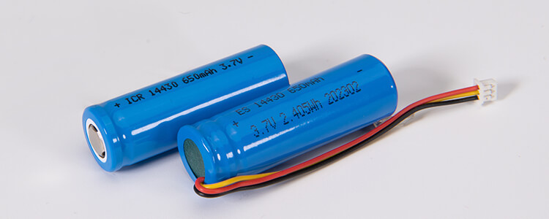
Figure 12: lithium batteries (Singh et al., 2023).

3.3.7 INVERTER
An inverter is an electrical device that converts direct current (DC) power into alternating current (AC) power. It is widely used in various applications, including home power backup systems, solar energy systems, and automotive power supplies. Since most household appliances and electronic devices operate on AC power, inverters play a crucial role in ensuring an uninterrupted power supply during outages or in off-grid locations. A 500W inverter is a power conversion device that transforms DC (Direct Current) power from a battery (such as a car or solar battery) into AC (Alternating Current) power, which is commonly used to run household or electronic devices. It is a compact and efficient solution for powering small appliances, tools, and electronic gadgets in areas where direct AC power is unavailable.
The inverter takes DC input from a 12V or 24V battery and converts it into standard 110V or 220V AC output, depending on the region and device requirements. It does this through electronic circuits that modify the voltage and frequency of the output current.
Figure 13 describes the pictorial view of 500W, inverter used in the system configuration.

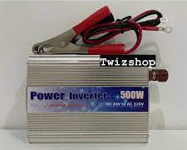
Figure 13: 500W power inverter (Petri et al., 2022).

3.3.8 AC LOAD
An AC load refers to any electrical device or appliance that operates on Alternating Current (AC) power. AC loads are commonly found in homes, industries, and commercial buildings since the standard electricity supply from power grids is in the form of AC. These loads consume electrical energy and convert it into useful work such as lighting, heating, cooling, or mechanical motion.

3.3.9 13A SOCKET OUTLET
A 13A socket outlet is a standard electrical power outlet designed to provide 13 amperes (A) of current at a specific voltage (typically 230V AC in the UK and many other countries). It is widely used in homes, offices, and commercial buildings to power a variety of electrical appliances and devices.
Figure 14 describes the pictorial view of the 13A socket outlet used in the system configuration.

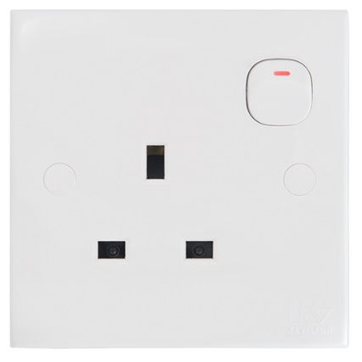
Figure 14: 13A socket outlet (Kim et al., 2020).

3.3.10 LAMPHOLDER
A lampholder is an electrical device designed to securely hold and connect a light bulb to an electrical circuit. It provides both mechanical support and electrical contact to allow the bulb to function properly. Lampholders are widely used in homes, offices, industries, and outdoor lighting applications.
Figure 15 describes the pictorial view of the lampholder used in the system configuration.

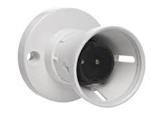
Figure 15: lampholder (Kim et al., 2020).

3.3.11 LED BULB
An LED (Light Emitting Diode) bulb is an energy-efficient lighting solution that uses semiconductor technology to produce light. Unlike traditional incandescent or CFL bulbs, LED bulbs consume less power, have a longer lifespan, and provide brighter illumination. They are widely used in residential, commercial, and industrial lighting applications due to their efficiency and durability.
Figure 16 describes the pictorial view of the 5W LED bulb used in the system configuration.

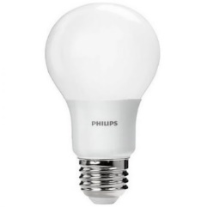
Figure 16: led bulb (Kim et al., 2020).

3.3.12 DC CABLE
A DC cable is an electrical cable designed to carry direct current (DC) power between components in a circuit. DC cables are commonly used in solar power systems, battery connections, automotive wiring, telecommunications, and industrial applications where direct current is required.
Figure 17 describes the pictorial view of the DC cable used in the system configuration.

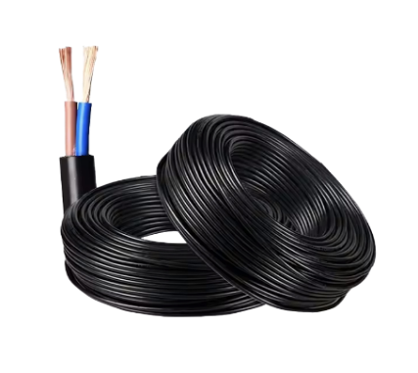
Figure 17: 6mm DC cable (Bruzek et al., 2015).

3.3.13 AC CABLE
An AC (Alternating Current) cable is an electrical cable designed to transmit alternating current (AC) power from a power source to electrical devices or systems. AC cables are widely used in household wiring, industrial power distribution, commercial buildings, and power transmission networks due to the global reliance on AC power systems.
Figure 18 describes the pictorial view of the AC cable used in the system configuration, showing the conductor strand and the insulation around the stranded conductor.

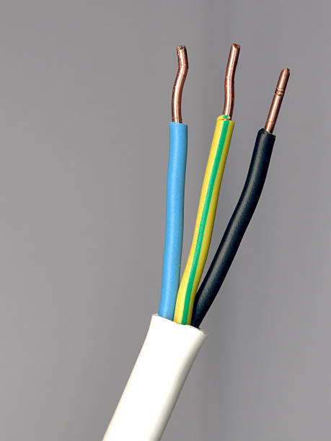
Figure 18: Ac cable (Amrouche et al., 2000).

Figure 19 describes the system installations and workability:
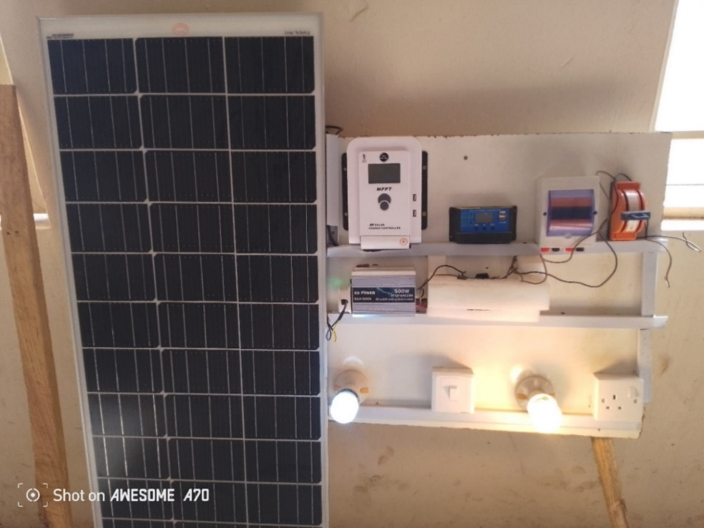
Figure 19: System installation and workability.

3.4 SUMMARY
This section consist of the method and materials used in design, construction, simulation and installation of a prototype stand-alone PV solar system. The system configuration consists of an 100W solar panel, 40A MPPT solar charge controller, 30A foreign PWM solar charge controller, 30A locally made PWM solar charge controller, 100A knife switch change over, 12volts lithium ion batteries, 500W power inverter, 13A socket outlet, lamp holders and led bulb. The solar panel convert electricity from the sun into electricity and passes through the charge controller for regulation before getting to the battery bank which then powers the inverter to supply the Ac load.

