
TECHNICAL REPORT
ON
STUDENTS’ INDUSTRIAL WORK EXPERIENCE
SCHEME (SIWES)
Undertaken at
TOWER ALLOYS INDUSTRIES LIMITED ROOFING DIVISION
Written by
TITILOPE ABUBAKAR DAJUMA
ND/23/CEC/PT/0273
DEPARTMENT OF CIVIL ENGINEERING
KWARA STATE POLYTECHNIC
Submitted To:
DEPARTMENT OF CIVIL ENGINEERING INSTITUTE OF TECHNOLOGY, KWARA STATE POLYTECHNIC, P.M.B. 1376 ILORIN

IN PARTIAL FULFILLMENT OF THE REQUIREMENT FORAWARD OF NATIONAL DIPLOMA (ND) CERTIFICATE IN CIVIL ENGINEERING

AUGUST-NOVEMBER 2024

DEDICATION
I would relish to dedicate this report to The Almighty Allah, who has been my ultimate source of bliss, vigor, sapience, good health and sustenance for visually perceiving me through and for the prosperous completion of my SIWES programme in one piece. Would additionally want to dedicate this report to my parents Mr. and Mrs Titilope who provided for me and to my sibling.
It is withal dedicated to the Construction Department of TOWER ALLOYSINDUSTRIES
LIMITED ROOFING DIVISION. For all the care, attention and understanding throughout the duration of my industrial training in their reputable organization.

ACKNOWLEDGEMENT
I hereby appreciate God Almighty for giving me the Grace, Opportunity and Strength to complete my industrial training successfully.
I acknowledge my parents; Mr and Mrs Danjuma for being there for me all the time and for providing the necessary support, I appreciate it a lot and I love you.
I also thank the management and staffs of Tower Alloys Industries Limited Roofing division most especially Engr. Oladele Mathew for their exposure, support and assistance, and a chance to prove myself. You are such wonderful and special people, who inspire and impact jubilance into the lives of others.
I also like to specifically thank my SIWES coordinator/Head of Department; Engr. --------------- my course adviser; my lecturers for the cognizance of Civil Engineering you all have imparted in me.

ABSTRACT
This report is a summary of the experience I acquired during my Four months Students'
Industrial Work Experience Scheme (SIWES) in the tower alloys industries
Limited roofing division. (Nigeria) limited, Ibadan, oyo state with highlights majorly on Civil Engineering, Building Construction and Project Management, giving a full enlightenment on equipment’s used in Construction, as well as various structural components of Building Construction steps and processes, giving a clear idea of the student involvement in all operational activities carried out in the Construction Firm.

TABLE OF CONTENTS
COVER PAGE………….......………………………………………….…………...i
CERTIFICATION PAGE…...………………………………………….…………..ii
LETTER OF TRANSMISSION…………………………………………………...iii
DECLARATION…….…...…...….………………………………………………..iv
DEDICATION ………………..……………………………………………...…….v ACKNOWLEDGEMENT…..…………………………………………………......vi ABSTRACT….……………………………………………….………………......vii
TABLE OF CONTENT…………………….……………….……………………...8
LIST OF FIGURES……………………………………………………………….11
LIST OF PLATES..……………………………………………………………….12

CHAPTER 1: INTRODUCTION
1.1 Background of Study ………………..…………………………...………......16
1.2 Brief history of SIWES……………...…………………………………….…17
1.2.1 Vision Statement………………………………………….…………..…20
1.2.2 Mission Statement……………………………………………………….20
1.3 Aim of SIWES ................................................................................................18
1.4 Objectives of The Study………………………………………………….…..19
1.5 Importance of The study…………………………………………………......19
1.6 Justification of The Study…………………………………………................20

CHAPTER 2: THEORETICAL FRAMEWORK
2.1: Civil Engineering………………………..,………………………….………21
2.2: Building…. ………………………………………………………….………21
2.3: Building Occupancy Classification …………………………………………22
- 3.1: Slab Design ……………………………………………………….………23
  - 1.1: Solid Slab..……...……..…………….…..….….……….………..……24
2.3.1.1.1: Design of slab……...……..…………….…..…….……….…………25
2.3.1.2: Flat Slabs....…...……..…………….…..…..…………….……….……26
2.3.1.3: Ribbed Slab...……...……..…………….…………………...…………27
2.3.1.4: Waffle Slab…..……...………………….…………………...…………28
2.3.1.5: Design Summary for a One-way slab………………….…………30
2.3.1.5: Design Summary for a Two-way slab…………………………………31
2.3.1.5: Design Summary for a Restrained slab……………………….……….32
- 3.2: Beam Design …..…..…….………………………...………………………34
2.3.2.1: Types of Beam Supports.………………..…………….…………35

2.3.2.2: Analysis of beam ….…...…………….….………...………36
2.3.2.3: Design Summary for a Beam………………………………37
- 3.3: Stair Design….……….…...……………...…………………..38
2.3.3.1: Types of Stair...……...……..…………..…..…….…………39
2.3.3.2: Design Summary for Stair………………...…………...……40
- 3.4: Column Design.………….………………….…………..…….….41
2.3.4.1: Column Classification…...…...……..…………….…..…...…41

CHAPTER 3: COMPANY PROFILE
3.0: Brief history of the Establishment..…..…………...…..……………..43
3.1: Organization Address….……..…………….…..…….………………43
3.2: Objectives of the Establishment….......................................................44
3.3: Department/sections in the establishment............................................44
3.4: Place of Primary Assignment …..........................................................45
3.5: Organizational structure/Organogram of the Establishment...............46
3.6: Major Function Of Place of Primary Assignment …..........................47

CHAPTER 4: SERVICES RENDERED AND EXPERIENCE GAINED
4.0: Services Rendered………………………….…………….….……...49
4.1: Marriott Site……………….………..................................................49
4.3: Construction terms and techniques experienced on site…...……….50
4.4: Few list of equipment’s/machineries used on Marriott site………...55
4.5: General experience acquired …………………………….…...…….62

CHAPTER 5: CONCLUSION AND RECOMMENDATION
5.1: Challenges of SIWES…………..….……………………….……...64
5.2: Recommendations..……….………………..………….…….…….65
5.3: Conclusion……….......……………………..………….…….…….66
References …………………..………………………………....…..67

CHAPTER ONE

1.0 INTRODUCTION

1.1 Background of Study
Students’ Industrial Work-experience Scheme (SIWES) is one of the Industrial Training Fund (ITF) programme which was introduced in 1974 due to the inability of engineering and technology students in Nigeria universities and polytechnics to meet the practical aspects of their training. That is, the needs to enable students match their theoretical school knowledge with the practical aspect of their training in industry. The Training lasts for six months. According to Ekpenyong (2011), one of the principles underlying any industrial work experience scheme for students in institutions of learning is the desire to marry the practical with the theoretical learning which characterizes conventional classroom situations with a view to striking a balance between theory and practice. The author stressed further that it was in realization of this that the ITF when it was established, set out to study the extent to which the theoretical knowledge that students in engineering technology and other allied fields in Nigerian institutions offering technology based courses related to the kind of work experience expected of them by employers.
The result of the ITF survey showed a great disparity between students’ knowledge and their ability to apply it in relevant jobs. In order to bridge the gap between the two, the ITF in 1974 established a co-operative internship programme, which enabled students of technology to spend some part of their courses for relevant on the-job practical experiences in appropriate areas of the Nigerian industry (Ekpenyong, 2011). The author further stressed that the internship programme, SIWES, can therefore be seen as that which is intended to give Nigerian students studying occupationally related courses experience that would supplement their theoretical learning as a well of equipping the students with the needed skills to function in the world of work.
This need to combine theoretical knowledge with practical skills in order to produce results in the form of goods and services or to be productive is the essence and rationale for industrial training, and a basic requirement for the award of B.Eng.

1.2 Brief history of SIWES
In recognition of the shortcomings and weakness in the formation of SET graduates, particularly with respect to acquisition of relevant production skills (RPSs), the Industrial Training Fund (which was itself established in 1971 by decree 47) initiated the Students’ Industrial Work experience Scheme (SIWES) in 1973. The scheme was designed to expose students to the industrial environment and enable them develop occupational competencies so that they can readily contribute their quota to national economic and technological development after graduation.
Consequently, SIWES is a planned and structured programme based on stated and specific career objectives which are geared toward developing the occupational competencies of participants.
In spite of the challenges faced by SIWES in the four decades of its existence, the Scheme has not only raised consciousness and increased awareness about the need for training of SET students, but has also helped in the formation of skilled and competent indigenous manpower which has been manning and managing the technological resources and industrial sectors of the economy.
Participation in SIWES has become a necessary condition for the award of degrees and diplomas to SET students graduating from higher institutions in Nigeria. It is therefore, not in doubt that SIWES is a veritable means or tool for National

1.2.1 Vision Statement
To be the prime Skills Training Development Organization in Nigeria and one of the best in the world.

1.2.2 Mission Statement
To set and regulate standards and offer direct training intervention in industrial and commercial skills training and development, using a corps of highly competent professional staff, modern techniques and technology.

1.3 Aim of SIWES
The effort is aimed at helping/training students in the Nigerian tertiary institutions the practical aspect of their field of study by exposing students to machines and equipment, professional work methods and ways of safeguarding the work areas and workers in industries and other organizations.
1.4 Objectives of SIWES
The Industrial Training Fund’s policy Document No. 1 of 1973 which established SIWES outlined the objectives of the scheme. The objectives are to:
- It provides an avenue for students in institutions of higher learning to acquire industrial skills and experience during their course of study.
- It expose Students to work methods and techniques in handling equipment and machinery that may not be available in their institutions.
- It makes the transition from school to the world of work easier and enhance students’ contact for later job placements and a chance to evaluate companies for which they might wish to work.
- It provides students with the opportunities to apply their educational knowledge in real work and industrial situations, there by bridging the gap between theory and practice.
- The programme teaches the students on how to interact effectively with other workers and supervisors under various conditions in the organization.
1.5 Importance of SIWES to civil engineering
- It exposes students to more practical work methods and techniques in civil engineering.
- It provides students in civil engineering with an opportunity to apply their theoretical knowledge to real life situations.
- It enables students in civil engineering to gain experience in handling equipment and machineries.
- It provides an environment whereby students in civil engineering can develop their creativity and interpersonal skills through software design techniques.
- It is one of the requirements for the award of Bachelors of Science Degree (B.Sc.) in Civil Engineering.

CHAPTER TWO

2.0 THEORETICAL FRAMEWORK

2.1 Civil Engineering
Civil engineering is a professional engineering discipline that deals with the design, construction, and maintenance of the physical and naturally built environment, including works like roads, bridges, canals, dams, and buildings. Civil engineering is the second-oldest engineering discipline after military engineering, and it is defined to distinguish non-military engineering from military engineering. It is traditionally broken into several sub-disciplines including architectural engineering, environmental engineering, engineering, control, structural engineering, earthquake engineering, transportation engineering, construction surveying, and construction engineering, etc. Civil engineering takes place in the public sector from municipal through to national governments, and in the private sector from individual homeowners through to international companies.
2.2 Building
A building or edifice is a structure with a roof and walls standing more or less permanently in one place, such as a house or factory. Buildings come in a variety of sizes, shapes and functions, and have been adapted throughout history for a wide number of factors, from building materials available, to weather conditions, to land prices, ground conditions, specific uses and aesthetic reasons. To better understand the term building compare the list of nonbuilding structures.
2.3 Building Occupancy Classification
The following is based on the International Building Code, the most commonly used building code in the United States:
- Assembly (Group A) - places used for people gathering for entertainment, worship, and eating or drinking. E.g: churches, restaurants (with 50 or more occupants), theaters, and stadiums.
- Business (Group B) - places where services are provided (not to be confused with mercantile, below). Examples: banks, insurance agencies, government buildings (including police and fire stations), and doctor's offices.
- Educational (Group E) - schools and day care centers up to the 12th grade.
- Factory (Group F) - places where goods are manufactured or repaired (unless considered "HighHazard" (below)). Examples: factories and dry cleaners.
- High-Hazard (Group H) - places involving production or storage of very flammable or toxic materials. Includes places handling explosives and/or highly toxic materials (such as fireworks, hydrogen peroxide, and cyanide).
- Institutional (Group I) - places where people are physically unable to leave without assistance. Examples: hospitals, nursing homes, and prisons. In some jurisdictions, it may be used to designate Industrial.
- Mercantile (Group M) - places where goods are displayed and sold. Examples: grocery stores, department stores, and gas stations.
- Residential (Group R) - places providing accommodations for overnight stay (excluding Institutional). Examples: houses, apartment buildings, hotels, and motels.
- Storage (Group S) - places where items are stored (unless considered High-Hazard). Examples:
warehouses and parking garages.
Nevertheless, I underlined my priorities into the following even if I know that there is more to learn but I prehended this one’s so tight;
  - SLAB DESIGN
  - BEAM DESIGN
  - STAIR DESIGN
  - COLUMN DESIGN
  - FOUNDATION DESIGN/BASE AREA DESIGN
  - QUALITY CONTROL
  - BUILDING & QUANTITY SURVEYING
BUT FOR THE CAUSE OF THIS REPORT I WILL HIT ON JUST the structural section of the company which include; SLAB, BEAM, AND STAIR Design, as it relates more to my sub – discipline, which is Structural Engineering, and for full justification of my SIWES report guidelines.

2.3.1 SLAB DESIGN
A slab is a part of a reinforced concrete structure which more than often than not is subjected to bending (tensile or compression) in most cases slabs are horizontal members but they can be used as vertical members such as walls to infill panels, side walls to drains and sewer etc. slabs that are thicker than 200mm or where action of point or line loads is predominant.
Generally slabs are similar to beams except that slabs are;
- 1.0m width is generally assumed
- The section is mostly Rectangular, hence no Flanges
- Shear is generally not considered unless where concentrated or line loads predominant and the slab is thicker than 200mm.
- The design considers singly reinforced section, compression rebar are hardly used.
Types of slabs are Solid Slab, Flat Slab, Ribbed Floor Slab, Waffle Slab.
The type of slab type to be preferred may depend on the following
  - The span of the slab
  - The use of the space which may determine the span
  - The load to be carried and
  - Architectural aesthetics that are, required.
2.3.1.1 SOLID SLABS
Solid slabs are the most commonly used slab especially residentially areas and offices and are employed when the span does not exceed 6.0m. Research has shown that when the span exceeds 6.0meters deflection is problematic. It has beams at the four edges of the beam which partly increase cost of construction unlike the flat slab.
For example having a slab exceeding 200mm is generally un-economical. Solid slabs could be continuous or simply supported.
Solid slabs could be categorized as a;
- ONE-WAY SPANNING SLAB
- TWO-WAY SPANNING SLAB

DESIGN OF SOLID SLAB
Design is a plan or drawing produced to show the look, functionality, purpose and working of a structure. Hence, slab design is the provision of re-bars to resist flexural stresses (ability to resist deformation under load) for the purpose of its design. Slabs are designed to be functional, economic and safe.
Loading of slabs: The first thing to do with any proper design is to determine the functionality of the structure, e.g commercial, residential, church, gymnasium, etc. as the loading for these structures are different. The live load and dead load has to be determined in the loading of the slab.
Live Load: The live load of a structure is the load that is not permanent on a structure. E.g human beings, furniture’s.

FLAT SLABS
Flat slabs are beamless reinforced concrete slabs supported directed by columns. They have uniform thickness or deeper thickness around the vicinity of columns carrying the slabs this is called drops .the stability of the flat slab depends upon the monolithic interaction between the supporting columns and the maximum deflection occurs at the middle and when loaded it deflects away from the column from the column head. To reduce this column can be enlarged at junction of the slab and from what is called column head.
Column head could be rectangular or conical in shape. The drops are effective in reducing shearing stress especially where large live load are involved and because of its enhanced thickness, provides higher moment of resistance for negative moments occurring at the column area. Since flat slabs are beamless, they allow both light and Air circulation within the premises and offer reduced Storey height and they are easy to construct.
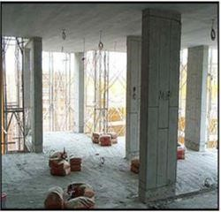
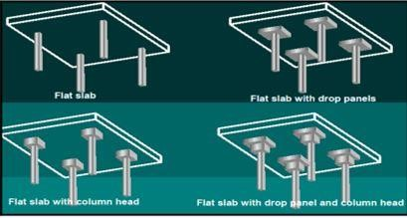

Shows different types of flat slab

RIBBED FLOOR SLAB
Ribbed floor is similar to flat used in offices and large spans are expected. They can be whole concrete ribbed floor or ribbed floor with hollow pots in fill. The floor consist of series of T-beams closely the floor consist of series of T-beams closely spaced in most cases, between 400mm600mm. the slab is more or less designed as T-beams.
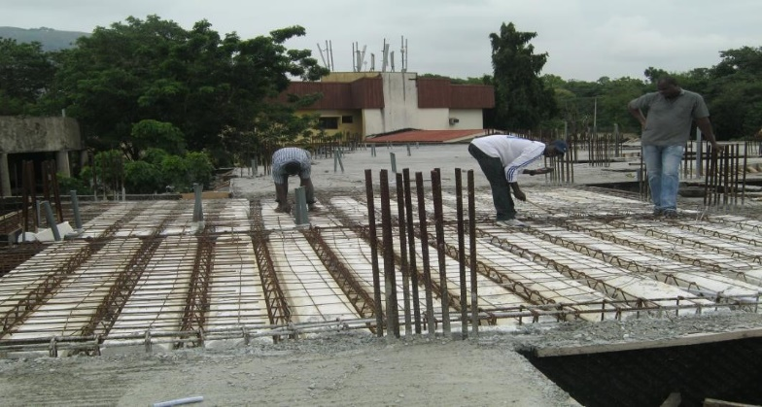

Rib slab at Lagos megacity: the garden atrium apartment, Lagos.

2.3.1.4: WAFFLE SLAB DESIGN
Waffle slab is an extension of the ribbed floor slab in which the slab is ribbed in two directions. Hence, an inverted pot like hollow is formed which serves as the ceiling for the floor below. Waffle slab is all concrete and the slab thickness may be up to 500mm. Hence, they are expensive and should only be used with large spans carrying heavy live load at least 5.0KN/m² or more.
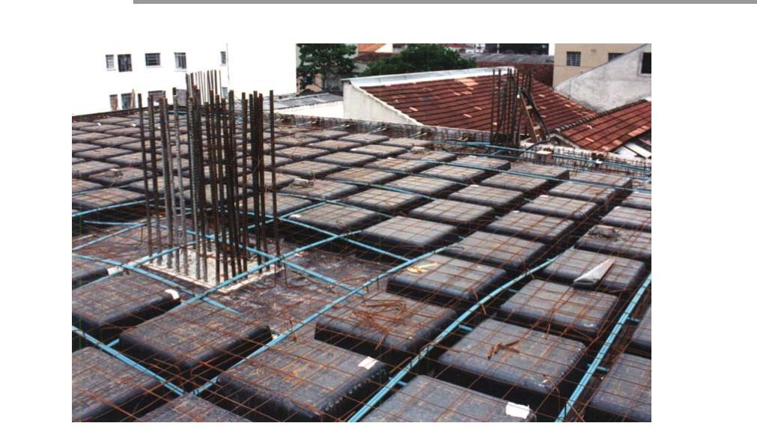
Waffle slab under construction
Flat and waffled are used where large and or heavy live loads are required or where their use would be pleasing. Flat slabs span between columns with no beams at all. On the other hand, waffle slabs are of two types;
- Slab and beam waffle: Those with beams from columns to columns on all sides
- Mushroom waffle: Mushroom type has no beams but with capital columns
Slabs of reinforced concrete slabs can be classified as
  - One-way spanning slab or one- way slab.
  - Two-way spanning slab or two- way slab.

One Way Spanning Slab: A one-way spanning slab is a type of slab where its structural action is in two directions only.
2.3.1.5: DESIGN PROCEDURE SUMMARY FOR A ONE- WAY SPANNING SOLID SLAB
- Select a suitable thickness for the slab on the basis of deflection, durability and fire resistance criteria.
- Compute the dead load of the slab and consequently the ultimate design load.
- Calculate the ultimate design moment and shear forces of the slab using suitable method of analysis.
- Determine the quantity and spacing of main and secondary/ distribution reinforcement.
- Check for deflection, shear and cracking.
- Present a neat sketch of slab details.

Two way Slabs: A two-way spanning slab is a type of slab where its structural action is in all direction.
Panelling: A panel is simply the naming of the slab considering its edge condition and dimension. It is termed panel when a slab is designed one at a time. It is termed a bay when 2, 3 or more slab panels are designed together as one. Panels help to comfortably transfer loads from the slab to the beam. When a slab spans into another slab crossing a beam it is known as a continuous slab but when it doesn’t it is termed discontinuous slab.

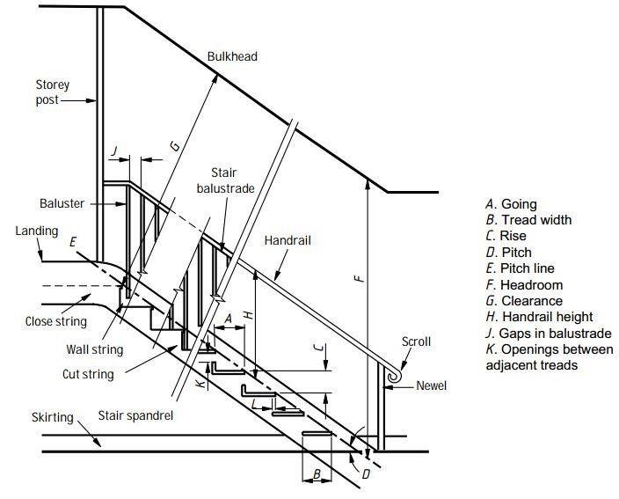
stair terminology

TYPES OF STAIRS
Stairs can be constructed of reinforced concrete, steel and timber.
- Straight flight- a flight between the two floors to be accessed without intermediate landing.
- Half-turn (180deg) Stair- two flights between the floors with an intermediate landing known as half landing. This stair is also known as dogleg.
- Free standing -it’s similar to half turn but with a suspended half landing i.e. the half turn is supported by the two flights. This calls for more rigorous design for torsion at ends of the stair.
- Quarter-turn (open well stair) - three flight between the two floors with two intervening landing.
- Helical stair-this is usually common in the building of the affluent. It occupies less space than others. It has a curved like shape it is always a straight flight but turning as it rises. It also experiences great torsion as it curves.
- Cantilever – in this type of staircase, there is a central reinforced concrete spine wall and each I0step cantilevers out of this wall. Each landing are designed as double cantilever like a beam in turn a cantilever.
- Spiral stair- this is the most economical stair to design in terms of space utilization and in terms of cost. Consist of series of cantilever step jotting out like leaves from a central circular column. The landing spans from the supporting column to the wall

CHAPTER THREE
SITE WORK- PROPOSED THREE BEDROOM
3.1 construction of substructure of a building
Building construction can be classified in the following stages
- Substructure
- Superstructure
Sub-structure
This is the solid base under the ground to support the building above the ground. This consist of concrete building block wall in foundation, hardcore filling damp proof membrane (D. P.M) and oversite concrete.
Building of the substructure is done sequently as enumerated.
- Site clearance
- Top soil
- Setting out of the building plan
- Trench excavation
- Block work in foundation
- Hard core filling
- Damp proof membrane (D. P.M)
- Over site concrete
SITE CLEARANCE
As the name implies it involves clearing the measured price of land form grasses shrubs bushes and removal of plants to get a clean ground for setting out. Tools used are shovels, hoe, cutlass, rake, axe etc.
SOILS EXCAVATION
It is the removal of vegetable top soil depth of 150mm which is not good for building purpose.
SETTING OUT OF A BUILDING PLAN
This is a process or procedure where marked of full size on the ground to enable construction here the building plan is use so as to make sure the land is mark out with responds to plan correctly.
Tools use includes peg hammer, measuring tapes, line builder square theodolite etc.
The lengths and width are marked out with measuring tape, and peg place in position to identify shapes and individual rooms the marked out showing the length width to be excavated.
TRENCH EXCAVATION
It involves the removal of soil in the trench to the required depth. Tools use in exacting includes digger, shovel, hoe etc.

BLOCK WORK IN FOUNDATION
This is the placing blocks usually 225 X 255 450mm in the excavated trench after leveling and compacting of sides and surfaces of the threch respectively and concrete blinding is done blocks are bedded and join with cement mortar mixed with cement and fine sand aggregate in proportion 1.4 by volume thoroughly mixed with water to make it plastic while blocks are been laid good bend between blocks and mortar to acquire strength.
HARD CORE FILLING
This done by filling the hollow of the blocks with rocks granite and general filling with laterite and consolidated manually by taming water sprinkled over laterite to achieve maximum compaction.
It usually filled 50-51mm make up level wen compacted. Hard core filling prevent growth of vegetable matter.
DAMP PROOF MEMBRANE
This a sheet mainly spreed over the entire foundation on the blocks only as the name implies prevent moisture from penetrating underground to the surface of the floor
OVER SITE CONCRETE
This is the last stage in substructure which is placing off concrete in position after from has been done covering the area of foundation. The concrete mixture is of cement fine aggregate and coin aggregate which are mixed in the proportion (1.3.6) or (1.2.4) depending on the structure engine recommendation and water to desired level. The concrete thickness is 100mm, the floor plan of the proposed 3 bedroom attached.
These are structure that is constructed on top of the building
- Block work
- Roofing
BLOCK WORK
Block work begin on the substructure some day after casting the over site concrete. These include division of the building into rooms, toilets corridors and other apartment with windows doors openings. The work is done in accordance with the floor and in alignment with the block walls in the foundation. When the wall attains the height of 900m, openings are made in the room according to windows specification from the building plan, only the toilet room are exceptional as their opening position begins the height of 1350mmat a height 2100 intel beam is cat round the top of external walls.
The reinforcement steel bars are introduce in the form work and form work then supported with brace at top to make it strong and straight, then the concrete is place in form works, where is tamped gently with a stick for proper compacting until is filled round this last course is known as head course.

ROOFING
Is the uppermost element of a building which provides shelter and gives protection from the weather and has significant role to play in reduction of heat loss from the building.
There are different roofing components which includes
Roofing
Roof covering
ROOF MEMBRANE
This comprises of all the wood involved in the building which are.
- 50 x 500mm for noggins
- 50 x 75mm for purling’s
- 50 x 150mmm for rafters
- 75 x 100mmm for kingpost
- 25 x 250mm for facial board
- 12 x 38mm for battens
ROOF COVERING
This is an essential part of a roof usually laid over the form work to provide protection from weather and other atmosphere condition are different types of roof covering such as
- Galvanized corrugated iron sheet
- Corrugated aluminum sheet (0.35,0,4,5,0,7mm)
- Asbestos cement sheet
- Bitumen
- Concrete
NAILS
This a material made up of iron the roof membranes together in a desire position and strong as well as holding the roof covering to the roof members, they are of different sizes and types which they function in roofing the kingpost is erected at the center of the beam and raters.
The roof covering is nailed directly on the purling’s the under the beams.
At a square shape of 60 x 600mms in each room of the building giving way to the celling sheet with battens (as shown in roof in a proposed 3 bedroom)
ELECTRICAL INSTALLATION
This act of placing electrical units in the building after the wall roof are been constructed electrical units such as sockets, switches control point for fan bulb etc. is being placed at various points in the building.
Electrical installation can be done in two ways such surface wiring and conduct wiring
Surface wiring
Is when the cables are exposed on the walls celling noggins, it less expensive and easy to detect a fault built it takes time in working on it. While conduct wiring on the other hand is when cables are passed through the wall and the with the aid of pipe (12mm diameter) this is done before the wall is plastered or before the covered it is costlier but safe and does not take a lot time working on it and less strenuous.

MECHANICAL INSTALLATION
(plumbing work) this is the act of installing mechanical unit building such as water clos toilets, shower rose, shower tray, bath tub floor drain, wash hand basin (WHB) kitchen sink etc.
Like electrical mechanical installation also done in two ways surface and conduct piping.
Surface piping is where the pie and fiting are passed through the wall for supply of water in the accessories 13mm and 19mm diameter pipes and fittings are used while supply from the over the is with 25mm pipe and fitting for discharge of excreta to the soak away 100mm pipe and fitting use in covering excreta from the water closet (WC) to the inspection chamber outside and onward the septic tank. While other water waist is conveyed from their points by 32mm diameter pip fitting for wash hand basin 38mm diameter pipes and onward conveyance to the septic thank are away through 100mm diameter pipe.
3.3 FINISHING
Finishing can be described as the direct application of plaster paint vanishes or wall papers structure finishing are carried out to improve the appearance of the structure and reduce main costs.
In particular situations other actors may also be importance such as resistance of conden acoustic properties and provision of smooth surface.
FINISHES
- Rendering: this is a form of plastic applied to the external surface of wall using a mixture of cement and sand and lime to give extra protection against adverse weather condition or to provide a desire texture. The coast is 133mm thick.
- Plastering: this term is usually applied to the internal surface of walls and to give a joint less easily decorated and usually smooth surfaces often on even background. There are also other finishing like dry lining, glazed tiles claddings stone works mosaic/flint etc.

CELLING FINISHES
Celling is used to serve as internal finish for roof frame work, provide thermal installation and top reduce noise especially coming from rain fall, celling framework are normally constructed and covered with suitable material or celling lining that serves as the top liner surface of a room.
CELLING BOARDS
The following materials are used as celling board in the topic
- Asbestos cement
- Wooden board
- Clattes material
- Particle board
- Plaster of Paris- precast board (pop)
- Bamboo
- Reeds
- Mat etc.
The celling board or sheet can be constructed in the following procedure
- Plan the strut so that they are flat square and smooth
- The struts are cut to the required length after determing the number needed.
- The noggins are cut to the required length needed
- Battens are preformed into different sizes.
- Nails one end of each strut to the beams or rafther as appropriate
- Established the required level and position the noggins to the level nailed into the strut at plugged into the wall. The middle noggin are nailed together and secured to the strut at predetermined dimension.
- The junctions formed by celling board are covered by the preformed batting using wires nail
3.4 TENDERING
This can be defined as an act by which submission of a quotation is made by a tender when so desired by a client which may be an individual a group of people a company, government ministry or any of parastails. The purpose for such invitation may be for the supply of certain goods such as furniture allumuim or bitumen or roofing materials or specials door and windows etc. and can be one man baid company a medium size company a big time manufactured or distributor or the highest caliber contractors when such quotation submitted it constitute what is known as Tender.

Types of tender
It commonly believed that tender can be obtained by three basic methods viz open, selective and negotiated.
opening tendering: in this method tenders are invited by public advertisement. The open tender method is usually adopted for public work as the rules generally requires that government contracts and others publicity to obtain the most advantageous terms. Any contractor who is within to undertake a piece of work and who has the requite finances and requirement to complete it to complete it satisfaction is allowed to submit the offer.
Selective Tendering : under this method the owner invites tenders from a few contractors who are know to have specialized in a particular type of work and form whom he has no previous occasions obtained excellent result

CHAPTER FOUR

4.4: EXPERIENCE GAINED
Working at the Construction & Project Management department as a student trainee in Tower Alloys Industries Limited Roofing Division has given me the opportunity of getting a firsthand appreciation of Construction & Project Management technology, learning its fundamentals, learning to work with various equipment used in Construction & Project Management, and also acquiring skills in software design packages. I was able to apply some of the theoretical knowledge gained during my study at the university to real work situations thereby bridging the gap between school work and actual practice.
I also gained experience in other fields of science, engineering and project management. I learnt invaluable lessons on the code of conduct of big firms and it prepared me for work scenarios I am likely to meet after graduation.
Personally, one of the most important skills I gained during the course of my IT was commercial communication skills within major companies. During the course of my work, I had to interact with engineers and IT professionals from Architectural firms, manufacturing companies, oil and gas industries, multinational companies and others. To carry out projects, I had to work together with personnel from different departments. I also had to relate with senior engineers from my company and our international service partners.
My General experiences concerning Structural Engineering are as follow:
- I learnt how to read bar bending schedule and detailed drawing for reinforcement bars as it relates to building construction.
- I was able to grasp adequate knowledge and understanding regarding quality assurance and quality control in construction.
- I learnt how to improve construction quality and productivity by ensuring environmentally friendly construction best practices and materials are implemented.
- I learnt how WBS (Work Breakdown Structure) helps in organizing what needs to be done in small packages of activities.
- I learnt how difficult tasks are handled to ensure smooth progress of a project work in conjunction to the time frame for a given project.

CHAPTER FIVE

5.0: SIWES CHALLENGES
- A week strike occurred during the internship program which principally was a general strike for all construction workers in the country thereby, a week without work elongated the project time for completion.
- Due to long hours of transporting materials needed on site (shipping imported materials), there were days whereby petite activities took place, thus limiting work progress on site.
- Inadequate equipment to carry out some tests in the quality control section limited my experience concerning test for rebar.
- During my first few weeks, I had difficulties understanding a lot of the terms and terminologies that was used at the office because a lot of them were very new to me. This made it hard for me to follow the procedures.

5.1: CONCLUSION
This report has been able to x-ray an account of the entire work – experience garnered by me during my SIWES program at TOWER ALLOYS INDUSTRIES LIMITED ROOFING DIVISION which is a core scheme in ITF and which is saddled with the responsibility of strengthening the effective teaching and learning of skill based course such as Civil Engineering. I therefore concludes that SIWES is of great benefit to students in tertiary institutions. It therefore implies that the proper and effective administration of SIWES will go a long way in boosting and enhancing the competencies of the workforce of the country. I also concluded that SIWES is confronted with series of challenges and this may have hindered the realization of the goals and objectives of the scheme and it therefore needs to be given attention by all concerned stakeholders. Also, my general relationship with people and also work ethics has increased greatly.
5.2: RECOMMENDATION
In view of the relevance of the SIWES program, it is important that it is sustained by the government through the Industrial Training Fund (ITF) as it exposes the student to work tools, facilities, and equipment that may not be available in their respective institutions in relation to their course of study.
To this end, I recommend that the following under-listed points should be implemented:
- Students’ Industrial Works Experience Scheme (SIWES) needs to be strengthened by all concerned stakeholder in order for its objectives to be fully realized.
- Regular monthly allowances for students on attachment should be paid promptly.
- Organizations should always accept students for SIWES and subsequently assign them to relevant jobs.
- Experience staff should always be made to train the students on attachment
- There should be more funding of the scheme by the government in order for it to be more effective.
- The companies should put in place all the necessary facilities needed to enhance the knowledge of the student in industrial attachment.
- It will be of great benefit if the institution can create a platform whereby student can obtain presiwes knowledge or excursion programs, before student embark for general 4 months industrial training programme.

