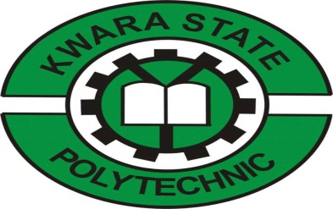
TECHNICAL REPORT ON
STUDENTS INDUSTRIAL WORKS EXPERIENCE SCHEMES
(SIWES)

HELD AT
YUSTECH ELECTRICAL, ELECTRONIC & SOLAR SYSTEM ENGINEERING
NO 1, AJIKOBI, ILORIN KWARA STATE
PRESENTED BY:

GANIYU FARUK OPEYEMI
ND/23/EEE/PT/0245
SUBMITTED TO:
DEPARTMENT OF ELECTRICAL/ELECTRONIC ENGINEERING, INSTITUTE OF TECHNOLOGY (IOT) KWARA STATE POLYTECHNIC, P.M.B 1375 ILORIN KWARA STATE
IN PARTIAL FULFILMENT OF THE REQUIREMENT FOR THE AWARD OF NATIONAL DIPLOMA (ND) IN
ELECTRICAL/ELECTRONIC ENGINEERING DEPARTMENT KWARA STATE, POLYTECHNIC ILORIN, NIGERIA.
SEPTEMBER-DECEMBER 2024

DEDICATION
I am delighted to dedicate this report to Almighty God who gave me the grace and opportunity to complete this programme.
I also dedicate it to my lovely parent Mr. & Mrs. HABEEBLLAH

ACKNOWLEDGMENT
First and foremost, I give thanks to almighty God, the creator of the universe for the greatest protection and love been given to me as a privilege to start and complete my SIWES programme. I extend my special thanks to my parent Mr. & Mrs. GANIYU for their morally, spiritually and financially, word of encouragement and prayer given to me, who makes my SIWES programme successful.
I express my profound gratitude to my department Lecturers and my SIWES Supervisor for the support towards the success of the time used in SIWES. I also gives thanks to my Brothers and Sisters and entire family of GANIYU for their advice to me during my SIWES programme. May almighty God bless you all (Amen).
I also appreciate the effort of the entire staff of YUSTECH ELECTRICAL ELECTRONIC & SOLAR SYSTEM ENGINEERING for the tremendous moral assistance throughout the period of my attachment especially and also my grateful lovely friends for their Contribution in one way or other. May almighty God bless them all and provide for their needs.

PREFACE
The student industrial work experience scheme (SIWES) helps in exposing students to the practical application of their course and to get used to equipment and machines used in the factory. The SIWES was established to promote student skill in industrial Practice and pre-expose them to working experience in industrial settings.
The SIWES programme covered a period of four months from September to December 2024 and it is a partial fulfillment of a two year academic programme to obtain an OND certificate in Engineering. The report explains the description of the work done.

TABLE OF CONTENT
Title page i
Dedication ii
Acknowledgement iii
Preface iv

Table of content v-vi

CHAPTER ONE

1.0 Introduction of SIWES 1
1.1 Objectives of the SIWES 1
1.2 The need for industrial training 2
1.3 The benefit of industrial training 2
1.4 Organization chart 2
CHAPTER TWO

2.0 Electrical system installation 3

2.1 Electrical service 3

2.1.1 Residential consumer 3
2.1.2 Commercial consumer 3
2.1.3 Large industrial consumer 4
2.2 Installation of energy meters 4
2.2.1 The induction type energy meter 4
CHAPTER THREE
3.0 Wiring system 5
3.1 Type of wiring system 5
3.2 Surface wiring system 5
3.3 Material used for surface wiring system 5
3.4 Conduit wiring system 6
3.5 Method of conduit wiring system 6
3.6 Material used for conduit wiring system 7
3.7 Space factors 7
3.8 Trucking wiring system 7
3.9 Method of trucking wiring system 8

CHAPTER FOUR
4.0 Electrical/electronic tools and their uses 9
4.1 Uses of the above tools 9
4.2 Maintenance of the tools 12
4.3 Some safety precaution in electrical installation 12

CHAPTER FIVE
5.1 Conclusion 14
5.2 Recommendation 14

CHAPTER ONE
- INTRODUCTION
The Student Industrial Work Experience Scheme (SIWES), is a skill training programme, it was initiated in the year 1973 by the industrial training fund (ITF). It is a tripartite programme involving the students, the universities and industrial. It is found by the Federal Government of Nigeria and jointly coordinated by the ITF. It is a skill training programme designed to expose and prepare students of tertiary institution for the industrial work situation they are likely torment after graduation. The scheme also afford the students the opportunity of familiarizing and exposing themselves to the needed experience in handling equipment and machinery.
  - OBJECTIVES OF SIWES
Specifically the objectives of the students industrial work experience scheme (SIWES) are to
- Prepare students for the industrial work situation they are to meet after graduation.
- Enlighten and strengthen employer involvement in the entire educational process and prepared students for employment in industry and commerce.
- Make the transition from school to the world of work easier and enhance student contacts for later job placement.
- Provide an avenue for students in the higher learning to acquire industrial skill and experience in their course of study, which are restricted to engineering and technology.

  - THE NEED FOR INDUSTRIAL TRAINING
- The purpose for training is to guide, enlighten and empower students to participate effectively.
- It helps to derive the maximum benefit from doing so.
- The need to combine theoretical knowledge with practical skills in order to produce results in form of goods and services or to be productive
  - BENEFIT OF INDUSTRIAL TRAINING
- It exposes students to the environment in which they will eventually work, thereby enabling them to see how future profession and organized in practice.
- It provides an enabling environment where students can develop and enhance their personal attribute such as critical thinking creativity.
1.4 The Organization Chart
Chairman
General Manager
Secretary
Supervisor
Workers

CHAPTER TWO
2.0 ELECRICAL SYSTEM INSTALLATION
2.1 ELECTRICAL SERVICE:
Electrical service is the means of electric supply to consumer. There are three classes of consumer and these are residential commercial and industrial.
For every electrical service to consumer, there are three essential features required by the regulations. These are:
- A means of isolating all conductor of the installation from the supply by isolator, main switch, or main circuit breaker.
- Automatic protection against excess current by fuses or some form of circuit breaker
- Automatic protection against earth leakage current by fuses or an earth-leakage circuit breaker
All the above equipment must be in readily accessible position and must be capable of being operated without causing danger.
2.11 Residential Consumer:
Are those who use electric supply mostly for lighting, heating, and other domestic works like washing. The electrical load connection is low as compare with commercial usage. They can therefore connect directly to an existing distribution lines around the premises.
2.12 Commercial Consumer:
Are those use electric supply for lighting, heating, cooling, motive power more than the residential. These set off consumer can also be connected to an existing distribution line, but where the total load is up to 300kva separated distribution lines has to be provided from a nearby substation transformer where available.
2.13 Large Industrial Consumer:
Are those who use electric supply mostly for motive power and heating. A consumer of this nature will need a supply from a separate substation situated on his own land or in part of his factory premises. This substation will supply only the one consumer.
2.2 Installation of Energy Meters:
An energy meter is an instrument for measuring electrical energy consumed in kwh. There are two main type of energy meter, the single-phase which is supplied with a line and neutral, and three-phase which is supplied with three line and neutral.
The Most Common Form OF Energy Meter Is The Induction Type.
2.21 The Induction Type Energy Meter:
Part: It consist of a voltage coil, two current coil, aluminum disc that rotate to take a rending, between two electromagnet fields of voltage and current.
Operation: When the supply is on via energy meter to a load, the magnetic field produced by the voltage coil and the magnetic field produce by the current coil will both produce are resultant fluxes which induce eddy current into the aluminum disc.

CHAPTER THREE
3.0 WIRING SYSTEM
This is the continuous running of cable from the switch to another lighting point to another switch forming from one socket to another switch also forming a circuit finally to the distribution board or control switch.
Wiring system take place at home, shop, office, industries factories etc.
3.1 TYPE OF WIRING SYSTEM
i. Surface Wiring System
Ii. Conduit Wiring System
Iii. Trucking Wiring System
3.2 SURFACE WIRING SYSTEM
This is a wiring system that involve the use of pvc (poly vinyl chloride) insulated conductor which has two or more core cable runs on the surface of the wall with the use of brass nail and clip in which it is use to tight cable firmly on the surface of the wall in order to make it neat.
This type of wiring system is runs from the switch to the control box, from junction box to the lighting, to the socket, then to control switch or distribution board. It is run on the surface of the wall, inside the ceiling, underneath the decking and under floor.

3.3 MATERIALS FOR SURFACE WIRING SYSTEM
  - flux switch
  - switches
  - junction box
  - patresses
  - brass nail with clip
  - wooden screw
  - ceiling rose
  - lamp holder
  - wooden block
  - 13A and 15A socket outlet
3.4 CONDUIT WIRING SYSTEM
A conduit wiring system can be define as a tube or a channel in which cable is draw inside with the use of fixing tape which travel through the tube or channel. In electrical installation work “conduit” refers to metal tubing or non-metallic tubing is use because of the cable is been damage when it is draw in to metallic tubing
3.5 METHOD OF CONDUIT WIRING SYSTEM
A conduit wiring system, pipe can lay on the surface of the wall with use of shadow clip. It can also be lay inside the wall by making out the point to be chiseled, then chiseling follow the right from each switch, lighting point, socket outlet to distribution board, after then laying of pipe follow with boxes suitable for the point passing the chiseled area after laying the pipe.
The cable is then run in to the pipe after lying with the use of fixing tape which travels through the pipe from switch to the lighting point to another switch to form a circuit on the distribution board. Also cable is draw in to13A socket outlet point in radian form i.e. at most six number of 13A socket outlet point a circuit on the distribution board. All 15A socket outlet, cooker unit, water heater switch are draw directly to the distribution board i.e. without any looping.
3.6 MATERIAL FOR CONDUIT WIRING SYSTEM
1. Y, U,T, 4ways looping and iron or knock out boxes
2. 20mm, 25mm, plastic pipe
3. 20mm, 25mm, male and female brush
4. 20mm, 25mm coupling
5. Tanguit gum
3.7 SPACE FACTOR
Space factor is the considerable alliance(space) which is life after cable are been draw through a pipe I a conduit in order to avoid tighten while pulling the cable in a pipe according to IEE regulation which says space factors for conduit is 40%.
3.8 TRUCKING WIRING SYSTEM
This is type of wiring system wheel by some considerable number of cable are run together in aplastic of sheet manufacture in form of box which has a removable cover.
Trucking box may be inform of steel sheet or plastic, but nowadays plastic trucking are in common use.
3.9 METHOD OF TRUCKING WIRING SYSTEM
This is first pivoted on wall i.e. straight on the wall. It is then nailed on the wall. The cables are pack inside it and cover up with the removable cover. Thereby making the cable invisible and neat on the surface of the wall. In this type of wiring system, fault can be easily be detected a consideration number of cable run in to it , cable are not subject to tension. In order hand steel sheet, trucking box may become live under earth leakage or when live cable peals and comes in contact with trucking box it is not advisable to use it in where there is flammable situation, it is expensive to other.
There are three type of trucking wiring system, these are:
- Multiple cable trucking
- Bus bar trucking
- Tap on trucking

CHAPTER FOUR
4.0 Electrical/Electronic Tools and Their Uses.
Electrical Electronic Engineering Has Various Instruments In Performing Several Operation.
Some Of Their Instrument Are Listed Below:
- Megger Tester
- Screw Driver
- Gloves
- Bending Spring
- Plier
- Plume
- Meter Reading
- Soldering Iron
- Head Hammer
- Tester
- Fixing Tape
4.1 USE OF THE ABOVE TOOLS
Megger Tester: Megger Tester Is An Instrument That Is Used In Testing A Full Wiring, Installation In The Distribution Board Before Loading Current To The DB. 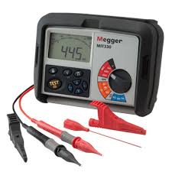
Screw Driver: This is another important tool in electrical works, it is used for loosing or tightening screw driver used in minus head screw.
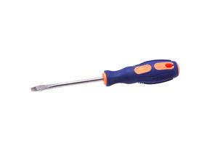
Hammer: Hammer is one of the electrical appliances that are used in hammering like nail and any other hammering substance under the electrical installation process.
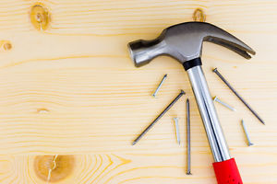
Plier: For cutting, disconnecting or for remove of installation material like rubber from the conductor. It can also be used to hold material firmly in other to couple the material together.
There Are Various Type Of Pliers Namely:
- Long Nose Plier
- Cutting Plier
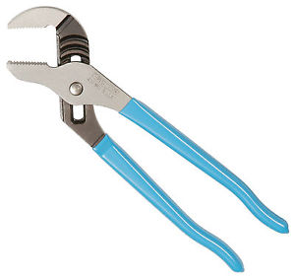
Meter Reading: It is used to read or know some certain value depending on type of meter.
Soldering Iron: It is used by the technician for electric soldering of the panel.
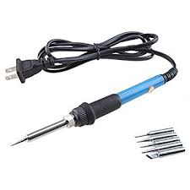
Gloves: it is used to guide against electrical and mechanical damage to the body.

Tester: this tool is used to detect the flow if current in the system and it comprises of three components inside. They are bulb, insulator and lead.
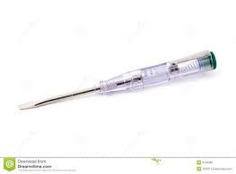
Fixing Tape: use in passing wire in to the pvc pipe when carrying out an installation, in order to fasten the work.
Bending Spring: is make up of a spring. is use in binding pvc pipe when working on a conduit wiring
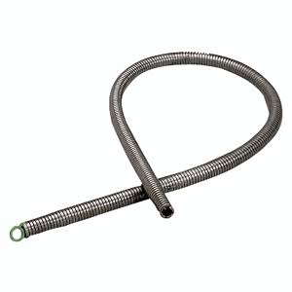
4.2 Maintenance of the Tools
It is very important to keep and protect electrical electronic tools or equipment. One of the ways to maintain an electrical tool is to keep them in a cool dry place; there is need for constant and regular checking to determine the working condition of the tools.
4.3 Some Safety precaution In Electrical Installation
- Always put on your overall when in workshop or any other place of working
- Never toy with live wire for any reason
- Always remove the fuse when carrying out installation
- Test the conductor polarity by mean of tester not by touching it ordinarily.
- It is dangerous to operate electrical machinery you are familiar with.
- Spark from switch can cause serious burns.
- Always use correct tools for all job as incorrect tools used can result to accident.
- When using ladder ensure that it is properly placed to avoid it from falling down.

CHAPTER FIVE
5.1 CONCLUSION
My six months period of industrial training was a myriad of exposure and preparation for the reality of my profession. The programme affects the life of students in various ways positively, mostly as it enlightens the practical knowledge of each student. However, the training equipped me with a lot of knowledge in many areas, which includes. In vitro and in vivo studies to develop new drugs and make life easier for man It also created an avenue for me to observe the hierarchy on public services and also the application of specialization and division of labour. A lot of skills of equal knowledge on ethics of public service and different believe were acquired. The acquisition of industrial skills and real work practical experience is considered as primus intersperse and highly imperative in the academic pursuit of every Nigerian University undergraduate. Indeed, a student’s quest for the award of a degree certificate in his/her field of study is never complete without the SIWES scheme. As it (SIWES programme) did not only provide me with a once in a lifetime opportunity of gathering invaluable practical experience that spans through the areas of the fields of laboratory practices, medical laboratory, biochemistry, phytomedicine etc.
Finally, my experience cannot be matched with anything except the confidence I presently have to go into the community and the world at large to impact lives and make a difference.
5.2 RECOMMENDATION
The SIWES scheme is indeed a life changing, destiny-shaping and career making period in the life of every university undergraduate in Nigeria. However, despite its enormous benefits, there are also areas that need reform and improvement. Some of these pitfalls are:
- LEGAL FRAMEWORK: The law establishing the scheme should be strengthened to compel employers of labour from rejecting students who applied to serve in their establishment, despite having met all the necessary conditions.
- ORIENTATION: Proper orientation should be given to students to prepare them socially and psychologically for the travails of IT work real work situation.
- FUNDING: The funding of the scheme should be increased and provisions should be made to compel employers of labour to pay IT students’ meager allowances for transport, lunch and other sundry needs no matter how little.
- IMPROVED SUPERVISION: The industrial based supervisors and university coordinators should work on themselves so as to maintain a cordial relationship with IT students for effective monitoring and supervision.

