
TECHNICAL REPORT ON THE STUDENT INDUSTRIAL WORK EXPERIENCE SCHEME (SIWES)

HELD AT
ARBICO PLC

PERSENTED BY:
SULEIMAN ABDULSAMAD
MATRIC NO: ND/23/CEC/PT/0117
SUBMITTED TO
THE DEPARTMENT OF CIVIL ENGINEERING, INTITUTE OF
TECHNOLOGY (IOT), KWARA STATE POILYTCHNIC, ILORIN, KWARA STATE

IN PARTIAL FULFILLMENT OF THE REQUIREMENT FOR AWARD OF
NATIONAL DIPLOMA (ND) IN CIVIL ENGINEERING

FROM AUGUST TO NOVEMBER 2024

DEDICATION
This report is dedicated to the Almighty Allah, the Beneficent, the merciful, the cherisher of the universe, the uncreated creator of all creatures and the most knowledgeable who seek knowledge just from himself for giving me the opportunity, privilege an understanding to participate in the student industrial work experience scheme (SIWES).
I also dedicate this report to my amiable parent Mr. and Mrs. Suleiman for their financial support during the course of the program. May Allah continue to bless them (AMIN).

ACKNOWLEDGEMENT
I acknowledge with sincerity the Almighty Allah. He has been in always faithful, caring, providing, sustaining, guarding and just so good to me. Glory honor and adoration be unto Almighty Allah.
My unalloyed thanks and appreciation goes to my parent MR & MRS Suleiman for the caring and support that has been driving me throughout the duration of my training.
I am also indebted to the entire staff of COMPANY most importantly the engineers on site for their contribution and support during the training, may Almighty Allah reward you abundantly (AMIN).

CHAPTER ONE

INTRODUCTION 1.1BACKGROUND
The student industrial work experience scheme (SIWES) is a skill development program being initiated by Industrial Training Fund (ITF) in the year 1973 to solve the problem of lack of adequate practical skills preparation for employment in industries by Nigerian graduates of national institutes.
The student industrial work experience scheme (SIWES) was also founded in order to expose students to industry based skills necessary for an easy transition from the classroom to the world of work, which enable students to exposed to work methods and techniques in handling equipment and machinery that may not be available in their institutions.
The scheme started with 784 students from 11 institutions with 104 suitable courses t inception in 1974. The number of students that participated in SIWES from Universities, polytechnics and colleges of education. At the end of the year 2007 was 194,890. In the year 2008, the number of the students that participated in the scheme increased to 210,390 students with over 112 suitable courses from 219 institutions.

1.2 OBJECTIVES OF SIWES
- To provide an avenue for student in the Nigeria universities to acquire experience and industrial skills during their course of study
- To prepare students for the work situations they are likely to meet after graduation
- To expose the students to work methods and techniques in handling equipment and machinery that may be available in their institutions
- To provide the opportunity to apply their theoretical knowledge in real work situation there by bridging the gap between theory and practice
- To allow the transition phase from school to the world of working environment easier and facilitate students contact for later employment opportunity

CHAPTER TWO

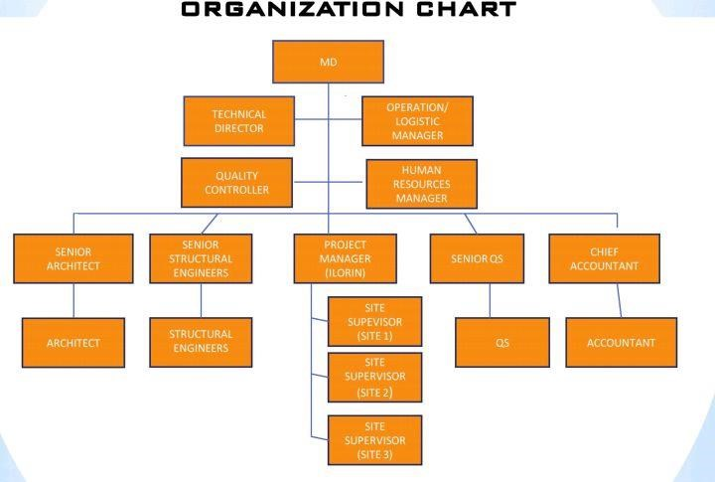

CHAPTER THREE

SITE EXPERIENCE GAINED 3.1 CALCULATION OF THE CUBIC CONTENT OF COLUMN AND BEAM
Quantities of materials for one cubic meter of concrete using
1:0.95:1.5 mix ratios
Step 1: volume required is 1m3.

Step 2: at a ratio 1:0.95:1.5 (1+0.95+1.5 = 3.45).

Step 3: Considering 2% entrained air, the actual volume of concrete is;
- 2% of 1m3 = 2/100 × 1m³ = 0.02m³
- 1m3 – 0.02m3 = 0.98m3. (This means after compaction it will be 0.98m3).
- To avoid shortage after compaction, add 0.02m3 (1m3 + 0.02m3 = 1.02m3).

Step 4: Calculate the Volume of materials;
- Volume of cement required is just 1 part of 3.45___ 1/3.45 ×1.02 = 0.296m³
- Volume of fine sand required is 0.95 parts of 3.45 --- 0.95/3.45 ×1.02 = 0.281m³
- Volume of coarse sand required is 6 parts of 10 --- 1.5/3.45 ×1.02 = 0.444m³
Step 5: Convert required volume to weight by multiplying their densities;
- Weight of cement required is ---- 0.296m³ × 1440kg/m³=426.24kg
- weight of fine sand required is ----0.281m³ × 1600kg/m³= 449.6kg
- weight of coarse sand required is ---- 0.444m³ × 1650kg/m³= 732.6kg • Weight of water required is ---- 426.24 × 0.50 = 213.12kg

Step 6: For true water content multiply by the average specific density of the most water absorbing aggregate (in this case 2.6);
- True water content ---- 213.12 × 2.6 = 554.112kg (554.112litres).

Step 7: 1m3 concrete has a density of 2500kgm3.
- Weight of 1m3 at 1:0.95:1.5 is (426.24+ 449.6 + 732.6 + 554.112= 2162.55kg).
The steps above were repeated in order to calculate for other mix ratios.
Step 8: Calculate the volume column or beam which depends on the shape and size
Rectangular column volume= (L×B×H)m³ Circular column volume= (πr²h)m³
Multiply the total volume by the mass of 1m³

3.2 CASTING CONCRETE (1:0.95:1.5) WITH THE USE OF MIXER
The concrete casting process is the process of creating structures or products using concrete. The process involves preparing the mold or formwork, mixing the concrete, placing the concrete in the mold, and allowing the concrete to cure. The concrete casting process involves the following steps:
- Preparing the formwork: The first step in the concrete casting process is to prepare the formwork, or the mold that will hold the wet concrete until it hardens. The formwork must be properly designed to create the desired shape and finish of the final product.
- Mixing the concrete: The next step is to mix the concrete, which involves combining cement, water, and aggregate (such as sand and gravel) in the appropriate proportions. The concrete is typically mixed using a concrete mixer or by hand. A concrete mixer was used at my SIWES COMPANY. Which has 9m³ capacity and a mix ratio of 1:0.95:1.5 was adopted.
- Placing the concrete in the formwork: Once the concrete is mixed, it is placed in the formwork using a variety of methods, including hand shoveling or pumping. The concrete is typically placed in layers, with each layer being compacted to remove air pockets and ensure a strong and durable final product
- Finishing the surface: After the concrete is placed in the formwork, it is typically smoothed and finished to achieve the desired surface finish. This can be done using a variety of tools, such as trowels, screeds, and floats.
- Curing the concrete: The concrete is then allowed to cure, or harden, which typically takes several days. During the curing process, the concrete must be protected from extreme temperature fluctuations and kept moist to ensure proper curing.
- Removing the formwork: Once the concrete has cured, the formwork can be removed to reveal the final product. The formwork is typically dismantled and the materials are reused or disposed of appropriately.
The concrete casting process is an essential part of the construction industry, as it allows for the creation of a wide range of structures and products using concrete. Proper execution of each step is crucial to the success of the project and the quality of the final product.
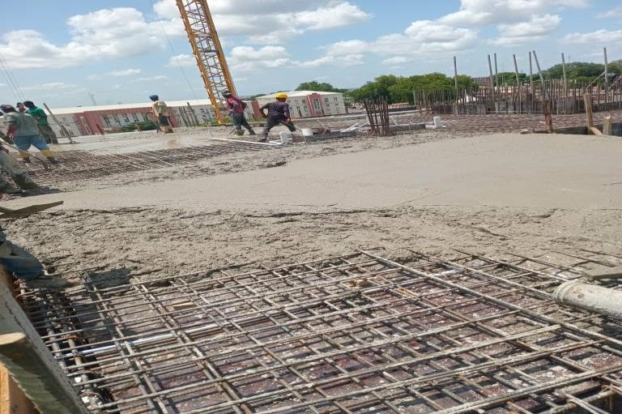

3.3 EXCAVATOR AND MIXER
EXCAVATOR
Excavator is a heavy machine consisting of a boom stick, bucket and cab on a rotating platform known has the house. It is used for digging of trenches, material handling, demolition and river dredging.
CONCRETE MIXER
This is also a machine that has to major type namely:
- Mobile Concrete Mixer: this is used for two major purpose simultaneously. Mixing and transporting from the point of mixing to the point placement or usage.
- Drum concrete mixer: This is most common type of concrete mixer. It has a rotating drum that mixes the concrete. It is available in electric and gaspowered models and can handle all types of concrete projects

3.4 CUBE TEST
Cube testing is a procedure used to test the compressive strength of concrete. It involves making and curing concrete cubes, then crushing them at defined periods. This provides a straightforward check of the concrete mix's ability to resist loads which will compress it.
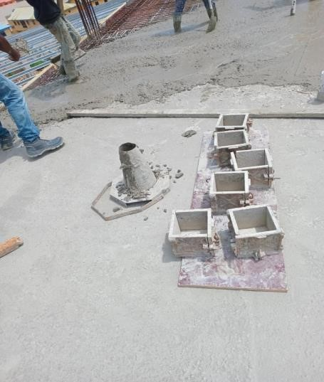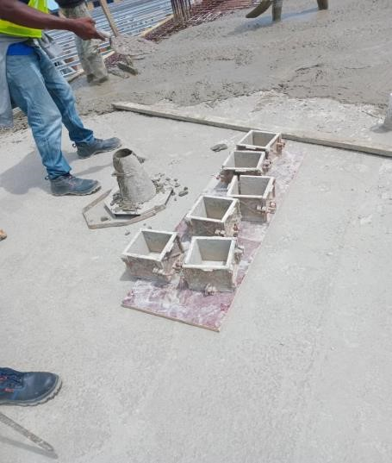
Step 1: Cube Preparation
Mix the Concrete: The first step in cube testing is to prepare your concrete mix according to the specifications required for your project.
Fill the Moulds: Fill the moulds with the concrete mix, ensuring it is compacted into the corners. Fill the mould in three layers, compacting each layer with a rod 35 times.
Step 2: Curing the Cubes
Cure the Cubes: Once the cubes have been formed, they should be stored in a curing tank at a temperature of 20 ± 2 degrees Celsius for a specified period, typically 7 or 28 days.
Step 3: Testing the Cubes
Prepare for Testing: After curing, the cubes should be removed from the tank and any excess concrete should be carefully removed to ensure a flat surface.
Compressive Strength Test: The cubes are then placed in a Concrete Cube Test Machine, where a load is gradually applied until the cube fails. The maximum load at which the cube fails is recorded.
Safety Considerations
Safety should be paramount in all construction-related tasks, including cube testing. Consider the following safety measures:
Proper Equipment Use: It's crucial to understand how to operate the testing machinery correctly. Incorrect use can lead to inaccurate results and even injury.
Personal Protective Equipment (PPE): Always wear appropriate safety gear, such as safety goggles, gloves, and steel-toe boots when working with concrete and heavy machinery.
Proper Handling: Be careful when handling the concrete cubes, especially when placing them in and removing them from the testing machine.

3.5 FORMWORK FOR CANTILEVER BEAM
Cantilever beam is a type of beam that is supported at one, without support at the other end. The FORMWORK is erected by the use of planks or marine boards which is supported the wall at one edge in conjunction with bamboo all over. The beam reinforcement is placed in FORMWORK with proper settings by living space all around the reinforcement to accommodate concrete cover.

3.6 EXCAVATION
This is the process of remove top soil on a site in another to attain a stabled ground. This is done before commencing the construction of foundation.
Building foundations are the most crucial structural components in any house or building, as it bear the entire load of the structure and transfer it safely into the ground below. It forms the base that supports the entire weight of the walls, floors, roof, utilities and inhabitants of the home. The primary purpose of foundations is to provide stability by evenly distributing the structural loads into the underlying soil. While building foundations this prevents uneven settlement of the building over time, which can cause major cracks and damage.
Two main types of foundations are used in residential construction, shallow and deep. Shallow foundations extend down around 1.5 meters or less and are suitable for single-family homes and low-rise buildings. They include spread footings, mat slabs, floating slabs, etc. Deep foundations go beyond 1.5 meters in depth into deeper soil or bedrock. They are required for multi-storied buildings and homes on weak or unstable soils. Piles, piers and caissons are common deep foundation systems. The type of house foundations depends on soil conditions, building loads and construction budget. A properly designed and built foundation keeps the home steady, secure and free from settlement issues.
They are required for multi-storied buildings and homes on weak or unstable soils. Piles, piers and caissons are common deep foundation systems. The type of house foundations depends on soil conditions, building loads and construction budget. A properly designed and built foundation keeps the home steady, secure and free from settlement issues.

Required Tools & Materials for Manual Excavation
- A shovel for digging
- A pickaxe for tough terrain
- A trowel for concrete work
- A spirit level for precision
- Measuring tapes, string and pegs for markings,
- A wheelbarrow for transport,

3.7 BLINDING
Blinding in construction to the practice of applying a layer of material, usually concrete or granular material, to the ground before laying the main structural elements of a building. This initial layer serves several crucial purposes, including providing a clean working surface and ensuring that the primary structural elements are not compromised by contaminants or environmental factors.

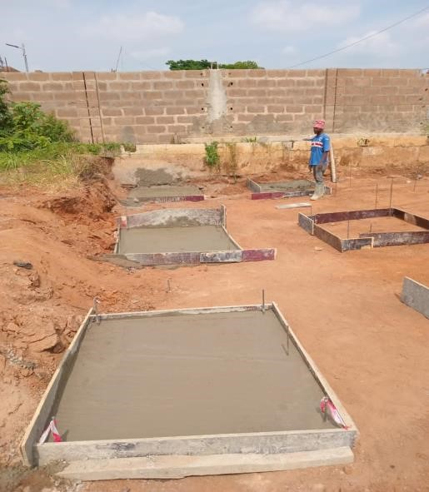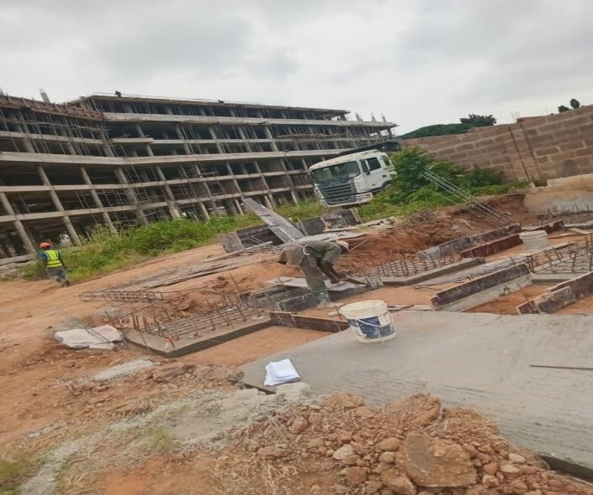

Purpose of Blinding
- Creating a Level Surface
One of the primary purposes of blinding is to create a smooth, level surface for the subsequent construction phases. This layer helps to fill in any irregularities in the ground, ensuring that the foundation or other structural components are laid on a uniform surface.
- Preventing Contamination
Blinding acts as a barrier between the ground and the concrete or other materials used in the foundation. It prevents contaminants such as soil, water, or organic materials from mixing with the concrete, which could otherwise weaken the structure or affect its durability.
- Protecting the Foundation
By providing a clean and stable surface, blinding helps to protect the foundation from potential damage caused by shifting soil or groundwater. This is particularly important in areas with unstable or variable soil conditions.
- Facilitating Construction
Blinding simplifies the construction process by providing a consistent and reliable base for laying subsequent layers of concrete or other materials. It helps to speed up the construction process and improve the overall efficiency of the project.
Types of Blinding Materials
- Concrete Blinding
Concrete blinding involves pouring a thin layer of concrete over the ground to create a stable and level surface. This type of blinding is often used in more demanding construction projects where a high degree of stability and protection is required.
Advantages: Offers excellent protection against contaminants and provides a durable, level surface.
Disadvantages: More expensive and time-consuming compared to other materials.
- Granular Blinding
Granular blinding uses materials such as sand, gravel, or crushed stone to create a level surface. This type of blinding is often used in less critical applications or where a cost-effective solution is required.
Advantages: Less expensive and easier to apply compared to concrete.
Disadvantages: May not provide as strong a barrier against contaminants or environmental factors.
- Combination Blinding
In some cases, a combination of concrete and granular materials may be used for blinding. This approach allows for the benefits of both materials to be utilized, depending on the specific requirements of the project.

The Blinding Process
- Site Preparation
Before applying the blinding layer, the site must be properly prepared. This includes clearing any debris, removing vegetation, and leveling the ground to ensure a smooth and stable surface.
- Application of Blinding
Once the site is prepared, the blinding material is applied according to the specifications of the project. This typically involves spreading the material evenly over the ground and ensuring that it is compacted to create a uniform surface.
- Curing and Setting
After the blinding material is applied, it must be allowed to cure and set properly. This ensures that the material achieves the necessary strength and stability before any further construction work is carried out.
- Inspection
A thorough inspection is conducted to ensure that the blinding layer meets all the required specifications and standards. This may involve checking for consistency, levelness, and any potential defects that could affect the subsequent construction.

3.8 ISOLATED and COMBINED FOOTINGS
Isolated and combined footings are both types of foundation systems used in construction to support structures, but they serve different purposes and are used in different scenarios. Here’s a breakdown of their differences:

Isolated Footing
Definition: An isolated footing is a type of foundation that supports a single column or load-bearing wall. It is typically a square or rectangular slab that distributes the load from the column to the soil below.
Usage: Commonly used for structures with widely spaced columns where each column can be supported independently.
Design: Isolated footings are designed to handle the vertical loads from the column and provide adequate resistance against soil settlement. They may also include reinforcement to enhance their strength.
Construction: Generally simpler and quicker to construct than combined footings, as they are independent of other footings.
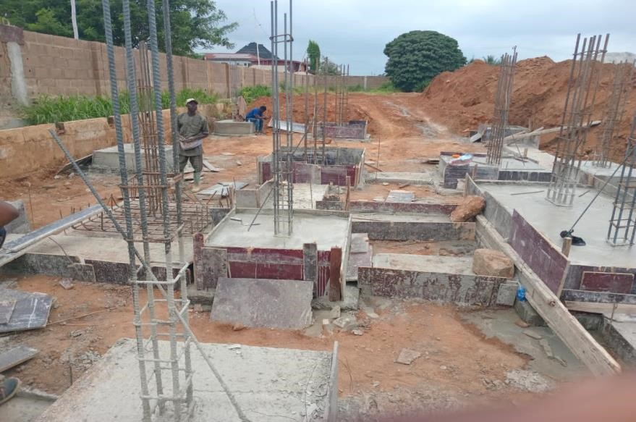

Combined Footing
Definition: A combined footing supports two or more columns or walls that are closely spaced, often used when the columns are too close together for isolated footings to be practical.
Usage: Ideal for situations where columns are closely spaced or when one of the columns is subjected to less load, requiring a larger footing to distribute the total load evenly.
Design: Combined footings are designed to support multiple loads and distribute them evenly to the soil. They often have a wider footprint than isolated footings to accommodate the combined loads.
Construction: More complex than isolated footings, as they require careful design to ensure that the load distribution is balanced and that the footing can support the combined weight of the columns.
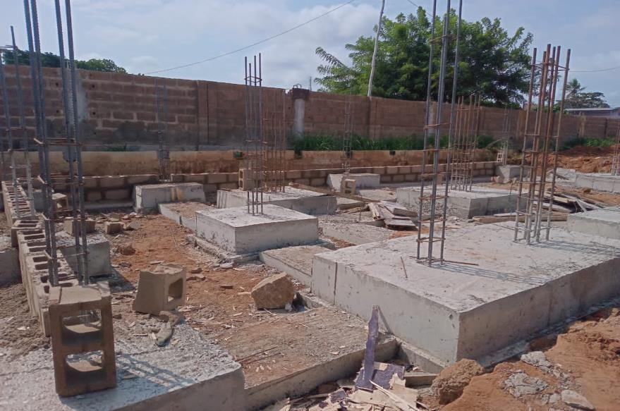

3.9 LAYING OF BLOCKS
Step 1: Build Foundation
After determining the boundaries of your project with chalk, you need to create the basis of the project. Start by making a mortar bed. Make sure that the thickness of the mortar bed is between 2.5 cm and 4 cm.
Step 2: Place Corner Block
Place corner block in the mortar bed so that it fits the borders that you have drawn with chalk. You have to be very careful at this stage.
Because the rest of the project will be shaped on this basis. Be sure to properly place the block using a variety of equipment.
Step 3: Adjust Height
Draw lines evenly spaced of approximately 1 meter on a wooden stick so that each tier of concrete blocks can be at the proper height. When you insert the blocks, take measurements with this wooden stick. Press the blocks as much as possible to make the alignment properly. If the level of blocks is low, remove and make it again with a little more mortar.
Step 4: Prepare Other Block
Place the other block on the side of the first block you have placed. To do this, apply mortar to the both sides of the concrete block with a trowel. Thanks to this mortar, the appropriate distance between the concrete blocks will be achieved.
Step 5: Place Other Block
When placing the block, be sure to leave enough space that does not exceed 1 cm between the first block and the second one. Repeat these operations on all the blocks you will line up side by side.
Step 6: Continue Laying
When you have finished laying the three blocks side by side, you can start laying another layer of concrete blocks. Before you start adding new blocks, be sure to check whether they are at balance with the spirit level.

3.10 SPIRIT LEVEL
Spirit levels are indispensable tools used to assess the alignment of surfaces, whether they're meant to be perfectly vertical (plumb) or horizontally level. The term "spirit" in their name refers to the liquid enclosed within the level's vial. This liquid, often alcohol or another low-freezing-point substance, houses an air bubble whose position serves as a precise indicator of the surface's levelness or plumpness.

How to use spirit level
Placement: Position the spirit level on the surface you want to level. Ensure it sits firmly without wobbling.
Observation: Look at the bubble inside the vial. This bubble indicates whether the surface is level or plumb.
Alignment: Adjust the surface until the bubble rests between the two guideline marks. For horizontal leveling, make sure the bubble is centered. For vertical leveling, align the bubble with the center mark.
Calibration (Optional): To ensure your spirit level is calibrated properly, place it on a flat surfaced note the bubble's position. Then, rotate the level 180 degrees and compare the bubble's position again. If the bubble shifts, you may need to adjust the vial. Most spirit levels have a screw that allows for calibration. Turn the screw until the bubble aligns in the center for both orientations.

3.11 DAMP PROOF MEMBRANE D.P.M
Site preparation:
Level the ground and remove any debris before laying the membrane.
Measure and cut:
Measure the area and cut the damp proof membrane to size, allowing for overlaps at seams.
Laying the membrane:
Unroll the membrane on the prepared ground, ensuring it covers the entire foundation area.
Secure the membrane:
Use appropriate fasteners or adhesives to secure the membrane to the walls and overlaps, depending on the membrane type.
Concrete pouring:
Once the membrane is properly installed, pour the concrete foundation on top of it.

3.12 SANDFILLING
Sand filling refers to the process of placing and compacting sand into excavated areas, voids, or depressions in the ground. This technique is used to improve the ground conditions by filling gaps, providing a level surface, and enhancing the overall stability of the construction site. Sand filling can be applied in various construction contexts, including foundations, embankments, and road construction.
The primary objectives of sand filling are:
- Leveling: To create a smooth and even surface for the placement of construction materials.
- Stabilization: To enhance the stability of the ground by filling voids and reducing the risk of settlement.
- Protection: To shield underlying layers from damage and contamination during construction activities.

CHAPTER FOUR 4.1 RECOMMENDATION
- I would recommend that the kwara State polytechnic should improve the school by assisting the SIWES student with computer and modern technology and it would lead to create development of the school
- I would recommend that the department of Civil Engineering in kwara State should expose student to practical skill and allow them to practice until they understand it perfectly well.

4.2 CONCLUSION
Student Industrial Work Experience Scheme is very Essential for all student to be able to understand what their cause of study will present to them after graduation and also learn beyond what you they will be able to learn in school.
SIWES is really helping student a lot by also allowing student to connect with people that are already practicing in the field. All thanks to the Government, Kwara State Polytechnic and my Department.

Reference
• Kwara State Polytechnic Students SIWES Manual

