
KWARASTATEPOLYTECHNIC,ILORIN

PROJECT SEMINAR PROPOSAL ON DESIGN AND CONSTRUCTIONOF 2 KVASOLAR PO

ND/23/EEE/PT/177

SUPERVISEDBYMRS.MUSTAPHAHUSSE
PRESENTEDTO
DEPARTMENTOFELECTRICAL& ELECTRONIC
INSTITUTE OF TECHNOLOGY KWARASTATEPOLYTECHNIC,ILOR

JANUARY,2025

PROJECTOUTLINE
- INTRODUCTION
- PROBLEMSTATEMENT
- AIM
- OBJECTIVE
- SCOPE
- LITERATUREREVIEW
- METHODOLOGY
- CONCLUSION
- REFERENCES

INTRODUCTION

The global demand for renewable energy solutions has risen significantly due to the growing concerns over climate change, energy security, and the depletion of fossil fuels. Solar energy, being one of the most abundant and sustainable sources of energy, plays a crucial role in addressing these issues. A solar-powered inverter is an essential component in solar energy systems, converting the direct current (DC) output from solar panels into alternating current (AC), which is used by most electrical appliances.

This proposal aims to design and construct a 2 kVAsolar-powered inverter. The inverter will convert DC from a solar array into AC that can be used to power small to medium household appliances or serve as a backuppower system inareas with unreliablegrid electricity.

PROBLEMSTATEMENT

The primary challenge faced in many regions, especially rural areas, is the lack of reliable access to electricityfrom thegrid.Solar energy offers a sustainablesolution,but efficient and affordableinverters areoften not readily available.Many inverters on themarket are expensive, requirehighmaintenance,or arenotsuitedfor smalltomedium-scalesolar power systems. This project aimsto design an affordable, efficient, and reliable solar-powered inverter with a capacityof 2 kVA, whichwill caterto theneedsof homes andsmall businesses.

AIM

Designandconstructionof2kVAsolarpoweredinverter

OBJECTIVE

Themainobjectivesofthisprojectare:
- Todesigna2kVAsolar-powered inverterthatefficientlyconvertsDCpowerfromsolar panels toAC power.
- Toconstructtheinverterusingreadilyavailableandcost-effectivecomponents.
- To ensurethattheinverterisefficient,compact,andreliablefor residentialor small commercial applications.
- Totestandevaluatetheperformanceoftheinverterundervariousloadconditions.
- To incorporatesafetyfeaturessuchasover-voltage protection,shortcircuitprotection,and thermal shutdown.

SCOPE
Thisprojectwillinvolve:
  - Designing theinvertercircuit:Thisincludesselectingsuitablecomponents(suchasMOSFETs, diodes, capacitors,and transformers)and designing the overall topology of the inverter.
  - Constructionoftheinverter:Assemblingthecomponentsonaprintedcircuitboard(PCB)andtesting
thecircuitforfunctionalityandperformance.
  - Solar panelintegration:Ensuringtheinverteris compatiblewith theDC outputfroma solarpanelarray, typically operatingat 12V, 24V, or 48VDC.
  - Testingandoptimization:Conductingteststoensuretheinvertermeetstherequiredoutput
specifications(220VAC,50Hz)andperformsefficientlyunderdifferentloadconditions.
  - Safety and protectionfeatures:Incorporatingfeaturessuchas over-voltage protection,under-voltage protection, over-temperature protection, and short circuit protection.

LITERATUREREVIEW

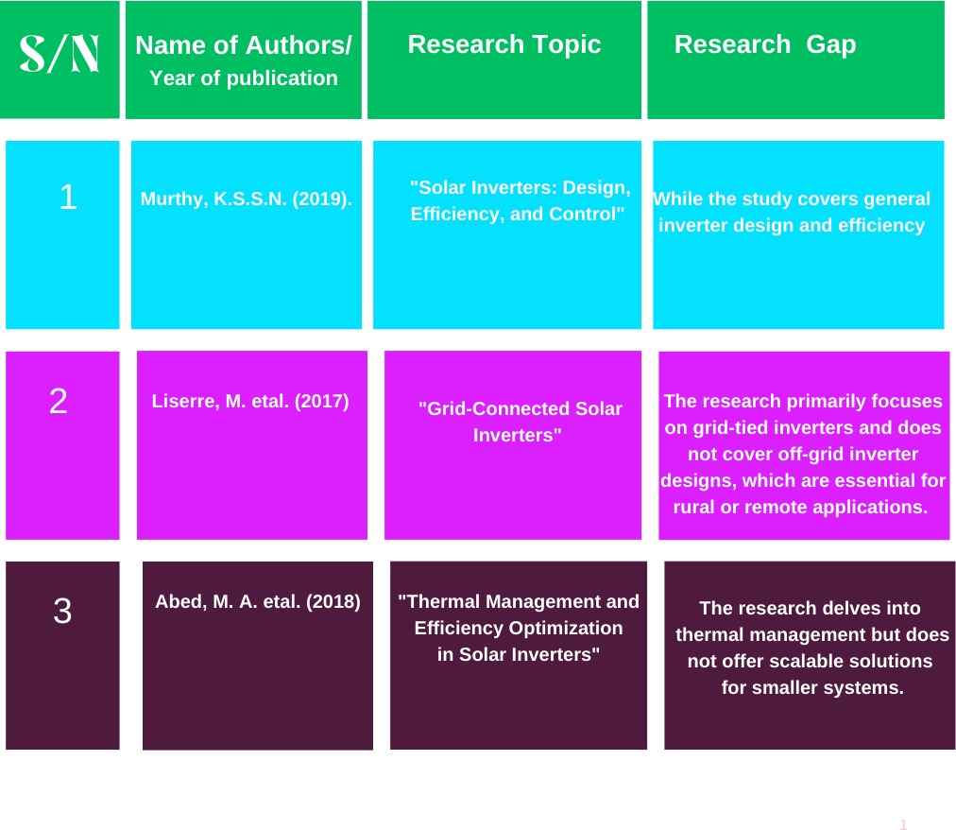

METHODOLOGY
Themethodologyfortheproject willfollowthesestages:
- LiteratureReview&ConceptualDesign:
Review existingsolarinverterdesigns,focusingonefficiency, reliability,andcost-effectiveness.Definethesystem specifications anddeterminethe technical approach based on the literature review.
- DetailedDesign:
Usingsimulationtools(e.g.,MATLAB,Simulink,orPSpice),designtheelectricalschematicandlayoutoftheinverter.Identifythekeycomponentsand
designthecontrolalgorithmfortheinverter'soperation.
- ComponentProcurement:
Procurethenecessarycomponentssuchasmicrocontrollers,transformers,transistors,capacitors,resistors,etc.
- PrototypeConstruction&Testing:
Buildtheprototypeandtestitunderavarietyofconditions,measuringkeyparameterssuchasefficiency,voltagestability, currenthandling,andthermal
performance.
- FinalAssembly&Deployment:
Uponsuccessfulprototypetesting,finalizethedesignandassemblyofthecompleteinverter system.
- PerformanceEvaluation:
Performlong-termtestingofthefinalproductundersolarirradianceandvaryingloadconditionstoensureitmeets performancerequirements.
- Documentation&Training:
Createusermanuals,maintenanceguides,andoffertrainingforend-usersonhowtouseandmaintaintheinverter.

METHODOOGYDIAGRAM

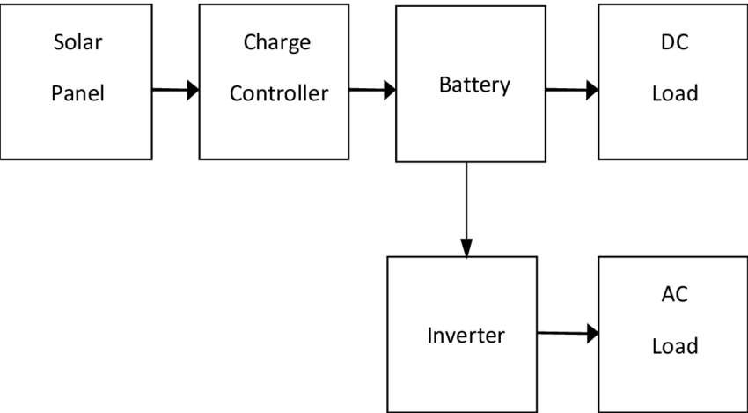

CONCLUSION
The design andconstructionof a 2kAVsolar-powered inverter will contributetothe growing need for sustainableenergy solutions.This project will providean affordable, reliable, andefficientinverterfor residentialandsmallcommercialapplications,offering long-term benefits for energy users while reducing carbon footprints.Successful completion of this project will not only demonstratetechnicalproficiencybut will also have a positiveimpacton energy accessibilityand environmentalsustainability.

REFERENCE
- Murthy,K.S.S.N.(2019)."Solar Inverters:Design,
Efficiency,andControl"
- Abed,M.A.etal.(2018)."ThermalManagement and Efficiency Optimization in Solar Inverters"
- Liserre,M.etal.(2017). "Grid-ConnectedSolarInverters"

