A TECHNICAL REPORT
ON
STUDENT INDUSTRIAL WORK EXPERIENCE SCHEME (SIWES)
Held At
BAMEED DIGNOSISTIC CENTER
BY
BAMIGBADE BAMISHE
ND/23/SLT/PT/0792

SUBMITTED TO
THE DEPARTMENT OF SCIENCE LABORATORY TECHNOLOGY (PHYSICS UNIT), INSTITUTE OF APPLIED SCIENCE, KWARA STATE POLYTECHNIC, ILORIN

IN PARTIAL FULFILLMENT OF THE REQUIREMENT FOR THE AWARD OF NATIONAL DIPLOMA (ND) IN SCIENCE LABORATORY TECHNOLOGY (SLT).

APRIL, 2025

CHAPTER ONE
1.0 INTRODUCTION AND MEANING OF SIWES
The Student Industrial Work Experience Scheme [SIWES] was purposely introduced to enable student whose courses are practical oriented like sciences, environmental and engineering course to have the practical knowledge of the theories they were been taught in the school. The program [SIWES] was established in the year 1973 by the government of Nigeria This exercise is been conducted and monitored by the industrial training fund [I.T.F].
1.1 DEFINITION OF SIWES AND HIGHLIGHTS OF ITS AIMS AND OBJECTIVES
Student Industrial Working Experience Scheme (SIWES) can be defined as the practical experience of student in order to have quality control and satisfactory performance, when in the field. The word SIWES can simply be defined as a body or person (Student) who is interested in a particular subject who is connected with the peoples and activities involved in producing a particular thing (Industrial) by involving a hard physical work rather than office work, in other to gain knowledge and skills through the job undergo for a period of time (experience) under a system for organization things (Scheme).
Student Industrial Working Experience Scheme (SIWES) was established by ITF in 1973 to solve the lack of adequate practical skills preparatory for employment in industries by Nigeria Graduate of Tertiary Institution. The scheme exposes student of industry based skills necessary for smooth transition from classroom to the word of work. It affords student of Tertiary Institutions the opportunity of being familiarize and exposed in handling machinery and equipment which are usually not available in the educational institution. The Industrial Training Fund (ITF) was set up under Act No: 47 of 1971 (as mended up to date) to promote and encourage the acquitting of skill industry and commence with a view to generating a pool indigenous trained man power sufficient to meet the need of the economic student are advisable to spend this SIWES period in the field related to their course of study, so as to stand a better chance of facing challenges in their respective sectors of student. However, the SIWES period usually span is between four and six months depend on institutional adoption.
1.2 AIM
The aim of SIWES is to make education more relevant and to bridge the yawning gap between the theory and practice of engineering, technology and science related disciplines in Tertiary Institution in Nigeria.
1.3 OBJECTIVES
- To help curbing the problem of lack of adequate practical skills in preparatory for employment in industries by Nigeria graduates of Tertiary Institutions.
- To afford student of Tertiary Institution the opportunity of being familiarized and expose of the needed experience in handling machinery and equipment which are usually not available in the Educational Institution.
- To promote and encourage the acquisition of skills in Industry and commence with a view to generate indigenous trained man power sufficient to meet the need of the economy.
- To expose the student and broaden their knowledge on the practical aspect of the course they are pursuing in their various schools.
- To improve the technology development in the country.
- The scheme exposes student to industry based skills necessary for a smooth transition from the classroom to the world work.
The industrial fund as a human resources development organization has its core mandate to be that of training to improve the performance of the industrial work in the economy by training for skills acquisition and improvement of work process.
1.4 MEDICAL LABORATORY
This can be explain in various ways such as a room or place for studying, Teaching, learning and research with appropriate equipment and facilities for testing methods and science work carried out.
A laboratory can be refer to as supreme court where all science invention difficulties challenges and secret are carefully revealed and analyzed to the reliable truth are established.
According to various definitions above a “place” mentioned means laboratory is a place where ignorance about technology is eliminated and new scientific knowledge and practices are introduced which means “if you don’t think about the foundational of knowledge you will surely die in the desert of ignorance
1.5 VARIOUS LABORATORIES
There are many laboratories with their various experiement carried out such as:
- Dots laboratory
- HCT laboratory
- Diagnosis laboratory
- Pediatrics laboratory
Dots Laboratory
This is a place where LTV, PT, HbsAg has been carried out to determine the value and occurances change in body using blood, serum, or urine.
Peadiatrica Laboratory
This is a place ehere experiement like BG, widal, PCV, and urinalysis has bbeen carefully analized to determine the group, percentage and change on the sample using urine and blood as a sample.
1.6 LABORATORY APPARATUS
There are many types of Laboratory apparatus but some are listed below.
- Centrifuge machine
- Electrophoresis machine
- Needle & syringe
- Plan & EDTA bottle
- Kit;- unigold, mp, etc.
- Capillary tube
- Pipette bottle
- Blood lancet
- Microscope
- Beaker & cup
- Picker & scissors
- Slider & slide box
- Drying & staining rack
- Tiles
- Filter paper
- Applicator stick etc.

LABORATORY APPARATUS
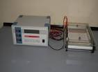 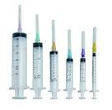 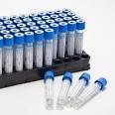Electrophoresis machine Needle & syringe Plan & EDTA bottle

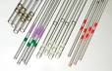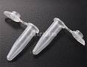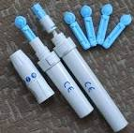
Capillary tube Pipette bottle Blood lancet
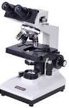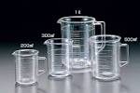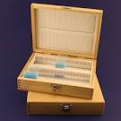
Microscope Beaker & cup Slider & slide box

1.7 LABORATORY REAGENTS
There are many types of laboratory reagent but some are listed below;
- Blood sample: serum & plasma
- Urine
- Water
- Acid alcohol
- Methylene blue solution
- Carbon fusion
- Sulfuric acid
- Disinfectant soap
- Alcohol
- Gimser stain
- Immersion oil
Blood sample which is divided into two after spinning are serum and plasma.
Serum is the yellowish liquid coloured fluid part of blood which does not contain clotting factor and make up 6.8% of protein like albumin and globins.
Plasma is the free cell part of the blood which contains clothing factor and water with 55% of protein.
1.8 SOME TERMINOLOGIES USED IN THE LABORATORY
FBS: Fasting Blood Sugar
RBS: Random Blood Sugar
PCV: Packed Cell Volume
HIV: Human Immune Various
AIDs: Acquired Immune Deficiency Syndrome
HBsAG: Hepatitis B Surface Antigen
MP: Malaria Parasite
PT: Pregnancy Test
Widal: Typhoid Test
RSV: Retroviral Screening
LVT: Lentivrial Test
LFT: Liver function Test
KFT: Kidney Function Test
CHAPTER TWO
2.0 INTRODUCTION
2.1 HIV/AIDS
Aids (Acquired Immune Deficiency Syndrome) discovered in loss Angeles, USA in 1981 and are now one of the most deadly diseases ever to face a mankind which belongs to a group of RN (Ribonucleic Acid) virus referred to be RETROVIRUES. They capable of converting their RNA to DNA (Deoxyribonucleic Acid) utilizing an enzyme called reverse transcriptase. Cause by infection with human immunodeficiency virus (HIV) following initial infection, a person may experience a brief period of influenza-like illness. This is typically followed by a prolonged period without symptoms. As the infection progress, it interferes more and more with the immune system, making a person more susceptible to common infections like tuberculosis, as well as opportunistic influence and tumors that do not usually affect people who have working immune system. The late symptoms of the infection are referred to as AIDS., this stage is often complicated by an infection of lung known as pneumocysitis pneumonia, severe weight loss, and a type of cancer known as Kaposi’s sarcoma, or other AIDS-defining conditions.
Genetic research indicates that HIV originated in west-central Africa during the late nineteenth or early twentieth century, AIDS was first recognized by the united state center for disease control and prevention (CDC) in 1981 and its-cause HIV infection was identified in early part of the decade. Since its discovery, AIDS has caused an estimated 36million death worldwide (as of 2012). HIV/AIDS is considered a pandemic-a disease outbreak which is present over a large area and is actively spreading.
HIV/AIDS has had great impact on society, both as an illness great and as a source of discrimination. The disease also has significant economic impacts. There ate many misconceptions about HIV/aids such as the belief that it can be transmitted by casual non-sexual contact. The disease has also become subject to many controversies involving religion. It has attracted international medical and political attention as well as large scale funding.
2.2 SIGN AND SYMPTOM
There are three main stages of HIV infection: acute infection, clinical infection, latency and AIDS.
Acquired immunodeficiency syndrome (AIDS) is defined in terms of either a CD4+T cell count below 200 cells over U1 or the occurrence of specific disease in association with an HIV infection. In the absence of specific treatment, around half of people infected with HIV develop AIDS within ten years. The most common initial conditions that alert to the presence of AIDS are pneumocystic (40%), cachexis in the form of HIV wasting syndrome (20%) and esophageal candidacies. Other common sign include recurring respiratory tract infections. Opportunistic infections may be caused by bacteria, viruses, fungi and parasites that are normally controlled by the immune system. Which infections occur partly depends on what organisms are commonly in the person’s environment. These infections may developing various viral induce cancers nervous system lymphoma and cervical cancer. Kaposi’s sarcoma is the most common cancer occurring in 10-20% of people with HIV. The second most common cancer is lymphoma which is the cause of death of nearly 16% of people with AIDS and is the initial sign and AIDS in 3-4%. Both these cancers are associated with human herpes virus

2.3 SCREENING TO DETERMINE THE VIRAL IN THE BLOOD SAMPLE
Application and Reagent used are determined kit, unigold kit, Start Park, chase buffer, blood lancet, alcohol pad, (swab) and blood or serum sample.
PROCEDURE
STEPI: wear and clean the hand tip with swab, then pick with lancet drop the blood sample on the hole-like of either kits or the white dot surface on the top of the determine kit add a drop of chase buffer if withdrew sample is not too much.
STEP II: allow the reaction for 10-15 min for clearly and confidentially reacts, after allowing it to react, double lines appears on the control window of kit which means reactive and report as positive, and a single line means Non reactive and report as negative. While the absences of the lines means invalid. Note an invalid and negative patient should retest after 3 months because of the window period.
LOCATION OF THE VIRUS IN THE HOST
- Blood
- Brest milk
- Virginal secretion
- Semen
- Serum

2.4 DIAGRAM TO ILLUSTRATE AND DIAGNOSIS THE NON-COLD CHAIN DEPENDENT TEST KIT OF THE HIV/AIDS TEST
BLOOD SAMPLE
TEST 1
DETERMINE KIT

NON REACTIVE REACTIVE
Report as Negative
U UNGROUP Kit
TEST 2

NON REACTIV REACTIVE
TEST 3

NON REACTIV REACTIVE
Report as Negative Report as Positive

HIV/AIDS screening is recommended by both the united state preventive services task force for all people 15 years to 65 years of age including all pregnant women. The infectious (Virion) contain an inner core participate enclosing viral genome, antibodies specific to the hepatitis B core antigen may be the only serological evidence of disease. Therefore most hepatitis B diagnostic panels contain HBsAG and total antigen

2.5 TRANSMISSION
Average per act risk of getting HIV by exposure route to an infected source
EXPOSURE ROUTINE | CHANGE OF INFECTION
Blood transfusion | 90%
Childbirth (to child) | 25%
Needle sharing injection drug use | 0.65%
Percutaneous needle stick | 0.30%
Receptive anal intercourse | 0.04-3.0%
Insertive anal intercourse | 0.03%
Reception penile-vaginal intercourse | 0.05-0.30%
Insertive penile-vaginal intercourse | 0.01-0.38%
Reception oral intercourse | 0-0.04%
Insertive oral intercourse | 0-005%
Assuming no condom use source refers to oral intercourse perform on a man

2.6 PREVENTION
Honestly since the virus has been discovered NO known cure has also been discovered but yet there are still many ways of controlling it.
- National mass campaign to educate everybody about the danger of HIV/AIDS how it spread and how to avoid it.
- Use condom when having sex (but not 100% safe).
- Avoid transfusion of unsterilized blood and other sharp object
- Pro-exposure
- Post-exposure
- Vaccination
Note: HIV/AIDS virus attacks, infects and destroy certain cells of the white blood cells called Helper T or Lymphocytes which are responsible for the immune system of the body

CHAPTER THREE
3.0 INTRODUCTION
3.1 BLOOD GROUP
A blood type (also called a blood group) is a classification of blood based on the presence or absence if inherited antigens substances on the surface of red blood cells (RBCs). There antigens may be protein, carbohydrate, glycolipids depending on the blood group system. A blood type is inherited and represents contribution from both parents. The two (2) most important ones are ABO and RhD antigens; they determine someone’s blood type (A, B, AB, and O with + or –denoting RhD status.
TO DETERMINE THE BELONGED GROUP OF THE BLOOD SAMPLE
Apparatus and reagent needed are blood sample, swab, anti sara A, B, and D, needle and capillary tube.
STEP I: warm and clean the hand tip with swab then pick with needle and withraw the sample by capillary tube and put the sample on the tile into a three place-like dot each label A, B, and D then add the anti sera reagent A, B, and D to each sample label dot then stir and shake the sample for the reaction.
STEP II: after staring and shaking the blood sample on the each reagent will start coagulate or normal. Since the grouping is subjected to four types has it mentioned above.
3.2 RED BLOOD CELL COMPATIBILITY
- Blood group AB: individuals have both A and B antigen on the surface of their RCBs, and their blood plasma does not contain any antibodies agent either A or B antigens. Therefore, an individual’s agents with AB blood can receive blood from any group other than AB. They are known as universal recipients.
- Blood group A: individuals have the A antigen on the surface of their RBCs, and blood serum containing IgM antibodies agent the B antigen. Therefore, a group individual can receive blood only from individual of group A or O (with a being preferable), and can donate blood to individual with type A or AB.
- Blood group B: individual have the B antigen on the surface of their RBCc and the blood serum containing IgM antibodies agent the A antigen. Therefore, a group B or O (With B begin profitable, and can donate blood to individuals with type B or AB.
- Blood group O: individual do not have either A or B antigens on the surface of their RBCs, and their blood serum contains IgM anti-B antibodies against the A and B blood group antigens. Therefore, a group o individual can receive blood only from a group O individual, but can donate blood to individuals of any AOB blood group (i.e., A, B, AB or O).

RED BLOOD CELL COMPATIBILITY CHART
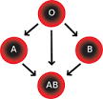
in addition to donating to the same blood group; type O blood donors can give to A, B and AB: blood donors types A and B give to AB.
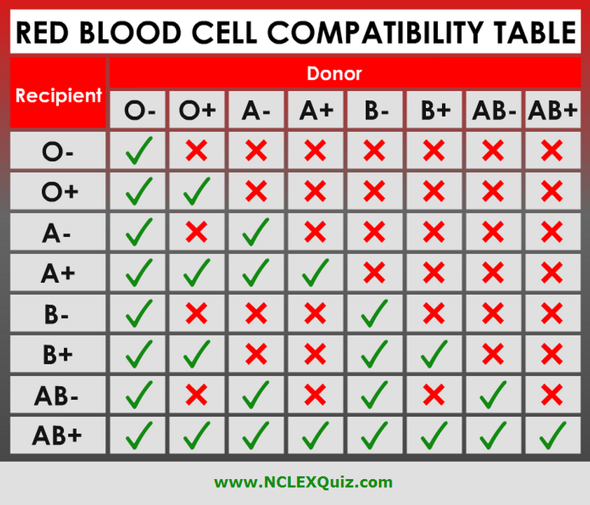
Assumes absence of typical antibodies that would cause an incapability between donor and recipient blood, as is used for blood selected by crossing-matching
An RhD-negative patient who does not have any anti-D antibodies can receive a transfusion of D-positive blood once, but this would cause sensitization to the D antigen, and a female patient would become at risk for hemolytic disease of the newborn.
3.3 PACKED CELL VOLUME
Packed cell volume also erythrocyte volume friction or heamotocrit is the volume percentage of red blood cells in the blood. It is normally 45% for men 40% for woman. It is considered an integral part of a person’s complete blood count, and platelet count. Anemia refers to an abnormally low haematocrit, as opposed to polycythemia which refers to an abnormally low high haematocrit. Both are potentially life-threatening disorder.
3.4 SCREENING TO DETERMINE THE VOLUME OF BLOOD IN THE BODY
The packed cell volume (PCV) can be determined by centrifuging haparinizied blood in a capillary tube (also known as microheamotocrit tube) at 10, 00 RPM for five (5) minutes, it escape the blood into layers. The volume of packed red blood sample gives the PCV. Since a tube is used, this can be calculated by measuring the lengths of the layers.
READINGS
- Place the capillary tube on the reader in a way that the bottle of the tube corresponded with 0 mark and top level plasma should corresponded with 100 mark.
- Move the charge adjustable pointer to fall at the interfere between the bottom of the RBC and the top level plasma.
- Read the highest of the RBC and has the PCV is express in percentage.
RANGE OF THE PERCENTAGE
Every patient or individual has his /her own percentage but the range or volume will base on age breaker which means
- Men 45 - 54%
- Women 35% - 45%
- Children 55% - 75%
- Infant 75% - above.
Calculation; using an ordinary capillary tube means subtract 2 from the original result which means the highest of RBC in the capillary tube at 10% while the lower level at plasma on 0%.
3.5 ADVANTAGES OF SCREENING (PCV)
- For detect anemia
- To know if the RBC is packed correctly
- To know the amount of red blood cell in the whole body
- For detecting polyetemia
3.7 RISK DEVELOPING ANEMIA
- Infant without adequate iron intake
- Children going through a rapid growth sport, during which the iron available cannot keep up with the demands for growing red cell mass.
- Menstruating woman, which have a greater need for iron because of blood loss during menstruation.
- Pregnant woman, in which the growing fetus create a high demand for iron.
- Patient with chronic kidney disease whose kidney no longer secrete sufficient level of the hormone erythropoietin that promotes RBC proliferation

CHAPTER FOUR
4.0 INTRODUCTION
4.1 MALARIA PARASITE
Malaria is a mosquito-infectious disease of human and other animal caused by parasitic protozoan (a type of single cell microorganisms) of the plasmodium type. Malaria causes symptoms that typically include fever, fatigue, vomiting and headache. In several symptoms, usually been ten to fifteen days after bitten. I those who have recently survived an infection, re-infection typically caused milder symptoms. This partial resistance disappears over months to years if there is no longer ongoing exposure to malaria.
Commonly, the disease is transmitted by the bite of an infected female anopheles mosquito. This bite introduces the parasites from the mosquito saliva into a person’s blood. The parasite then travel to the liver where they mature and reproduce.
Five species of plasmodium can infect and be spread by humans. Most deaths are caused by;
- Plasmodium falciparum
- Plasmodium vivax
- Plasmodium ovale
- Plasmodium malaria
Generally cause a milder form of malaria. The species Plasmodium Knowlesi rarely causes disease in humans. Malaria is typically diagnosed by the microscopic examination of blood using blood films, or with antigen based rapid diagnostic test.
4.2 RECURRENT MALARIA
Malaria infection develops via two phases. One that involves the liver (exoerthrocytic phase), and one that involves red blood cell or (erythrocytic phase) when an infected mosquito pierces a person’s skin to take a blood meal, sporozites in the mosquito’s saliva enter the bloodstream and migrate to the liver when they infect hepatocytes, multiplying asexually and asymptomatically for a period of 8-30 days.
4.3 COMPLICATION OF MALARIA
There are several serious complications of malaria among those is the development of respiratory distress which occurs in up to 25% of adults and 40% of children with severe O. faciparum malaria. Possible causes include non-cardiogency pulmonary oedema, concomitant pneumonia and severe anemia. Although rare in young children with severe malaria, acute respiratory distress syndromes occur in 5-25% of adults and up to 29% of pregnant woman. Co-infection of HIV with malaria increases mortality. Renal failure is a feature of black water fever, where hemoglobin from lysed red blood cells leaks into the urine.
Malaria in pregnant woman is an important cause of stillbirths, infant mortality and low birth weight, particularly in P. Faciparum infection but also with P. vivax.
4.4 LIFE CYCLE OF MALARIA PARASITE
In life cycle of malaria parasite, a mosquito causes an infection by a bite. First, sporozoites enter the blood stream, and migrate to the liver. They infect liver cells, where they multiply into morozoites rupture the liver cells and return to the blood stream. Then the merozoites infect the red blood cell where they develop into ring rorms, trophozoites and schizonts that in turn produce further merozoties. Only female mosquito feed on blood; male mosquitoes feed on plant nectar, and thus do not transmit the disease. The female of the anopheles genus of mosquito prefer to feed at night. They usually start searching for a meal at disk, and will continue throughout the night until taking a meal. Malaria parasites can be transmitted b blood transfusion; although this area is rare.

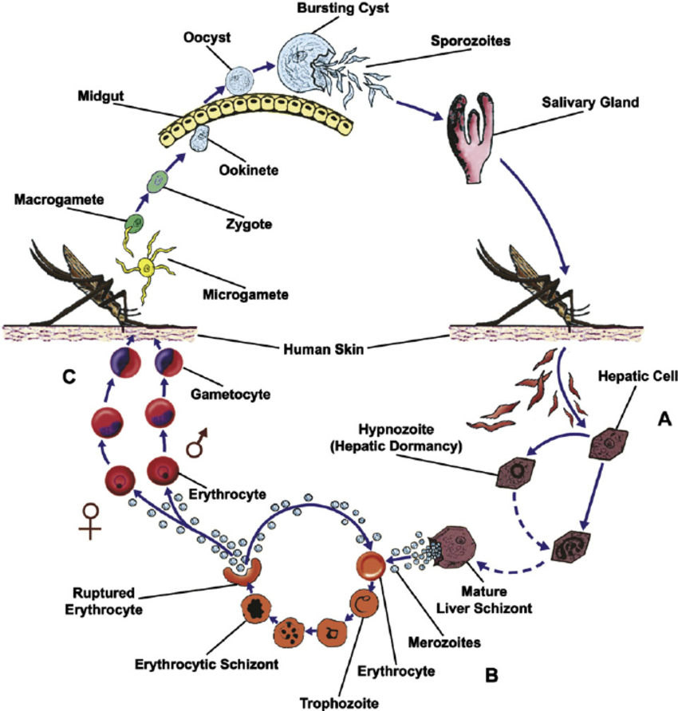
LIFE CYCLE OF MALARIA PARASITE

CHAPTER FIVE
5.0 CONCLUSION & RECOMMENDATIONS
5.1 CONCLUSION
During my period at the UITH Ilorin Kwara State as a SIWES student, I was taking to the laboratory by my supervisor and classify some information about the health Center and I also participate in some activities like taking of blood samples.
5.2 RECOMMENDATIONS
The main problem encountered during the programme was problem of transportation. It is difficult for student that leaves in far place to get to the organization every day, so I recommend that the Government should make sure that provision is made for certain sum of money which will be given to students for their transportation..
5.3 PERSONAL IMPRESSION ABOUT THE ORGANIZATION
My personal impression about the organization is good simply because the organization has a conducive environment and most importantly have a good and loving staffs, that are caring and has a great understanding.
5.4 SUGGESTIONS / RECOMMENDATIONS TO THE ORGANIZATION AND THE POLYTECHNIC CONCERNING SIWES PROGRAMME
For a smooth SIWES programme the polytechnic and the organization must take note of the following:-
- The organization should make adequate provision in the annual budget of proper funding of SIWES in view of the potentials of the scheme to con tribute in enhancing the quality of the pool of technical skills available to the economy.
- In other to guarantee quality assurance of the scheme there is a need for thorough supervision of SIWES participant by the institution and the ITF.
- The ITF in collaboration with institution should evolve minimum standards in respect of SIWES and develop, monitor and review job specifications to guide the training of students.
- The institution and the organization should make the student realize that SIWES is not an holiday job but a course of study designed to enhance the relevant production skills and employability after graduation.
The institution needs to double effort in securing quality places of industrial attachment for student during SIWES.

