A
TECHNICAL REPORT
ON
STUDENT INDUSTRIAL WORK EXPERIENCE SCHEME (SIWES)
AT
IBADAN ELECTRICITY DISTRIBUTION COMPANY
(IBEDC)
BY
ADAM ABDULLAHI OLAMIDE
MATRIC NO: ND/23/EEE/PT/0054
SUBMITTED TO
THE DEPARTMENT OF ELECTRICAL AND ELECTRONICS ENGINEERING
INSTITUTION OF TECHNOLOGY
KWARA STATE POLYTECHNIC ILORIN
IN PARTIAL FULFILMENT OF THE REQUIREMENTS FOR
THE AWARD OF BACHELOR OF ENGINEERING IN
ELECTRICAL AND ELECTRONICS ENGINEERING
STARTED SEPTEMBER 22ND, 2024
ENDED DECEMBER 30TH, 2024

DEDICATION
I dedicate this report to God who gave me the grace and strength to finish my SIWES program successfully and my parents who helped in providing all the necessary resources.

ACKNOWLEDGEMENT
I acknowledge the entire institution and staff of the Department of Electrical and Electronics Engineering, Kwara state polytechnic, Ilorin. Through their efforts, I gained theoretical knowledge translated into practical aspects.
I wish to take this opportunity to thank the host company Ibadan Electricity Distribution Company, for making my industrial training experience with them a distinct one. I am grateful to the Technical engineers, my supervisor, Head of technical engineers – Engr.Mrs. Jimoh, who provided me with timely assistance and valuable guidelines that helped me seamlessly traverse through my overall training experience. I express gratitude to the staff of every department at IBEDC whose guidance and support encouraged me to delve deeply into process details. And to every single individual who contributed to my growth and professional development in various ways during this period. I say a very big “thank you”.
This acknowledgment will remain incomplete if I fail to express my deep sense of obligation to God and my parents for their consistent blessings and encouragement during the training period.

TABLE OF CONTENTS
Dedication
Acknowledgment
CHAPTER ONE
1.1 Introduction
1.2 Scope of SIWES
1.3 Objectives of SIWES
CHAPTER TWO
2.1 Description of the establishment of attachment
2.2 Location of place of attachment
2.3 IBEDC Organizational Structure
2.4 About Place of Primary Assignment: Technical Department
CHAPTER THREE
WORK DONE
3.1 Job Responsibilities
CHAPTER FOUR
4.1 Tools and Technologies
CHAPTER FIVE
5.1 Summary
5.2 Problems Encountered
5.3Suggestions for Improvement
5.4 Conclusion

Report Overview
This report provides a comprehensive account of my Student Industrial Work Experience Scheme (SIWES) at the Ibadan Electricity Distribution Company (IBEDC). The program offered hands-on exposure to electrical engineering practices across various technical departments, including dispatch, 33kV crew, Protection and Control (P&C), Network Planning and Design (NP&D), fitter, and cable jointing sections.
The report outlines my learning journey through tasks such as power monitoring, high-voltage operations, relay testing, network planning, mechanical maintenance, and fault management in underground cables. It also highlights challenges encountered, such as resource constraints, high-voltage safety risks, and communication gaps, and provides recommendations for improving future SIWES experiences at IBEDC.
This experience not only strengthened my technical skills but also deepened my understanding of the essential safety protocols and collaborative practices required in the electrical power industry. The report concludes with reflections on how this program has prepared me for a professional engineering career, equipped with practical skills and industry insights.

CHAPTER ONE
INTRODUCTION 1.1 BACKGROUND The Industrial Training Fund established by decree 47 was introduced in 1971, vis-à-vis the birth of the Students Industrial Work Experience Scheme (SIWES) the same year by the Federal Government of Nigeria (FGN). It is an integral part of the requirements for the award of Certificates, Diplomas, and Degrees in higher institutions of learning i.e. Colleges of Education, Polytechnics, Universities, etc. Student Industrial Work Experience Scheme (SIWES) exposes students to industry-based skills necessary for a smooth transition from the classroom to work environments. It accords students of tertiary institutions the opportunity to familiarize themselves with the needed experience in handling machinery and equipment which are often found in such an educational institution.
1.2 SCOPE OF SIWES
SIWES is a skills acquisition program geared towards the nation's technological development. The SIWES scheme’s major aim is to bridge the gap between classroom learning and theoretical experience, guaranteeing that students not only see practical answers to every subject but also comprehend the workings of the labor market, ensuring that they are quickly absorbed into it.
VISION: To be the foremost human resource development institution in providing dynamic, need-based knowledge and quality-driven intervention for industrial skills development in Nigeria and one of the best in the world
MISSION: To set and control standards of excellence, and effectiveness and offer direct training of Professionals, technicians, technologists, and entrepreneurs to meet the human resource needs for rapid industrialization and sustainable economic development of Nigeria, by using best-of-breed training techniques and modern technology to produce highly motivated and competent products
1.3 OBJECTIVE OF SIWES
SIWES is aimed at providing skills for students in their various fields. Some of the various objectives the program put in place include;
- To solve the problem of inadequate practical skills, preparatory for employment in industries by Nigerian graduates of tertiary institutions.
- To provide students with relevant practical experience
- To familiarize students with typical environments in which they are likely to function professionally after graduation.
- To enlist and enhance industry involvement in university education.
- To promote and encourage the acquisition of skills in industry and commerce, with a view of generating a pool of indigenous-trained manpower sufficient to meet the needs of the economy.
- To provide access to equipment and other facilities that would not normally be available in the University workshop.
- Provide students with an opportunity to apply their knowledge in real work situations thereby bridging the gap between theory and practice
- To change the orientation of students towards the labor market when seeking jobs.
CHAPTER TWO
2.1 DESCRIPTION OF ESTABLISHMENT OF ATTACHMENT
The establishment of the Ibadan Electricity Distribution Company (IBEDC) is rooted in the Nigerian government's efforts to reform the power sector to enhance electricity supply and distribution. This reform was initiated through the Electric Power Sector Reform Act (EPSRA) of 2005, aimed at restructuring the National Electric Power Authority (NEPA) and encouraging private sector involvement in the power industry.
The Power Holding Company of Nigeria (PHCN), which succeeded NEPA, was unbundled into several independent entities focusing on generation, transmission, and distribution of electricity. This unbundling was designed to decentralize power management, improve efficiency, and attract private investment into the sector.
In November 2013, the Nigerian government privatized the distribution segment of PHCN, creating 11 distribution companies, including IBEDC. During the privatization process, Integrated Energy Distribution and Marketing Limited (IEDM) acquired IBEDC, taking over its operations with a mandate to enhance electricity distribution and customer service within its coverage area.
IBEDC serves a vast geographical area encompassing Oyo, Ogun, Osun, Kwara, and parts of Niger, Ekiti, and Kogi States. This extensive coverage makes IBEDC one of the largest electricity distribution companies in Nigeria.

IBEDC is organized into various departments such as Operations, Network Planning and Design, Protection and Control, Commercial, Customer Service, and Dispatch. These departments work collaboratively to manage the distribution infrastructure, respond to service disruptions, plan future network expansions, and ensure customer satisfaction. As a distribution company, IBEDC also plays a crucial role in connecting customers to the national grid, ensuring that electricity supply is consistent, and conducting maintenance on distribution lines and substations.
2.2 Location
Ibadan Electricity Distribution Company (branch) is located at Ojatun-tun along Baboko Road Ilorin Kwara state
2.3 IBEDC Organizational Structure
To profit from specialization and the division of labor, IBEDC divides its departments into those that perform particular responsibilities. This leads to lower unit costs and greater efficiency in internal processes. The departments are listed as follows:
•Customer Service Department
•Technical/Engineering Department
•Operations Department
•Health, Safety, and Environment (HSE) Department
•Human Resources (HR) Department
•Finance and Accounts Department
•Information Technology (IT) Department
•Legal Department
•Corporate Communications Department
•Procurement Department
•Audit and Risk Management Department
• Marketing and Sales Department
• Regulatory Affairs Department
• Administration Department
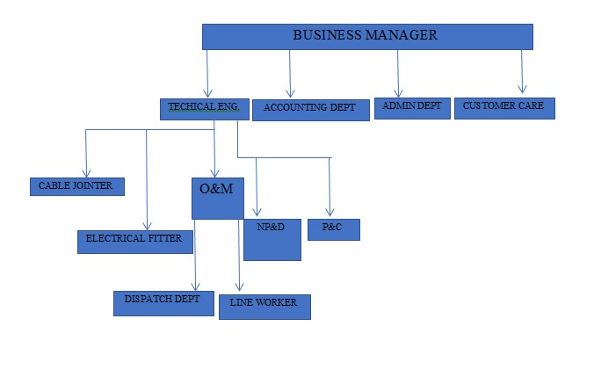

2.4 About Place of Primary Assignment: Technical Department
The technical department in the IBEDC (Ibadan Electricity Distribution Company) office plays a crucial role in ensuring the effective distribution and maintenance of electricity.
TECHNICAL DEPT
DISPATCH DEPT
NP&D DEPT
P&C
DEPT
33KV CREW DEPT
CABLE FITTER
DEPT

Organ gram of the Technical Department

Responsibilities of the Technical Department
Here are some of their primary roles:
- Ensure the continuous operation of the electrical distribution system.
- Perform regular maintenance on equipment and infrastructure to prevent outages.
- Plan and implement network expansion to accommodate new customers and growing demand.
- Upgrade existing infrastructure to improve efficiency and reliability.
- Monitor the network for faults and outages.
- Quickly respond to and repair issues to restore service to customers.
- Monitor and manage electrical load distribution to prevent overloads.
- Implement load-shedding strategies when necessary to maintain system stability.
- Ensure all technical operations comply with safety standards and regulations.
- Conduct regular safety inspections and training for technical staff.
- Address technical complaints and service issues reported by customers.
- Provide technical assistance and advice to customers regarding their electrical connections.
- Maintain records of network performance, maintenance activities, and incidents.
- Generate reports for management to aid in decision-making and strategic planning.
- Explore and implement new technologies to improve service delivery and operational efficiency.

CHAPTER THREE
WORK DONE
Throughout my four-month tenure at IBEDC (Ibadan Electricity Distribution Company), I was entrusted with a diverse range of responsibilities encompassing the entirety oftechnicalsupport and network designs. These duties played a pivotal role in guaranteeing the uninterrupted operation of the company's technical infrastructure and consequently, in augmenting overall productivity.
3.1 JOB RESPONSIBILITIES
- Electrical Maintenance and Repair of Cable
Responsibility: As an electrical student I assisted in performing scheduled maintenance to prevent faults, troubleshoot issues, and repair damaged components.
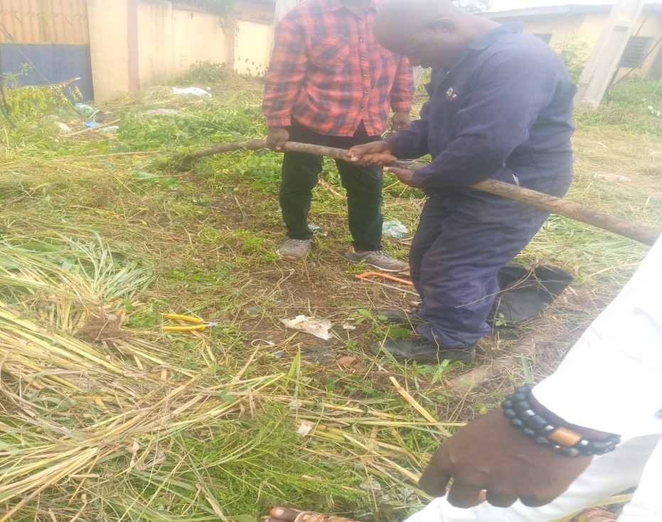
Termination and Re-termination of burnt underground cable
- Installation of Electrical Equipment
Responsibility: I aided the Engineers and technicians in the installation new equipment, ensuring it is done according to safety and regulatory standards.
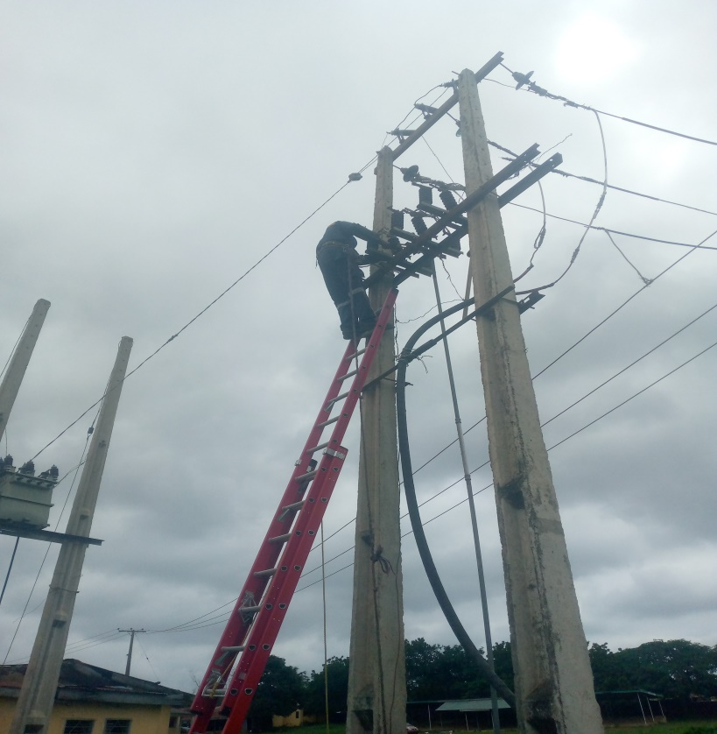
Replacement of silicon isolators with porcelain type isolators
- Fault Detection and Response
Responsibility: As part of my duties I implemented a rigorous schedule of Electrical restoration and faults detection and fixing together with the Engineers and technicians in the electrical network to restore power quickly.
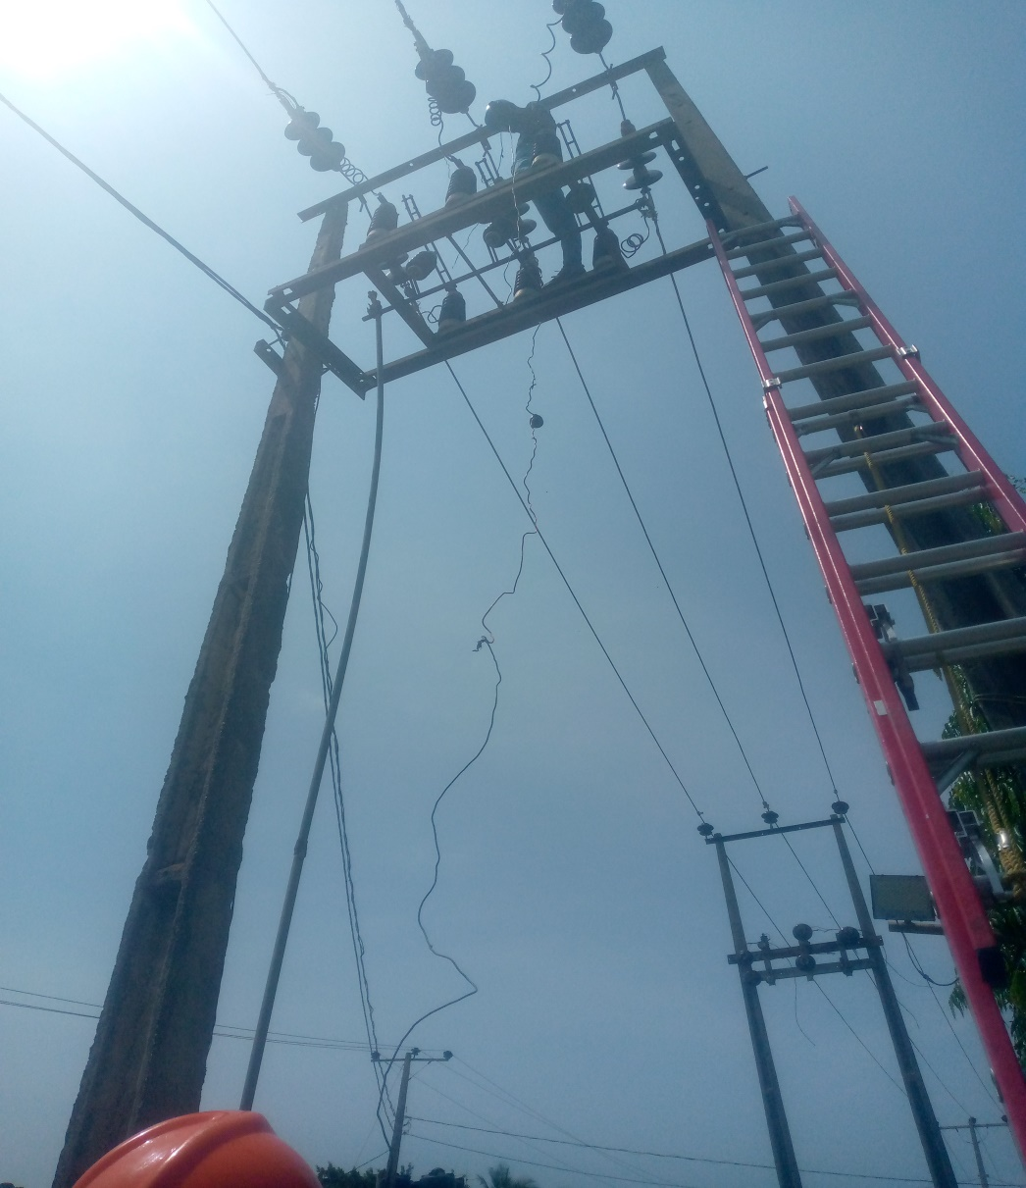
Testing the phases of an isolated part to check for fault using Meger tester
- Checking the Earth Resistance
Responsibility: I checked the earth resistance of different transformers using the earth resistance tester machine under the guidance of the protection and control engineer
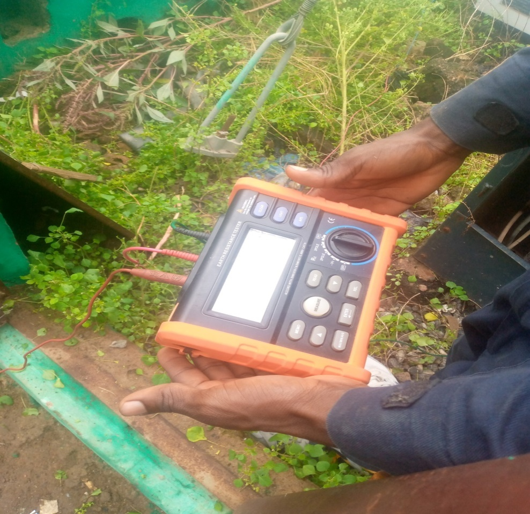
Testing the Earth Resistance of substation
- Power Outage Management
Responsibility: Engineers and supervisors plan for routine maintenance outages and I participated in managing emergency outages by ensuring quick restoration of power.

- Transformer Maintenance
Responsibility: I did oil level checks, inspecting insulation, testing for proper voltage levels, and cleaning parts to prevent overheating.
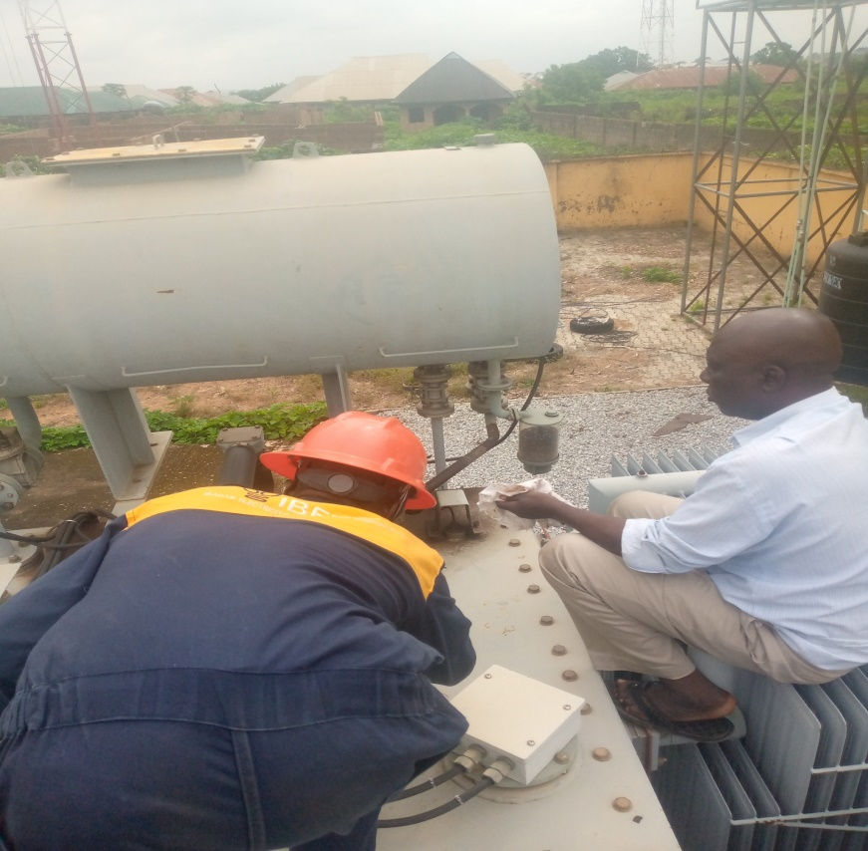
Checking the oil level at injection substation

- Transformer Testing
Responsibility: I conducted some tests which involve conducting insulation resistance tests, oil testing, and temperature monitoring to detect any early signs of malfunction.
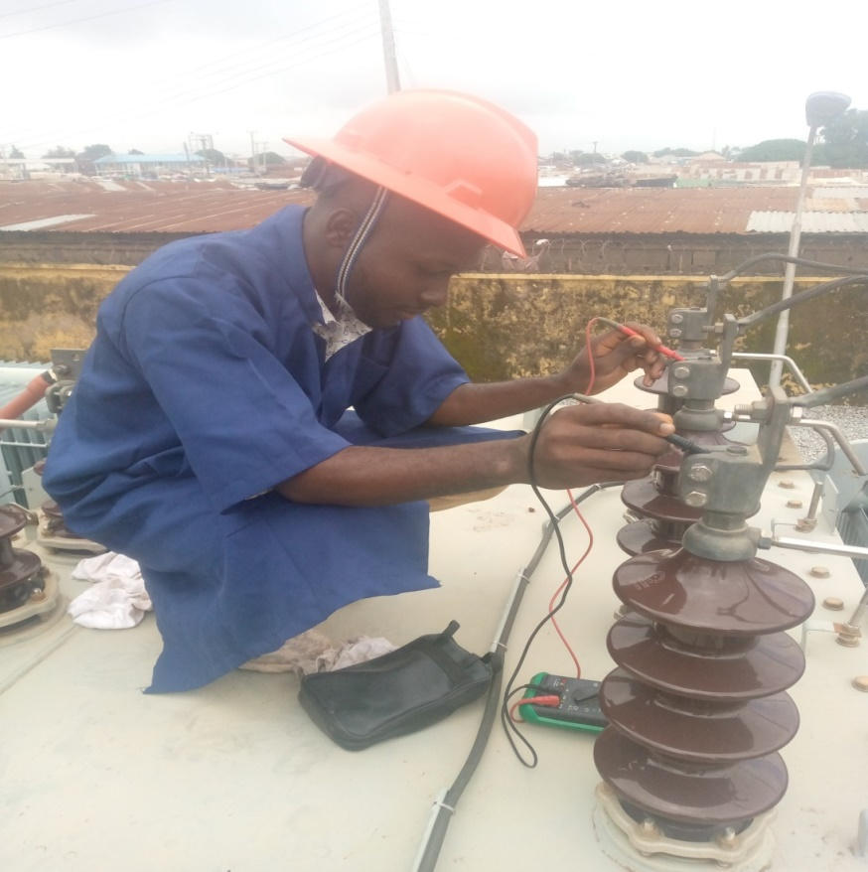
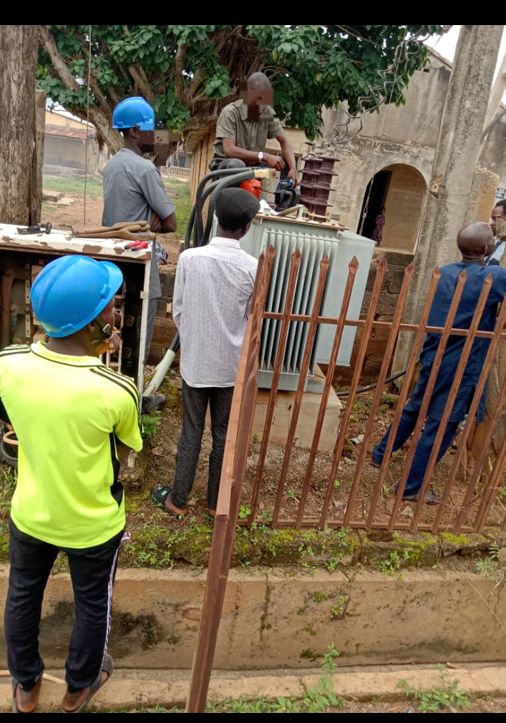
Bi-annual Maintenance at injection substation

- Network Design and Planning
Responsibility: I assisted the engineers in determining where to install substations, transformers, and cable routes. I also draw a schematic diagram under the guidance of my supervisor of a proposed 500KVA 33/0.415KV (KISHI RICE MILL NIGERIA LIMITED).
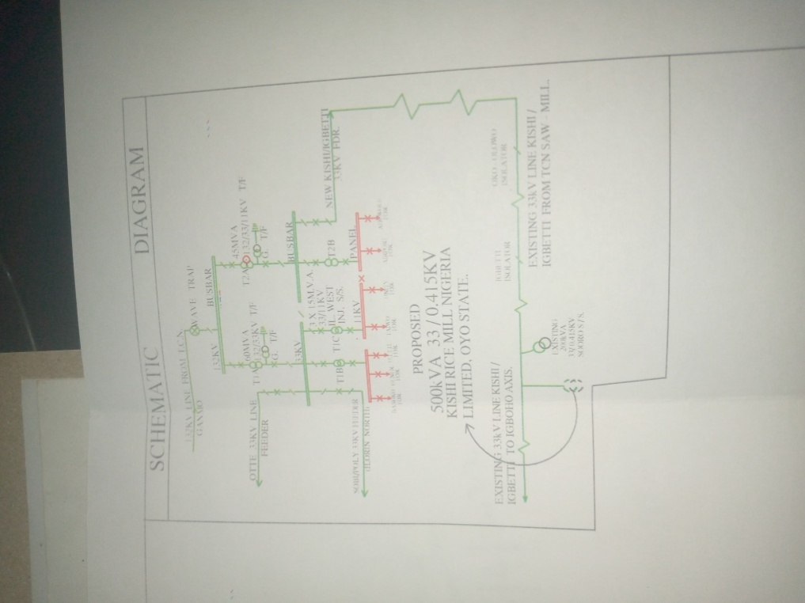
A schematic diagram of a proposed substation
- Load Forecasting and Demand Planning
Responsibility: I assisted the engineers in forecasting future electricity demand which helps in planning additional transformers, substations, and network reinforcements.
- Network Expansion
Responsibility: I participated in planning new routes for cables and expanding substation capacities to ensure reliable electricity supply to growing population areas
.
- Voltage Regulation and Stabilization
Responsibility: I aided the engineers in designing systems with automatic voltage regulators (AVRs) and capacitors to keep voltage levels stable across long distances.
- Energy Theft Detection and Prevention
Responsibility: I assisted the engineers in using data analytics from metering system to detect energy theft. I joined the field teams to investigate and disconnect illegal connections.
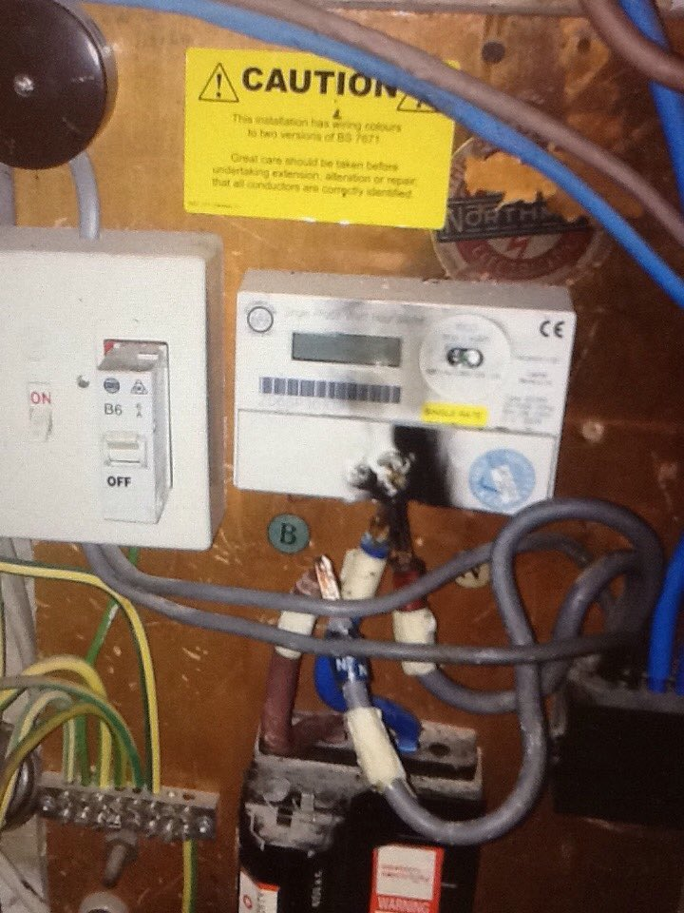
A typical bypassed electrical meter

- Monitoring and Control of Distribution Networks
I observed and learned how the dispatch department monitors the real-time status of the power distribution network, including the load and voltage levels across various substations.
- Dispatch Coordination with Field Teams
I coordinated with technical crews like the 33kV crew, Protection and Control (P&C), and fitters, to assign and update the status of tasks related to power restoration and repairs.
- Data Logging and Analysis
Logging data on power availability, faults, and scheduled maintenance, which is crucial for planning and optimizing the network's performance. I worked effectively in logging data for power availability.
- Routine Communication with Customers
Handling customer reports of outages and complaints, and updating my supervisor about the complains and finding out solutions to solve the customers complaints. In which I updated the customers on restoration timelines when possible, providing insights into customer service aspects within power distribution.
- Learning Safety and Compliance Protocols
I gained knowledge on safety measures essential in dispatch operations to ensure the protection of personnel and equipment. I attended safety meetings in which we are enlightened about what safety is about and always know that ‘SAFETY FIRST’.
- Calibration of Protective Devices
I observed & assisted in the calibration of protective relays and circuit breakers to ensure they function correctly during faults. We make sure there is power flow back during fault to avoid any kind of casualties.
- Relay Testing and Configuration
I learned the methods of testing relays, configuring settings, and understanding their role in preventing damage to the network during faults.
- System Protection Studies
I studied system diagrams, understanding how the network system flows from the source to various substations down to the consumers and learning how protection devices are strategically placed within the network.
- Substation and Line Design
Observing or assisting in the layout and design of substations and distribution lines to ensure they meet regulatory standards and safety requirements is part of the tasks i undergone
- Inspection and Maintenance of 33kV Lines:
Observing maintenance checks on 33kV power lines, including inspections of insulators, transformers, and other equipments was part of my daily routine in the 33kv department.
- Preventive Maintenance:
I participated in routine inspections and preventive maintenance of equipment and substations every end of month clearing the bushes in substations and climbers that may cause the line to be tripping just to minimize outages.
CHAPTER FOUR
4.1 Tools and Technologies
The successful execution of these tasks involved the utilization of a diverse set of tools and technologies, including:
- Grounding Cluster
The function of the cluster is that it provides a safe grounding point for electrical equipment, preventing unintended current flow and ensuring worker safety during maintenance.
- Usage: Grounding clusters are installed by clamping them onto conductors and connecting them to an earth ground. They help to safely divert stray or fault currents away from workers by creating a path to ground.
- Earth Resistance Tester
The function is that it measures the resistance of the earth grounding systems to ensure they provide a low-resistance path to ground.
- Usage: Place probes in the ground, then connect the tester to measure resistance. A low reading indicates a good grounding system, essential for safety, especially in fault conditions.
- Multi-meter
The function is that it measures voltage, current, resistance, and continuity in electrical circuits.
- Usage: Connect probes to the circuit points to measure. It uses voltage settings to check for live circuits, resistance to verify component integrity, and continuity to detect broken connections.
- Clamp Ammeter
The function is that it measures AC/DC current in a conductor without needing to disconnect it.
- Usage: Open the clamp, place it around the conductor, and close it. This non-contact method allows safe current measurement, especially in high-voltage lines.
- Insulated Tools
Function of insulator tools such as Pliers, Screw drivers, Spanners, Pipe-Retch is that it protects workers from electric shocks when working near live circuits.
- Usage: These tools (like screwdrivers, pliers) have insulating materials on handles, allowing work on live circuits without conducting current to the user.
- Personal Protective Equipment (PPE)
They protect workers from hazards, including electrical shocks, burns, and falling objects.
-Usage: PPE includes insulated gloves, safety boots, face shields, and arc-rated clothing. It is essential to wear PPE properly during all electrical work for maximum protection.
- Megger (Insulation Tester)
Function: Tests the insulation resistance of cables and electrical equipment.
- Usage: Connect test leads to the equipment being tested and apply a high voltage. The Megger measures resistance; higher readings indicate better insulation, while lower readings show potential faults.
- Circuit Breaker Analyzer
Function: Analyzes the performance of circuit breakers to ensure they operate correctly.
- Usage: Connect the analyzer to the circuit breaker and initiate testing. It measures trip times and contact resistances, ensuring the breaker functions properly to protect the system during faults.
- Battery Testers
The function of battery tester is that it measures the health and charge level of batteries.
- Usage: Connect the tester to battery terminals to check voltage, capacity, and condition. Useful for verifying backup power sources in protection systems.

- AutoCAD
Function: it is a design software used for creating technical drawings and plans for electrical layouts and infrastructure.
- Usage: Engineers use AutoCAD to draft and modify electrical designs, ensuring accurate layouts and planning for installation or upgrades of electrical systems.
- Lubrication Equipment
The function of the lubrication equipment is that it provides lubrication to moving parts in machinery, preventing wear and ensuring smooth operation.
- Usage: Use grease guns or oilers to apply lubricants to bearings, gears, or other components as part of routine maintenance.
- Cable Cutters
Function: it is use to cuts through different types and sizes of electrical cables cleanly and safely.
- Usage: Position the cable inside the cutter’s jaws, apply force, and make a clean cut. Essential for preparing cables for jointing or connecting.
- Cable Fault Locator
We used the cable fault locator to detects faults within cables, such as breaks or insulation failures.
- Usage: Connect the device to the cable and activate testing. It locates faults by measuring signal reflections or resistance, making it easy to locate issues for repairs.

CHAPTER FIVE
5.1 Summary
During my four-month industrial training at IBEDC, I gained invaluable experience working in the power distribution sector. This placement provided me with hands-on experience in the departments of Protection & Control (P&C), Network Planning & Design (NP&D), 33kV, Dispatch, and Fitter, which collectively equipped me with practical skills, theoretical knowledge, and a deeper understanding of power distribution systems.
Departmental Experiences
- Protection & Control (P&C) My placement in the Protection & Control department involved learning about the critical role of protective devices in maintaining the safety and reliability of the power distribution network. I observed the calibration and testing of protective relays and circuit breakers, which are vital in preventing equipment damage during power surges or faults. Additionally, I studied the configuration settings for relays and learned about system protection strategies, which taught me how precise adjustments help ensure network stability. This experience heightened my understanding of electrical protection principles and the importance of regular device maintenance for system resilience.
- Network Planning & Design (NP&D) In the Network Planning & Design department, I was introduced to the planning process for network expansion to accommodate growing electricity demand. I learned how engineers analyze load flow and demand trends, helping them plan upgrades and expansions to the network. Observing substation and line design practices provided insight into the structural and technical considerations involved in ensuring safety and regulatory compliance. This department exposed me to the technical and logistical aspects of designing an efficient power distribution network, enhancing my skills in project planning and electrical design.
- 33kV Department My time in the 33kV department involved practical learning on the inspection and maintenance of high-voltage distribution lines. I observed the process of inspecting transformers, insulators, and other equipment essential to the 33kV system. I gained practical knowledge of fault localization and isolation techniques, which are critical for maintaining reliable service and minimizing downtime during power outages. Observing tests on transformers and breakers taught me the importance of preventive maintenance and prepared me to handle high-voltage equipment safely.
- Dispatch Department The Dispatch department provided me with insight into the real-time operations of the distribution network. I learned how dispatchers monitor power flow, track network stability, and manage load shedding schedules during peak demand. This role required communication with field teams to coordinate fault repairs and ensure rapid service restoration. My experience here deepened my understanding of network monitoring, load management, and customer service coordination. Additionally, I observed the protocols for reporting outages, which showed me how systematic record-keeping supports network reliability and performance analysis.
- Fitter Department Working in the Fitter department provided hands-on experience with the installation and maintenance of distribution equipment. I assisted with the installation of transformers, poles, and circuit breakers, which expanded my technical skills. I also observed cable jointing and termination procedures, learning the intricacies of joining and securing power cables. This experience helped me understand the foundational aspects of power distribution and gave me valuable field experience in equipment handling, tool use, and safety practices for physical installations.
Skills Acquired
Throughout my SIWES placement, I developed both technical and professional skills essential for a career in electrical engineering:
- Technical Skills: Calibration of relays, fault isolation techniques, load analysis, network design, transformer testing, and equipment installation. These skills reinforced my practical knowledge and ability to apply theoretical concepts.
- Analytical Skills: Load flow analysis, demand forecasting, and fault analysis taught me how to approach problem-solving from an analytical perspective, using data to support decision-making.
- Communication and Teamwork: Collaborating with various departments improved my interpersonal skills and taught me the value of effective communication in coordinating tasks with field crews and providing customer support.
- Safety and Compliance Awareness: Observing and adhering to safety standards across departments emphasized the importance of maintaining safe working conditions, especially around high-voltage equipment.

5.2 Problems Encountered
Throughout my time at IBEDC, I faced several challenges that impacted my learning experience:
- Dispatch Department: System downtimes occurred periodically, leading to delayed responses to faults. Limited access to certain software features sometimes slowed down real-time monitoring.
- 33kV Crew: Working with high-voltage equipment presented inherent safety risks. Additionally, certain specialized tools required for safe operations were occasionally unavailable, which impacted efficiency.
- Protection and Control (P&C): The complexity of diagnosing relay issues proved challenging, especially early on when I was unfamiliar with using the testing kits.
- Network Planning and Design (NP&D): Using design software like AutoCAD without extensive prior training was difficult. Understanding load forecasting and network planning also required additional guidance.
- Fitter: Limited access to specific equipment, such as hydraulic presses, reduced my ability to gain hands-on experience with mechanical tasks.
- Cable Jointer: Locating faults in underground cables was time-consuming and occasionally inefficient due to the lack of advanced fault-location equipment.
In addition to these departmental issues, I encountered general challenges:
- Resource Constraints: Occasional shortages of essential tools and materials limited our ability to carry out certain tasks efficiently.
- Communication Gaps: Inter-departmental communication was sometimes unclear, leading to delays and miscommunication on tasks.
- Time Constraints: Due to high demand, tasks often had to be completed under pressure, especially during outage repairs, which occasionally affected task quality.

5.3 Suggestions for Improvement
Based on these observations, I propose several improvements that could enhance the experience for future interns and improve departmental efficiency:
- Training and Skill Development: Regular training on equipment operation, safety procedures, and software tools like AutoCAD would better prepare trainees. This could include introductory workshops on each department’s specific tools and software.
- Enhanced Resource Allocation: Ensuring that each department has access to essential tools, especially portable devices like high-quality cable fault locators, would greatly improve efficiency. Investing in reliable, updated equipment can streamline troubleshooting and maintenance.
- Strengthened Safety Protocols: To mitigate high-voltage safety risks, frequent safety drills and updated PPE distribution would be beneficial, especially for those working in field settings like the 33kV crew.
- Improved Communication Channels: Creating a more robust communication system, possibly using integrated software for real-time updates, would facilitate coordination, particularly between dispatch and field teams.
- Mentorship Programs: Implementing a mentorship program where students are paired with experienced staff in each department could improve knowledge-sharing, provide guidance, and help students overcome technical challenges.
5.4 Conclusion
The SIWES program at IBEDC has been a great experience, bridging the gap between theory and practice. It has equipped me with practical skills in electrical operations, system monitoring, and fault handling while emphasizing the importance of safety and teamwork in technical environments.
Through exposure to real-world challenges, I have gained a better understanding of the responsibilities and complexities involved in maintaining a stable power distribution network. This experience has prepared me to face similar challenges in my future career, where I hope to apply the knowledge and skills I acquired to make meaningful contributions to the field of electrical engineering.
Overall, this placement at IBEDC has been an enriching and transformative experience. It has given me a well-rounded exposure to the power distribution sector, honed my technical abilities, and instilled a professional work ethic. As I complete my final year studies, I am eager to apply the knowledge and skills I’ve gained, contributing to advancements in the power sector and supporting Nigeria’s drive for improved and sustainable energy infrastructure.

