

TECHNICAL REPORT

ON

STUDENTS’ INDUSTRIAL WORK EXPERIENCE

SCHEME (SIWES) Undertaken at

FEDERAL MINISTRY OF WORKS AND HOUSING, ILORIN

Written by

SOLIU HAMIDAH GEGELE
ND/23/CEC/PT/0150

DEPARTMENT OF CIVIL ENGINEERING

KWARA STATE POLYTECHNIC

Submitted To:

DEPARTMENT OF CIVIL ENGINEERING
INSTITUTE OF TECHNOLOGY ,
KWARA STATE POLYTECHNIC, P.M.B. 1376 ILORIN.

DEDICATION
I dedicate this work to the Almighty Allah who had made this training a success for me. Ithank all my well-wishers for their support and words of encouragement they offered to me during my training, most especially the entire team of Federal Ministry of works for accepting me whole heartedly. May God bless you all, Amen.

ACKNOWLEDGMENT

I am grateful to Almighty Allah for His abundant Grace and guidance throughout m industrial training. It would have been impossible without many people. I remain grateful to my industry-based supervisor, Engr. Adediran M.B for her untiring effort, taking her time to give me a clear explanation of the things that were difficult forme.
Her patience and accurate guidance gave me the impetus to complete this training. I also appreciate my institution lecturer in the department of Civil Engineering.
My appreciation also goes to my parents, uncles, friends and fellow students for their supports and love towards making this task a success.

PREFACE

This booklet contains the details of activities and experience undergone during my four (4) months Student Industrial Work Experience Scheme, also known as SIWES which was held at of FEDERAL MINISTRY OF WORKS The experience and knowledge acquired during the program was written in this report which is basically on construction, which is also essential for the fulfilment of National Certificate. It has exposed me to the use of various tools whose operation techniques work only but theoretically explained in the lecture room. I thank the National Board of Technical Education for the introduction of the Student Industrial Work Experience Scheme (SIWES) programmed to the school of learning.

TABLE OF CONTENTS
Title page i
Dedication ii
Acknowledgement iii
Abstract IV
Table of contents V-
VI
List of figures VII
CHAPTER ONE
1.0 Introduction 1
1.1 Background of SIWES 1
1.1.2 Brief history of SIWES 1-2
1.1.3 Mission statement of SIWES 2
1.1.4 Vision Statement of SIWES 2
1.2 Aims of SIWES 2
1.2.1 Objectives of SIWES 3
1.2.2 Importance of SIWES to Civil Engineering 3
1.2.3 Justification for choice of industry 3
1.3 History of establishment and profile 4-5
CHAPTER TWO
2.0 Theoretical framework
6
2.1 Civil Engineering
6
2.1.2 Transportation Engineering System
6
2.1.3 Origin of highway 6-
7
2.1.4 Significance of highway … … … … … … … … … … … … … .. … ... … … … … ....... 7-
8
2.2 Components of road structure 8
2.2.1 Road and water 9

2.2.2Crack sealing procedures
9
2.2.3 Roadway excavation
10
2. 2.4Filling and
grading 11
2.3 Spraying of water
11
2.3.1Field compaction
12
2.3.2Blinding
13
2.3.3Primin
14
2.3.4Asphalt overlaying 14-15
CHAPTER THREE
3.0 Asphalt plant
16
3.1 Materials
17
3.2 Forms of Bitumen … … … … … … … … … … … … … … … .... … … … .. … … … … …
17
3.3 Types of bitumen … … … … … … . … … … … … … … … … … … … … … … … … … .
17
CHAPTER FOUR
4.0 Drainage system … … … … … … . … … … … … … … … … … … … .. … … … … .... 19-
21
CHAPTER FIVE
5.0 Summary 22
5.1 Conclusion 22
5.2 Recommendation 22
Reference Appendix

CHAPTER ONE
1.0 INTRODUCTION
1.1 BACKGROUND OF SIWES
Students’ Industrial Work-experience Scheme (SIWES) is one of the Industrial Training Fund (ITF) programme which was introduced in 1974 due to the inability of engineering and technology students in Nigeria universities and polytechnics to meet the practical aspects of their training. That is, the needs to enable students match their theoretical school knowledge with the practical aspect of their training in industry. The Training lasts for six months. According to Ekpenyong (2011), one of the principles underlying any industrial work experience scheme for students in institutions of learning is the desire to marry the practical with the theoretical learning which characterizes conventional classroom situations with a view to striking a balance between theory and practice. The author stressed further that it was in realization of this that the ITF when it was established, set out to study the extent to which the theoretical knowledge that students in engineering technology and other allied fields in Nigerian institutions offering technology based courses related to the kind of work experience expected of them by employers. The result of the ITF survey showed a great disparity between students’ knowledge and their ability to apply it in relevant jobs. In order to bridge the gap between the two, the ITF in 1974 established a co-operative internship programme, which enabled students of technology to spend some part of their courses for relevant on the-job practical experiences in appropriate areas of the Nigerian industry (Ekpenyong, 2011).
1.1.2 BRIEF HISTORY OF SIWES
In recognition of the shortcomings and weakness in the formation of SET graduates, particularly with respect to acquisition of relevant production skills (RPSs), the Industrial Training Fund (which was itself established in 1971 by decree 47) initiated the Students’ Industrial Work experience Scheme (SIWES) in 1973. The scheme was designed to expose students to the industrial environment and enable them develop occupational competencies so that they can readily contribute their quota to national economic and technological development after graduation. Consequently, SIWES is a planned and structured programme based on stated and specific career objectives which are geared toward developing the occupational competencies of participants. In spite of the challenges faced by SIWES in the four decades of its existence, the

Scheme has not only raised consciousness and increased awareness about the need for training of SET students, but has also helped in the formation of skilled and competent indigenous manpower which has been manning and managing the technological resources and industrial sectors of the economy. Participation in SIWES has become a necessary condition for the award of degrees and diplomas to SET students graduating from higher institutions in Nigeria.
1.1.3 VISION STATEMENT
To be the prime skills training development organization in Nigeria and one of the best in the world.
1.1.4 MISSION STATEMENT
To set and regulate standards and offer direct training intervention in industrial and commercial skills training and development, using a corps of highly competent professional staff, modern techniques and technology.
1.2 AIM OF SIWES
The effort is aimed at helping/training students in the Nigerian tertiary institutions the practical aspect of their field of study by exposing students to machines and equipment, professional work methods and ways of safeguarding the work areas and workers in Industries and other organizations.
1.2.1 OBJECTIVES OF SIWES
The Industrial Training Fund’s policy Document No. 1 of 1973 which established SIWES outlined the objectives of the scheme. The objectives are to:
1. It provides an avenue for students in institutions of higher learning to acquired industrial skills and experience during their course of study.
2. It expose Students to work methods and techniques in handling equipment and machinery that may not be available in their institutions.
3. It makes the transition from school to the world of work easier and enhance students’ contact for later job placements and a chance to evaluate companies for which they might wish to work.
4. It provides students with the opportunities to apply their educational knowledge in real work and industrial situations, there by bridging the gap between theory and practice.
5. The programme teaches the students on how to interact effectively with other workers and supervisors under various conditions in the organization.

1.2.2 IMPORTANCE OF SIWES TO CIVIL ENGINEERING
1. It exposes students to more practical work methods and techniques in civil engineering.
2. It provides students in civil engineering with an opportunity to apply their theoretical knowledge to real life situations.
3. It enables students in civil engineering to gain experience in handling equipment and machineries.
4. It provides an environment whereby students in civil engineering can develop their creativity and interpersonal skills through software design techniques.
1.2.3 JUSTIFICATION FOR CHOICE OF INDUSTRY
Theoretical knowledge alone would not usually prepare and prepare an educated person for the world of work. The worker or productive individual must not only be knowledgeable but also be versatile in the application of skills to perform defined jobs or work. Both education and training are important; there cannot be effective education without some training input and there cannot be effective training without some educational input. The productive individual, particularly in this millennium, must be able to combine and utilise the outcomes from the two forms of learning (Know-How Ability and Do-How Capability) for production of goods and services which is crucial in pursuing careers in science, engineering and technology (SET) disciplines.

CHAPTER TWO
2.0 INTRODUCTION

Civil Engineering as a whole is distributed into several sections i.e., highway engineering, geotechnical engineering, structural engineering, water resources and environmental engineering, etc. I was opportune to work at one of the different sections which is the highway engineering.

2.1.1 HIGHWAY ENGINEERING
Highway engineering is a specialized branch of civil engineering focused on the planning, design, construction, operation, and maintenance of roads, highways, and related infrastructure. The primary goal of highway engineering is to ensure the safe and efficient movement of people and goods across road networks. It plays a critical role in connecting communities, supporting economic growth, and facilitating transportation.

2.2.1 ROAD AND WATER
The greatest threat to an asphalt road is water. When a road is laid down, it flexes and moves slightly to accommodate changes in temperature and load. All this flexing eventually leads to cracking. Water penetrates those cracks and through processes like freezing, causes damage to the roadway. Crack sealing cleans debris from these cracks then fills them with an asphalt-based polymer that adheres to the sides and bottom of the cracks, preventing the water from getting in. Depending on the climate, the materials used, the pavement conditions and the technique used, crack sealing will last
three to eight years.
Crack sealing has two primary purposes:
1. To prevent the intrusion of water through the crack into the underlying pavement structure.
2. To prevent extraneous materials from entering the crack and causing further deterioration as the pavement expands and contracts with temperature changes.

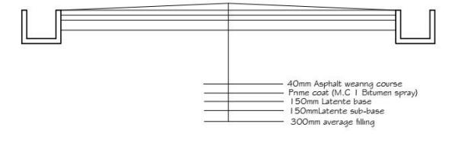
Road cross section

Road Cross section

2.2.2 CRACK SEALING PROCEDURES
For crack sealing, the most important aspect of the procedure is the preparation of the crack for treatment. Also, the season when the crack sealing is done will affect its performance. If the cracks need to be routed or sawed to remove extraneous material, it should be done before cleaning the cracks. The routing or sawing is best accomplished using a vertical-spindle router, rotary- impact router, or a random-crack saw. After doing the routing or sawing, clean the cracks using high-pressure air, sandblasting, wire brushing, hot air blasting or high-pressure water.

2.2.3 ROADWAY EXCAVATION
The work consists of all the required excavation within the limits of the right of way unless covered by other Sections of these Specifications. This shall include excavation of side ditches,where required, the removal, hauling and proper utilization or disposal of all excavated materials and shaping of excavation and preparation of exposed surfaces of excavation on the entire length of the roadway, in accordance with these Specifications and to the lines, levels, grades, dimensions and cross sections shown on the Drawings or as required by the Engineer. The works specified shall also include operations in part widths and small areas of roadway where directed by the Engineer

without any extra cost to the Employer. Roadway excavation shall include the following:
a) All excavation indicated on the Drawings within the limits of the cross sections and excavation of all materials for side roads and intersections.
b) The removal of existing pavement, sidewalks, kerbs and gutters within the limits of construction.
c) Excavation for stream and channel changes where not covered under Section .4, Channel Excavation.
d) Excavation required in cuts under embankments below the lowest normal limit of excavation indicated on the Drawings or below ground line and for the removal of unsuitable material. Materials from roadway excavations shall be classified as suitable or unsuitable as fill material, or as road pavement material, by the Engineer. To be suitable as fill material, soil must not contain roots, sods or other deleterious materials.
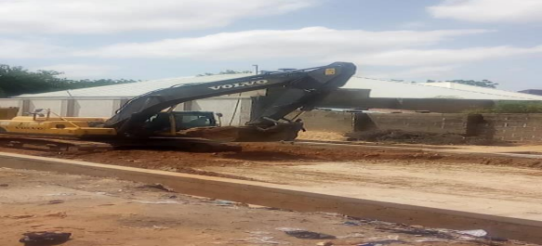
Roadway Excavation

2.2.4 FILLING AND GRADING
Laterite is filled into the cut portion of the road and compacted using sheep foot roller and smooth wheel roller. Laterite is a deep brown soil of cellular structure, easy to excavate, but gets hardened on exposure to air owing to the formation of hydrated iron oxides. The CBR (California Bearing ration) ratio of the laterite on our site is 85%. The laterite is brought form the borrow pit, the borrow pit is a hole dug to a certain depth where laterite of good CBR ratio can be obtained. There are three borrow pits where the laterite is been brought;

THE 90KM DUALISATION OF ILORIN JEBBA-MOKWA/BOKANI JUNCTION (KWARA AND NIGER STATE) WHICH BEGINS FROM EIYEKORIN

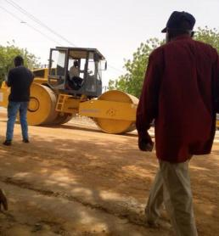
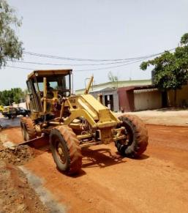
Road grading laterite compaction

2.3 SPRAYING OF WATER
Water is sprayed on the laterite to give it the required moisture just enough to allow maximum compaction. Also water is sprayed after compaction of laterite when there will be another layer of laterite to be laid on the current layer to create bond between the two layers.
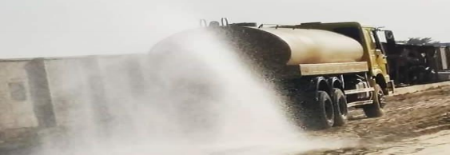

spraying of water by the water bauxer

2.3.1 FIELD COMPACTION
Most of the compaction in the field is done with the aid of compaction equipment such
as rollers. The four most common types of rollers are:
a. Smooth-wheel rollers: they are suitable for proof rolling sub-grades and for finishing operation of fills with sandy and clayey soils. These rollers provide 100% courage under the wheels, with the ground contact pressure as high as 310 to 380 KN/m2. They are not suitable for producing high nit weights of compaction when used on the thicker layer.
b. Pneumatic rubber tyre rollers: they are heavily loaded with several rows of tyres. The contact pressure under the tyre ranges from 600 to 700 KN/m2, and they produce up to 70 to 80% courage. Pneumatic rollers can be used for sandy and clayey soil compaction.
c. Sheep foot rollers: these are drums with large number of projections. The area of each projection ranges from 25 to 85 cm2. These rollers are most effective in compacting clayey soils. The contact pressure under the projection ranges from 1400 to 7000 KN/m2. These projections help in creating bond between the current layer of soil and the next layer of soil to be laid.
d. Vibratory Rollers: they are extremely efficient in compacting granular soils. Vibrator con be attached to smooth-wheel, pneumatic robber type, or sheep foot rollers to provide vibratory effects to the soil.
Factors affecting field compaction
I. Soil type and moisture content
II. Thickness of the layer of the soil
III. The intensity of pressure applied by the compacting equipment IV. The area over which the pressure is applied


Pneumatic rubber tyre roller Drum wheel roller

2.3.2 PRIMING
This is the spraying of MC1 (Medium curing) on the surface of the prepared base course material e.g. laterite or stone base. After spraying the MC1, it should be allowed for about 1-hourto allow it penetrate into the base course material. It is recommended to spray 0.9 l/m2, 1.o l/m2 or 1.1l/m2. MC1 is one of the amongst the product of cutback bitumen. After applying MC1, it should be allowed to cure for a minimum of 48 to 72 hours before asphalt is placed, with norain in the forecast. The temperature of MC1 during the application process should not be less than 1500C.The main purpose of priming is to;
a. To coat and bond loose material particles on the surface of the base,
b. To harden or toughen the base surface to provide a work platform for
construction equipment,
c. To plug capillary voids in the base course surface to prevent migration of moisture,
d. To provide adhesion between the base course and the succeeding asphalt
course. For the prime coat to be successful, it must be able to penetrate into the base course at least ½inches.
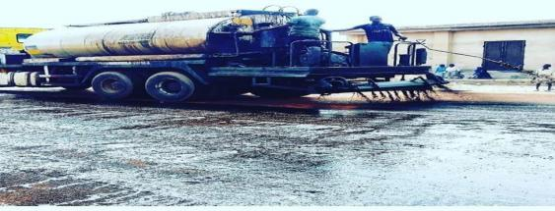

Bitumen Boiler

2.3.3 BLINDING
After application of MC1 (prime coat) to the base and the asphalt is not readily available from the Marini, blinding is done. This is the application of river sand OR Quarry dust after priming to;
a. Remove the air voids in the MC1,

b. To allow vehicles to use the roads immediately after priming and blinding,
c. To prevent the MC1 from sticking to the tyres of vehicles thereby cleaning it away from the applied surface.
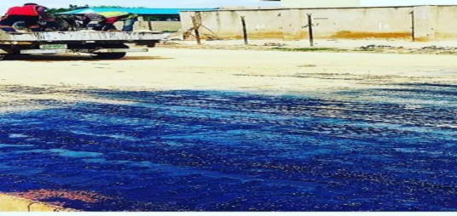
Blinding of the primed surface using quarry dust

2.3.4 ASPHALT OVERLAYING
An asphalt overlaying is simply the process of installing a new layer of hot mix asphalt directly over the existing asphalt on roads. The main aim of overlay is to add structural support to the existing pavement. Overlaying existing asphalt is a good solution when the existing road is still in decent shape and the existing elevations will allow proper drainage without milling of the entire surface. To maximize the overlays useful life, failed sections of the existing pavement were cut, excavated and replaced. If the percentage of bitumen in the asphalt mix is high, it will result in folding of the road surface and if the percentage of the aggregates is higher in the mix, it will result in excessive cracking of the road. This not only results in poor surface, but it result in a surface that retains water, thereby reducing the life span of the road by accelerating the ravelling process. Hot mixed asphalt is manufactured at temperatures between 270oF and 325oF, depending on the environmental conditions and the distance from the hot mix plant to the site, hot mixed asphalt can lose between 5oF and 25oF.After overlaying the hot asphalt, it is left for the temperature to cool to a temperature below 80oc before compaction is started. The measurement of temperature atour site is done by the use of thermometer. If the compaction process is started at a temperature above 80oc, it leads to development hairy crack which enlarges as time passes.

In the overlay process, if the hot mix asphalt pavement cools too quickly, the entire surface will ravel living a rough, rocky surface in a short period of time. For the compaction of the newly over-
laid asphalt, smooth wheel and pneumatic rubber tyre rollers are used. The smooth wheel roller compacts it first, water is sprayed to the wheel so that the asphalt does not stick to the wheel during the compaction process.


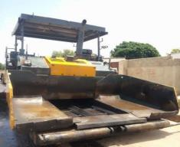
Pneumatic finisher ready for use compaction of laid asphalt

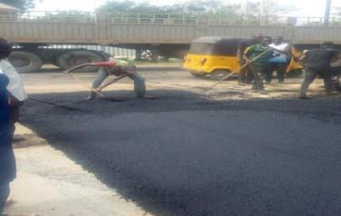
Workers spreading asphalt

CHAPTER THREE
3.0 ASPHALT PLANT
This chapter discussed our visit to the drum mixing asphalt plant located along Sango Road. The main purpose of the asphalt plant is to produce Asphalt. We were shown the machines involved in the production of asphalt and the procedure involved was thoroughly explained to us. Some of the equipment used was:
a. Hopper: there are about four hoppers at the Marini namely: hopper 1, hopper 2, hopper 3 and hopper 4. The hopper has a conveyor belt used for transporting the aggregates to another section of the production process. The aggregates fall onto the conveyor by gravity.
b. Dryer: used to dry moist aggregate that enters it. Its temperature ranges
between 1500c and 1700c.
c. Bunner fan/Air Blower: this helps in pumping air into the dryer. It also sprays diesel to the dryer and flames it to create fire.
d. Hot Elevator: this collects the hot aggregates and passes it to the mixer.
e. Mixers: this is used to mixes the aggregates with bitumen by the use of
Paddles.
The mixture is then dumped into a bucket.
f. Bitumen Storage Tank: this is used for heating the bitumen. MATERIALS
a. Aggregates: the main aggregates used in mixing asphalt at the Marini are⁄inch, ⁄ inch, inch, Quarry dust, river sand and Bitumen.
b. Bitumen: Production of Bitumen: Bitumen is the residue or by-product when
the crude petroleum is refined. A wide variety of refinery processes, such as the straight distillation process, solvent extraction process etc. maybe used to produce bitumen of different consistency and other desirable properties. Depending on the sources and characteristics of the crude oils and on the properties of bitumen required, more than one processing method may be employed.

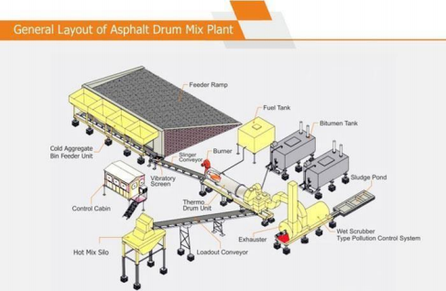
General layout of Asphalt drum mix plant

3.2 FORMS OF BITUMEN
- Cutback bitumen
Normal practice is to heat bitumen to reduce its viscosity. In some situations preference is given to use liquid binders such as cutback bitumen. In cutback bitumen suitable solvent is used to lower the viscosity of the bitumen. From the environmental point of view also cutback bitumen is preferred. The solvent from the bituminous material will evaporate and the bitumen will bind the aggregate. Cutback bitumen is used for cold weather bituminous road construction and maintenance. The distillates used for preparation of cutback bitumen are naphtha, kerosene, diesel oil, and furnace oil. There are different types of cutback bitumen: rapid curing (RC), medium curing (MC), and slow curing (SC). RC is recommended for surface dressing and patchwork. MC is recommended for premix with less quantity of fine aggregates. SC is used for premix with appreciable quantity of fine aggregates. Other forms of bitumen include Bitumen emulsion, Bitumen Primers, and Modified Bitumen.
3.3 TYPES OF BITUMEN
a. Asphalt: This is the product gotten from the mixture of aggregates, river sand and bitumen. The mixture is done in percentage based on the required quality of asphalt needed. E.g. 33% of ½ inch, 33% of 3/8 inch, 36% of ¾ inch, 30% of river sand and 4.0% of bitumen.

Basically, when the entire aggregate particles (including the large aggregate particles)
are coated with asphalt, the mix is said to be properly mixed.
b. Oil: This is used together with the heater to heat the bitumen and it also helps in preventing the bitumen from flaming during the heating process.

CHAPTER FOUR
4.0 DRAINAGE SYSTEM
One of the most important aspects of the design of a road is the provision made for protecting the road from surface water or ground water. If water is allowed to enter the structure of the road, the pavement will be weakened and it will be much more susceptible to damage by traffic. Water can enter the road as a result of rain penetrating the surface or as a result of the infiltration of groundwater.
The road surface must be constructed with a sufficient camber or crossfall to shed rainwater quickly and the formation of the road must be raised above the level of the local water table to prevent it being affected by groundwater.
Water can also have a harmful effect on shoulders, slopes, ditches and other features. High water velocities can cause erosion which, when severe, can lead to the road being Alternatively, low velocities in drainage facilities can lead to silt being deposited which, in turn, can lead to a blockage. Blockages often result in further erosion. A good road drainage system, which is properly maintained, is vital to the successful operation of a road. It has four main functions:
1. To convey rainwater from the surface of the carriageway to outfalls
2. To control the level of the water table in the subgrade beneath the carriageway
3. To intercept ground and surface water flowing towards the road
4. To convey water across the line of the road in a controlled fashion.
The first three functions are performed by side drains and the fourth by culverts, drifts and bridges.
4.1 SIDE DRAINS
The cost of side drains will normally be calculated as part of the cost of earthworks Side drains should be flat-bottomed if they are to be maintained by hand or 'v'-shaped if they are to be maintained by machine. Wide flat drains, known as 'meadow drains', can be used with advantage if there is room. The longitudinal gradient of side drains should always exceed 0.5 per cent to reduce the possibility of silting up. In hilly terrain, providing side drains with the same gradient as the road may result in water velocities that are too high. It may therefore be necessary to reduce the maximum gradient to an acceptable level by the provision of shallow dams or scour checks. These are often constructed of masonry, but can also be constructed in concrete or even timber. Wide drains are preferred to reduce the velocity and so minimize erosion.

The provision of turnouts or cut-off drains should also be considered to reduce or control the amount of water in the side drains. Costing may need to take account of these and the need to line drains with masonry or concrete in highly erodible soils.
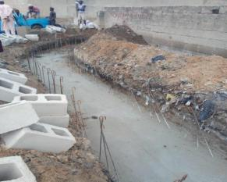
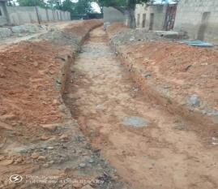
Excavated Drainage trench Plate Blinding and concrete base

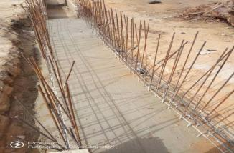
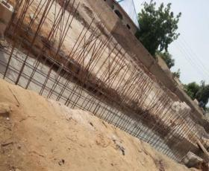
Arranged re-bars Arranged re-bars with concrete base
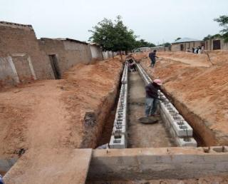
Block drainage underconstruction

CHAPTER FIVE
5.0 SUMMARY
I observed that Civil Engineers use their conceptual design method to build a structure for safety, stability, economy and durability. But at the same time supervising the project closely to make sure it is being executed exactly the way the design was and plan. they also accept material base on what the specification comes from the client to avoid using materials of poor quality that may alter their design calculation, for this may result in the failure of their structure.
5.1 CONCLUSION
This report has been able to x-ray an account of the entire work – experience garnered by me at the Federal Ministry of Works and Housing for the past 4 months, I had the opportunity to see practical application of what I learned in my classes that comprises of use of earth moving equipment’s use in excavation, grading earth spreading and piling, soil watering, compaction, spreading of MC1 , asphalt laying. In structural work how scaffolding places.
.
5.2 RECOMMENDATION
In view of the relevance of the SIWES program, it is important that it is sustained by the government through the Industrial Training Fund (ITF) as it exposes the student to work tools, facilities, and equipment that may not be available in their respective institutions in relation to their course of study. To this end, I recommend that the following under-listed points should be implemented:
1. Students’ Industrial Works Experience Scheme (SIWES) needs to be strengthened by all concerned stakeholder in order for its objectives to be fully realized.
2. Regular monthly allowances for students on attachment should be paid promptly.
3. Organizations should always accept students for SIWES and subsequently assign them to relevant jobs. Experience staff should always be made to train the students on attachment
4. There should be more funding of the scheme by the government in order for it to be more effective.

