CHAPTER FOUR

4.0 TEST AND RESULTS
This section outlines the experimental setup, methodologies, and procedures used to evaluate the efficiencies of the charge controllers. The results are analyzed to address the hypotheses posed in the introduction.
The experimental data shown in the tables below represent the experimental data of voltage, current, and power for the solar panel, foreign MPPT charge controller, foreign PWM charge controller, and locally made PWM charge controller. From this tested value, the overall efficiency of these parameters was determined.
Table 5: The results of voltage, current and power of the 100w solar panel
Time (hrs) | Voltage (V) | Current (A) | Output power (W)
10:45am | 14.5 | 2.08 | 30.16
11.45am | 15.0 | 2.26 | 33.9
12:45pm | 15.8 | 2.95 | 46.61
1:45pm | 16.3 | 3.59 | 58.517
2:45pm | 16.1 | 3.02 | 48.622
3:45pm | 15.6 | 2.92 | 45.552
4:45pm | 14.9 | 2.35 | 35.015
Choosing a constant value of the power of the solar panel at its peak value of 58.517 in order to calculate the efficiency of the solar panel at 1000w/m² . The results obtained is shown below:
$$Efficiency \left(\%\right)=\frac{Power output}{irradiance×area}×100$$
Where:
Power input = 100w
Area = 0.7432m²
$Efficiency \left(\%\right)=\frac{58.517}{1000×0.7432}×10$0
Efficiency (%) of the solar panel = 7.87% at the maximum irradiance of 1000W/m².
Table 6: The results of voltage, current, input power and output power of the MPPT solar charge controller with time.
Time | Voltage  (V) | Current (A) | Power input  (W) | Power output  (W) | Efficiency  (%)
10:45am | 12.2 | 1.13 | 30.16 | 13.786 | 45.7
11.45am | 13.0 | 1.56 | 33.9 | 20.28 | 61.3
12:45pm | 13.3 | 2.5 | 46.61 | 33.25 | 71.3
1:45pm | 14.2 | 3.2 | 58.517 | 45.44 | 77.6
2:45pm | 13.6 | 2.8 | 48.622 | 38.08 | 65.0
3:45pm | 13.2 | 2.2 | 45.552 | 29.04 | 49.6
4:45pm | 13.0 | 1.6 | 35.015 | 20.8 | 35.6

$$Efficiency \left(\%\right) of the MPPT=\frac{Power output}{power input}×100$$
Efficiency of MPPT controller ranges from (45-77.6)%
Figure 20 describes the graph representation of the power input, power output and efficiency of the MPPT solar charge controller.

Figure 20: The graph showing the power input, power output, and efficiency of the MPPT controller with time.

Table 7: The results of voltage, current. power input, power output and efficiency of the foreign PWM solar charge controller
Time | Voltage  (V) | Current (A) | Power input  (W) | Power output  (W) | Efficiency  (%)
10:45 am | 12.0 | 1.06 | 30.16 | 12.72 | 42.1
11.45 am | 12.6 | 1.32 | 33.9 | 16.63 | 49.06
12:45 pm | 13.0 | 1.9 | 46.61 | 24.7 | 52.9
1:45 pm | 13.2 | 1.8 | 58.517 | 23.76 | 40.6
2:45 pm | 13.5 | 1.5 | 48.622 | 20.25 | 41.64
3:45 pm | 12.9 | 21.7 | 45.552 | 21.93 | 37.4
4:45 pm | 12.4 | 1.2 | 35.015 | 14.88 | 25.3
$$Efficiency \left(\%\right)=\frac{Power output}{power input}×100$$
Efficiency of foreign PWM controller ranges from (42-55)%
Figure 21 describes the graph representation of the power input, power output and efficiency of the foreign PWM solar charge controller.

Figure 21: The graph showing the power input, power output and efficiency of the foreign PWM controller with time.

Table 8: The results of voltage, current, input power, output power and efficiency of the local PWM solar charge controller with time.
Time | Voltage  (V) | Current (A) | Power input  (W) | Power output  (W) | Efficiency  (%)
10:45 am | 12.0 | 1.08 | 30.16 | 12.96 | 42.9
11. 45am | 12.6 | 1.33 | 33.9 | 16.758 | 49.43
12:45 pm | 13.0 | 1.9 | 46.61 | 25.08 | 53.8
1:45 pm | 13.2 | 1.8 | 58.517 | 23.76 | 40.6
2:45 pm | 13.5 | 1.5 | 48.622 | 20.25 | 41.64
3:45 pm | 12.9 | 1.7 | 45.552 | 21.93 | 37.4
4:45 pm | 12.4 | 1.2 | 35.015 | 14.88 | 25.3

$$Efficiency \left(\%\right)=\frac{Power output}{power input}×100$$
Efficiency of local PWM controller ranges from (43-55)%
Figure 21 below shows the graph representation of the power input, power output and efficiency of the local PWM solar charge controller.

Figure 22: The graph showing the power input, power output and efficiency of the local PWM controller with time.

4.1 CHARGING AND DISCHARGING OF THE BATTERY
First of all, the charging current for 1300mAh battery was calculated. As we know that charging current should be 10% of the Ah rating of battery.
Therefore,
Charging current for 1300mAh Battery I $=1300mAh×({10}/{100})$
$I=0.13Amps$.
But due to some losses, 0.13 – 0.15 Amperes for batteries charging purpose instead of 0.13Amps was considered.
Battery Charging Time:
Taking 0.13 Amp for charging purpose,
Then,$$Charging time for 1300mAh battery =\frac{1300mAh}{0.13}=10hours$$
Practically, it has been noted that 40% of losses occurs in case of battery charging.
Then:
$1300mAh×\left({40}/{100}\right)$= 0.52mAh
Therefore, 1300+ 0.52 = 1300.52mAh (1300mAh + Losses)
Now Charging Time of battery = Ah ÷ Charging Current
Putting the values;
1300.52mAh ÷ 0.13 = 10.004hrs
Therefore, the 1300mAh battery would take 10 Hours to fully charge in case of the required 0.13A charging current.

Calculating Discharge Time:
Formula:
$Discharge time\left(hours\right)=battery capacity$÷$current drawn$.
A 1300mAh battery with an 800mAh load:
$$discharge time(hours) =\frac{1300mAh}{800mAh}=1.625hrs$$
Calculating Depth of Discharge (DoD):
$$DoD (\%) =\frac{discharge capacity}{total capacity}×100$$
1300mAh battery discharges 800mAh:
$$DoD (\%) =\frac{800mAh}{1300mAh}×100$$
$DoD \left(\%\right)=61.54$
DoD is a percentage indicating how much of the battery’s capacity has been used.

4.2 EFFICIENCY OF THE INVERTER
Experimental data shown below shows the experimented data of the inverter, from this tested value, the efficiency of the inverter was determined.
In determining the efficiency of the inverter:
$$\text{Watt-hour (}\text{Wh}\text{) of the battery =}\frac{\text{mAh×Voltage}\text{ (V)}}{1000}\text{​}$$
$$\text{Watt-hour (}\text{Wh}\text{) of the battery =}\frac{\text{1300×12}}{1000}\text{​}$$
$\text{Watt-hour (}\text{Wh}\text{) of the battery}$ $\text{=}$ 15.6Wh
Energy Supplied to Load
The load of 28W was powered for 30 minutes = 0.5 hours, so:
Energy Supplied=28W×0.5h=14Wh
$$Efficiency \left(\%\right)=\frac{ Power output}{ power input }×100$$
$Efficiency \left(\%\right)=\frac{14Wh}{15.6wh}×10$0
Efficiency (%) of the inverter = 89.7%.
Figure 23 and figure 24 describes the waveform quality of the high frequency inverter and low frequency inverter, showing the frequency, volt per division and other parameters.

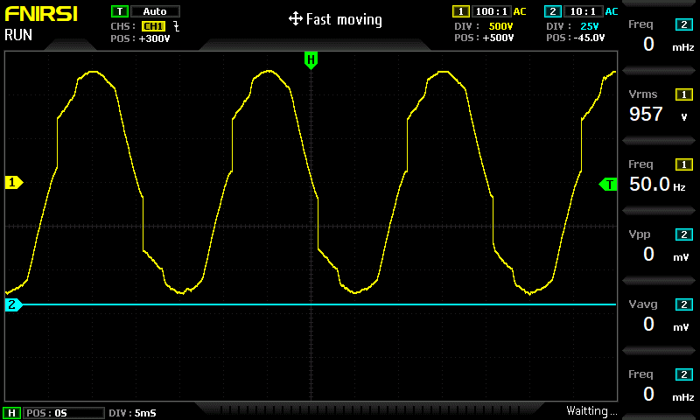
Figure 23: Waveform quality of the high frequency inverter.

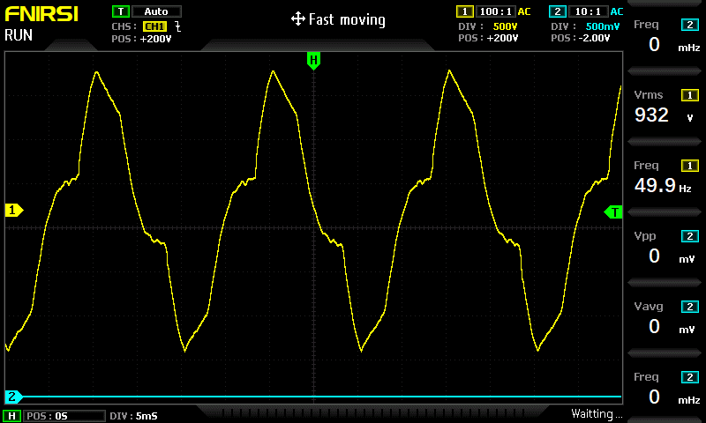
Figure 24: Waveform quality of the low frequency inverter.

4.3 OVERALL EFFICIENCY OF THE SOLAR SYSTEM
$$\text{Efficiency of the system with the MPPT controller}$$
$Efficiency \left(\%\right)=0.58×0.77×$ 0.89
Efficiency (%) = 39.7%.
Efficiency of the system with the foreign PWM controller
$Efficiency \left(\%\right)=0.58×0.55×$ 0.89
Efficiency (%) = 28.4%.
Efficiency of the system with the local PWM controller
$Efficiency \left(\%\right)=0.58×0.55×$ 0.89
Efficiency (%) = 28.4%.

4.4 SUMMARY
This section outlines the test carried out and the results obtained through the installation. The voltage and current of each device was measured carefully and was used to calculate the power and efficiency. The efficiency of the MPPT solar charge controller ranging from (25-78%), while the efficiency of the PWM solar charge controller ranging from (24-53%) both foreign and locally made. The charging hours for the 1300mAh battery under a charging current of 0.13A is estimated to be 10hrs while the battery discharges in 1.6hrs, making the depth of discharge (DoD) to be approximately 61.54%. The efficiency of the inverter used achieved 89.7% making it efficient in powering AC loads.

