CHAPTETHR THREE
3.0 TRANSFORMER
A transformer is a static electrical machines or device that transfer electrical energy from one circuit to another through inductively coupled electrical conductors. Transformer is made up of magnetic core and several copper windings and the windings are divided into primary and secondary winding he ability to receive power at one voltage or current level and delivers it at some other voltage / current level is the most unique feature of transformer and they can be used to power circuit that are isolated to control voltage and power system and they are used in cen1cal engineering for impedance matching The essential points of a transformer are primary winding which energize t:he coil from an external voltage while in secondary winding which is used to deliver power to an external load the magnetic core which is made up of laminated metal sheets stamped together to provide a high performance impedance so as to liked magnetic field developed in the primary winding to all forms of the secondary winding.
3.1 THE FORMER AND THE LAMINATED IRON CORE
The former is the insulated material used in winding the coils, It is normally plastic that can withstand a fairly high temperature which is show in the diagram 3.1 (a) while laminated iron core is made up of small amount of carbon steel and iron stamped together. This lamination is insulated from one another to reduce eddy current. The diagram also show In fig 3.1 (b).

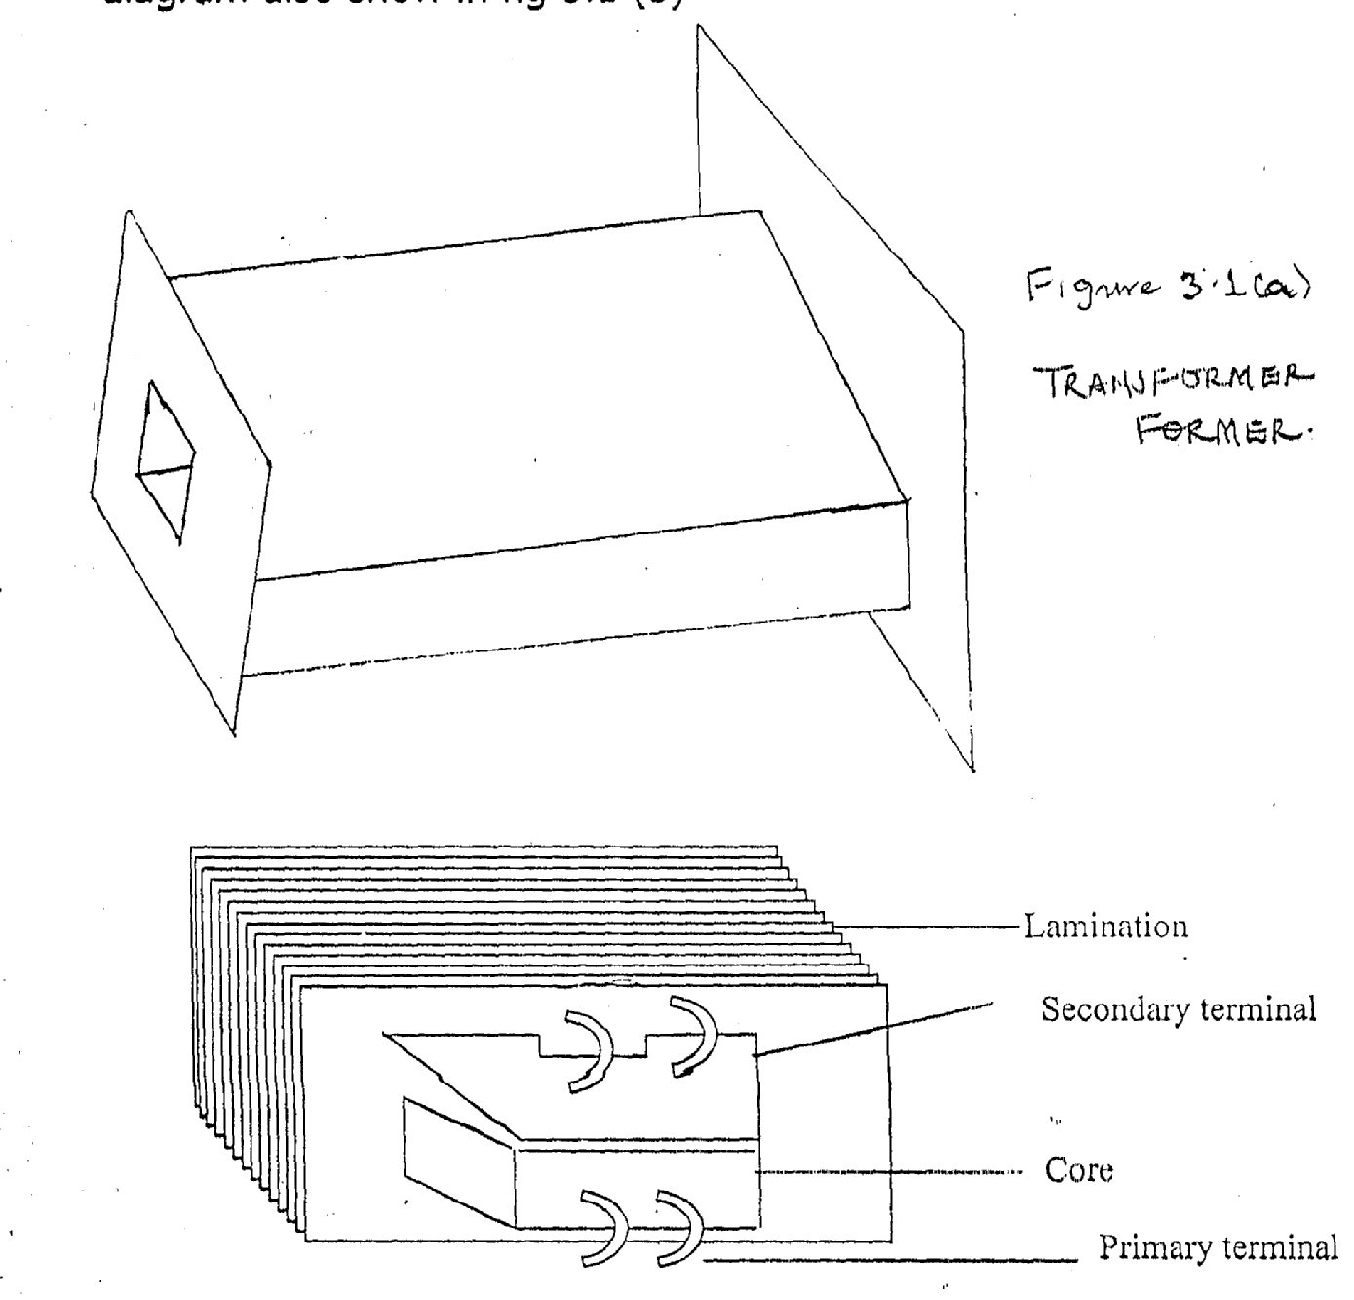

LAMINATED IRON CORE
Figure 3.1b LAMINATED IRON CORE
3.2 TRANSFORMER RATIO WINDING
The transformer turns ratio consists of two or more winding interlined by a mutual magnetic field. The transformer turns ratio is the ratio of primary turns and secondary turns. This shown in fig 3.2
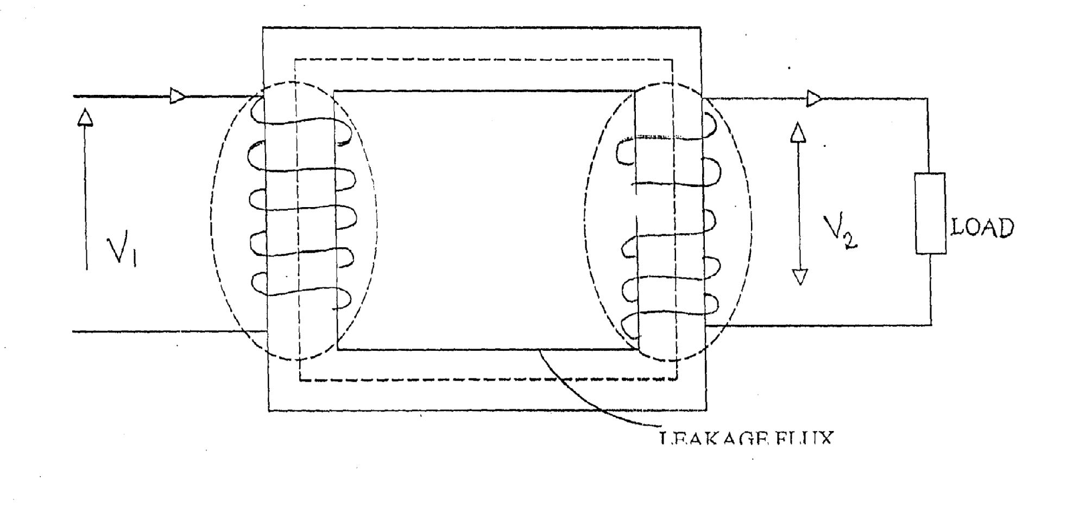

V1 — primary voltage
V2 — secondary voltage
Np — primary winding turns
Ns — secondary winding turns
Q—flux in webber
The value of induced e.m,f E n a winding of N turns is given by E = NdQ where dO is the rate at charge of flux linkages with the turn.
V2 N2 11
V1 N1 12

The ratio of the e,m.f under open circuit condition on no load may be ‘replaced by the voltage across the winding terminals, since, V= El and = V2
Therefore, V2 = V1 = N2
N1

3.3 TRANSFORMER RATING
Rating of transformer could be best determined by knowing the rate at which the heat generated by the internal losses can be dissipated. Since the prevalent loss in a transformer is copper loss, then, the rating of a transformer is “current limited” because of this, transformer are rated in volt amperes. In power transformer, the multiple KVA and MVA are used, Hence transformer rating VA = V2 V1 (full load) where 12 is the full load secondary current for the purpose of this project VA rating is the transformer used, As we are mandated to achieve a current of (0-10A), 25v as such, ruling of the transformer is V2 I2 25 x 10 = 25A. The approximate volt ampere is 250 VA or 0.025KVA. hence the project has 250V, L
3.4 TRANSFORMER RATIO
This is the ratio of input voltage V1 to that of the output voltage V2 and is determined by the ratio of the winding turns. Suppose, a transformer has an input voltage Vito be 80v, secondary voltage 160v and as primary number of turns up to be 300 turns and as secondary number of turns Ns:
Ns
300 : 600
1 : 2

This denotes a step up transformer as Ns > Np similarly if the source voltage is 200v and the output voltage is 200v with primary winding number 1000 turns and that of secondary to be 500 turns, the ratio at the transformer will be
100 : 500
2 : 1
This denotes step up transformer as NP > Ns => Ns < Np

3.5 PRINCIPLES OF OPERATION
The primary is connected to an alternative flux will produced whose amplitude will depend on the primary voltage and number of turns. This flux (mutual) will linked the other winding (the secondary) and induces a voltage in it, whose value will depends on the number of secondary winding almost any desired voltage ratio or ratio of transformer are obtained.
The above operation is obtained if an air core is used but it will be obtained much more effectively with a core of iron or other ferromagnetic material cause most of the flux will be confined to a definite path linking both winding and thus having a much higher permeability to that of air such transformer is called an iron core transformer and virtually all transformers are iron core type

3.6 TYPES OF TRANSFORMER
There are two major types of transformer namely, power transformer and instrument transformer Instrument transformer are divided into two, VIZ voltage and current transformer this depend on the parameter which they step down. Power transformer also classified that made up the following practical; auto transformer, center-tapped transformer and double wound transformer. ‘Power transformer could either be s:e o step down depending on its winding configuration on both primary and secondary side respectively.

3.7 LAMINATION
A practical iron circuit has a certain amount of power loss because of induced eddy current power loss in the on circuit using good engineering design, it is possible to minimize this power loss in power transformer by constructing the iron circuit with thin iron arranged properly culled lamination. The lamination use in this project is in thin sheet of guage 22.
3.8 IMPORTANCE OF LAMINATION
When laminate it increases the resistance of the iron core to the flow of eddy current, so that the induced eddy current in the core is reduced, as most of the flux are confined to e core and therefore links both winding. Its sometimes, the total gross sectional area of the iron circuit is not reduced so that the magnetic flux density is in charge. The laminations are isolated from one another by a very thin coat of varnish (or oxide) on one side of each lamination.
The following are the types of lamination: - letters L, letters E and I. The shell type of transformer uses E and I combination of lamination while the core type I transformer uses either a combination of L and I. The shaper of the thin iron used for lamination determines its shape. In this project work construction I²_{S} shape was used.

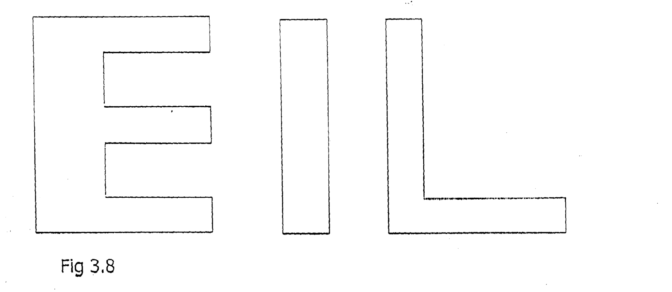
Fig. 3.8
3.9 TRANSFORMER DESIGN
In designing a transformer, the following parameter should be consider:-
Number of primary turns — N1
Number of secondary turns — N2
Primary current — 11
Secondary current— 12
Coefficient of coupling — K
Magnetomotive force — MMF
Mutual inductance — M
Relevance of the magnetic at — S
Mutual inductance - M= KN1N2
S
And MMF =N2 12
Since the magnetizing force is the same through out in the coil
then,
N1 11 = N2 12
I1 = N2 12
N1
11 = N2
12 N1
Also, EMF — produced in the primary is given by El =
4.44F1OMIN and e.m.f linking the secondary is given by E2 =
4.44OF2M2N2
4.44F1OMTN1 El
4.44F2OM2N2 E2
Since the maximum flux and frequency are the same
i.e OM1 = OM2 and F1 = F2
then, = E1 N1
E2 N2
So, E₁= N1 O and E2= N₂ O
E E

E1=N1 O/ E
N2 O E

Rate of change of flux is same in both windings, therefore,
El = N1
E2 N2

Now, Having known the principle of operation of particular equipment, it is possible to determine design values of it using good engineering design

