INTRODUCTION
Background of the study
A regulated power supply is indispensable in powering or precision equipment operations. Joshua DuBois defined electrical current as the time rate of change of charge flow in a circuit. Williams, O. A., suggested that since the energy from the wall outlet is practically unlimited, it can be converted from its alternating current (AC) to direct or steady current (DC), and tailored to provide the voltage suitable for electronic equipment. This can be achieved in a DC power supply unit (PSU), and the PSU used in the laboratory for experiments is termed a laboratory bench supply. It can be designed as a variable power supply unit that can supply either a uni-polar or bi-polar power to the load (Shoewu et al.,).In most countries the electricity from the power grid to homes, industries and laboratories is transmitted and distributed in AC form, while most electronic equipment directly use the suitable means of converting the alternating supply to direct current therefore becomes indispensable. An alternating current is a current that varies in magnitude and direction with time and a direct current is a current that maintains a constant magnitude as it flows through a wire without change in direction with time. Figure 1. Schematic representation of AC (A) and DC (B) Currents (Source: Williams, 1995)The primary characteristics that need to be considered in the design of a regulated power supply are the output dc voltage (Vdc), maximum current (Imax) required by the load, the tolerance level and the percentage regulation (%Reg) allowable (Berkowitz, S., Horowitz, P. and Hill, W.). There are various ways of designing regulated power supply units. The most commonly used are the linear regulated power supply, mostly used in low power application and the switching mode regulated power supply which this work is mainly concerned with is mostly used in high power applications. Moreover, the use of a battery as a source of DC voltage for electronic circuits has several short comings. These include, relatively short life-time, relatively low circuits that can be continuously supplied without battery recharging, and relatively large volume requirement.
Highlight the importance of battery chargers in powering electronic devices. Discuss the need for multi-voltage chargers to accommodate various devices and applications.
2.0 AIMS AND OBJECTIVES OF THE STUDY
Objective: The goal is to design and construct a battery charger capable of charging batteries at 3V, 6V, 9V, 12V, and 24V with adjustable voltage levels.
3.0 PROBLEM STATEMENT
Explain the challenges in current battery chargers:
Limited voltage options for different battery types.
Inconvenience of using separate chargers for different devices.
Inefficiency in power management.
4. SCOPE OF THE PROJECT
Design a multi-voltage battery charger circuit.
Ensure compatibility with multiple battery types (e.g., NiMH, Li-ion, Lead-acid).
Integrate safety features like overcurrent and overvoltage protection
5. 0 METHODOLOGY
Describe the steps to accomplish the project:
1. Circuit Design:
Use a transformer to step down the AC supply.
Implement a rectifier circuit to convert AC to DC.
Include voltage regulator ICs (e.g., LM317 or LM338) for adjustable voltage levels.
Add a selector switch to choose between 3V, 6V, 9V, 12V, and 24V outputs.
2. Block Diagram:
Input: AC mains power supply.
Step-down Transformer: Converts high voltage AC to low voltage AC.
Rectifier Circuit: Converts AC to DC.
Voltage Regulator: Provides adjustable DC outputs (3V, 6V, 9V, 12V, 24V).
Switch Selector: Allows users to choose the desired voltage.
Output: Regulated voltage to charge batteries.

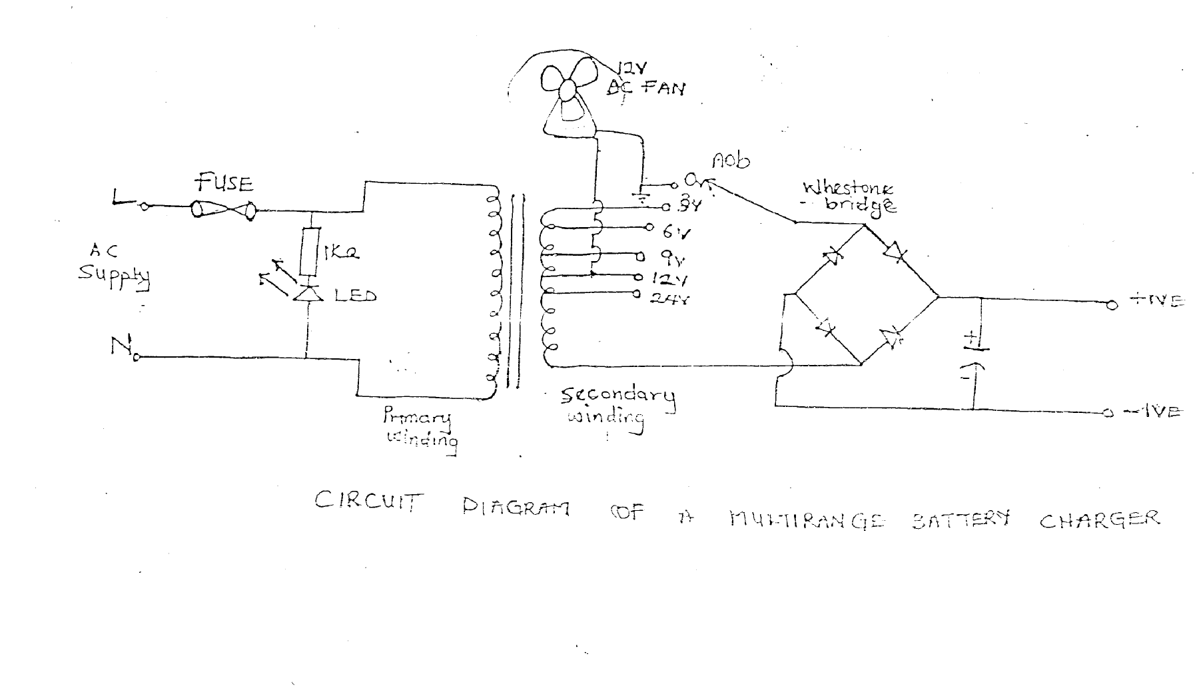
3. Component Selection:
Transformer, rectifier diodes, voltage regulators, capacitors, heat sinks, and safety components.
4. Testing and Evaluation:
Verify the accuracy of output voltages.
Test with different battery types.
5. Expected Outcome
A functional battery charger capable of delivering adjustable voltage outputs (3V, 6V, 9V, 12V, and 24V).
Enhanced flexibility and safety in battery charging.
6. Budget and Resources
List the components with estimated costs.
Mention the tools required (e.g., multimeter, soldering kit).
8. Timeline
Provide a Gantt chart or milestones for:
Circuit design (1 week).
Component procurement (1 week).
Assembly and testing (2 weeks).
6.0 CONCLUSION
Summarize the project's significance in addressing the need for versatile and efficient battery chargers. Emphasize the innovative aspect of combining multiple voltage outputs in a single device
REFERENCES
Berkowitz, S. 2003. Powering Digital Circuits and Systems. Orbit Educational Book Publishers: Toronto, Canada.
Hammed, O.S. and Ademola, A.K. 2008.”Design and Construction of an Emergency Rechargeable Lamp Incorporated with a Battery Overcharging Preventer Circuit”. Medwell Journal of Engineering and Applied Sciences. 3(9):684-687.
Horowitz, P. and Hill, W. 1980. Art of Electronics. Cambridge Press: Cambridge, UK.
Joshua DuBois. 2009. ECE 480.Team 6 – BorgWarner Fan Clutch.
Shoewu, O., Olaniyi, O.M. and Ogunleye, O.M., 2011. Design and Development of an Intelligent Variable Power Supply Device. The Pacific Journal of Science and Technology Volume 12. Number 1.
Williams, O.A. 1995. Design and Construction of a Regulated Power Supply Unit. Cambridge Press: Cambridge, UK.
DDC

