CHAPTER TWO
2.0 STAGES INVOLVED IN CHARGING CIRCUIT USED
There are categories stages involved in the circuit used. These are, the input stage, rectifying stage, smoothing stage and the output stage. The figure below shows the block diagram of individual stage involved in the circuit used.
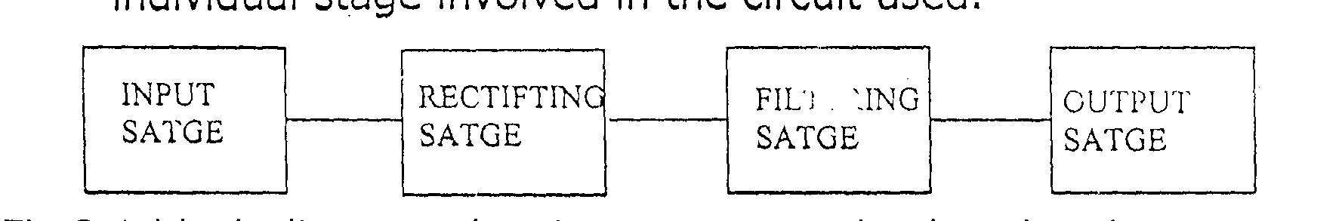

Fig 2.1: Block diagram showing stages involved in the charging circuit used

INPUT STAGE: - This is the stage through which power is being supplied from Electrical mains source of 230v, 50Hz to the circuit. Transformation of voltage is also takes place in this stage
RECTIF(ING STAGE: -In this stage conversion is take place where an alternating current (a.c) is being converted to direct current (d.c) through the means of rectifying diode in form of bridge rectifier
FILTERING STAGE: - In this stage, the remaining a.c component after rectification (i.e ripples) are filtered to give a more perfect direct current
OUTPUT STAGE: This is final stage in which the output terminal of the battery charger is connected to the battery to be charged.

Fig 2.2 (a) and (b) below show the arrangement of transformer voltages transformation and wave form produced in voltage transformation respectively.

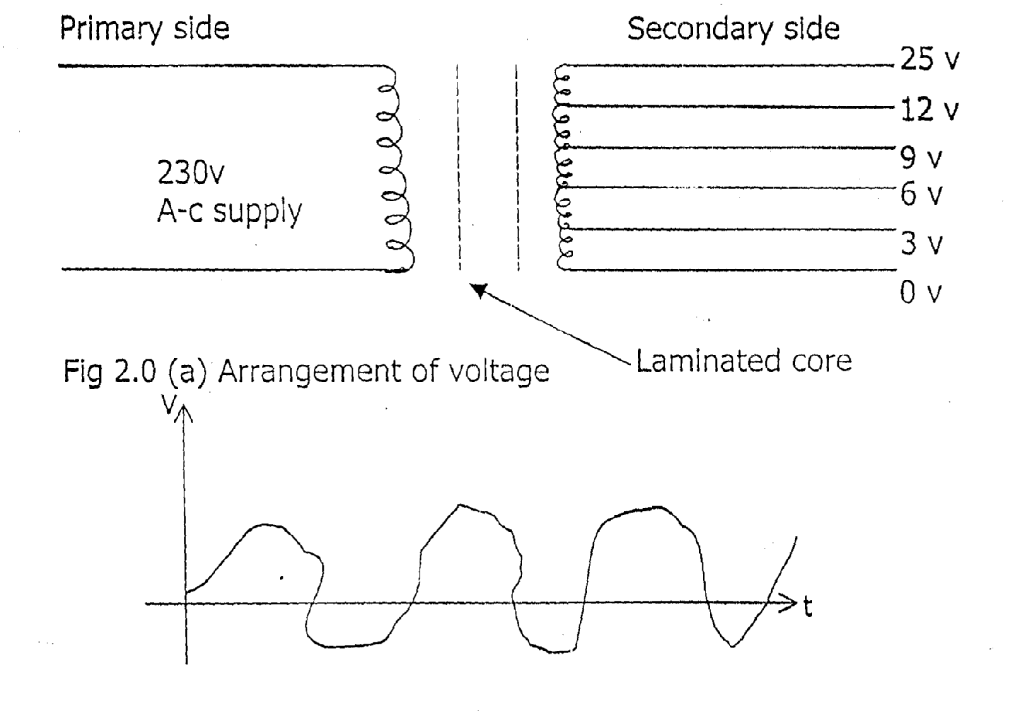
Fig 2.1 (b) wave form produced in voltage transformation

2.1 POWER SUPPLY
The source of electrical power supply is from the National Electric Power Authority (N EPA) or Power Holding Company Of Nigeria (PHCN) the supply is in form of alternating current and voltage. The supply voltage is 230 volts, which is being stepped down by step down transformer to 25v, 12v 9v, 6v, and 3v respectively. And the frequency of the supply still remain constant 50Hz.
2.2 VOLTAGE TRANSFORMATION
In voltage transformation a transformer is needed which is made up of magnetic core and several copper winding. The transformer used for this project is a step down transformer which consist of two separate windings, primary winding and secondary winding. These two winding share a common magnetic circuit i.e they are electro — magnetically coupled the primary coil is connect to time varying voltage source while. the secondary coil is connected to the load circuit. The ability to receive power at one voltage or current level and deliver it at other voltage or current level is the most unique feature which can be used to power the circuit that are isolated from the main power supply.
The magnetic core is made up of laminated metal sheets stamped together to provide a high performance so as to link magnetic field that develop at primary winding to the secondary winding. The transformer used is tapped at different point to give different voltage level and also to enable the voltage to be varied. The gauge of the wire used for the primary side is 25mm², which that of the secondary side is 19mm².
The turns on each side of the transformer are determined by using the transformation formulae
N1 = V1
N2 V2
Where N1 — The number of turns on the primary windings
N2 — The number of turns on the secondary windings
V1 — The primary voltage which is 230v
V2 — The tapped voltage at the secondary sides of the transformer, which are 25v, 12v, 9v, 5v, and 3v,

2.3 VOLTAGE RECTIFICATION
It is important to convert the alternating current to a direct current because charging of batteries is achieved through a direct current. This current can only be obtained from an alternating supply by means’ of rectifying diodes which is a device that allow current flow in only one directing i.e unidirectional way.
There, are two types of ratification which are half wave rectification, which consists of only one diode and full wave rectification, which consists of two diode or four diodes also known as bridge rectifier. But in this project, the type of rectification used is full wave rectification, a bridge rectifier which is incorporate to the a.c supply to obtain d.c as shown in diagram below.

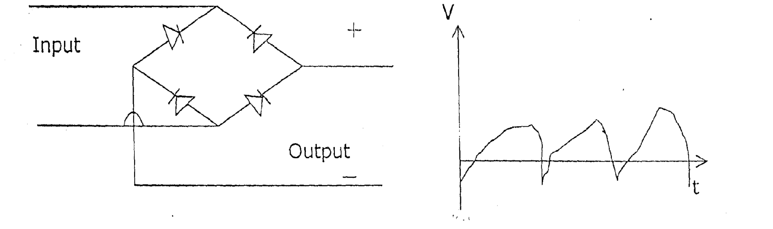
Fig. 2.2 (a) Bridge rectifier Fig. 2.2 (b) Was form produced by full wave rectification

2.4 VOLTAGE SMOOTHING
This is a process by which the alternating current components or ripples remaining after rectification are filtered with the use of a capacitor to give a more perfect direct current.

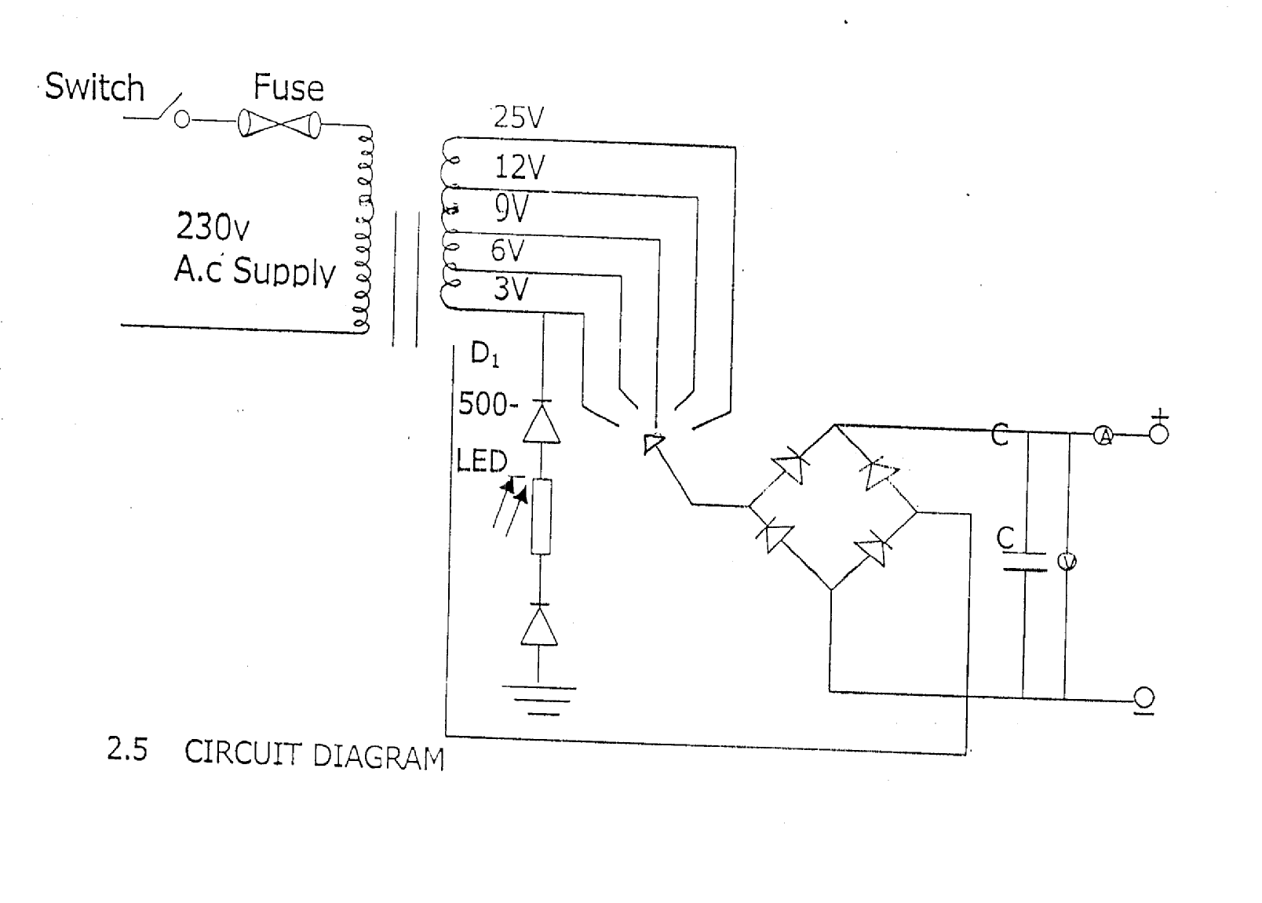

2.5 Circuit Diagram

