CHAPTER ONE
1.0 THEORETICAL BACKGROUND OF BATTERY CHANGER
The introductions of battery charger make life more comfortable. The invention of battery charger became necessary due to the fact that there must be a way to restore energy back into any partially or completely run — down batteries to its normal position.
The problem that the run down batteries might be to the users is solved due to the introduction of battery charger and now become useful in every part of the world.
However, for the purpose of this project, a 230/25v battery charger with an output of O-40A is constructed to charge lead acid cell battery of 24v 12v, 9v, 6v, and 3v.
This device comprises o three parts namely, the power circuit and control circuit, charging circuit and control. Power circuit consists of transformer which step down the 230v, voltages A.C from the source to 25v A.C, the A.C is rectified by means of a bridge rectifier to unidirectional current in form of pulsating (D.C)
The control circuit is provided to switch the charging circuit to trickle charging when the battery is fully charged. The circuit consist of light emitting diode (LED) coupled to limiting resistor with a light emitting diode which conduct when the battery reach charging voltage settled by preset resistor. The battery charge is designed to change 24v lead acid batteries. The Electrical energy is converted in to electrical energy to supply external circuit in form of unidirectional current D.C
1.1 CHARGING OF BATTERIES
The cells of each battery whose to be charge are normally connected in series so that each cell receives the same charging current for equal charges Run down batteries either partially or complete one are charged by passing direct current through then by means of a probes from the supply voltage of the charger to the battery or batteries to be charged. To ensure an effective charging, the following steps are to be considered.
i) You must ensure that the charger is switch off before the connection of the battery to the charger
ii) You must make sure that correct polarity is observed i.e. positive to positive and negative to negative
iii) Remove the filler plugs if recommended and switch On the charger
iv) There will be gas when the battery approaches full charge due to chemical reaction that take place inside the battery
v) Check and record the specific gravity of the cell that of water because volume of water must be less than that of electrolyte
vi) Replaces the filler plugs if it had been removed
vii) Leave the battery to cool before use to ensure that battery is
Working under temperature so as not to shorten the life span of wooden separator.

1.2 METHOD OF CHARGING EMPLOYEE
This method falls under four different categories they are: -
(1) Trickle charging method
(2) Floating system method
(3) Constant potential method
(4) Constant current method
But for the purpose of this project the method of charging employed is constant potential method of charging batteries. In this method the charging voltage is maintained at a suitable value for the cells, The charging current for this method is not fixed or constant as the batteries is being charged the current start to decrease until it finally gets to zero (0) point on the ammeter signifying that the battery is fully charged. For charging cells at different range the most practical method is to employ a three bus-bar system with 15v between the other of the 12v batteries and 7 ½ V for the 6v batteries where necessary resistance should be inserted to the required value as shown in the Figure below
(e) Always add acid to water (not water acid)
(f) Fire fighting appliance should be at hand
(g) First aid box must be installed
1.3 PRINCIPLE OF OPERATION OF THE BATTERY CHARGER
When an a.c of 230v is supplied to the primary side of the transformer which is made up of five different tapings at the secondary side as a result of these five different voltages of 25v, 12v, 9v, 6v, and 3v, can be obtained at the secondary side of the transformer The secondary side of the transformer is connected to a bridge rectifier for the purpose of converting the alternating current (a.c) to direct current (d.c) which is the current used to charged batteries. An electrolytic capacitor is connected in parallel with the bridge rectifier for smoothing and filtration of ripples from a.c component remaining after rectification. A d.c voltmeter is also connected in parallel to indicate the changing voltage and d.c ammeter to indicate the charging current.
When a battery which serve as load is connected to the output of the charger and the supply to the charger is ON, the voltmeter will read the charging voltage and since there is load, current also will flow and the ammeter will indicate the value of the charging current.
Since the method of charging employed is constant voltage method as the battery is charging, the current will be reducing gradually until it becomes steady, that is the ammeter and voltmeter readings will be steady which indicate that the battery is fully charged.
1.4 FUNCTION OF THE BATTERY CHARGER
The basic function of battery charger is to restore back the current in the batteries, which has run down as a result of constant used. The previously stored electrical energy in the electrolyte has been used up by emergency lighting stand by equipment in public buildings such as hospitals, telecommunication industries, bank etc after some time, the energy run down and can be restore back as result of battery charger.
1.5 ECONOMIC IMPORTANCE OF THE BATTERY CHARGER
In day in day out of this modem world, the activity of the Charger has got many role to play which directly or indirectly demanded for, its economic importance.
One of its economic important is that it save cost, this is because, in case of car, car are start by the battery and In a family that have many cars, if the battery is not provided the means of charging after its run down, then we have to throw it away and buy new one. But if there is means of charging, we chare it again and it will start working. The cost of charging is far more less than buy another one. In case of dry cell, this may not be possible.
The durability of lead and batteries is another one of the main economic importance i.e in the case of lead acid battery it is rechargeable, once the battery is charging from time to time It will last long.
This diagram is the feed back system of charging battery

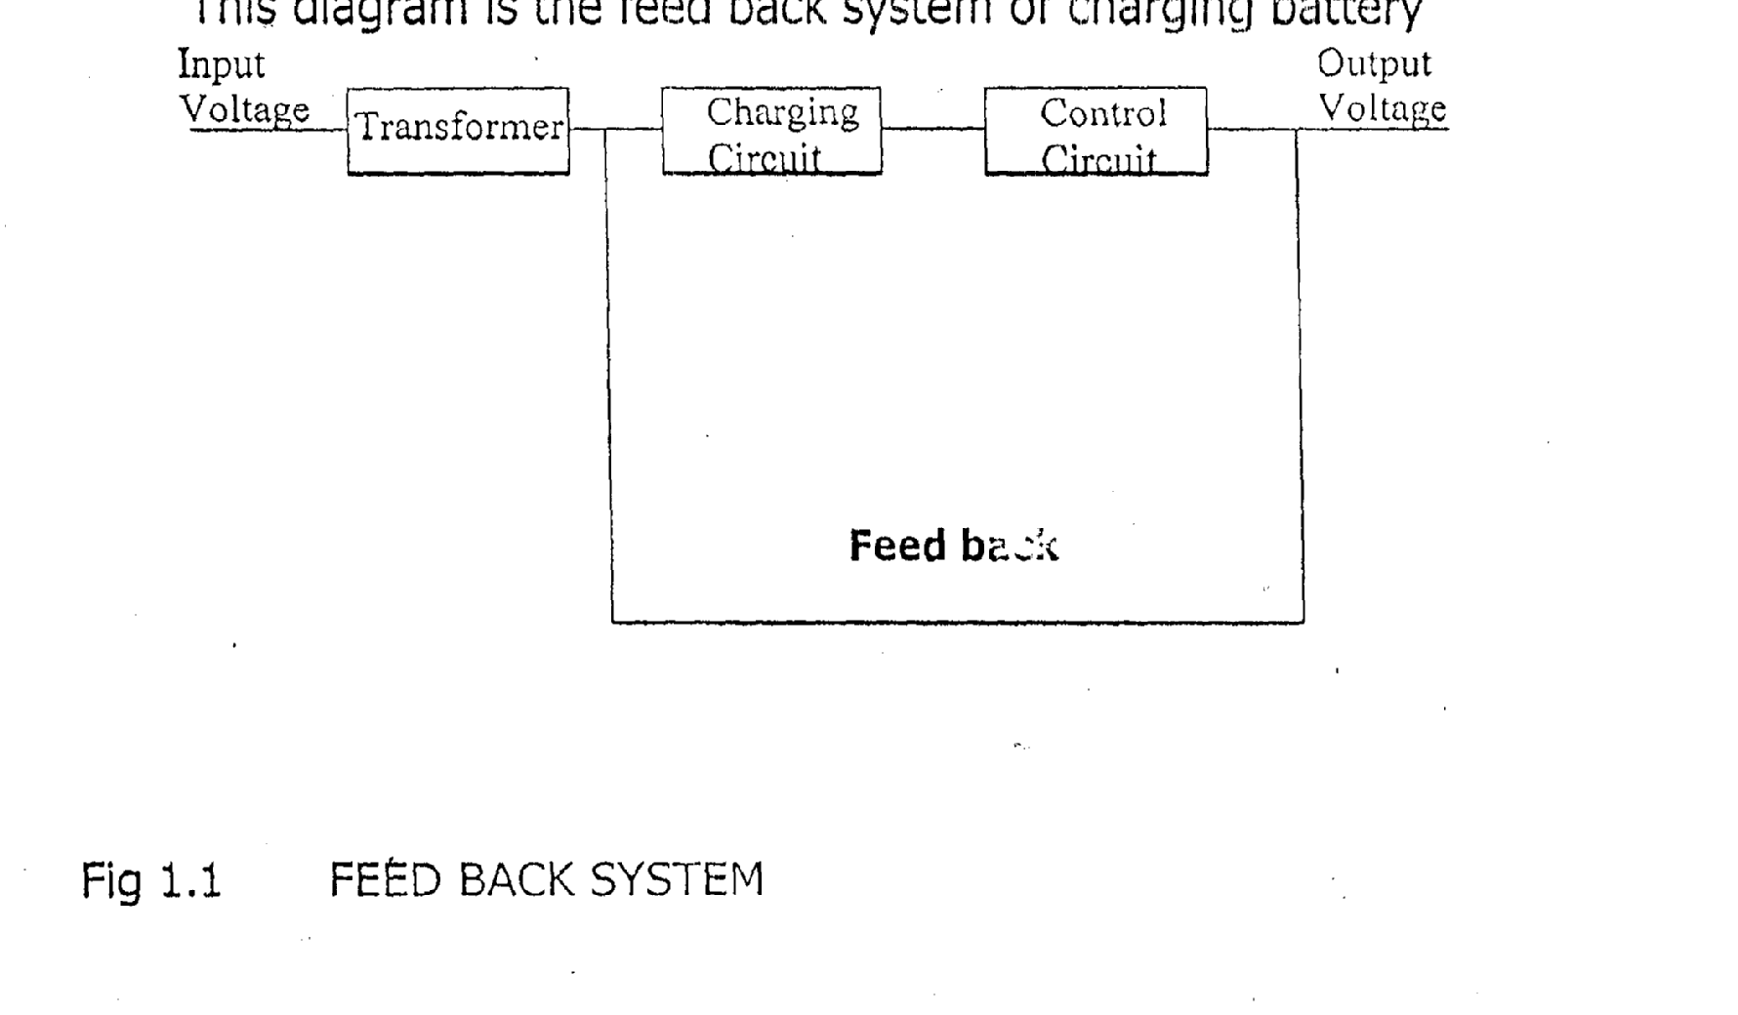

Fig. 1.1: Feed Back System

