CHAPTER THREE
3.0 METHODOLOGY
3.1 System Design and Architecture
The smart reading lamp comprises a rechargeable battery, LED lighting system, touch sensor module, and power management circuitry. The system is designed for low power consumption and high efficiency.

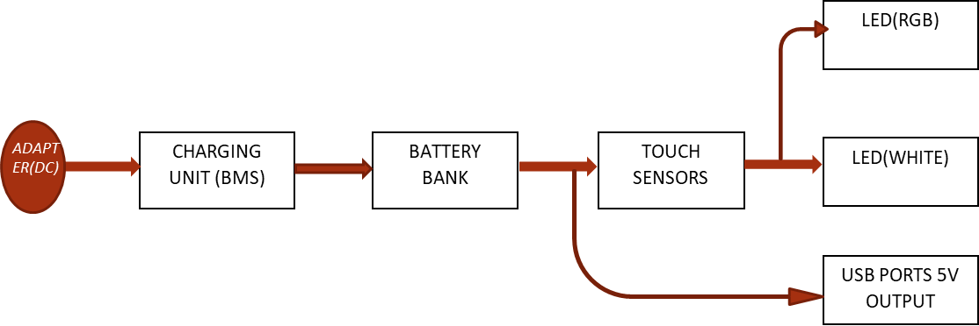
Figure 9: Block diagram of the construction of a multifunctional USB rechargeable table lamb with touch sensor and power bank
  - Components Selection and Justification
- Lithium-ion battery (20,000mAh): Chosen for its high energy density and recharge ability.
- LEDs (RGB + White): Selected for their efficiency, longevity, and customizable color options.
- Touch Sensor Module: Enables seamless control without physical buttons.
- Battery charging unit: It is used to protect the battery from over charging and over discharging, it also protect the battery against the excessive use of current.
  - Circuit Design and Implementation
The design involves creating an efficient power distribution network, integrating the touch sensor with lighting modules, and programming the microcontroller for responsive control.

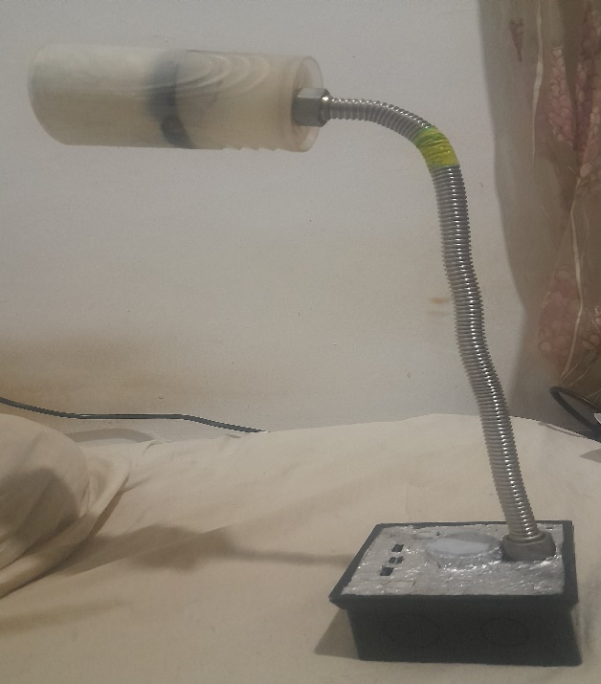
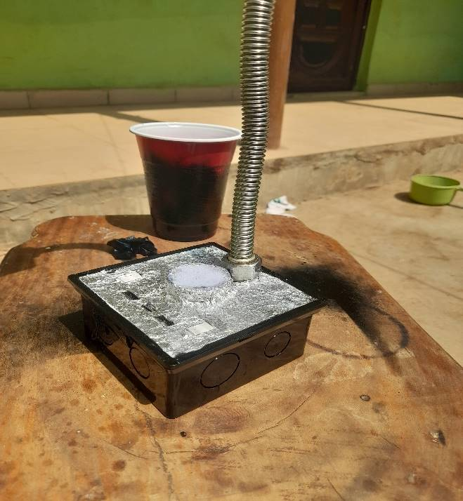



Figure 10: The physical appearance of the lamp

