CHAPTER FOUR
CONSTRUCTION
4.0 The construction work on any electrical/electronics equipment includes the main construction work on the circuit and the casing. The construction of this project was carried out inside the casing and not on Vero — board the component used in the construction was arranged properly as indicated on the circuit diagram Effective soldering was made from point to point so as to Avoid any fault due to improper soldering.
The construction work carried out can be categorized into two units. These units are mounted in the casing specially designed for the project.
4.1 COMPONENT TESTING
The testing of components used was done to make sure that all the components used are in good condition.
The test is carried on every component in the circuit such as switch, capacitor transformer and diode.
TEST ON SWITCH: - This was tested ohmmeter with two probes to the switch terminals to check its continuity, which was found to be okay.
TEST ON CAPACITOR: - Capacitor was tested with ohmmeter and it was found good because it defected initially and later going down which shows that it charges and then discharges.
TEST ON TRANSFORMER: - The transform was tested at the output side with voltmeter to make sure that the output voltages are of the require values.
TEST ON DIODE:- This was tested with analogue multi — meter which indicated that the diode conducts only in the forward direction.
4.2 COMPONENTS ARRANGEMENT
The arrangement of component in this project were from the left to right starting with switch and fuse connected to the primary terminal of the transformer. A bridge rectifier was connected to the secondary side of the transformer. Capacitor was connected very close to the bridge rectifier in parallel for the filtering and smoothing purposes.
Also a d.c voltmeter to indicate the charging voltage is connected in parallel with the rectifier, and a d.c ammeter to indicate the charging current is also connected in series with the rectifier.

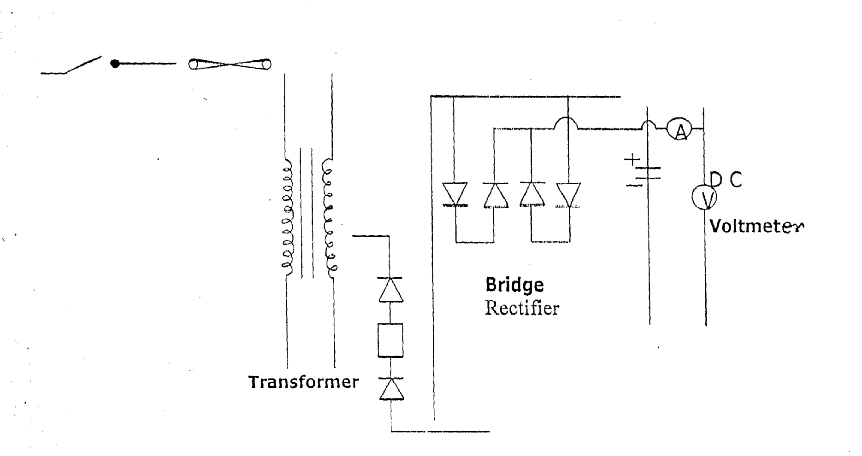

4.3 CONNECTIONS OF FAN REGULATOR TO THE TRANSFORMER
This was done by connecting the fan regulator to the secondary side of the main transformer the striating of the secondary winding to the one side of the bridge rectifier and then, the common point of the fan regulator to the other side of the diode bridge rectifier. This enhances the variation of output voltage from the secondary side of the main transformer with the tapping 9v, 12v, and 25v depending on the battery to be charged.

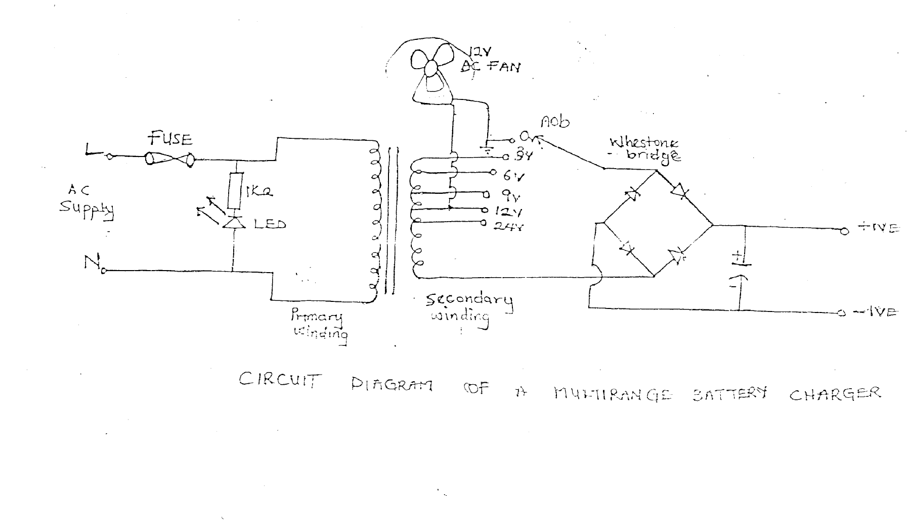

4.4 CONNECTION OF CAPACITOR TO THE BRIDGE RECTIFIER AND BRIDGE RECTIFIER TO THE FAN REGULATOR
The capacitor is connected to the D.C output of the rectifier as used in the diagram below and it’s acts as a smoothing capacitor which smoothes and filters the ripples from the rectifier to reasonable level in the circuit.
The bridge rectifier contains four diode connected in star shaped and is capable of withstanding more than 30 amperes without breakdown. The diode has four pins , two at which are of the alternating current input and the other two for direct current output

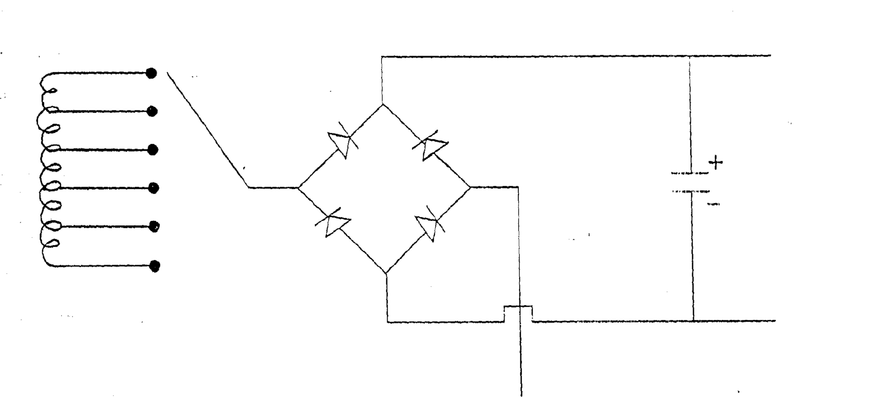
4.5 CONNECTION OF LED TO TRANSISTOR AND CONNECTION IN FUSE
The light emitting diode (LED) is connected in parallel to the circuit to indicate output power position (of ON and OFF). The fuse is connected to the line conductor of the 230v A.C supply as a means of protection of the circuit, from excessive current, with a switch to make and break the circuit the figure below shows connection in fuse.
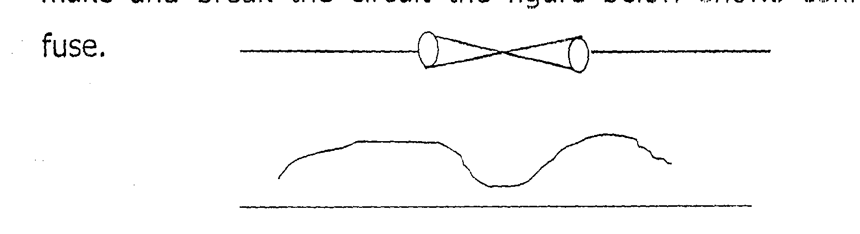

4.6 CONNECTION OF MEASURING INSTRUMENT TO THE CIRCUIT AND CONVERTING OF RESISTOR TO THE CIRCUIT
The measuring instrument which are ammeter and voltmeter.
The ammeter is connected in series used to measure the output current and the voltmeter is connected in parallel used to measure the output voltage respectively. The resistor used are connected in with the diode and light emitting diode as shown in the diagram below. The series resistor is used to limit some of the current why led operates on a very low current.

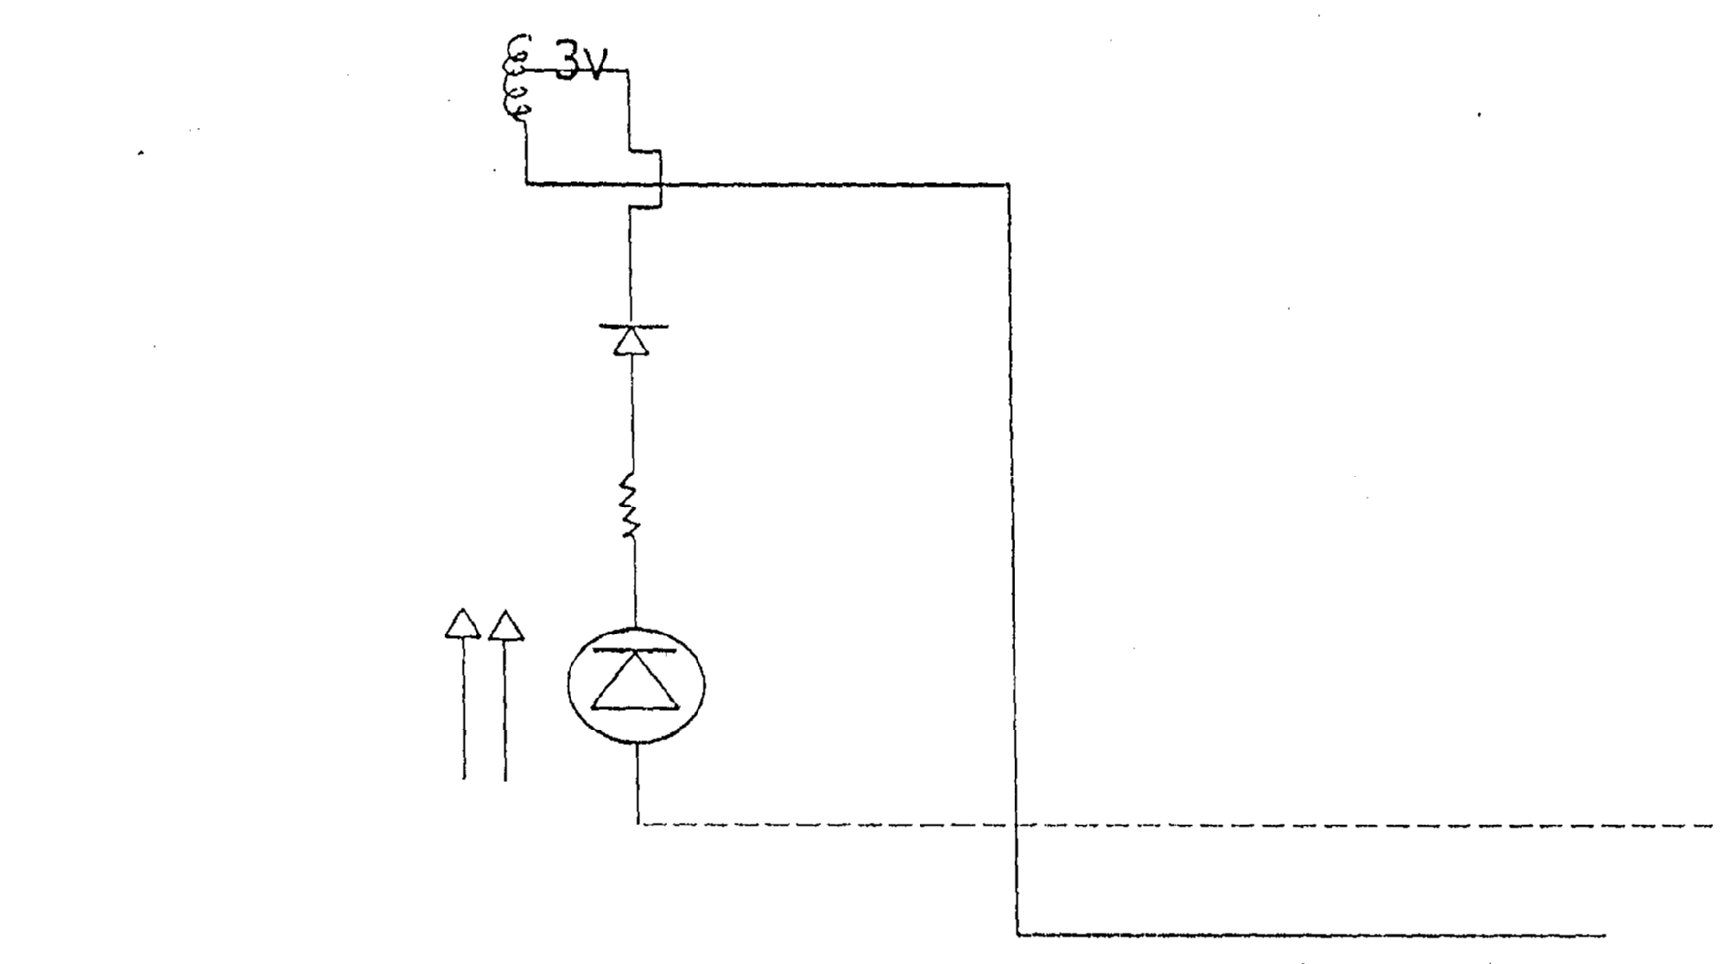

4.7 SOLDERING METHOD AND PRECAUTION
Having properly arranged the components soldering was the next step. Soldering is the method of joining two or more component together to give a firm joint that is mechanically strong and electrical continuous. For effective soldering the following soldering defects must be avoided.
- No solder: - This occurs when a joint is left completely unsoldered.
- Insufficient solder: - these can cause partial contact and to avoid this there must be enough solder at the joint to form good filler between the connecting point.
- Dry joint and overheating must also be avoided for a good soldering, it must have the following characteristics, which are.
- Free of holes, scars and spite
- After soldering the outline of the conductor must be left clearly and have bright shinning appearance finally, when soldering heat must not be two much on the components to be soldered, otherwise, the components might be damaged
4.8 CASING AND FINAL COUPLING
In construction of cabinet (casing), there are many factors to be considered such as the size of cabinet, mounting position of component, component ventilation, cabinet movement: and painting.
Taking into consideration the size of the transformer constructed and other component us d made the cabinets. This was done so as to give enough room. For the accommodation of all the components, the cabinet is rectangular in shape with six (6) sides, which are the following:-
Length Width
Front view 25cm 18cm
The back view 25cm 18cm
The two sides view 25rm 15cm
The top view 35m 18cm
The base view 35cm 18cm
Fan is constructed at the back of the casing to provide air cooling (Ventilation) for the transformer and other Components used.
The front cover contains components such is voltmeter, ammeter, control variable switch, limp indicator and the output terminals at the back of the casing
4.9 PROBLEM ENCOUNTERED AND COST ESTIMATION
The construction of battery charger is as easy as being provided in the circuit. But some of the problems encountered during the construction is that of malfunction of the component such as diode capacitor, resistor etc.
None availability of some components used also posed problem, because component such as d.c ammeter, d.c voltmeter are not easy to get in the market. Since we are unable to get these components we need to travel from one place a another to buy thorn which increased the cost of the project.
However, in view of all the problem being enumerated above, we will suggest that Polytechnic Authority and the Government should try to assist the final year students in form of financial aid just because not all the parents are economically buoyant to provide all the needs of their children at school. In times of state bursary, they should let this circulate to all the students because during our time in us to collect bursary form, obtain Nakks receipt e.t.c but at last, we won’t see our name.

COST ESTIMATION (ENGINEERING BILL OF QUANTITY)
Before undertaking any project it is necessary to consider the overall cost. In order to avoid stoppage of the project you want to embark on the table below shows the cost of the materials used for the project. Table one
S/N | Quantity | Description | Rate | Amount (N)
1 | 1 | D.C Voltmeter | 800.00 | 800.00
2 | 1 | D.C Ammeter | 1,200.00 | 1,200.00
3 | 1 | Cord | 250.00 | 250.00
4 | 1 | Transformer | 2,500.00 | 2,500.00
5 | 1 | Capacitor | 50.00 | 50.00
6. | 4 | Jack Plug & Socket | 25.00 | 100.00
7 | 1 | Diode | 150.00 | 150.00
8. | 1 | Fan regulator | 200.00 | 200.00
9. | 1 | Switch | 60.00 | 60.00
10. | 2 yards | Cable | 50.00 | 100.00
11 | 1 | Fuse | 40.00 | 40.00
12. | 2 | Clip | 75.00 | 150.00
13. | 1 | Casing |  | 1,500.00
 |  |  |  | 1,500.00
TOTAL |  |  |  | 7,000.00

