CHAPTER THREE

METHODOLOGY
This research employs an experimental approach to optimize the hybrid foam concrete mix design by incorporating palm kernel oil-based surfactants and sawdust. This methodology focuses on designing, testing, and analyzing mixed compositions to achieve an optimal balance between density, compressive strength, and workability.
This research was carried out in stages; the first stage involves sourcing and preparation of Materials, at the second stage, trial mix of foam concrete was conducted to achieve a mix design for the concrete mix while the next stage involves the casting of concrete cubes (150 mm x 150 mm x 150 mm) and the last stage involved the testing of concrete cubes at 1:2 nominal mix for foam concrete and a water/cement ratio of 0.6.

MATERIALS NEEDED
The materials used for this research work are mainly cement, water, aggregate (stone dust and sawdust), Palm Kernel Oil and Foaming Agents. These materials were used for casting of 150mm x 150mm x 150mm cubes size. The batching was made for the mix ratio 1:2 and the concrete produced was cast into the cube using mold of 150 mm x 150 mm x 150 mm. After the casting, the mold was removed after 24 hours and the samples were immersed into the curing container. The curing period will be for 7, 14 and 28 days and crushing test, density and water absorption test will be done. The materials are briefly explained below:
    - Portland Limestone Cement:
Portland Limestone Cement Typically Grade 42.5R, as specified in ASTM C150-20 and BS EN 197-1:2011 was used during this research. The cement serves as the primary binder in foam concrete. The cement is gotten from a cement depot around the school area (Eleko) in Ilorin, Kwara State. Each bag of PLC is 50kg in size.
    - Sawdust:
Sawdust was used as a partial replacement for conventional coarse aggregates in the foam concrete mix. Sourced from a local woodworking facility around oyun, the sawdust was sieved to remove larger particles and then used as an aggregate in the foam concrete.

    - Hybridized Stone Dust: Stone dust is being introduced as a hybridized coarse aggregate in the mix. Since, there is no need for coarse aggregate in foam concrete to reduce its weight and density. Stone dust is collected from quarry sites and sieved using a 1.7mm sieve to remove particles. The gradation is verified as per ASTM C33/C33M.
    - Palm kernel oil-based surfactants: Palm kernel oil-based surfactants are derived from the oil extracted from the seeds of the palm kernel through processes such as polyesterification or amidopropylation. PKO-S is being gotten from a nearby market around Ilorin metropolis.
3.1.5. Water: Water is essential for hydration and foam generation. Potable water is being used for mixing and curing, conforming to ASTM C1602. The water used for this work was obtained from the nearby water source at Institute of Technology, Kwara State Polytechnic, Ilorin. The water was free from injurious amount of oil, acid, organic matter, alkali and other deleterious substances
3.1.6. Foaming agent: Sodium Lauryl Sulfate (SLS) is a commonly used foaming agent in foamed concrete. The SLS is sourced for in OJA TUNTUN market, Ilorin.

METHODS
Three different samples of foamed concrete were produced for optimization. Optimization will be between a sample with PKO-S and LS and another without PKO-S. The mix ratio used samples is 1:2. The foaming agent varies in response to the water cement ratio.
Mixing Procedure:
- Weigh and mix the PLC, sawdust, and Stone dust in a dry mixer until well combined
- In a separate container, mix the SLS in a small amount of water to create a foam solution.
- Add Water to the dry mix and mix until a uniform paste is obtained.
- Mix the generated foam into the wet mix until well combined.
- Add the Palm Kernel Oil into the mix.
- Mix the hybridized foam concrete for an additional 2-3 minutes before pouring and curing for the specified amount of time.
Mix Proportioning:
- Mixes is being prepared with sawdust content as a partial replacement for fine aggregate.
- PKO-S concentrations - 1.5%
- The water-to-binder ratio follows the required water-to-cement ratio.
- The Foaming agents is in concentration with the water – cement ratio.
- Specimens (150 mm x 150 mm x 150 mm cubes) were casted, compacted, and cured in water for 7, 14, and 28 days.

Various types of tests were carried out on the sample to check for the compressive strength, water absorption and density of the Foam Concrete, and to know the effect of Palm Kernel Oil Based Surfactant on the sample. The following tests were carried out by following the code of practice:
  - Compressive Strength
The compressive strength test is a standard method for determining the strength of concrete. The compressive strength test was conducted using the ASTM C39/C39M standard. During this research, 9 cubes of 150 mm x 150 mm x 150 mm of concrete was being casted and cured for 7, 14 and 28 days (2 cubes for each concentration of PKO) in water of average room temperature after 24 hours of casting. The specimens were tested for compressive strength by applying compressive load to the specimen until it fails. Therefore, the maximum load is recorded which is given by N/mm². The compressive strength is then calculated using the formula:
$$Compressive Strength = \frac{Maximum Load}{Cross-sectional Area}$$
Where:
Maximum load (N) = The maximum load from the machine until failure
Cross – sectional Area (mm²) = The area of the cube
  - Workability test: The workability test is a standard method for assessing the ease of handling fresh concrete. The workability test was conducted using the slump test method, following the ASTM C143/C143M standard. This test helps determine the consistency and flow of concrete, which directly affects its placement and compaction on site.
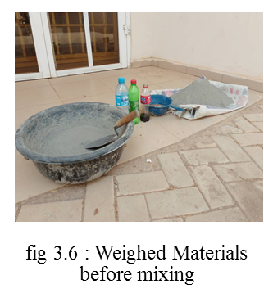
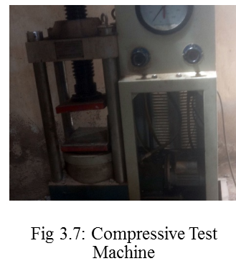
  - Density: The specimens after been cured for 7, 14 and 28 days were being weighed to calculate for the density of the specimens following the code of practice standards. The density is being calculated in g/cm³.

