CHAPTER THREE
3.0 METHODOLOGY
3.1 System Design and Architecture
The smart reading lamp comprises a rechargeable battery, LED lighting system, touch sensor module, and power management circuitry. The system is designed for low power consumption and high efficiency.

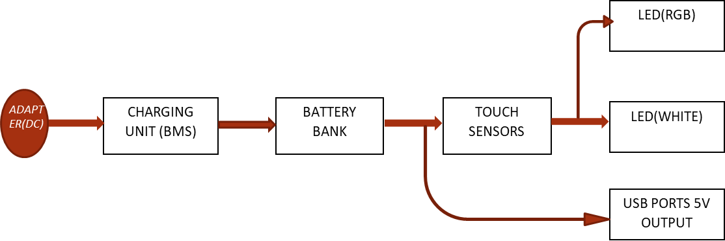
Figure 9: Block diagram of the construction of a multifunctional USB rechargeable table lamb with touch sensor and power bank
3.2 Components Selection and Justification
- Lithium-ion battery (20,000mAh): Chosen for its high energy density and recharge ability.
- LEDs (RGB + White): Selected for their efficiency, longevity, and customizable color options.
- Touch Sensor Module: Enables seamless control without physical buttons.
- Battery charging unit: It is used to protect the battery from over charging and over discharging, it also protect the battery against the excessive use of current.
3.3 Circuit Design and Implementation
The design involves creating an efficient power distribution network, integrating the touch sensor with lighting modules, and programming the microcontroller for responsive control.


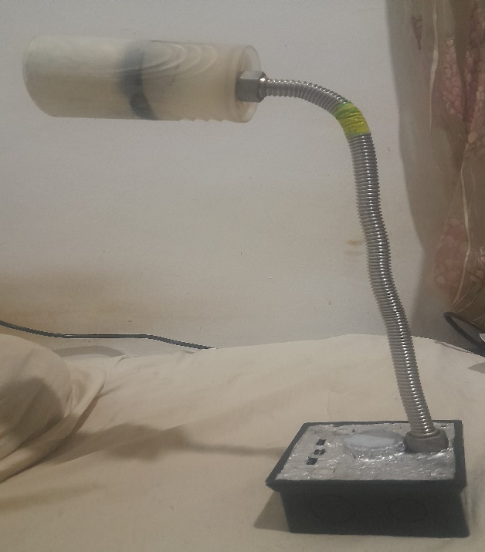

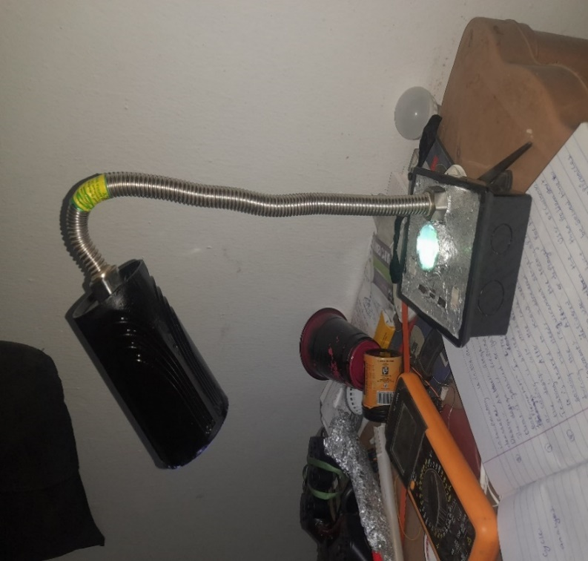

Figure 10:The physical appearance of the lamp

