CHAPTER THREE
METHODOLOGY
3.1 Introduction
This chapter deals with the design of a 360º solar tracking system with temperature and solar radiation measurement capability. A solar tracking system is a device that tracks the position of the sun during the day and throughout the year for a maximum and efficient absorption of the solar energy. A solar panel is a device that converts solar energy to electrical energy. The solar tracker rotates the solar panel so that is will be facing the sun at right angle at all time of the day and the year. The system also determines the solar intensity or radiation of the given area and also the weather monitoring system is designed to measure and monitor key environmental conditions in the surrounding area. Parameters such as temperature and solar radiation are captured and displayed on a Liquid Crystal Display (LCD), which serves as the user interface. It deals with the design of the hardware and the software of the system and as well the actual construction of the various parts of the system.

The following are the list of the electronics components for their specification used in the project.
3.2 List of Electronic Components
S/No. | Components of Solar Tracker | Specification
1. | Resistors | 10k
2. | Capacitors | 1000uf, 25v
3. | Diodes | C1815
4. | Crystal oscillator | 16,000
5. | Voltage regulator | LM7805
6. | IC socket | ATmega 328P
7. | Inductor
8. | LCD | 1602A
9. | LDR
10. | servo motor | Tower pro SG-90
11. | PCB
12. | Battery | 12v, 18AH
13. | Pannel | 30w, 17.5v
14. | Temperature sensor | DHT11

3.3 Resistor
Resistor is a passive two-terminal electrical component that implements electrical resistance as a circuit element. In electronic circuits, resistors are used to reduce current flow, adjust signal levels, to divide voltages, bias active elements, and terminate transmission lines, among other uses was shown in the figure below:
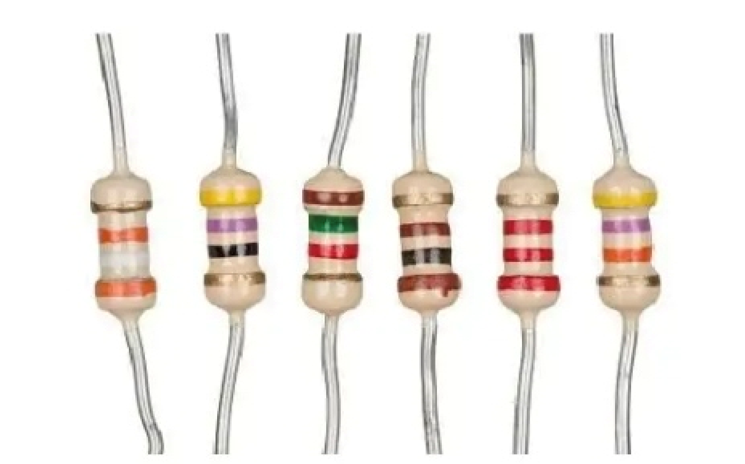
Figure 3.1: Resistor
V= IR (1)
Where:
R = Resistance (Ohms)
V = Voltage (Volts, V)
I = Current (Amperes, A)
R = $\frac{V}{I}$
I = $\frac{V}{R}$

3.4 Light Dependent Resistors (LDRs)
A photoresistor (acronymic LDR for Light Decreasing Resistance, or light-dependent resistor, or photo-conductive cell) is a passive component that decreases resistance with respect to receiving luminosity (light) on the component's sensitive surface. The resistance of a photo resistor decreases with increase in incident light intensity; in other words, it exhibits photoconductivity.
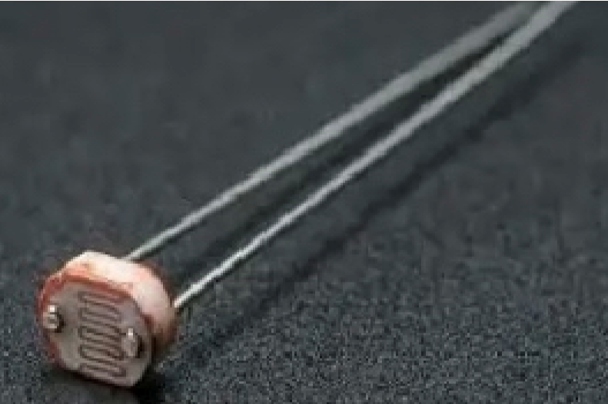
Figure 3.2: Light Dependent Resistors (LDRs

(2)
Where:
R = Resistance of the LDR (Ohm’s)
L= Light intensity (Lux)
A and K = constant that depend on the specific LDR (from its datasheet)
K is typically between 0.7 and 1.1

3.4 Capacitor:
Capacitor can store electric energy when it is connected to its charging circuit. And when it is disconnected from its charging circuit, it can dissipate that stored energy, so it can be used like a temporary battery. Capacitors are commonly used in electronic devices to maintain power supply while batteries are being changed.
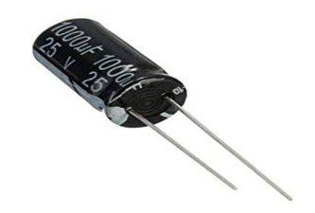
Figure 3.3: Capacitor
Capacitance
C = Q x V (3)
Where:
C = Capacitance (Farads, F)
Q = Charge (Coulombs)
V = Voltage (Volts)
Other uses capacitor equations
- Energy stored in capacitor
E =
- Capacitors in series
- Capacitors in parallel
C_{total} = C₁ + C₂ + C₃ + ….

3.5 Inductor:
An inductor is a passive electrical component that stores energy in a magnetic field when electric current flows through it. It typically consists of a coil of wire wound around a core (which can be air, iron, or another magnetic material)
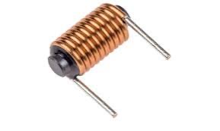
Figure 3.4: Inductor
V = L (4)
Where:
V = Voltage across the inductor (Volts)
L = Inductance (Henrys, H)
= Rate of change of current (Amps per second)

3.6 Diode
Diode is a two-terminal electronic component that conducts current primarily in one direction (asymmetric conductance); it has low (ideally zero) resistance in one direction, and high (ideally infinite ) resistance in the other.
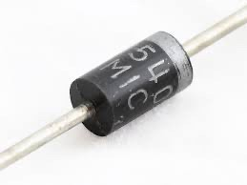
Figure 3.5: Diode
(5)
Where:
I = Current through the diode (A)
I_{s} = Reverse saturation current (A)
V = Voltage across the diode (V)
n = Ideality factor (usually between 1 and 2)
V_{T} = Thermal voltage (≈25.85 mV at room temperature)

3.7 Voltage Regulator Circuit
Voltage regulators are designed to automatically maintain voltages at a constant level. The LM7805 voltage regulator is used. It is a member of the 78xx series of fixed linear voltage regulator ICs. Voltage sources in circuits could be having fluctuations and thus not be able to give fixed voltage output. The voltage regulator IC maintains the output voltage at a value that is constant. The LM7805 provides +5V regulated power supply. Capacitors are connected at the input and output depending on respective levels of voltage [42].
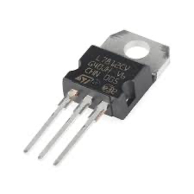
Figure 3.6: Voltage Regulator Circuit
V_{out} = V_{ref} (6)

Where:
(Usually V_{ref}≈ 1.25V)
R₁ and R₂ set the output voltage
I_{adj} is usually small and often neglected
3.8 Crystal Oscillator
Crystal oscillator is an electronic oscillator circuit that uses the mechanical resonance of a vibrating crystal of piezoelectric material to create an electrical signal with a precise frequency. The crystal oscillators have very high frequency stability. The crystal oscillator is possible to obtain very high precise and stable frequency of oscillators.
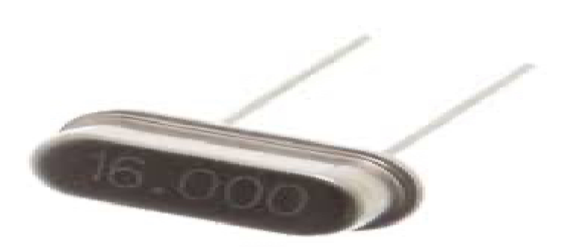
Figure 3.7: Crystal Oscillator

Series Resonant Frequency:
f_{s} = (7)
Where:
f_{s} = Series resonant frequency
L = Inductance of the crystal
C_{s} = Series capacitance

3.9 Servo Motor

In this project, the servomotors were interfaced to the microcontroller’s digital pin and for the vertical and the horizontal movements respectively. The VCC pins were connected to a +5V power supply, the GND pins were connected to the common circuit GND while the PWM pins wire connected to the digital pins and for the vertical and horizontal servos respectively.

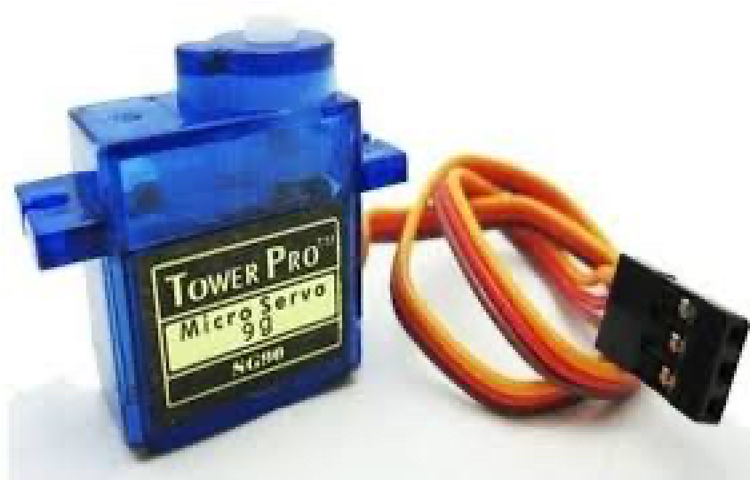
Figure: 3.8: Servo Motor
3.9.1 Servo Motor Interface to the Microcontroller
In this project, the servomotors were interfaced to the microcontroller’s digital pin – and – for the vertical and the horizontal movements respectively. The VCC pins were connected to a +5V power supply, the GND pins were connected to the common circuit GND while the PWM pins wire connected to the digital pins – and – for the vertical and horizontal servos respectively. The connections of the servomotor to the microcontroller were as shown in the figure below.

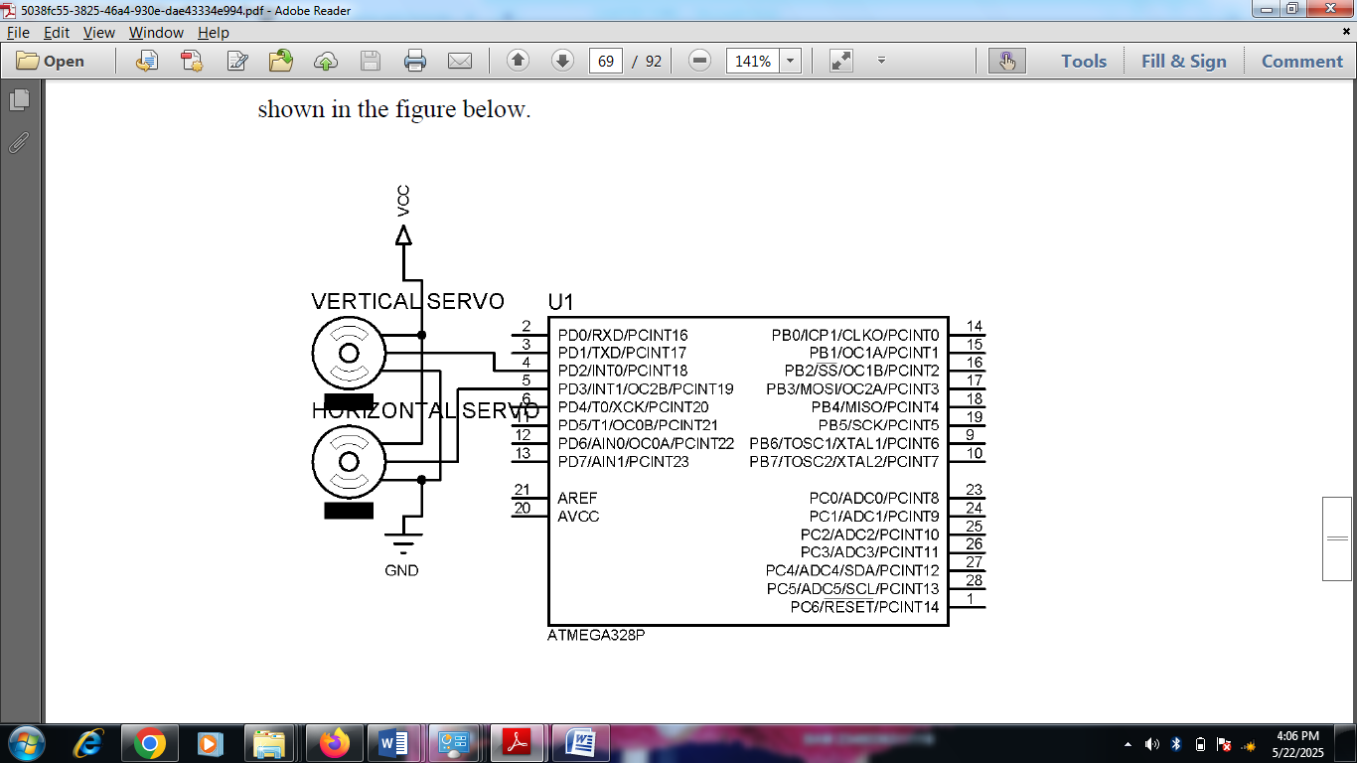
Figure 3.9: Servo Motor Interface to Microcontroller

Table 3.1: Servomotor Wire Configuration
Wire Number | Wire Colour | Description
1 | Brown | Ground wire connected to the ground of system
2 | Red | Powers the motor typically +5V is used
3 | Orange | PWM signal is given in through this wire to drive the motor

TowerPro SG-90 Features
- Operating Voltage is +5V typically
- Torque: 2.5kg/cm
- Operating speed is 0.1s/60°
- Gear Type: metal
- Rotation : 0°-180°
- Weight of motor : 9gm
3.10 Temperature Sensor
The DHTIl is a commonly used Temperature and humidity sensor that comes with a dedicated NTC to measure temperature and an 8-bit microcontroller to output the values of temperature and humidity as serial data.
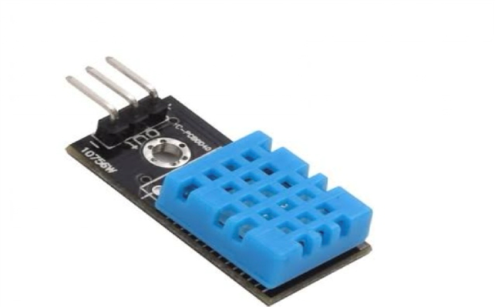
Figure 3.9: Temperature Sensor

Table 3.2: DHT11 Pin Configurations
DHT11 pin configurations
1 | VCC | Power supply 3.5V to 5.5V
2 | Data | Outputs both Temperature and Humidity through serial Data
3 | Ground | Connected to the ground of the circuit

Interfacing DHT11 to the Microcontroller
The temperature gives out a digital output at a specific intervals. The sensor is connected to the analogue ports of the microcontroller. The power pins which includes the VCC and GND were connected to the systems +5V and ground terminal of the power supply respectively. The signal pin of the sensor was connected to the pin 27 of the microcontroller which is analogue pin A4. The sensors senses the environmental temperatures and constantly sends it to the microcontroller through the data pin. The interface of the sensor to the microcontroller is as shown in the diagram below.

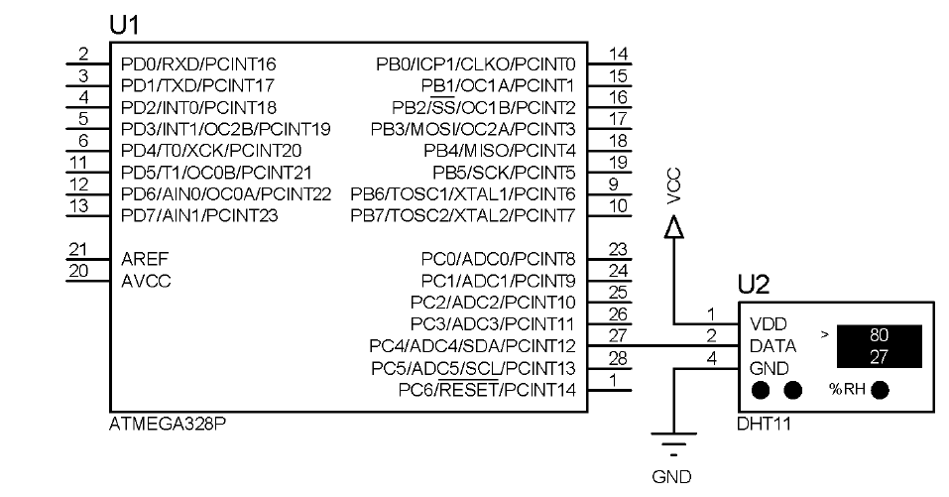
Figure 3.9.1: DHT11 Interface to the Microcontroller

3.11 IC Socket
An IC socket, or integrated circuit socket, is a tool that connects an integrated circuit (IC, also commonly referred to as a chip,) to a printed circuit board (PCB).
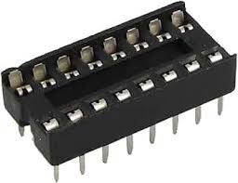
Figure 3.10IC Socket

3.12 LCD Display
LCD (Liquid Crystal Display) screen is an electronic display module which is a very basic and commonly used module in various devices and circuits. These modules are preferred over seven segments and other multi segment LEDs. The reasons being popularity of LCDs because it is economical, easily programmable, has no limitation of displaying special & ever custom characters (unlike in seven segments), animations and so on. A 16x2 LCD means it can display 16 characters per line and there are 2 such lines. In this LCD each character is displayed in a 5x7 pixel matrix. This LCD has two registers, namely, Command and Data.
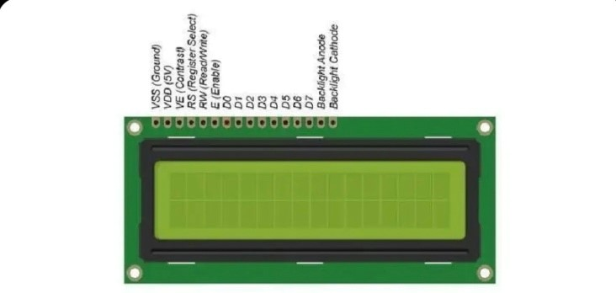
Figure 3.11: LCD Display
3.13 Printed Circuit Board (PCB)
Printed Circuit Board (PCB) provides the framework for connecting electronic components and facilitating the flow of electrical signals
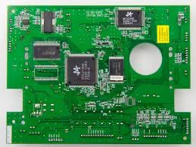
Figure 3.12: Printed Circuit Board (PCB)
This is a solar tracker circuit, its goal is to maximize the efficiency of solar panels by adjusting their position to follow the sun throughout the day. Here's a detailed explanation of the components and their functions in the schematic you provided:

3.14 Solar Panel
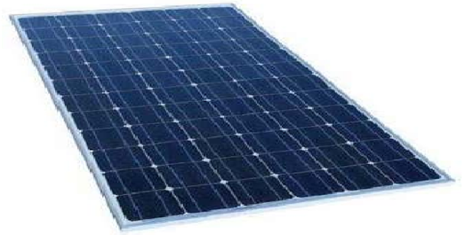
Figure 3.13: Solar Pannel
Solar panels are devices that convert light into electricity. They are called "solar" panels because most of the time, the most powerful source of light available is the Sun, called Sol by astronomers. Some scientists call them photovoltaic which means, basically, "light-electricity."
A solar panel is a collection of solar cells spread over a large area and can work together to provide enough power to be useful. The more light that hits a cell, the more electricity it produces.
3.15 Battery
An electric battery is a device consisting of one or more electrochemical cells with external connections provided to power electrical devices such as flashlights, and electric cars. When a battery is supplying electric power, its positive terminal is the cathode and its negative terminal is the anode. The terminal marked negative is the source of electrons that will flow through an external electric circuit to the positive terminal. When a battery is connected to an external electrical load.
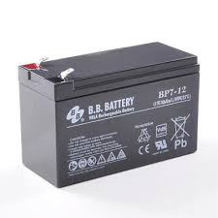

Figure 3.14: Battery

3.16 Background of Solar Tracking Systems
The amount of sunlight received varies throughout the year as a result of the motions of the Earth; however, the amount of solar energy received over a certain period on a surface that is perpendicular to the radiation’s path of propagation outside of the atmosphere at the mean earth–sun distance is known as the solar constant [40] and can be expressed mathematically as given in Equation (8):
GS_{C} = σ.T^{4.2} = 1367W/m² (8)
Where σ denotes the Stefan–Boltzmann constant (5.67×10⁻⁸ Wm⁻²K⁻⁴), R is the radius of the Earth (6371 km), and D denotes the average distance between the Sun and Earth (148.72×10⁹ km).
According to [41], the substantial amount of daily solar irradiation has led to the use of solar energy for power generation in a variety of applications, such as water pumping, telecommunication, and lighting. This has resulted in the design and implementation of solar photovoltaic panels, which can collect solar energy and convert it to other forms of energy, such as electrical energy. However, the amount of energy that may be produced is directly proportional to the intensity of the sunlight that falls on the panel. As a result, the necessity to build a system that can follow the position of the Sun over time has emerged, hence the solar tracking system. A solar tracking system can track the Sun’s movement and location over time to increase solar energy output, which in turn boosts electrical energy. Figure 3.15 shows the difference and limitations of the fixed solar tracking system compared to a simple solar tracking system.
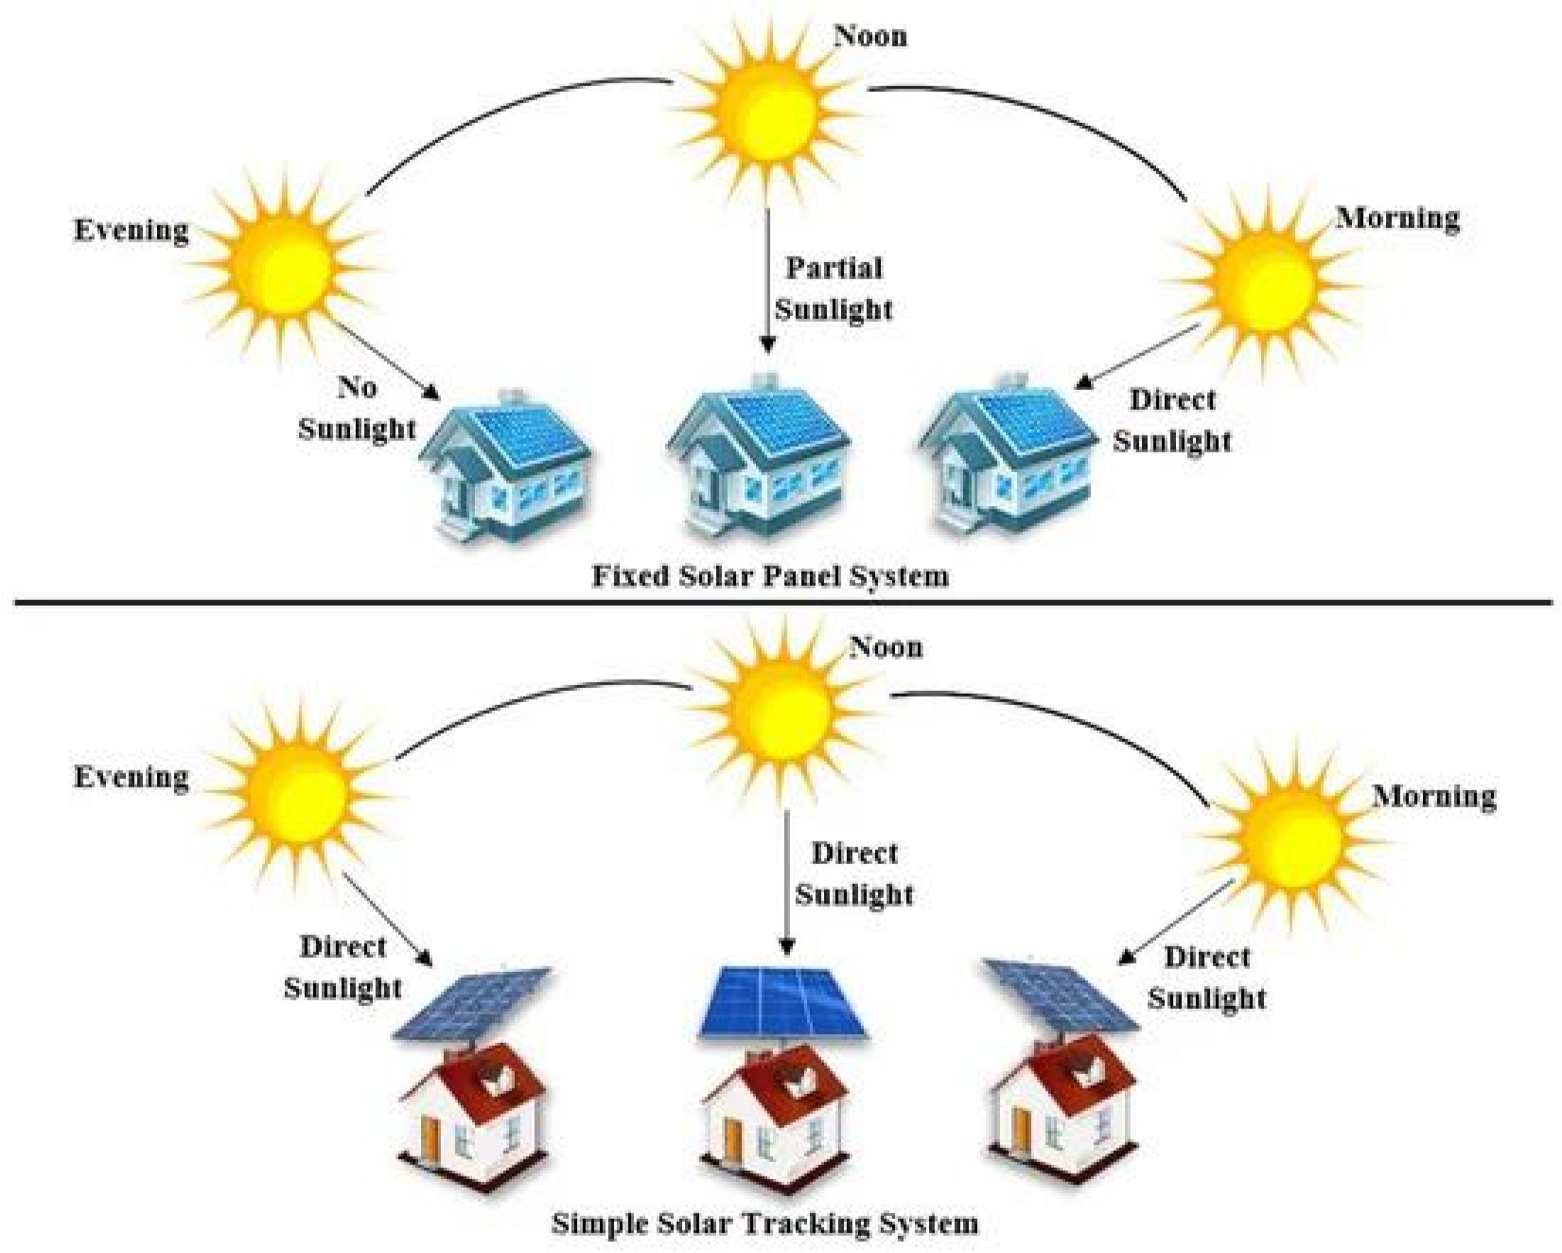
Figure 3.15: Comparison between Fixed and Simple Solar Tracking Systems.
For the accurate design, implementation, and installation of a solar tracking system, several parameters must be considered, such as the latitude, angle of incidence, solar irradiance, tilt angle, declination angle, elevation angle, zenith angle, orientation angle, solar azimuth angle, and inclination angle.
Latitude is a measure used to calculate the angular distance (south or north) of the equator in any location on Earth. The latitude angle can be measured in degrees. The angle of incidence is the most critical factor to consider when installing solar tracking systems. It is the angle formed by the Sun’s rays falling on the surface and the rays perpendicular to that surface.
Solar irradiance is another important parameter to consider, and it can be calculated by measuring the power of the light source or the luminous flux. The angle formed by the solar tracking system and the horizontal axis is known as the tilt angle. The angle of incidence is a variety of tilt angles. The declination angle is the angle formed between the equator and a line drawn from the center of the Sun to the center of the Earth. It can be expressed mathematically as given in Equation (9):
δ = −23.45×cos (9)
The elevation and zenith angles are similar to the declination angle: the elevation angle is the angle between the Sun’s center and the horizon, while the zenith angle is the angle formed by the center of the Sun and the vertical. They are both measured in degrees and expressed mathematically as shown in
Equations (10) and (11), respectively:
α = 90° - θz (10)
qz = cos−1 sin Ls_{t}sind + cosLs_{t}cosdcos ST (11)
where αis the elevation angle, θzis the zenith angle, L_{st}is the standard longitude that is positive for the east region and negative for the west, δ is the declination angle, and ST is the standard time.The orientation angle can be used to adjust a solar tracking system to keep the solar photovoltaic module perpendicular to the Sun and generate the maximum power. The solar azimuth angle is defined as the angle formed by projecting the Sun’s center onto the horizontal plane and pointing due south. It is represented with a positive sign for the position east of south, and the position west of south is represented with a negative sign. It can be represented mathematically as given in Equation (12): (12)
Where is the solar azimuth angle, 𝛿is the declination angle, δ is the zenith angle, and ℎis the hour angle expressed as given in Equation (13):
ℎ=15° (solartime−12) (13)
The inclination angle is the angle between a photovoltaic module and the positive x-axis, measured in degrees. As shown in Figure 3.16, these variables can be used to determine the optimal location for installing a solar tracking system or to establish the best orientation for such systems to obtain the maximum solar power.

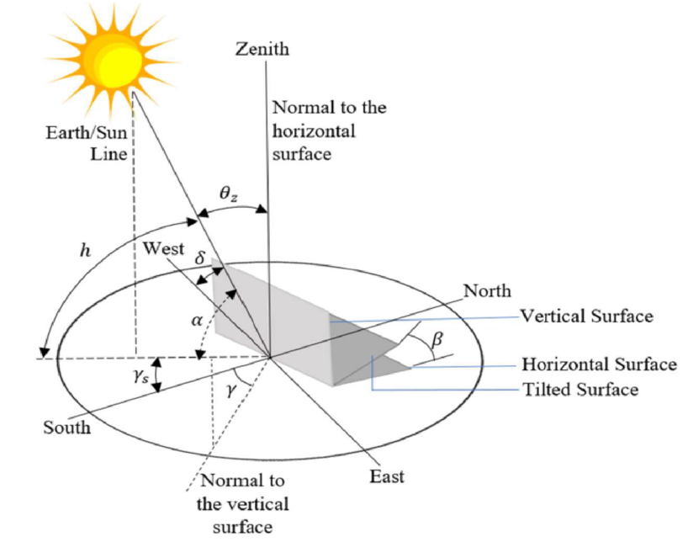
Figure 3.16: Solar Angles.

Although a solar tracking system can be used to maximize solar power, designing and implementing one is complex for a variety of reasons, including the need for intensive mathematical computations and detailed measurement of numerous solar parameters. It is also more expensive and sophisticated than a fixed-angle solar tracking system. The complexity, however, is determined by the number of axes utilized to move the solar panels horizontally or vertically.

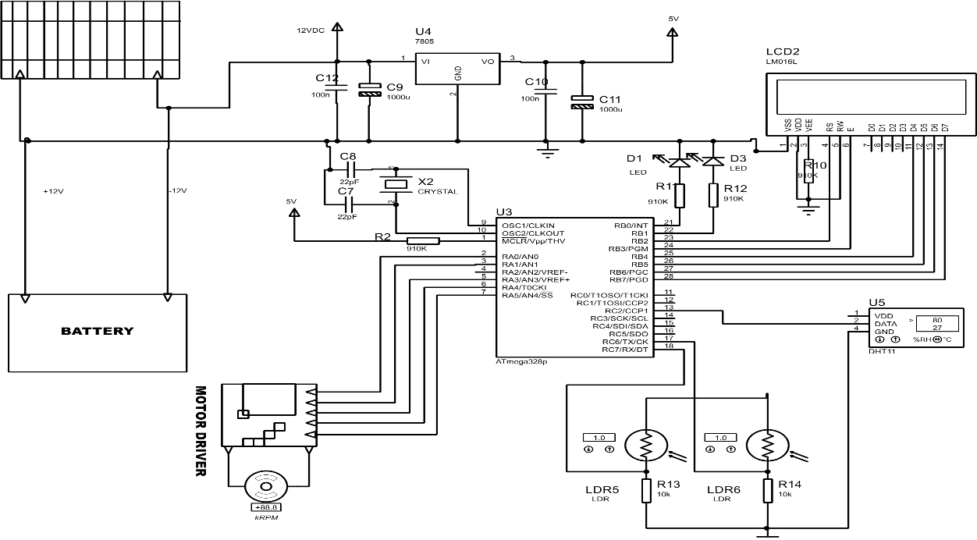

Figure 3.17: Circuit diagram of 360º rotation solar tracker with weather monitoring system.

