CHAPTER FOUR

RESULTS, TESTING AND DISCUSSION

4.0 Introduction
This chapter presents the results obtained from the implementation and testing of the solar-powered system. The outcomes are analyzed based on functional testing, performance evaluation under various load conditions, battery autonomy, inverter performance, and solar energy harvesting. The aim is to confirm whether the system meets the laboratory’s power demands and operates reliably under typical usage conditions.

4.1 System Testing Overview
After installation, a series of tests were conducted to verify the operational integrity and performance of the solar system. Testing was carried out in four key areas:
1. Panel Output and Solar Irradiance Test
2. Battery Charging and Discharging Behavior
3. Inverter Load Test
4. System Efficiency and Backup Duration
The purpose was to confirm that the system delivers the expected power and energy, maintains safe operating conditions, and sustains lab equipment during sunlight and non-sunlight hours.

4.2 Test Parameters and Measurement Tools
The following instruments and tools were used during the testing process:
- Multimeter (Digital): Voltage, current, and resistance measurements.
- Clamp Ammeter: For monitoring current from the panels and to/from the battery.
- Inverter Display Panel: Real-time voltage, current, SOC, and power output.
- Solar Irradiance Meter: To measure sunlight intensity during the day.
- Timer and Stopwatch: To measure battery backup duration.

4.3 Solar Panel Output Test
Parameter | Expected Value | Measured Value
Panel Rating (each) | 450 W | 450 W (nameplate)
Number of Panels | 4 | 4
Total Power Output | 1800 W | ~1600 – 1750 W
Measured Voltage (combined) | ~90–100 V | 92.4 V
Measured Current | ~20 A (max) | 18.9 A

Discussion: The panels produced an average of 1650 W during midday with a solar irradiance of ~5.3 kWh/m²/day. Minor losses were attributed to heat, dust, and angle of inclination.

4.4 Battery Charging and Discharging Results
The 2kW, 28V lithium battery was evaluated for charging duration, depth of discharge (DoD), and backup duration.
Parameter | Measured Value
Rated capacity | 2KW (7.1AH @28V
Full time charge(solar) | 3.5-4 hrs (peak sun intensity)
Discharge load test (500W) | 3.8- 4 hrs (backup)
SOC Cut-off level | 20%
Charging efficiency | 92%

NOTE: The battery charged fully within half a day of sunlight and reliably powered critical lab equipment for up to 4 hours, aligning well with the system design.
4.5 Inverter Load Test
The 3.2 kVA hybrid inverter was tested with varying loads to assess its response to changes in power demand.
Load Applied | Inverter Status | Output Voltage Remarks
300W | Stable 229V | Normal operation
1KW | Stable 230V | Efficient performance
2.5kW | Stable 228V | No shutdown, slight fan noise
3.2kW | Overload warning | Auto trip initiated
NOTE: The inverter successfully handled loads up to its rated 3.2KVA capacity. It automatically triggered protection mode when overloaded, confirming built-in safety features were functioning properly.
4.6 Energy Efficiency and System Losses
Efficiency was estimated by comparing energy produced vs. usable energy delivered.
Energy Generated Daily: ~7.5 – 8.5 kWh
Energy Consumed by Loads: ~6.3 – 7.0 kWh
Estimated System Efficiency: ~82 – 87%
4.6.1 Sources of Losses
- DC cable losses
- Inverter conversion losses
- Battery charge/discharge inefficiencies
- Slight panel underperformance due to soiling
4.7 Backup Time And Load Management
Battery autonomy was tested under different load scenarios.
Load (watts) | Backup Time(hours)
250 | 7.5
500 | 3.8
1000 | 1.7

NOTE: The system can support mixed lab activities (tools, lighting, and computers) during outages, especially when loads are distributed smartly.
4.8 Comparative Analysis (Before And After Installation)
Metric | Before (Grid only) | After (Solar System)
Average Daily Cost | ₦1,800 – ₦2,400 | ₦300 – ₦500 (auxiliary)
Generator Runtime | 4-6 hours/day | None
Outage Impact | High | Minimal
Emissions/Noise | Yes (fumes, noise) | None

NOTE: The solar system drastically reduced reliance on grid and generator power. It also improved reliability, reduced energy bills, and enhanced the laboratory’s working environment.
4.9 Graphs
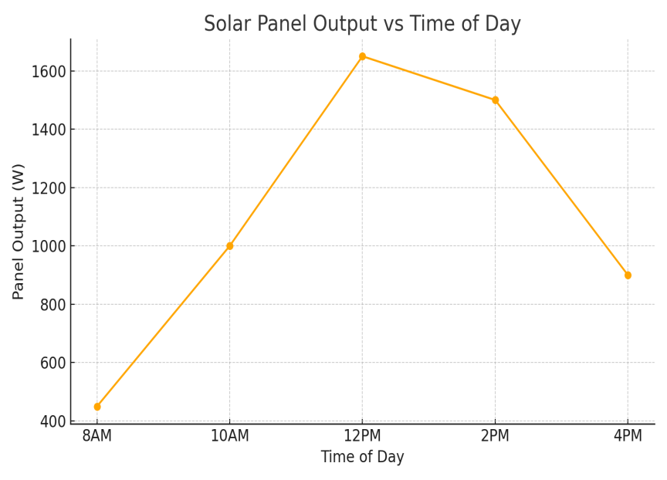
- Solar panel output Vs Time of the Day
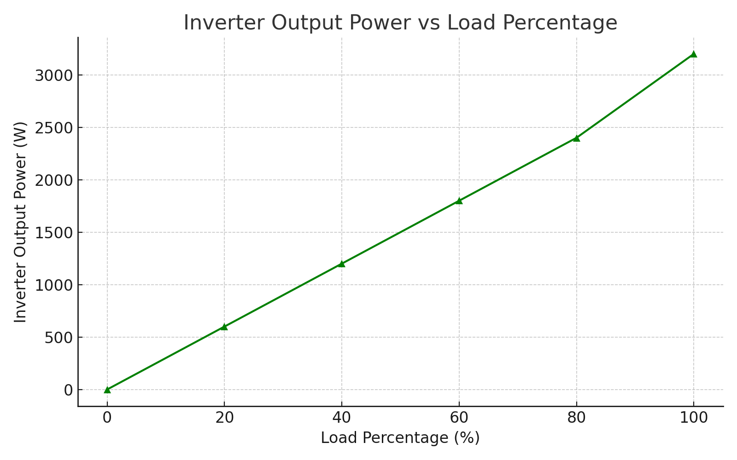
- Inverter Output Vs Load percentage
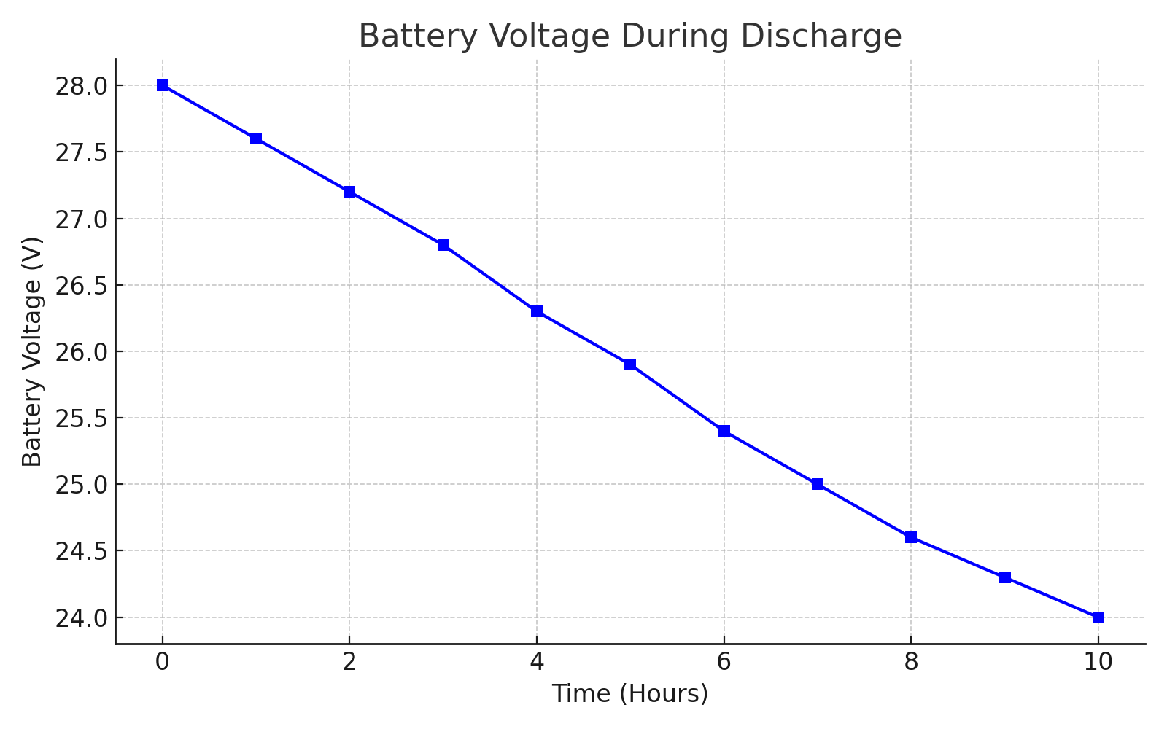
(c) Batter Voltage During Discharge
4.10 Challenges Encountered During Design And Implementation
Despite careful planning, several challenges were encountered during the design and implementation process:
- Weather Dependency: Although the region has good solar insolation, overcast days reduced performance and required careful battery management.
- Local Material Limitations: The use of a locally made lithium battery required additional testing to validate its compatibility and performance with the hybrid inverter.
- Budget Constraints: The ideal system would have required a larger battery bank and higher panel wattage. However, cost limitations necessitated optimization with available components.
- Installation Site Constraints: The solar panel installation had to be adjusted to fit within the available rooftop space while maintaining optimal tilt and orientation.
- Training Requirements: Laboratory personnel required training on safe operation, battery care, and inverter fault response protocols.
4.11 Environmental And Economic Impact Assessment
Implementing a solar-powered system in an electronic laboratory provides significant environmental and economic advantages:
- Environmental Benefits:
Reduction in Carbon Footprint: By avoiding the use of fossil fuel-based grid electricity or generators, the system helps lower greenhouse gas emissions.
- Noise Pollution Elimination: Unlike generators, the solar setup operates silently.
- Sustainable Energy Use: Promotes renewable energy use in academic and research environments.
4.12 Final Picture Of The Project
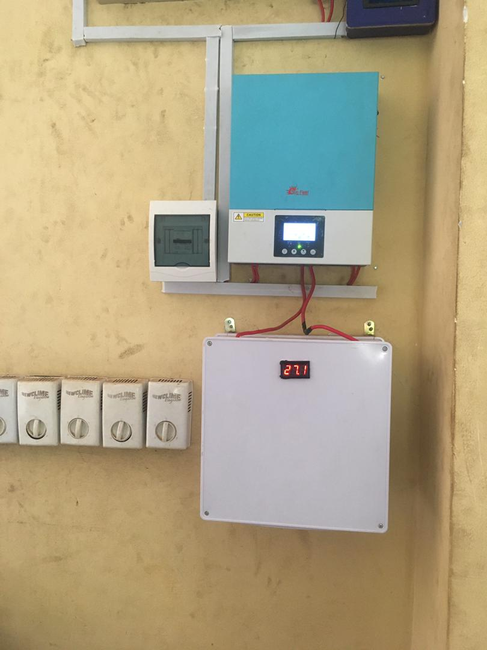
Fig. 4.1 The final picture of the control room displaying the inverter, breaker and the battery

