CHAPTER FOUR
4.1 Principle of operation of the 2kva inverter system
- When the inverter is powered on, the processor IC (PIC 16672-1/sp) initializes and begins executing its programmed instructions.
- The processor continuously monitors various parameters such as input voltage, output load, temperature, and system status.
- The processor generates PWM (Pulse Width Modulation) signals based on the desired output voltage and frequency settings. These signals control the switching of the inverter active section switch (likely MOSFETs or IGBTs), regulating the output voltage and frequency.
- The voltage regulator (L7805CV) ensures a stable 5-volt supply voltage to power the processor IC and other components in the circuit.
- The switching output side, consisting of relays and transistors, is controlled by the processor to manage various loads or external devices connected to the inverter output. The relays may switch between different output configurations or provide power to different loads based on system requirements.
- The circuitry includes protection mechanisms such as Over-voltage protection, Over-current protection, and temperature monitoring to ensure safe and reliable operation of the inverter system.
- The system indicator provides visual or audible feedback to the user about the status of the inverter system, indicating whether it's operating normally, in standby mode, or experiencing an issue.
- The processor incorporates a feedback control loops to adjust the PWM signals based on real-time measurements of output voltage and frequency, ensuring stable and accurate output under varying load conditions
An inverter power system is an electronics device, which invert and charge the chemical energy stored in a battery bank. An electrical apparatus provides emergency power to load when the input power source or main power fails.
An inverter differs from an emergency Power System or Standby generator in that it will provide near instantaneous protection from input power interruptions, by supplying energy stored in batteries the on – battery runtime of some uninterruptible power supply/sources is relatively short but sufficient to start a standby power source or properly shut down the protected equipment. The batteries are rated in certain period[13].
An inverter is typically used to protect hardware such as computers, data centers, telecommunication equipment or other electrical equipment where an unexpected power disruption could cause injuries, facilities, serious business disruption or data loss.
The most basic features of a ups is providing surge protection and battery backup. The protected equipment is normally connected directly to incoming utility power. When the incoming voltage falls below or rises above a predetermined level the ups turns on its internal DC – AC inverter circuitry, which is powered from an internal storage battery. The inverter then mechanically switches the connected equipment on to its DC- AC inverter output. The switch over time can be as long as 25 milli seconds (ms) depending on the amount of time it takes the standby inverter to detect the lost utility voltage.

4.2 RESULTS
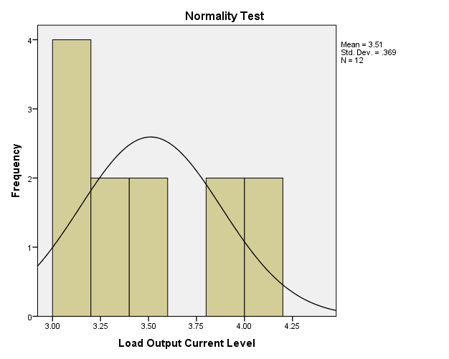
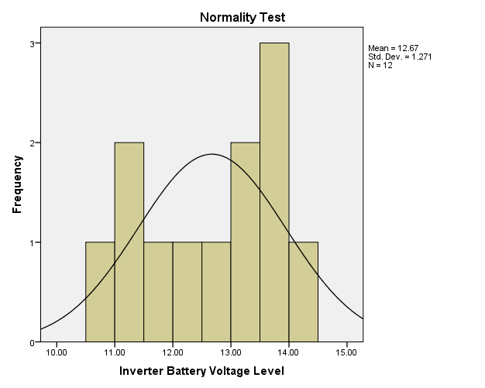
(a) (b)
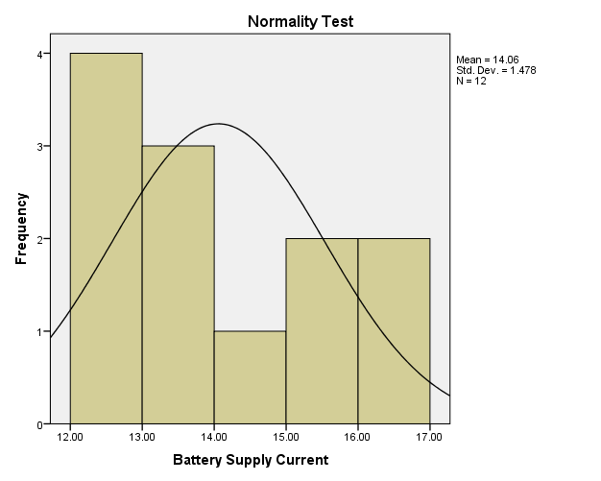
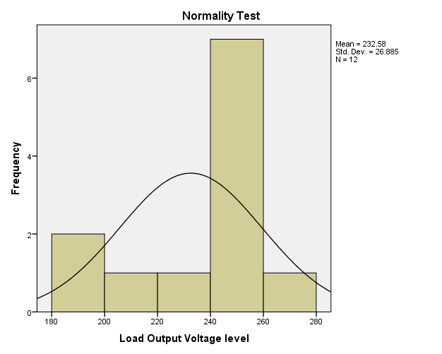

(c) (c)
Figure 1.0: Normality Test for the Measured Values of 2kVA Locally Designed and Constructed Inverter (a) Inverter Battery Voltage Level (b) Load Output Current Level (c) Load Output Voltage Level and (d) Battery Supply Current.

(a)

(b)

(c)
(d)
Figure 2.0: Metric Parameters Observation over Time (a) Load Voltage Variation (b) Battery Voltage Variation (c) Battery Current Variation and (d) Load Current Variation.

Table 4.1: Model Summary
Model | R | R Square | Adjusted R Square | Std. Error of the Estimate
1 | .965ª | .930 | .904 | .22852

a. Predictors (Constant), Load Output Current Level, Measurement Time, Load Output Voltage Level

Table 4.2: Modeling Coefficients
Model Variables |  | Unstandardized Coefficients |  | Standardized Coefficients | t | Sig.
 |  | B | Std. Error | Beta | t | Sig.
1 | (Constant) | 18.472 | 5.851 |  | 3.157 | .013
1 | Measurement Time | .012 | .003 | 1.184 | 3.582 | .007
1 | Load Output Voltage level | -.034 | .011 | -1.216 | -2.974 | .018
1 | Load Output Current Level | -2.906 | 1.062 | -1.453 | -2.737 | .026
a. Dependent Variable: Perfomance Level
4.3 DISCUSSIONS AND EQUATION MODELLING
Generally, measurements are known to be liable to outliers, sometimes called error. Errors arise due to imperfection on the part of human and machines that are used to obtain the numeric data. In this research work, a normality test was run on SPSS-23 software simulator to check for the normality test of the measured data in Table 1.0 as presented in Figure 1.0. The Figures show that the metric data are normal and they are completely devoid of outliers, hence they possess some level of credence when used in the investigation of the 2KVA performance and equation modeling analysis. Figure 2.0 shows the depiction of the metric parameters variation with time. In Figure 2.0 (a), the graph depiction shows that the inverter provides support when maximally loaded for about four (4) hours, however, the inverter output voltage only drops by 20 volts in nearly two (2) hours. This indicates a very good performance by the inverter, although, afterward the output drops drastically with a compensation for the load sustainability through the corresponding increase in the battery current level as shown in Figure 4.1(c). Table 4.1.0 on the other hand comprises the model summary and it shows the Adjusted R square value, which indicate that the metric parameters that were keyed in to the SPSS-23 software were 90.4% capable of determining the success of the inverter performance and it was therefore adjudged okay. Table 4.2 shows the modeling coefficients for the metric parameter that was keyed in to SPSS software. At this stage, it is worth mentioning that, all the components used as well as the metric parameters obtained are all ohmic in nature (i.e they obey ohm’s law, having a voltage – current linear relationship), with this credence, a linear regression equation was adopted for the equation modeling formulation. Fundamentally, the equation modeling therefore takes a form of general regression equation of the form:
where P(invt) is the inverter performance, K is the constant value in the modeling coefficient table, K₁ is the constant of measurement time at time t, K₂ is the constant of the load output voltage and K₃ is the constant of load output current. In this regard, the performance equation for the 4KVA inverter is equal to
2
With the equation modeling derived, the performance of a 4 kVA locally designed and constructed inverter can be determined at any time t of operation of the inverter with the load output voltage measured (V_{OL}) at time t and the load output current (I_{OL}) at time t

