CHAPTER FOUR
TESTING, RESULTS, AND DISCUSSION
4.1 COMPONENTS TESTING
Each component is tested individually to ensure proper operation.
- Bread boarding: The initial circuit is assembled on a breadboard to facilitate easy modifications and troubleshooting.
- Soldering and Assembly: Once the design is validated on the breadboard, the components are soldered onto a printed circuit board (PCB) for a more permanent and robust assembly.

4.2 FUNCTIONAL TESTING
The assembled project undergoes extensive testing to ensure it meets the design specifications and performs reliably under various conditions.
- Solar Charging Test: The system is exposed to sunlight, and the charging performance of the solar panel is monitored. Parameters such as voltage, current, and state of charge are recorded.
- AC Charging Test: The system is connected to the AC charging outlet, and similar parameters are monitored to evaluate the performance of the AC charging circuit.
- Battery Performance Test: The charging and discharging cycles of the lithium battery are tested to ensure the BMS manages the battery effectively without overcharging or deep discharging.
- LED Performance Test: The LED array is tested for brightness, uniformity, and power consumption to ensure it meets the required lighting standards.

4.3 DURABILITY AND RELIABILITY TESTING
The project is subjected to durability tests to ensure it can withstand environmental conditions such as temperature variations, humidity, and mechanical shocks.

- Temperature Cycling Test: The system is exposed to temperature extremes to test the reliability of the components and connections.
- Humidity Test: The system is tested in a humid environment to check for moisture ingress and corrosion resistance.
- Mechanical Shock Test: The system is subjected to mechanical shocks to ensure the physical integrity and robustness of the assembly.

4.4 PERFORMANCE OPTIMIZATION
Based on the testing results, adjustments and optimizations are made to improve the system's performance. This may involve The refinement of the BMS settings, optimizing the solar panel orientation, or adjusting the LED arrangement for better light distribution.

4.5 SUSTAINABLITY AND ENVIRONMENTAL IMPACT ASSESMENT
- Life Cycle Analysis
A life cycle analysis (LCA) is conducted to evaluate the environmental impact of the dual-charging LED lamp system. This involves assessing the environmental footprint of the materials used, manufacturing processes, operational energy consumption, and end-of-life disposal.

- Cost-Benefit Analysis
A cost-benefit analysis is performed to evaluate the economic viability of the system. This includes comparing the initial investment, operational costs, and potential savings from reduced energy consumption.

4.6 DOCUMENTATION AND REPORTS
- Technical Documentation
Comprehensive technical documentation is prepared, detailing the design, component specifications, assembly instructions, and testing procedures. This documentation serves as a reference for future development and potential commercialization.

- Final Report
A final report is compiled, summarizing the project objectives, methodology, results, and conclusions. The report includes recommendations for further improvements and potential applications of the dual-charging LED lamp system.

4.7 IMAGES OF THE PROJECT
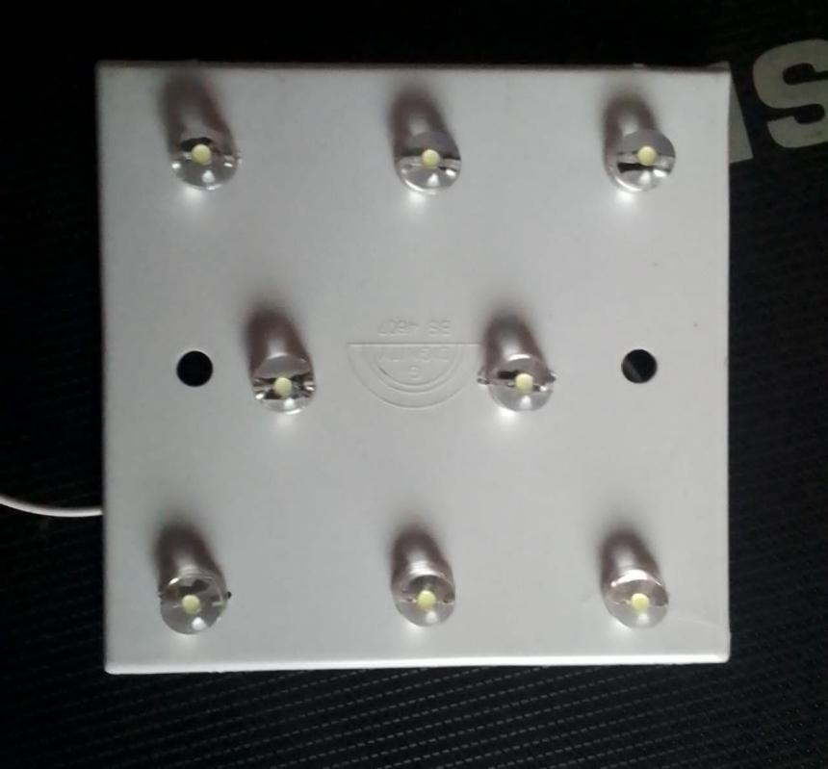
Fig. 4.1 The interface of the project showing the LED lightings

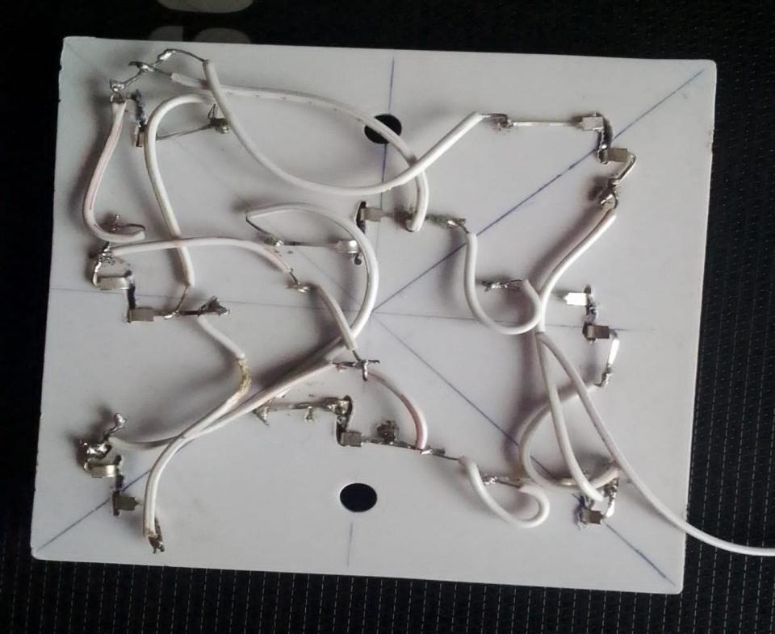
Fig. 4.2 The parallel connections of the LED lightings after soldering
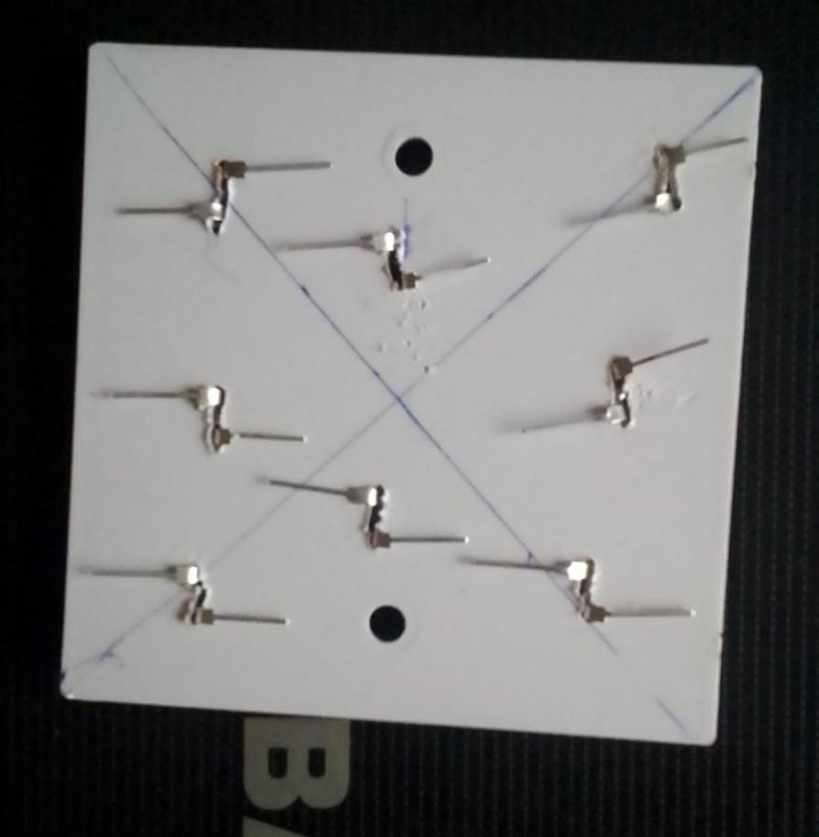
Fig. 4.3 The marking-out of the LED lightings

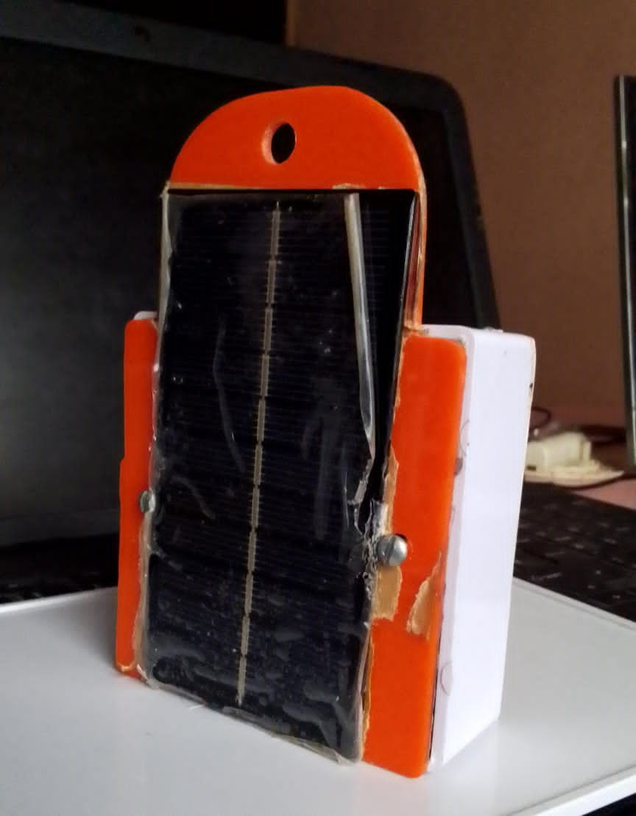
Fig. 4.4 The Final work of the project showing the Solar panel attached.

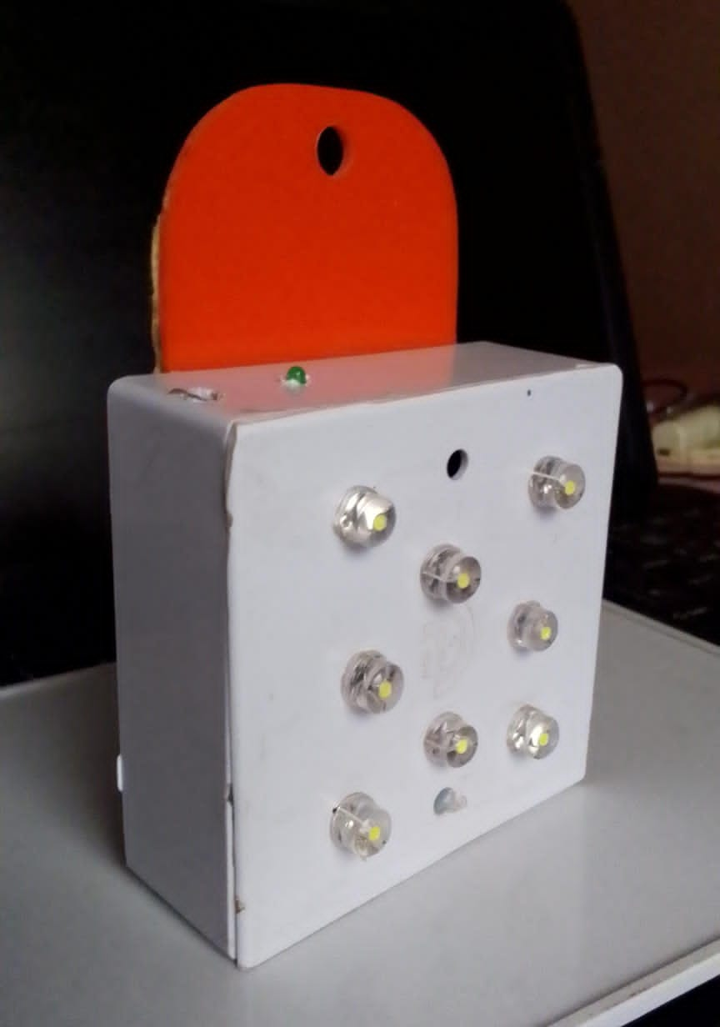
Fig. 4.5 The final interface of the project showing the LED Lightings

