CHAPTER THREE
DESIGN METHODOLOGY
3.1 INTRODUCTION
The methodology for constructing a dual-charging LED light using a battery management system (BMS) involves a systematic approach to design, development, testing, and evaluation. This section outlines the detailed steps and processes involved in achieving the project objectives.

3.2 BLOCK DIAGRAM OF THE PROJECT

DIODE
BATTERY
MANAGEMENT SYSTEM
SOLAR
PANEL
LITHIUM
BATTERY

AC
INPUT
LIGHT
EMMITING
DIODES

(LED LIGHTING)

RESISTOR
DIODE
LED
INDICATOR

Fig. 3.1 The block diagram of the project
3.3 SYSTEM DESIGN
The dual-charging LED lamp system is designed to operate using both solar and AC power sources. The main components include an 8-watt, 5-volt polycrystalline solar panel, a 5-volt AC charging outlet, a 3.7V lithium battery, and a configurable BMS.

3.3.1 Solar Panel: The solar panel harnesses sunlight and converts it into electrical energy. It is selected based on its efficiency, cost, and suitability for the required power output.
3.3.2 AC Charging Outlet: The AC outlet provides an alternative charging option, ensuring that the LED lamp can be charged even in the absence of sunlight.
3.3.3 Battery Management System (BMS): The BMS is at the core of the system, managing the charging and discharging of the lithium battery. It includes an integrated circuit (IC), transistors, diodes, and other electronic components.

3.4 CIRCUIT DESIGN
The circuit design involves the following key connections:
- The positive output of the solar panel is routed through a diode to prevent back-flow of current, then connected to the BMS.
- The negative output of the solar panel is directly connected to the BMS.
- The AC charging outlet is similarly connected to the BMS, allowing for dual charging capability.
- The BMS is connected to the 3.7V lithium battery, ensuring efficient charge management.
- LEDs are arranged in parallel and connected to the battery, with appropriate resistors to control current flow.

3.5 COMPONENT SELECTION
.Components are chosen based on their specifications, compatibility, and performance characteristics.
3.5.1 Solar Panel: An 8-watt, 5-volt polycrystalline solar panel is selected for its balance of efficiency and cost-effectiveness.
3.5.2 Battery: A 3.7V lithium battery is chosen for its high energy density, long life cycle, and safety features.
3.5.3 BMS: A configurable BMS that includes an IC, transistors, and protection circuits is selected to manage the battery effectively.
3.5.4 LEDs: High-efficiency LEDs are chosen to maximize light output while minimizing power consumption.

3.6 SOME IMPORTANT COMPONENTS USED FOR THE PROJECT CONSTRUCTION
For this project to be complete, there is a need to know the components used in the design. In electronics, the power system is designed in such a way that the equipment always has power so that it can function effectively. Some of these components includes;
- Resistors
- Light emitting diode (LED)
- Lithium battery
- Battery management system

3.6.1 RESISTORS
Resistors are passive elements used to oppose the flow of electricity in a circuit. The resistance of a resistor is measured in ohms. They are used to limit the current in the circuit and as a potential divider to achieve a specific value of voltage across a terminal. Resistors are either fixed or variable. A typical symbol of a resistor is shown in Fig. 3.2


FIG 3.2 Resistor

3.6.2 LIGHT EMITTING DIODE (LED)
This is a two lead semiconductor light source. It is a p-n junction diode that emits light when activated. When a suitable current is applied to the leads, electrons are able to recombine with electrons holes within the device, releasing energy in the form of photons. A typical diagram of a Led is shown in Fig 3.3
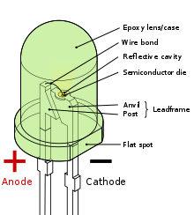
Fig. 3.3 light emitting diode (LED)

3.6.3 LITHIUM BATTERY
A battery consists of two or more cell electrically connected together and packaged as a single unit. Although technically, a battery has two or more cells, the term battery is often used to indicate either a single cell or a group of cells.
Cells and batteries are classified either as primary or secondary:
1. Primary cells are cells that are not rechargeable i.e. the chemical reaction that occurs during discharge is not easily reversed. When the chemicals used in the reaction are all converted, the cell is fully discharged.
2. Secondary cells may be discharged many times. Secondary cells include the following types: Rechargeable Alkaline; Lead Acid; Nickel Cadmium; Nickel Iron and Lithium Iron cells. Secondary cells are also called Wet cell.

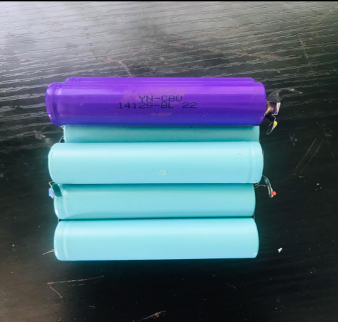
Fig. 3.4 Lithium battery

3.6.4 BATTERY MANAGEMENT SYSTEM
A battery-management system (BMS) is an electronic system or circuit that monitors the charging, discharging, temperature, and other factors influencing the state of a battery or battery pack, with an overall goal of accurately indicating the remaining time available for use. It’s used to monitor and maintain the health and capacity of a battery.

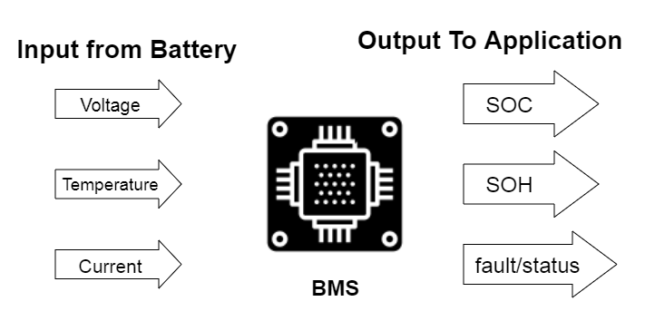
Fig. 3.5 Battery management system

3.7 DESIGN CALCULATION
Given the specification of the adapter of the charger to be used for the AC charging (5V 9A), the efficiency of the lithium battery is 85%.
Getting the average time of charging for AC only =
$\frac{Battery Capacity (mAH)}{Charging current (mA) × Efficiency}$ = $\frac{2000}{0.009× 0.85}$ = 2.35H

Getting the average time of charging for Solar only =
Charging Current (mA) = Panel Output (mA) × Sunlight Efficiency =

Considering the 5V, 8W polycrystalline panel used = I = $\frac{P}{V}$
= $\frac{8}{5}$ = 1.6A
Panel Output in mA = 10³ × 1.6 = 1600mA
Sunlight Efficiency = 50%
Charging Current (mA) = 0.0016 × 0.5 = 800mA
Charging time = $\frac{Battery Capacity (mAH)}{Charging current (mA) × Efficiency}$ = $\frac{2000mAH}{800 × 0.85}$ = 2.94H
AC Adapter: Approximately 2.35 hours
Solar Panel: Approximately 2.94 hours (under optimal sunlight conditions)
Combining both will give an absolute 5.29 hours

