CHAPTER TWO
2.0 LITERATURE REVIEW
2.1 The Evolution of Lamps
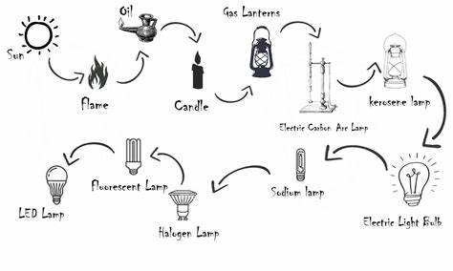
Lamps have evolved significantly over time, transitioning from primitive oil lamps to modern LED-based lighting solutions. The earliest forms of lamps, such as torches and oil lamps, provided limited illumination and were inefficient (Peterson, 2018). The invention of incandescent bulbs by Thomas Edison revolutionized lighting by introducing electric illumination (Johnson, 2019). Subsequent advancements led to the development of fluorescent and compact fluorescent lamps (CFLs), which offered improved efficiency (White, 2020).

Figure 1 the evolution of lamps

With the rise of LED technology, lighting solutions became more energy-efficient and customizable. LEDs consume significantly less power than incandescent bulbs and have longer lifespans (Anderson, 2019). Modern smart lighting integrates LED technology with automation, touch controls, and IoT capabilities, enabling users to customize lighting preferences through digital interfaces (Smith, 2021).
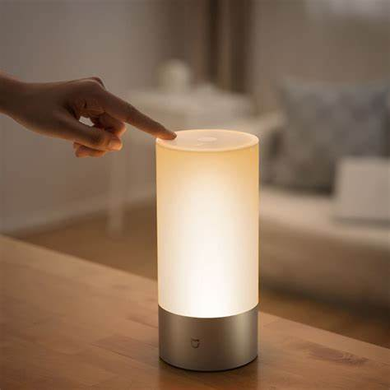

Figure 2: the modern and smart lamp.
2.2 Overview of Smart Lighting Systems
Smart lighting systems incorporate automation, energy efficiency, and customizable features to enhance user experience (Smith, 2019). Recent developments include LED-based solutions with wireless control and adaptive lighting (White, 2022). LED technology plays a crucial role in modern smart lighting systems due to its low power consumption and long lifespan (Anderson, 2019).
Advancements in lighting technology have led to the development of intelligent lighting solutions that adapt to user needs. For example, adaptive lighting systems automatically adjust brightness and color temperature based on ambient lighting conditions (Jones & Lee, 2021). Studies also highlight that integrating lighting systems with Internet of Things (IoT) platforms enhances user control, allowing remote management via mobile applications (Thomas, 2020).
2.3 Rechargeable Power Banks in Electronic Devices
Power banks have become essential for providing backup power to portable devices. Lithium-ion and lithium-polymer batteries are commonly used due to their high energy density and rechargeability (Brown, 2021). Recent studies have explored various power management strategies to improve the efficiency and longevity of battery-powered devices (Williams, 2018).These rechargeable power banks are simple, portable and are extensively used for charging all most all portable electronic gadgets. The mobile phones require high-powered batteries for enhancing the operating duration (TaharAllag, 2014). Therefore, thepower banks with enhanced capacities ranges from 2000mAh to 20000mAh or beyond are in a great demand for charging mobile phones.
The power bank consists of three components such as
- lithium-ion battery
- Hardware protection circuit
- Outer case.
Among all, the battery is the heart of the power bank and hardware protection controls the current, voltage and temperature as well.The health of the power bank is estimated by the LED profiles for better operation ofthe device.
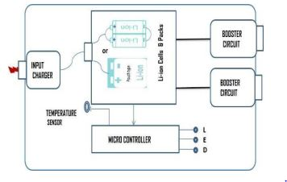

Figure 3:the block diagram of a power bank.

Battery technology has evolved to include features such as fast charging and energy optimization. According to Li and Chen (2022), modern power banks utilize intelligent charge management systems to regulate current flow, preventing overcharging and overheating. Furthermore, advancements in battery chemistry have led to safer and more efficient energy storage solutions (Ahmed et al., 2021).
Lithium ion battery technology
The lithium-ion battery is an apt technology to incorporate with all most all portable consumer electronic devices including power banks as well. The electrochemical characteristics of the lithium-ion batteries are well established their superiority among commercial batteries in terms of operating potential, cycle life, foot print, weight, etc. However, the performance of the lithium-ion batteries are varied with chemistry to chemistry (Masaki Yoshio et al., 2009). The most prominent chemistries of the Li-ion technologies are Lithium Cobalt Oxide (LCO), Lithium Manganese Oxide (LMO), Lithium Iron Phosphate (LFP), Lithium nickel manganese cobalt oxide (NMC), Lithium Nickel Cobalt Aluminum oxide (NCA), Lithium Titanium Oxide (LTO) (Naoki Nitta et al., 2015). The design of the lithium-ion battery are of four types and these are
(i) Button
(iii) Cylindrical
(iii) Prismatic
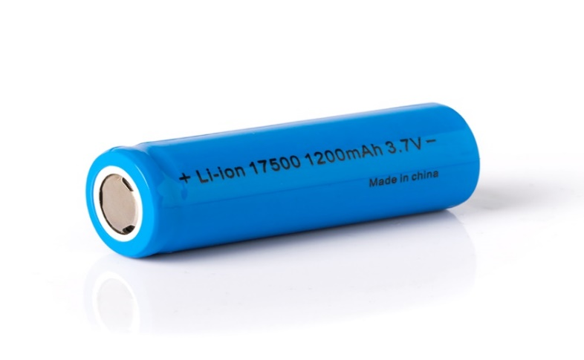
(iv) Pouch.

Figure 4:Lithium ion battery

The button type are extensively used forportable electronic devices including portable health care tool kits such as thermometers, wrist watches, etc. The cylindrical type of design is the most robust and reliable. The cylindrical 18650 type is economical and are used in laptops, power banks and other emerging applications e.g. electric-mobility as well. The prismatic type has a hard outer casing and are in medium and large sizes. Medium size are mostly used in mobile phones and the larger range are used in electric powertrains etc. The design of the pouch type is the most flexible, light in weight and compatible with electronic circuits and are used in large capacitypower bank in view of its flexible geometry and light in weight.
Electrical (Protective) Circuit
A set of lithium-ion cells are used in the moderate power bank and these cells are configured by connecting in parallel for higher rating.The batterypack is integrated with electric circuit to improve the safety of the power bank. The electrical protective circuit is to protect the device by controlling the operating voltages, currents and also temperature of the battery.
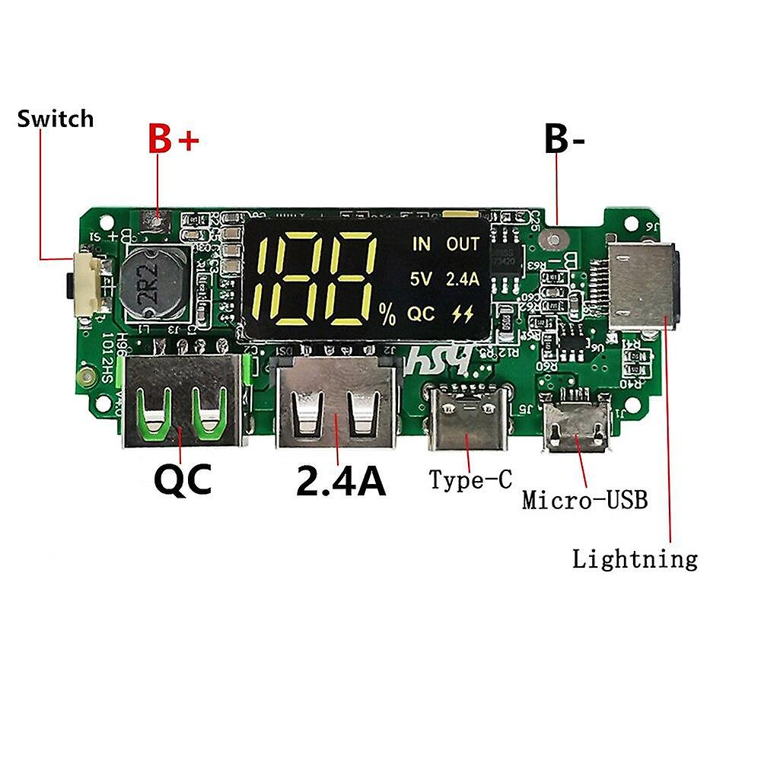
Figure 5: Battery Charging Unit for protection
The protective circuit consists of microcontroller, buck/boost converters and USB connectors. The microcontroller is programmed to control the voltage, current and temperature of the battery. The power bank is charged by plug-in and state of charging (SoC) levels are indicated through the light emitting diode (LED) and converters are also used in thepower bank such as:
- Buck
- Boost converters.
The power bank is charged either by wall charger or laptop and the output voltage is 5V. The buck converter is used to stepdown the voltage from 5V to 4.2V to charge the Li-ion battery in the power bank. The boost converter is to convert battery output voltage 4.2V to 5V in order to charge the load. The power bank input and output are designed to compatible with universal series bus (USB) and thisprotects the system from any electrical surgeswhile plug-in. The USB connectors are user friendly to connect with any portable electronic devices such as smartphones, cameras, tabs, etc.

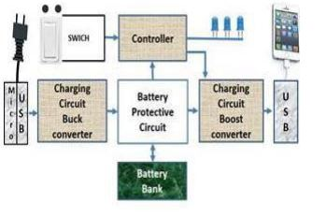

Figure 6: The function of major and minor electrical components in thepower bank

2.4 Touch-Sensitive Control Mechanisms
Touch sensors enable seamless user interaction, eliminating the need for mechanical switches (Zhang, 2020). Capacitive touch sensing is widely used in modern electronic appliances for improved durability and responsiveness. Studies indicate that touch control mechanisms enhance user experience and reduce maintenance costs in consumer electronics (Anderson, 2019).
The core principle behind touch lamp circuits is capacitive sensing. When a conductive object, such as a human finger, comes into contact with or in close proximity to a touch sensor, it alters the capacitance of the sensor. The circuit detects this change in capacitance and uses it as a trigger to switch the lamp on or off.
The human body acts as a capacitor when it comes into contact with the touch sensor. The capacitance of the human body is typically in the range of 100-300 pico-farads (pF). When the body touches the sensor, it forms a capacitive coupling with the sensor, which changes the overall capacitance of the system.

Sensitivity Adjustment
Touch lamp circuits often include sensitivity adjustment mechanisms to fine-tune the responsiveness of the touch sensor. This is important because the capacitance of the human body can vary depending on factors such as skin moisture, contact area, and environmental conditions.
The sensitivity adjustment allows the user to set the threshold at which the circuit responds to touch. It ensures that the lamp switches reliably when touched intentionally while avoiding false triggers from accidental touches or nearby objects.
De-bouncing and Latching
Touch lamp circuits incorporate de-bouncing and latching mechanisms to provide stable and consistent operation. De-bouncing is necessary because the human touch can introduce momentary fluctuations in the capacitance readings. Without debouncing, these fluctuations can cause the lamp to flicker or switch erratically.
De-bouncing is typically implemented using a capacitor and a resistor network that filters out the brief fluctuations and ensures a clean and stable trigger signal. The de-bounce time is adjusted to match the expected duration of a deliberate touch.
Latching is used to maintain the state of the lamp after the touch is released. Once the lamp is switched on by a touch, it remains on until another touch is detected, even if the finger is removed from the sensor. Latching is achieved using a bistable circuit, such as a flip-flop or a thyristor, which holds the state until a reset signal is received.
Components of a Touch Lamp Circuit
A typical touch lamp circuit consists of the following components:
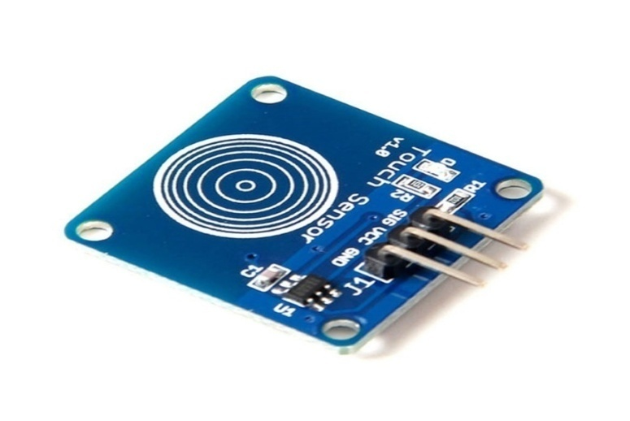
- Touch Sensor: The touch sensor is the conductive surface that detects the presence of a human touch. It can be a metal plate, a conductive pad, or any other conductive material that allows capacitive coupling with the human body.

Figure 7 Touch sensor board

- Microcontroller: A microcontroller is the brain of the touch lamp circuit. It processes the touch sensor input, performs de-bouncing and latching, and controls the switching of the lamp. Popular microcontrollers for touch lamp circuits include Arduino, PIC, and AVR.
- Sensitivity Adjustment: The sensitivity adjustment component allows the user to fine-tune the responsiveness of the touch sensor. It can be implemented using a potentiometer or a digital potentiometer controlled by the microcontroller.
- De-bounce Circuit: The de-bounce circuit filters out the momentary fluctuations in the touch sensor signal caused by the human touch. It typically consists of a capacitor and resistor network that introduces a small delay to stabilize the signal.
- Latching Circuit: The latching circuit maintains the state of the lamp after the touch is released. It can be implemented using a flip-flop, a thyristor, or a relay, depending on the specific design requirements.
- Lamp Driver: The lamp driver is responsible for switching the lamp on or off based on the output from the microcontroller. It can be a solid-state relay (SSR), a TRIAC, or a MOSFET, depending on the type and power rating of the lamp.
- Power Supply: The power supply provides the necessary voltage and current to operate the touch lamp circuit and the lamp itself. It can be a standalone power supply unit or integrated into the circuit board.
Designing a Touch Lamp Circuit
When designing a touch lamp circuit, several key considerations need to be taken into account:
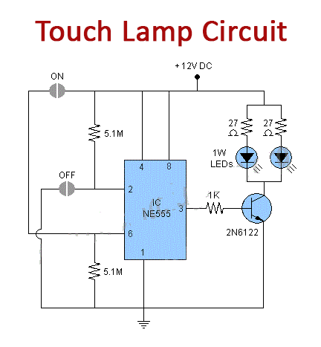

Figure 8 Touch sensor circuit design

Touch Sensor Design
The touch sensor is a critical component of the touch lamp circuit. It should be designed to provide reliable and sensitive touch detection while being aesthetically pleasing and easy to integrate into the lamp structure.

Some common touch sensor designs include:
- Metal plates: A simple metal plate can serve as a touch sensor. It can be shaped and sized to match the lamp design and mounted on the lamp surface.
- Conductive pads: Conductive pads are flat, adhesive-backed sensors that can be easily attached to the lamp surface. They are available in various sizes and shapes to suit different lamp designs.
- Conductive Paint: Conductive paint can be applied directly onto the lamp surface to create a custom touch sensor. It allows for flexibility in sensor shape and size.
When selecting the touch sensor material and design, consider factors such as conductivity, durability, and ease of integration with the lamp structure.

Microcontroller Selection
The choice of microcontroller for the touch lamp circuit depends on the complexity of the design and the desired features. Some popular microcontroller options include:
- Arduino: Arduino boards, such as the Arduino Uno or Arduino Nano, are widely used in touch lamp circuits due to their ease of use, extensive library support, and large community.
- PIC: PIC microcontrollers, offered by Microchip Technology, are another common choice for touch lamp circuits. They are known for their low power consumption and wide range of peripherals.
- AVR: AVR microcontrollers, such as the ATmega series, are also suitable for touch lamp circuits. They offer good performance, low power consumption, and a rich set of peripherals.
When selecting a microcontroller, consider factors such as the number of I/O pins required, memory size, processing speed, and available peripheral

Sensitivity Adjustment
Incorporating a sensitivity adjustment mechanism in the touch lamp circuit allows users to fine-tune the responsiveness of the touch sensor to their preferences and environmental conditions.
Adjustment Method | Description
Potentiometer | A potentiometer can be used to manually adjust the sensitivity threshold. The user can turn the potentiometer knob to increase or decrease the sensitivity.
Digital Potentiometer | A digital potentiometer is controlled by the microcontroller and allows for programmatic adjustment of the sensitivity. The microcontroller can read the touch sensor input and dynamically adjust the sensitivity based on predefined algorithms.
Capacitive Divider | A capacitive divider circuit can be used to adjust the sensitivity by changing the ratio of the capacitance between the touch sensor and a reference capacitor. The microcontroller can control the divider ratio to achieve the desired sensitivity level.

De-bounce and Latching
De-bouncing and latching are essential for ensuring stable and consistent operation of the touch lamp circuit. The de-bounce circuit filters out the momentary fluctuations caused by the human touch, while the latching circuit maintains the state of the lamp after the touch is released.
Circuit | Description
RC Debounce | An RC (resistor-capacitor) debounce circuit introduces a small delay to filter out the brief fluctuations. The resistor and capacitor values are chosen based on the expected duration of a deliberate touch.
Software  Debounce | Software debouncing can be implemented in the microcontroller firmware. It involves reading the touch sensor input multiple times within a specified time window and determining the stable state based on the majority of the readings.
Flip-Flop Latch | A flip-flop circuit, such as an SR (Set-Reset) flip-flop, can be used to latch the state of the lamp. When a touch is detected, the flip-flop is set, and the lamp turns on. Another touch resets the flip-flop, turning the lamp off.
Thyristor  Latch | A thyristor, such as a TRIAC or an SCR (Silicon Controlled Rectifier), can be used as a latching element. Once triggered by a touch, the thyristor conducts and latches the lamp in the on state until the power is cycled or a reset signal is applied.

Lamp Driver
The lamp driver circuit is responsible for switching the lamp on or off based on the output from the microcontroller. The choice of lamp driver depends on the type and power rating of the lamp being controlled.
Lamp Driver | Description
Solid-State  Relay (SSR) | An SSR is an electronic switching device that provides isolation between the control circuit and the lamp. It is suitable for controlling AC-powered lamps and can handle higher power loads.
TRIAC | A TRIAC is a bidirectional thyristor that can switch AC loads. It is commonly used for dimming and on/off control of AC lamps. The microcontroller generates the appropriate trigger signals to control the TRIAC.
MOSFET | A MOSFET (Metal-Oxide-Semiconductor Field-Effect Transistor) is used for switching DC loads, such as LED lamps. The microcontroller controls the gate of the MOSFET to turn the lamp on or off.

When selecting the lamp driver, consider the voltage and current requirements of the lamp, the desired switching speed, and any additional features like dimming or soft-start.
Capacitive touch sensors operate by detecting changes in electric fields when a conductive object, such as a human finger, comes into contact with the sensor surface (Kumar & Singh, 2021). Research has shown that capacitive touch technology is more durable and responsive compared to resistive touch systems, making it ideal for consumer electronics (Huang et al., 2022).
Building a touch lamp circuit involves the following steps:
- Gather the necessary components, including the touch sensor, microcontroller, sensitivity adjustment components, de-bounce and latching circuits, lamp driver, and power supply.
- Design the circuit schematic based on the chosen components and the desired features. Use circuit design software or draw the schematic manually.
- Assemble the circuit on a breadboard or prototyping board for initial testing and debugging. Ensure proper connections and double-check the wiring.
- Write the microcontroller firmware to handle touch sensing, de-bouncing, latching, and lamp control. Use the appropriate programming language and libraries for the selected microcontroller.
- Test the circuit functionality by touching the touch sensor and observing the lamp behavior. Fine-tune the sensitivity adjustment and de-bounce settings if necessary.
- Design a custom PCB (Printed Circuit Board) for the touch lamp circuit based on the finalized schematic. Consider factors such as component placement, trace routing, and ground planes for optimal performance.
- Fabricate the PCB and solder the components onto it. Perform a visual inspection and continuity tests to ensure proper assembly.
- Integrate the PCB into the lamp structure, ensuring secure and reliable connections between the touch sensor, lamp, and power supply.
- Perform final testing and calibration of the touch lamp circuit in the actual lamp environment. Verify the touch sensitivity, lamp switching, and overall functionality.
- Optionally, add additional features such as dimming, multiple touch modes, or remote control capabilities to enhance the functionality of the touch lamp.

Applications and Advantages of Touch Lamp Circuits
Touch lamp circuits find applications in various settings, including:
- Home lighting: Touch lamps provide a convenient and intuitive way to control room lighting without the need for traditional switches. They can be used as bedside lamps, desk lamps, or decorative lighting fixtures.
- Hospitality industry: Touch lamps are commonly used in hotels, restaurants, and lounges to create a modern and interactive lighting experience for guests.
- Retail displays: Touch-sensitive lighting can be incorporated into product displays and showcases to attract attention and engage customers.
- Assistive technology: Touch lamps can be beneficial for individuals with limited mobility or dexterity, as they eliminate the need for physical switches.
The advantages of touch lamp circuits include:
- Convenience: Touch control provides a simple and intuitive way to operate lamps without the need for mechanical switches or remote controls.
- Aesthetics: Touch lamps offer a sleek and modern design, eliminating the clutter of visible switches and enhancing the overall appearance of the lamp.
- Durability: Touch sensors have no moving parts, making them more durable and long-lasting compared to mechanical switches that can wear out over time.
- Customization: Touch lamp circuits can be customized to suit specific lamp designs and user preferences. The sensitivity, debounce time, and latching behavior can be adjusted to optimize the user experience.
- Energy efficiency: Touch lamps can incorporate energy-saving features such as automatic shutoff or dimming based on touch patterns or duration, contributing to overall energy efficiency
2.5 Review of Related Works
Several studies have explored the integration of LED lighting with smart control features. However, few designs incorporate both a high-capacity power bank and touch-controlled RGB lighting, highlighting the novelty of this project (Smith, 2019; White, 2022). Advances in power management and sensor technology have enabled the development of more efficient and user-friendly smart devices (IEEE, 2020).
Recent works in the field of smart lighting have focused on enhancing energy efficiency and user customization. For instance, research by Patel et al. (2021) demonstrated that integrating machine learning algorithms with smart lighting systems improves energy savings by predicting user behavior. Additionally, IoT-enabled lighting solutions have gained attention due to their ability to provide remote accessibility and automation (Garcia et al., 2022).

