

TECHNICAL REPORT ON
STUDENT INDUSTRIAL WORK EXPERIENCE SCHEME (SIWES)

HELD AT

SALMAK INVESTMENT MULTI-PURPOSE NIG. LTD (FARM EXECUTIVE CONSULT)
PLOT 3 OLD JEBBA ROAD, BESIDE KWARA AGRO MALL, ILORIN KWARA STATE

BY:

OWOYALE KAOSARA OPEYEMI
ND/23/AGT/PT/0005

SUBMITTED TO:

DEPARTMENT OF AGRICULTURAL TECHNOLOGY (AGT) INSTITUTE OF APPLIED SCIENCE,
KWARA STATE POLYTECHNIC, ILORIN.

IN PARTIAL FULFILMENT FOR THE AWARD OF NATIONAL DIPLOMA (ND) IN AGRICULTURAL TECHNOLOGY

2024/2025 ACADEMIC SESSION

PREFACE
This report is a solid build upon its predecessor tittle farm plantation which is one of the great line in agriculture that give entrepreneur a greater blend knowledge and practical skills to effectively play the role of intelligent and discovering plantation for economic advancement in Nigeria.
I am greatly indebted to God for the opportunity I have to write the report and to Mr. Itua Jude and Miss. Grace for their encouragement.

TABLE OF CONTENTS
Title page
Report overview
Acknowledgement
  - Concept to siwes
  - Objective of siwes
  - Importance of Siwes
CHAPTER TWO:
Description of the establishment of attachment
  - Brief History of Establishment
  - Organization chart of the company
  - Major activities in the organization
CHAPTER THREE
- WORK DONE
  - Green House
  - Parts of Green House
  - Types of Vegetables and Fruits Grown in a Greenhouse
  - Irrigation in the Greenhouse
  - Drip irrigation system in the green house
  - Horticulture tool and equipment used in Nursery Garden.
CHAPTER FOUR
- Experience gained during the period
  - Green House staking unit
  - Crop type collection unit
  - Nursery Unit
  - Nursery
CHAPTER FIVE
- Challenges encountered during the program
  - Summary of the attachment
  - Conclusion
  - Recommendations

CHAPTER ONE
1.0 CONCEPT OF SIWES
Siwes is a program initiated by the Federal government in 1971 during the 2nd national development plan under decree no. 47 of 1971. It is organized and managed by the industrial training fund (ITF) for a period of three months to one year depending on the institution and specialization involved.
Siwes is the accepted skill training program which forms part of the approved minimum academic standard (MAS) in the various degree programmes for most Nigerian universities. It is an effort to bridge the gap existing between theories and practices of sciences, agriculture, medicine, management, engineering and technology and technology and professional education Nnamdi Azikwe University Awka, the siwes program runs for 6months in the fourth year for student studying a 5year course and in the third years for those doing a 4year course. The training commence from the end of the first semester of that academic session.
  - OBJECTIVE OF SIWES
The objectives of the siwes are:
- To provide an avenue for student of tertiary institutions to acquire industrial skills and experience in their course of study.
- To get students ready for the industry work situation they are to meet after graduation.
- To expose students to work methods and techniques in handling machines that may not be available in their institutions.
- To make the transition from academic institution to the world of work easier and enhance student contact for later job placements.
- To make opportunities available for students to apply their knowledge in real work situations thereby bridging the gap between theory and practical.
- To enlist and strengthen employers involvement in the entire educational process of preparing university graduates for employment in the industry.

  - IMPORTANCE OF SIWES
It exposes student to better understand the work ethnics and regulations in the business environment, and also improve their professional skills as they are acquainted with the developments in their chosen career path.
The programme in the end will lead to manpower development and increased labour productivity, which in turn will have both direct and indirect impact on the growth and development of the nation’s economy.
The programme provide students with an opportunity to apply their theoretical knowledge to solve real life problems, thereby bridging the wide gap between work and real life practical experience.

CHAPTER TWO
2.1 BRIEF HISTORY OF THE ESTABLISHMENT
Salmak Investment multi-purpose Nig. ltd (farm executive consult) Farm, located at Plot 3 Old Jebba Road, Beside Kwara Agro Mall, Ilorin Kwara State. It was established in the year 2010. The organization deal with the sales of bell pepper and vegetables.
2.2 ORGANIZATION CHART OF THE COMPANY
C.E.O
Workers
Sales Manager
Farm manager
Workers

2.3 MAJOR ACTIVITIES IN THE ORGANIZATION
The following are the major activities in the farm
- Construction of a green house
- Fertigating of kits
- Selling of bell peppers.
- Keeping/taking of farm records

CHAPTER THREE
WORKDONE
3.1 GREEN HOUSE
A green house is a structure with wall and of male chiefly of transparent materials in which plants requiring regulated climate conditions are grown.
A green house is a special constructed place to trap warmth and maintain humidity. The place is generally constructed outside when sunlight can be trapped and warmth be created to help plants and seeds converted into plants.
USES OF A GREEN HOUSE
Green house allow for greater control over the growing environment of the plants depending upon the technical specification of a greenhouse, key factors which may be controlled include temperature levels of light and shade, irrigation, fertilizer application and atmosphere humidity.
Green house may be used to overcome shortcoming in the growing qualities of a piece of land such as a short growing season or poor high levels and they can thereby improve food production in marginal environment. As they may enable certain crops to be grown throughout the year
MAINTAINANCE OF GREEN HOUSE
- Keep of fire and hot objects
- Keep of sharp objects
- Clean the green house regularly
- Avoid leaning, hitting, mishandling
- Keep door closed always
ADVANTAGES OF GREEN HOUSE
- Small area big production
- Source of food
- Complete course of diet
- Growing round the season
- Source of family income
- Employment opportunity for the youth
- Management of limited resources
3.2 PARTS OF GREEN HOUSE
THE NEETED SIDES
- Control of insects pest from accessing the crop: this is part of integrated pest management strategy
- Ac as an air filter into the crops (Dust, environmental waste)
- Restriction of unwanted in-out movement
THE PLASTIC COVER
- Woven plastic and not plain nylon paper
- Not easily ultraviolet degradable
- Not easily torn and can be repaired with needle and thread or soaring path
- Diffusion/spread of light is uniform
- Rain and airborne water exclusion from crop
STEEL STRUCTURE
- Very strong and portable steel material
- Peaked roof to allow maximum growing space and easy drainage
3.3 TYPES OF VEGETABLES AND FRUITS GROWN IN A GREEN HOUSE
i. Leafy green
ii. Micro green
iii. Spinach
iv. Cucumber
v. Tomato
vi. Peppers
vii. Herbs
viii. Squash and swiss charel
ix. Citrus fruits
x. Grapes
xi. Strawberries
xii. Peaches
xiii. Coriander
xiv. Chillies
xv. Raspberries and e.t.c.
3.4 IRRIGATION IN THE GREENHOUSE
Irrigation in the green house is by drip lines if there is water in the tank that supply water to the green house but if there is no water in the green house i supply water to the plants with the help of a watering can.
IRRIGATION
Irrigation is the artificial application of water to the land or soil. It is used to assist in the growing of agricultural crops, maintenance of landscapes, and irrigation of disturbed soils in dry areas and during periods of inadequate rainfall to irrigation is two the process by which water is brought to dry land through artificial means, such as pipes, hoses ditches. The land that would be irrigated usually contains crops, grass or vegetation that would not usua;;y receive enough water from rainfall or other natural resources.
TYPES OF IRRIGATION
- CENTER PIVOT IRRIGATION:- is a form of overhead irrigation steel or aluminium pipes are joined together, supported by the trusses, mounted on wheeled towers. The sprinklers are situated on the length of the towers and they move in a circular motion.
- ROTARY SYSTEM:- is the best situated for larger areas for the sprinkles can reach with distance up to 100 feet. This system water is a larger area with small amounts of water over a larger period of time.
- SPRINKLER SYSTEM:- is an irrigation system based on overhead sprinkler, sprays or guns installed on paramount rises you can also have the system buried underground and the sprinkler rise up when water pressure rises, which is a popular irrigation system for the use of golf courses and parks.
- DRIP IRRIGATION:- Is known as the most water efficient method of irrigation. Water drops right near the root zone of the plant in a dripping motion.
- TERACED IRRIGATION:- Is a very labor intensive method of irrigation where the lead is cut into steps and supported by retaining wears. The flat areas are used for planting and the idea is that the water flows down each step while watering each pot. This allows sleep land to be used for planting crops.
3.5 DRIP IRRIGATION SYSTEM IN THE GREEN HOUSE
Drip irrigation is an irrigation method that saves water and fertilizer by allowing water to drip slowly to the roots of plants, either onto the soil surface or directly onto the root zone, through a network or valves, pipes, tubing and emitters. It is done through narrow tubes that deliver water directly to the base of the plants.
In drip irrigation, water is run through pipes (with holes in them) either buried or lying slightly above the ground next to the crops, water slowly drops onto the crop roots and stems unlike spray irrigation, very little is lost to evaporation and the water can be directed only to the plants that need it, cutting back on water waste
WHY THE DRIP WATER
- Bring water directly to the plants roots
- Plants uses it energy to develop production and not searching for water
- Soluble fertilizer (plant frod) can be brought directly to the roots
- The system is suitable for all types of soil, climates and water
- Its suitable for use in flat land or slight slopes
- Eliminates foliar wetting
- Easily manageable and accessories provided (e.g. the blind caps, connectors
MAINTAINANCE OF THE DRIP LINES
- Keep off sharp objects from drip lines
- Control rodents
- Keep off from fire
  - Filter-cleaning and flushing to be done accordingly. Make sure all tubes and emitters are cleaned of dirt and to observe for any issues on its performance.
  - When replacing emitters and run each value is at a time to observe for any issues on its performance.
  - When replacing emitters make sure it is installed correctly for it to work properly
  - Water pressure should also be checked, if it is too high, it might push the emitter out of its tubing, if it is too low, it might not be able to provide enough water for all the plants.
  - Replace any part of the drip irrigation equipment that is broken or missing. Apply any adjustment or repair that is necessary.
3.6 HORTICUTURE TOOL AND EQUIPMENT USED IN NURERY GARDEN
- Budding knife
- Cutlass
- Hoe
- Sprinkler
- Watering can
- Hand trowel
- Wheel barrow
- Duchet
- head pan
- Beet
- Knapsack sprayer

CHAPTER FOUR
EXPERIENCE ACQUIRED
4.1 GREEN HOUSE STAKING UNIT
The Green house is an erected structure with walls made from green and shade canopy in which plants can be grown in a controlled environment. This unit houses the Staking system which is used for the cultivation of seed yams.
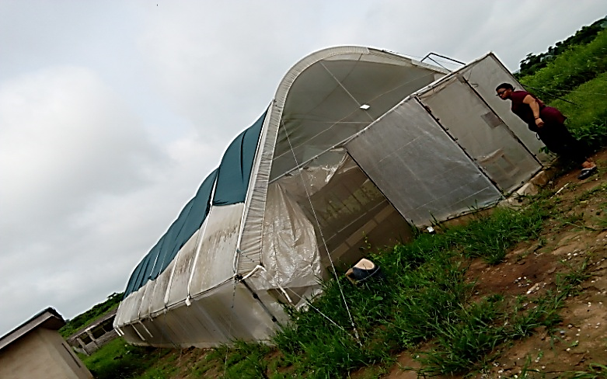
Green House
Staking is a process of growing plants or crops in an air or mist environment without the use of soil or an aggregate medium (geoponics). Water is used in Staking to transmit nutrients to plants.
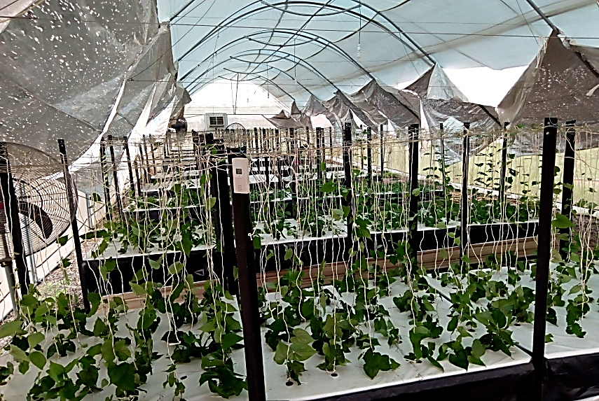
Staking System

METHOD USED
In Staking system, the plants root size suspended inside an environment where the roots are exposed to anatomized nutrient solution. The top of the plant, leaves and crown (canopy) is extended above the wet zone. The root and canopy of the plant are separated by the plant structure.
The last part of the plants support system and root system are sprayed or misted for intermitted duration with a hydro-atomized mist of pure water and nutrients enriched solution.
FEATURES OF THE GREEN HOUSE
- Misters
- Air pump
- Nutrient Tank
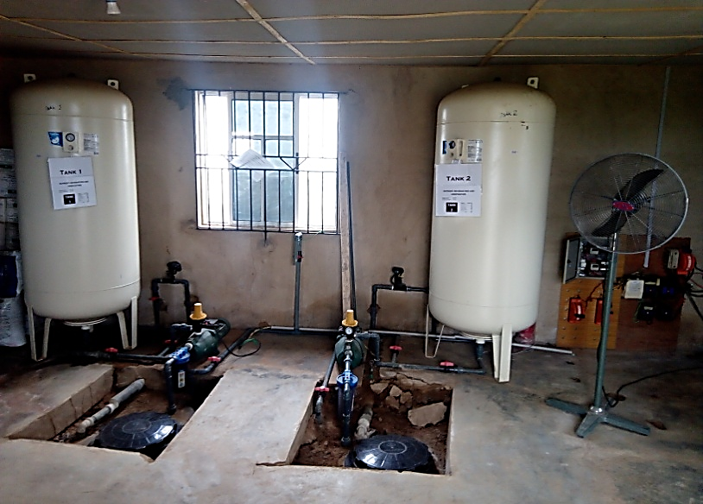
Nutrient Tank
Advantage of Green House Staking
- Eliminate crops exposure to disease
- Increase nutritional value of crops
- Increase yields of produce
- Requires less labour

Routine practices carried out in this unit;
- Checking of the nutrient level in the nutrient tank
- Pumping of Nutrients from the reservoir to the nutrient tank
- Staking of the plantlets

4.2 CROP TYPE COLLECTION UNIT
This unit is mostly concerned with growing of vegetables and species. It involves pre-planting to post planting operations. The land was cleared and tilled; beds are also made which are incorporated with organic manure to increase fertility before sowing of seeds.
Some of the vegetables planted at this unit are Amaranthus, Cucumber, Lettuce, Celosia spp. and pepper.
Routine management
- Sowing of vegetables
- Regular wetting of the seedlings
- Making of vegetable bed
- Clearing of bush
- Rouging of weed from vegetable bed
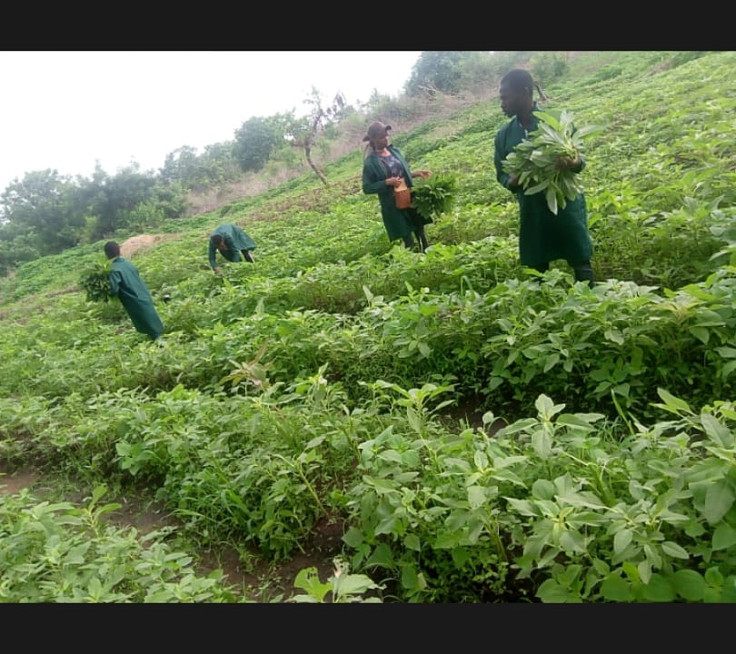
Vegetable Bed

4.3 NUESERY UNIT
This unit is purposely for growing of yam leaf vines collected from the green house Staking system for a period of one month before it is transplant to the field to produce seed yam after a period of three month in the soil.
A Nursery is a place where plants are propagated, grown and allowed to mature until they are ready for permanent planting.
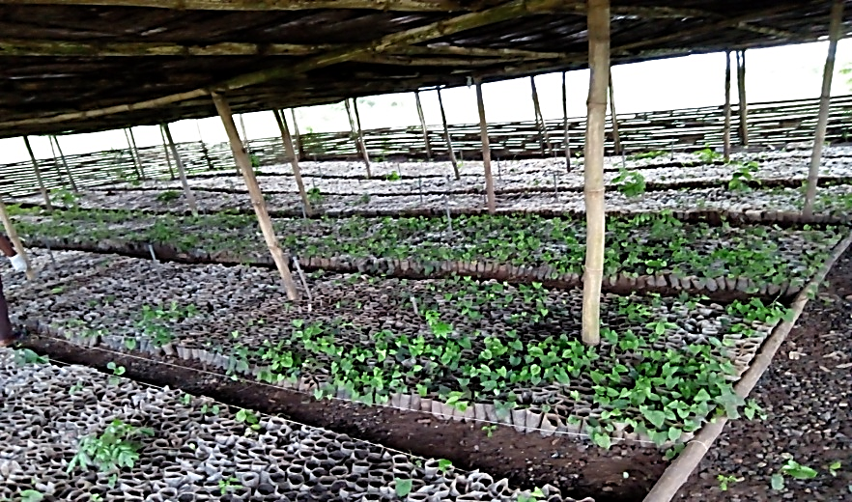
Nursery Unit
Routine practices carried out in this unit;
- Weed Control
- Irrigation
- Potting seedlings
- Transplanting
Benefits of Nursery unit
- Easy weed control
- Higher Yield
- Improved crop uniformity
- More accurate prediction of harvest date

4.4 NURSERY
Nursery can be define as place where the seeding of flowers ecumetic trees vegetable e.tc are raised to a certain level before transplanting to the main field
NURSERY ARE ALSO DEFINED IN VARIETY OF WAYS
- The function of the nursery such as production, retal mail- order or land scape nurseries.
- The production system such as field- gram
- The type of plant growth such as fruit trees or Christmas tree
CONDITION FOR SITING A NURSERY GARDEN
- Security
- Water supply
- Shade
- Store
- Fancing
- Garden tools
TYPES OF TREE IN NURSERY GARDEN
I was introduce to various types of tree in nursery garden
- Economic tree
- Vegetable tree
- Citrus tree
ECONOMIC TREE ARE:-
- Oil palm coconut
- Cocoa
- Cashew
VEGETABLE TREE ARE:-
- Shadok
- Tangerwing
- Tangel
- Rough lemon
- Grap
CITRUS TREE ARE
- Water leaf
- Buter leaf
- Water melan
- Onion
- Amarathus Spp

CHAPTER FIVE
5.0 CHALLENGES ENCOUNTER DURING THE PROGRAM
Challenges encountered are not much but the major challenges I encountered are;
- Accommodation
- Transportation
- Feeding challenges
5.1 SUMMARY OF THE ATTACHMENT
The SIWES programme carried out in SALMAK Investment multi-purpose Nig. ltd (farm executive consult) Farm was enlightening and educative. Many of the work and activities done and performed were mainly practical with respect to the theory taught in class. Works like raising of poultry.
Other activities carried out during SIWES programme include pepper bed and plantation, selling of pepper bell, setting up and maintenance of greenhouse, irrigation and dripping of greenhouse, maintenance of screen house maintainace and treatment of some common pest to vegetables etc.
SALMAK Investment multi-purpose Nig. ltd (farm executive consult) Farm is a farm that is based mainly on agricultural plantation that is farming.
5.2 CONCLUSION
The SIWES programme for me is educative and has empowered me with various opportunity to be self-employed and in fact to be able to establish a farm based on many of all that have been practicalized. With the help of God the programme has enable a kind of workable opportunity to perform many theories in a practical way, to see many of the equipment/tools used in the farm.
5.3 RECOMMENDATIONS
SIWES has its positive and negative sides and as a result though many things where Learnt yet the following where recommended:
- SIWES students should endeavour to participate actively and positively during the SIWES programme try to be hardworking
- SIWES students should see the industry where the programme is taking place as a research place where all that has been taught in class can be practicalized
- The industry should not see SIWES students as casual worker but as professionals in the making.
- The industry should try paying the students in kind and cash in order to encourage the SIWES students.
- The government also should do his own part in terms of paying SIWES pay to the students.
- The school authorities at large, Institute of Applied Science and the department of agricultural technology in particular should provide for students in the area of plantation as one of the options of agricultural technology with the basic knowledge through excursion, workshops and seminars even before going for their SIWES programme.
- The Industrial Training Fund (I.T.F) in conjunction with the school authority should work hand in hand in providing Company, Industries, research Institution that is in line with the course of studies of each I.T student so as to acquire basic knowledge in one’s field.

