CHAPTER THREE
DESIGN METHODOLOGY
3.1 INTRODUCTION
This chapter provides an in-depth explanation of the methodology employed in the design and construction of a multi-socket extension box with an uninterruptible USB power supply. The methodology discusses the materials, tools, theoretical calculations, and practical processes used to implement the system. The step-by-step procedures span from the marking of layouts to the final testing of the fully functional unit. Each stage is explained alongside relevant scientific principles and supported with appropriate illustrations and references.

3.2 DESIGN METHODOLOGY
To construct a reliable and efficient extension socket system with USB and backup functionality, several tools and electronic components were used. These include pencils, markers, rulers, scribers, cutters, screwdrivers, pliers, soldering irons, solder, printed circuit boards (PCBs), resistors, rectifiers, 13A sockets, relays, transistors, microcontrollers, crystal oscillators, USB ports, lithium batteries, and LCDs. The design methodology can be broadly classified into the following stages:

3.1.1 MARKING AND CUTTING
The initial step involved the measurement and marking of required shapes and placements for components such as 13A sockets, LCD screens, and USB ports. Pencils and rulers were used to define accurate outlines. Cutters and pliers were subsequently used to cut and shape the casing to accommodate these components. This phase is critical to ensuring proper component placement and aesthetics.

3.1.2 COMPONENT ARRANGEMENT AND SOLDERING
All electronic components were mounted and arranged on a printed circuit board (PCB). The soldering process was conducted using a soldering iron and lead solder. This step ensured firm and conductive connections among components, which is essential for efficient power transfer and signal integrity (Horowitz & Hill, 2015). Figure 3.1 illustrates the completed PCB with all components properly soldered.

3.1.3 LCD DISPLAY INTEGRATION
An LCD screen was included to display the AC input voltage, thereby enabling real-time voltage monitoring. The LCD was configured to draw power from the main AC supply and linked to the microcontroller, which processed the voltage readings. This display unit adds user value by improving usability and operational transparency (Mazidi et al., 2014). Figure 3.2 shows the installed LCD screen.

3.1.4 SOCKET WIRING
The 13A sockets were wired in a ring (parallel) configuration using high-quality copper connector cables (typically brown for live and blue for neutral). This configuration ensures that if one socket fails, the others remain operational. The parallel configuration allows uniform voltage distribution across all outlets while supporting varying loads simultaneously (Alexander & Sadiku, 2013). Figure 3.3 depicts the socket wiring arrangement.

3.1.5 BATTERY AND TRANSFORMER
A 240/12V step-down transformer was used to charge a 200mAh lithium-ion battery. The transformer steps down the voltage to a level suitable for charging the battery, and a rectifier converts AC to DC. This battery powers the USB ports during power outages. The system efficiency depends largely on battery capacity and health (Mohan et al., 2018). Figures 3.4 and 3.5 illustrate the transformer and lithium battery.

3.1.6 TRANSFORMER CALCULATIONS
The transformer design follows the standard relation:

$\frac{Vp}{Vs}$ = $\frac{Np}{Ns}$ …………………………………………… (Equation 1)

Where Vp = 240V (primary), Vs = output voltage, Np = 3000 turns (primary winding), and Ns = 150 turns (secondary winding).
Using:
Vs = ($\frac{Vp}{Np}$* Ns) ………………………………… (Equation 2)
Vs = ($\frac{240}{3000}$* 150) = 12V ……………………….. (Equation 3)

This output is suitable for USB charging and battery recharging purposes.

3.2 PARALLEL WIRING CONNECTION
In the design, a parallel connection was used for socket and circuit integration. This connection ensures consistent voltage across all sockets and allows the total current to be shared among different appliances:

V = V1 = V2 = V3 = ... = Vn (Equation 4)
The equivalent resistance (RT) in parallel circuits is given by:
1/RT = 1/R1 + 1/R2 + ... + 1/Rn (Equation 5)
Similarly, for inductors:
1/LT = 1/L1 + 1/L2 + ... + 1/Ln (Equation 6)
For capacitors in parallel:
CT = C1 + C2 + ... + Cn (Equation 7)

3.3 RESISTIVITY AND CONDUCTIVITY
Resistivity (ρ) of the connecting cables was considered. Resistance (R) of a wire is given by:

R α l/A (Equation 8)

R = ρl/A (Equation 9)
Where:
R = resistance in ohms (Ω)
l = length (m)
A = cross-sectional area (m²)
ρ = resistivity (Ωm)
Conductivity (σ) is the reciprocal of resistivity:
σ = 1/ρ (Equation 10)

3.4 OHM’S LAW AND CURRENT FLOW
Ohm's law explains the relationship between voltage (V), current (I), and resistance (R):
I = $\frac{V}{R}$ (Equation 11)

Additionally:
I = E / (R + r) (Equation 12)
Where:
E = electromotive force (V)
r = internal resistance (Ω)
The total charge (Q) and electrical work (W) are given by:

Q = I \* t (Equation 13)

W = IVt (Equation 14)
And power (P) can be expressed as:
P = I²R (Equation 15)

P = V² / R (Equation 16)

3.5 OPERATIONAL SUMMARY
A summary of the stepwise procedure is presented in Table 3.1 below:
S/N | OPERATION | EQUIPMENT USED | DESCRIPTION
 | Measurement and marking out | Pencil, Ruler | Makout shapes for 13A sockets
 | cutting | Cutters, Pliers | Cut shapes neatly
 | Assembly | Soldering led, bolts and nuts | Solder and bolts for the Adaptable box
 | Connection od components | Soldring iron, cables | Internal wiring and USB integration
 | Testing | Plug-in gadgets | Functional verification of the sockets and USB

3.6 FUNCTIONAL TESTING
Testing involved powering different household and office appliances. During grid supply, devices such as laptops, electric fans, and other gadgets were powered successfully. During a blackout, mobile phones continued charging through the USB ports powered by the lithium battery, confirming the uninterruptible feature.

3.7 Major components used in the project
- The Printed Circuit Board (PCB)
This image shows the neatly arranged and soldered electronic components mounted on a printed circuit board. The PCB serves as the backbone of the electronic system, providing both mechanical support and electrical connectivity for the components. Proper soldering ensures reliable current flow and reduces the risk of short circuits.

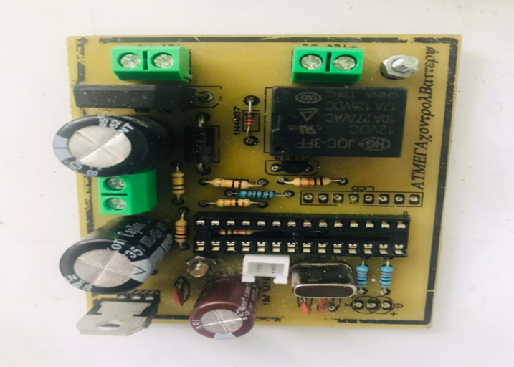
Figure 3.1: The Printed Circuit Board (PCB)

- The Liquid Crystal Display (LCD)
The LCD screen is responsible for displaying the real-time AC input voltage. This helps users monitor the power entering the device, enhancing usability and safety. The LCD is interfaced with the microcontroller, which processes and presents voltage readings.
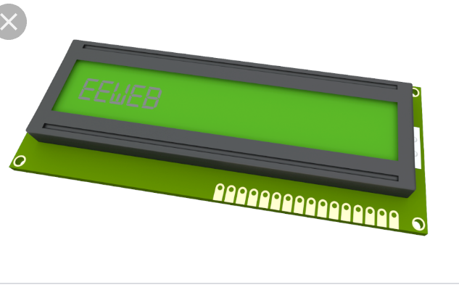
Figure 3.2: The Liquid Crystal Display (LCD)

- 13A Sockets
These sockets represent the output outlets of the extension box. Wired in a parallel configuration, they allow multiple devices to be connected and used simultaneously. Each 13A socket can support high-power appliances such as electric irons, microwaves, or heaters.
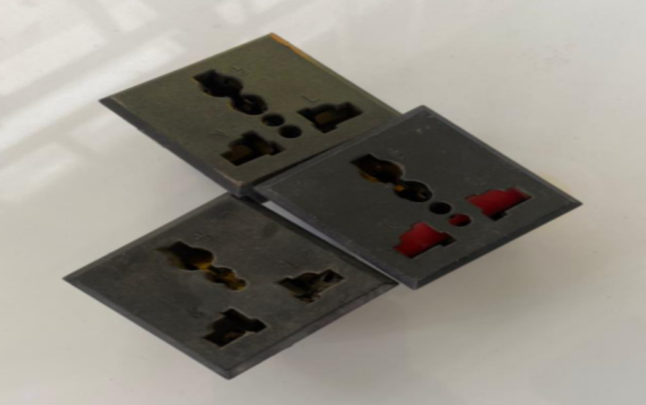
Figure 3.3: 13A Sockets

- 240V/12V Step-Down Transformer
This image shows the transformer used to reduce the 240V AC mains voltage to 12V AC. This reduced voltage is necessary for charging the lithium battery and powering the USB ports. The transformer also isolates the high voltage from the user-accessible components, improving safety.
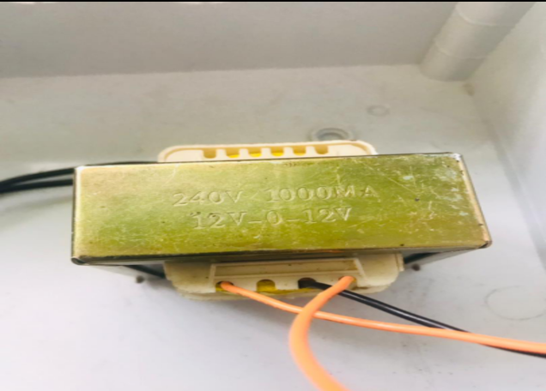
Figure 3.4: 240V/12V Step-Down Transformer

- The Lithium Battery
Depicted here is the 200mAh lithium-ion battery used as the backup power source for the USB ports. When there is a power outage, this battery supplies uninterrupted power to charge mobile devices, maintaining essential functionality even in the absence of grid electricity.

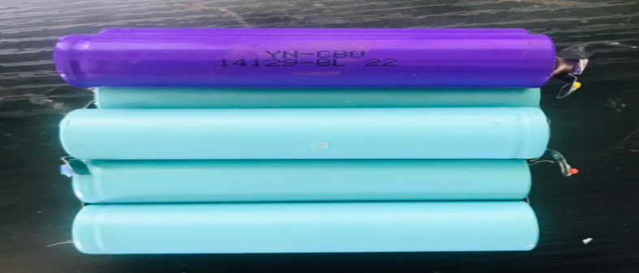
Figure 3.5: The Lithium Battery

