CHAPTER 5
CONCLUSION AND RECOMMENDATION

5.1 CONCLUSION
- The geometric features showed that Approach 1 (AbdulAzeez Attah Road), Approach 2 (Old Yidi Road), and Approach 3 (Emir Palace Road) each have a width of 11.2m, while Approach 4 (Pakata Road) has a width of 8.2m. The HCM 6th edition (2016) recommends intersection approach widths of 12-15m based on traffic volume. Given the traffic data from the study area, a redesign is needed. This will ensure a smooth and stress-free driving experience for all commuters.
- The traffic flow analysis showed that Approach 1 has the highest average number of traffic with 626.5 vph. It is followed by Approach 3 with 508.3 vph. Approach 4 has 486.2 vph while Approach 2 has 328.5 vph. Approach 1 handles the most significant traffic and might need priority improvements to handle the load efficiently. Approaches 2 and 4 could potentially benefit from traffic management adjustments.
- While for the delay, according to Highway Capacity Manual (HCM) LOS criteria, the Oja-Oba Roundabout has an LOS F, with an average control delay per vehicle exceeding 50 seconds. This implies severe congestion, long delays, and potential driver frustration.

5.2. RECOMMENDATION
The high level of congestion and delays at the Oja-Oba roundabout point to inadequacies in the current infrastructure to handle traffic volumes effectively which could lead to increased risk-taking behavior from commuters, while potentially compromising safety. Prolonged delays also affect the efficiency of transportation, impacting the economy, particularly for commercial vehicles and public transport. It is therefore very necessary for concerned bodies to find a way of solving this problem.
Based on my research result, I would recommend the following:
- Concerned bodies and agencies should consider redesigning the
roundabout to a larger width that can accommodate traffic freely.
- An improved design should include traffic signals to manage high traffic volumes.
- Also alternative traffic management strategies such as new inner routes could be developed as an option to efficiently distribute traffic even more evenly.

REFERENCE

Adebambo, S., & Adebayo, I. (2009). Impact of bus rapid transit system (BRT) on passengers’ satisfaction in Lagos Metropolis, Nigeria. International Journal of Creativity and Technical Development, 1(3), 106-119.
Akcelik, R. (1981). Traffic signals: capacity and timing analysis.
Akçelik, R. (1997). Lane-by-lane modelling of unequal lane use and flares at roundabouts and signalised intersections: the SIDRA solution. Traffic Engineering+ Control, 38(7), 388-399.
Bang, K., Wahlstedt, J., & Linse, L. (2016). Methodology for timing and impact analysis of signalized intersections. Transportation Research Procedia, 15, 75-86.
Barau, A. S. (2007). The great attractions of Kano: Research & Documentation Directorate.
Bester, C., & Meyers, W. (2007). Saturation flow rates. SATC 2007.
Biliyamin, I. A., & Abosede, B. A. (2012). Effects of Congestion and Travel Time
Variability along Abuja-Keffi Corridor in Nigeria. Global Journal of Research In Engineering, 12(3-E).
Bivina, G., Landge, V., & Kumar, V. S. (2016). Socio Economic Valuation of Traffic
Delays. Transportation Research Procedia, 17, 513-520.
Bui, K.-H. N., & Jung, J. J. (2017). Cooperative game-theoretic approach to traffic flow optimization for multiple intersections. Computers & Electrical Engineering.
Chubukov, A., Kapitanov, V., Monina, O., Silyanov, V., & Brannolte, U. (2017). Calculation of Traffic Capacity of Signaled Intersections. Transportation Research Procedia, 20, 125-131.
Darma, Y., Karim, M. R., Mohamad, J., & Abdullah, S. (2005). Control delay variability at signalized intersection based on HCM method. Paper presented at the Proceedings of the eastern Asia society for Transportation Studies.
Fan, H., Jia, B., Tian, J., & Yun, L. (2014). Characteristics of traffic flow at a nonsignalized intersection in the framework of game theory. Physica A: Statistical Mechanics and its Applications, 415, 172-180.
Ferreira, S., & Couto, A. (2013). Traffic flow-accidents relationship for urban intersections on the basis of the translog function. Safety science, 60, 115-122.
He, F., Yan, X., Liu, Y., & Ma, L. (2016). A traffic congestion assessment method for urban road networks based on speed performance index. Procedia engineering, 137, 425-433.
Hunter, M. P., Wu, S. K., Kim, H. K., & Suh, W. (2012). A probe-vehicle-based evaluation of adaptive traffic signal control. IEEE Transactions on Intelligent
Transportation Systems, 13(2), 704-713.
Jiang, Y., Li, S., & Zhu, K. Q. (2005). Traffic delay studies at signalized intersections with global positioning system devices. Institute of Transportation Engineers. ITE Journal, 75(8), 30.
Koonce, P. (2008). Traffic signal timing manual: United States. Federal Highway Administration.
Marfani, S., Shihora, D., Kanthariya, C., & Kansara, H. (2018). Traffic Improvement for Urban Road Intersection, Surat. Traffic, 5(03).
Mfinanga, D. A. (2014). Ineffective human control of signalised intersections in developing countries; Case of Dar es Salaam city. Transportation Research Part F:
Traffic Psychology and Behaviour, 27, 174-181.
MO, P., & SO, A. Traffic Congestion on Highways in Nigeria Causes, Effects and Remedies.
Okunola, O. J., Uzairu, A., Gimba, C., & Ndukwe, G. (2012). Assessment of gaseous pollutants along high traffic roads in kano, nigeria. International Journal of Environment and Sustainability, 1(1).
Olagunju, K. (2015). Evaluating traffic congestion in developing countries: A case study of Nigeria. Paper presented at the A paper presented at the.
Oskarbski, J., Guminska, L., Miszewski, M., & Oskarbska, I. (2016). Analysis of signalized intersections in the context of pedestrian traffic. Transportation Research
Procedia, 14, 2138-2147.
Preethi, P., Varghese, A., & Ashalatha, R. (2016). Modelling Delay at Signalized
Intersections under Heterogeneous Traffic Conditions. Transportation Research Procedia, 17, 529-538.
ROUPHAIL15, N., TARKO16, A., & LI17, J. (1992). Traffic flow at signalized intersections.
Sun, W., Wu, X., Wang, Y., & Yu, G. (2015). A continuous-flow-intersection-lite design and traffic control for oversaturated bottleneck intersections. Transportation Research Part C: Emerging Technologies, 56, 18-33.
Ukpata, J. O., & Etika, A. A. (2012). Traffic congestion in major cities of Nigeria. International Journal of Engineering and Technology, 2(8), 1433-1438.
Wang, J., Wang, C., Song, X., & Raghavan, V. (2017). Automatic intersection and traffic rule detection by mining motor-vehicle GPS trajectories. Computers, Environment and Urban Systems, 64, 19-29.
Xi, J., Li, W., Wang, S., & Wang, C. (2015). An Approach to an Intersection Traffic Delay Study Based on Shift-Share Analysis. Information, 6(2), 246-257.
Yao, W., Jia, N., Zhong, S., & Li, L. (2018). Best response game of traffic on road network of non-signalized intersections. Physica A: Statistical Mechanics and its Applications, 490, 386-401.
Yoshino, N., & Nakahigashi, M. (2000). The Role of Infrastructure in Economic
Development (Preliminary Version). Unpublished manuscript.
Zhu, Y., Gao, N., Wang, J., & Liu, C. (2016). Study on traffic flow patterns identification of single intersection intelligent signal control. Procedia engineering, 137,
452460.

APPENDIX I:

Table 2.2: Shows some of the literature review
S/N | AUTHORS | RESEARCH PERFORMED | RESULTS OBTAINED | RESEARCH  GAPS
1. | Harriet, T., Poku,  K., Emmanuel,  A.K. (2013) | Assessment of traffic congestion and its effect on productivity in urban Ghana | Identified key congestion points and their impact on productivity | General urban traffic analysis without a specific focus on roundabouts or intersection delays
2. | Rodrigue, J.P. et al. (2009) | The Geography of Transportation System | Comprehensive overview of transportation systems and their geographical implications | Broad scope with limited focus on micro-level traffic  management  strategies at specific intersections
3. | Australian  Transport | Overview of transport assessment and | Provided guidelines for transport | General guidelines without specific

 | Assessment and Planning (2018) | planning guidelines | planning and assessment | case studies or focus on roundabout intersections
4. | Austroads  (2013a) | Guide to road safety part 1: road safety overview | Overview of road safety strategies | Focus on safety rather than traffic delay or congestion management
5. | Austroads  (2013b) | Guide to road safety part 2: road safety strategy and evaluation | Evaluation of road safety strategies | Similar to above, lacks focus on traffic delay at intersections
6. | Austroads  (2016a) | Safe system assessment framework | Framework for assessing road safety systems | Primarily safetyfocused, not addressing traffic delay or congestion
7. | Austroads | Guide to traffic | Strategies for | General network

 | (2020a) | management part 4:  network management  strategies | managing traffic networks | strategies without specific focus on roundabouts or intersection delays
8. | Austroads  (2020b) | Guide to traffic management part 13: safe system approach to traffic management | Safe system approach to traffic  management | Safety-centric approach, not addressing specific intersection delays
9. | Department of  Infrastructure and  Regional  Development  (2016) | The safe system approach | Promoted a safe system approach to road management | Safety-focused, lacking in-depth analysis of traffic delays at intersections
10. | Ministry of Transport (2014) | Strategy 2010–2020: the safer journeys strategy | Strategy for improving road safety over a decade | Safety strategy without specific focus on traffic delay or congestion at intersections

11. | Monash  University (2003) | Traffic engineering and management | Comprehensive  guide on traffic engineering and management | Broad scope, lacking specific case studies on 4legged roundabouts in  African contexts
12. | Ukpata, J.O.,  Etika, A.A.  (2011) | Traffic Congestion at  Road Intersection in  Ilorin, Nigeria | Identified causes of congestion and proposed solutions | Focused on Ilorin; lacks specific analysis of roundabouts and their unique challenges
13. | Aworemi, J.R.,  Abdul-Azeez,  I.A., Oyedokun,  A.J., Adewoye,  J.O. (2009) | Causes, effects, and ameliorative measures of road traffic congestion in Lagos  Metropolis | Detailed causes and effects of congestion in Lagos | General urban analysis without specific focus on roundabouts or intersection delays
14. | OECD/ECMT  (2007) | Managing Urban Traffic Congestion | Policy-oriented recommendations for managing | Broad policy recommendations without specific

 |  |  | congestion | case studies on roundabouts or intersection delays
15. | Ogunbodede, E.F.  (2002) | Assessment of Traffic  Congestions in Akure  (Nigeria) Using GIS  Approach | Applied GIS to analyze traffic congestion patterns | Focused on Akure; lacks specific analysis of roundabouts and their unique challenges
16. | Ogunsanya, A.A.  (2002) | Maker and Breakers of  Cities | Discussed the impact of transportation on urban development | Broad discussion on urban transportation without specific focus on roundabouts or intersection delays
17. | Afrin T, Yodo N  (2020) | Survey of road traffic congestion measures towards a sustainable and resilient | Identified and compared various congestion measures, | Lacks specific focus on 4-legged intersections and case studies in

 |  | transportation system | highlighting their advantages and disadvantages | African contexts
18. | Al-Turki M,  Ratrout NT,  Rahman SM,  Reza I (2021) | Impacts of autonomous vehicles on traffic flow characteristics under mixed traffic environment | Explored the effects of autonomous vehicles on traffic flow in mixed environments | Limited focus on specific intersection types like 4-legged roundabouts; lacks case studies in  African contexts
19. | Adeleke, O.O.  (2010) | Empirical modelling of delays at traffic warden controlled urban intersections:  Case study of Ilorin,  Nigeria | Developed models to understand delays at traffic warden-controlled intersections | Focused on Ilorin; lacks specific analysis of roundabouts and their unique challenges
20. | Adeleke, O.O.,  Jimoh, Y.A.  (2011) | Sampling of intersections for traffic delay study in an  African sub-region | Provided methodologies for sampling intersections to | General methodologies without specific focus on 4-legged
 |  | urban city | study traffic delays | roundabouts

APPENDIX II:
Day One (Tuesday 11th March, 2025)
Morning: 8:00 – 9:00 am
Time | Approach 1 |  |  |  | Approach 2 |  |  |  | Approach 3 Approach 4
Time | Car | Bus/  Trailer | Minibus | Tricycle | Car | Bus/ truck | Bike | Tri- cycle | Car | Bus/ truck | Mini-  Bus | Tricycle | Car | Bus/  Truck | Bike | Tricycle
8:00  8:30 | 10 | 5 | 18 | 7 | 60 | 9 | 140 | 110 | 102 | 55 | 21 | 80 | 70 | 56 | 167 | 5
8:30  9:00 | 21 | 11 | 15 | 5 | 82 | 5 | 117 | 87 | 89 | 43 | 20 | 96 | 72 | 81 | 142 | 8
Total | 31 | 16 | 33 | 12 | 142 | 14 | 257 | 197 | 191 | 98 | 41 | 176 | 142 | 137 | 309 | 13

Total for Morning (day 1) = 1809 vehicles

Day One (Tuesday 11th March, 2025)
Evening: 5:00 – 6:00 pm
Time | Approach 1 |  |  |  | Approach 2 |  |  |  | Approach 3 Approach 4
Time | Car | Bus/  Trailer | Mini-  bus | Tricycle | Car | Bus/ truck | Bike | Tri- cycle | Car | Bus  /truck | Mini-  Bus | Tricycle | Car | Bus/  Truck | Bike | Tricycle
5:00  5:30 | 74 | 14 | 85 | 12 | 120 | 67 | 131 | 122 | 21 | 10 | 35 | 40 | 12 | 34 | 134 | 10
5:30  6:00 | 120 | 51 | 72 | 22 | 43 | 51 | 78 | 116 | 112 | 74 | 15 | 64 | 9 | 16 | 126 | 16
Total | 194 | 65 | 157 | 32 | 163 | 118 | 209 | 238 | 133 | 84 | 50 | 104 | 21 | 50 | 260 | 26

Total for Evening (day 1) = 1904 vehicles

Day Two (Wednesday 12
Morning: 8:00 – 9:00 am

Time | Approach 1 |  |  |  | Approach 2 |  |  |  | Approach 3 |  |  | Approach 4
Time | Car | Bus/  Trailer | Minibus | Tricycle | Car | Bus/ truck | Bike | Tri- cycle | Car | Bus/ truck | Mini-  Bus | Tricycle | Car | Bus/  Truck | Bike | Tricycle
8:00  8:30 | 23 | 23 | 14 | 8 | 87 | 12 | 187 | 98 | 120 | 65 | 32 | 102 | 112 | 76 | 165 | 4
8:30  9:00 | 20 | 18 | 15 | 10 | 123 | 18 | 153 | 112 | 114 | 72 | 15 | 112 | 96 | 58 | 156 | 2
Total | 43 | 41 | 29 | 18 | 210 | 30 | 340 | 210 | 234 | 137 | 47 | 214 | 208 | 134 | 321 | 6

Total for Morning (day 2) = 2222 vehicles Day Two (Wednesday 12
Evening: 5:00 – 6:00 pm

Time | Approach 1 |  |  |  | Approach 2 |  |  |  | Approach 3 Approach 4
Time | Car | Bus/  Trailer | Minibus | Tricycle | Car | Bus/ truck | Bike | Tri- cycle | Car | Bus/ truck | Mini-  Bus | Tricycle | Car | Bus/  Truck | Bike | Tricycle
5:00  5:30 | 24 | 44 | 25 | 12 | 120 | 21 | 131 | 122 | 64 | 102 | 35 | 40 | 112 | 34 | 134 | 8
5:30  6:00 | 20 | 51 | 12 | 22 | 43 | 51 | 78 | 116 | 92 | 74 | 25 | 64 | 95 | 16 | 126 | 12
Total | 44 | 95 | 37 | 34 | 163 | 72 | 209 | 238 | 156 | 176 | 60 | 104 | 207 | 50 | 260 | 20

Total for Evening (day 2) = 1925 vehicles Day Three (Thursday 13
Morning: 8:00 – 9:00 am
Time | Approach 1 |  |  |  | Approach 2 |  |  |  | Approach 3 |  |  | Approach 4
Time | Car | Bus/  Trailer | Minibus | Tricycle | Car | Bus/ truck | Bike | Tri- cycle | Car | Bus  /truck | Mini-  Bus | Tricycle | Car | Bus/  Truck | Bike | Tricycle
8:00  8:30 | 12 | 12 | 14 | 8 | 87 | 12 | 87 | 18 | 20 | 65 | 32 | 102 | 12 | 16 | 65 | 0
8:30  9:00 | 7 | 18 | 10 | 0 | 123 | 8 | 53 | 12 | 14 | 72 | 15 | 112 | 9 | 5 | 56 | 0
Total | 19 | 30 | 24 | 18 | 210 | 20 | 140 | 30 | 34 | 137 | 47 | 214 | 21 | 21 | 121 | 0

Total for Morning (day 3) = 1086 vehicles Day Three (Thursday 13
Evening: 5:00 – 6:00 pm

Time | Approach 1 |  |  |  | Approach 2 |  |  |  | Approach 3 |  |  | Approach 4
Time | Car | Bus/  Trailer | Minibus | Tricycle | Car | Bus  /truck | Bike | Tri- cycle | Car | Bus/ truck | Mini-  Bus | Tricycle | Car | Bus/  Truck | Bike | Tricycle
5:00  5:30 | 124 | 144 | 25 | 12 | 120 | 21 | 131 | 122 | 114 | 102 | 35 | 40 | 112 | 34 | 134 | 20
5:30  6:00 | 120 | 151 | 12 | 22 | 43 | 51 | 78 | 116 | 112 | 74 | 15 | 64 | 95 | 16 | 126 | 32
Total | 244 | 295 | 37 | 34 | 163 | 72 | 209 | 238 | 226 | 176 | 50 | 104 | 207 | 50 | 260 | 52

Total for Evening (day 3) = 2417 vehicles

Day Four (Friday 14th March, 2025)
Morning: 8:00 – 9:00 am

Time | Approach 1 |  |  |  | Approach 2 |  |  |  | Approach 3 |  |  | Approach 4
Time | Car | Bus/  Trailer | Minibus | Tricycle | Car | Bus/ truck | Bike | Tri- cycle | Car | Bus/ truck | Mini-  Bus | Tricycle | Car | Bus/  Truck | Bike | Tricycle
8:00  8:30 | 123 | 83 | 14 | 8 | 87 | 12 | 171 | 98 | 120 | 65 | 32 | 102 | 112 | 16 | 105 | 4
8:30  9:00 | 127 | 88 | 23 | 10 | 143 | 8 | 135 | 112 | 114 | 72 | 15 | 112 | 96 | 5 | 116 | 12
Total | 250 | 171 | 37 | 18 | 230 | 20 | 306 | 210 | 234 | 137 | 47 | 224 | 208 | 21 | 221 | 16

Total for Morning (day 4) = 2350 vehicles Day Four (Friday 14th March, 2025)
Evening: 5:00 – 6:00 pm
Time | Approach 1 |  |  |  | Approach 2 |  |  |  | Approach 3 |  |  | Approach 4
Time | Car | Bus/  Trailer | Minibus | Tricycle | Car | Bus/ truck | Bike | Tri- cycle | Car | Bus/ truck | Mini-  Bus | Tricycle | Car | Bus/  Truck | Bike | Tricycle
5:00  5:30 | 26 | 54 | 29 | 16 | 20 | 21 | 116 | 122 | 114 | 102 | 75 | 56 | 112 | 28 | 174 | 11
5:30  6:00 | 28 | 59 | 21 | 12 | 39 | 56 | 85 | 116 | 112 | 74 | 26 | 45 | 95 | 62 | 120 | 16
Total | 54 | 113 | 50 | 28 | 59 | 77 | 201 | 238 | 226 | 176 | 101 | 101 | 207 | 90 | 294 | 27

Total for Evening (day 4) = 2042 vehicles Day Five (Saturday 15th March, 2025)
Time | Approach 1 |  |  |  | Approach 2 |  |  |  | Approach 3 Approach 4
Time | Car | Bus/  Trailer | Minibus | Tricycle | Car | Bus/ truck | Bike | Tri- cycle | Car | Bus/ truck | Mini-  Bus | Tricycle | Car | Bus/  Truck | Bike | Tricycle
8:00  8:30 | 23 | 23 | 14 | 19 | 87 | 22 | 86 | 98 | 20 | 54 | 24 | 99 | 82 | 6 | 111 | 12
8:30  9:00 | 27 | 88 | 25 | 21 | 23 | 81 | 51 | 62 | 14 | 27 | 17 | 102 | 76 | 11 | 78 | 9
Total | 50 | 111 | 39 | 40 | 110 | 103 | 137 | 160 | 34 | 81 | 41 | 201 | 158 | 17 | 189 | 21
Morning: 8:00 – 9:00 am

Total for Morning (day 5) = 1462 vehicles Day Five (Saturday 15th March, 2025)
Evening: 5:00 – 6:00 pm
Time | Approach 1 |  |  |  | Approach 2 |  |  |  | Approach 3 Approach 4
Time | Car | Bus/  Trailer | Minibus | Tricycle | Car | Bus/ truck | Bike | Tri- cycle | Car | Bus/ truck | Mini-  Bus | Tricycle | Car | Bus/  Truck | Bike | Tricycle
5:00  5:30 | 74 | 48 | 45 | 12 | 88 | 21 | 132 | 115 | 123 | 52 | 56 | 32 | 122 | 41 | 94 | 30
5:30  6:00 | 98 | 56 | 52 | 22 | 64 | 51 | 76 | 97 | 92 | 98 | 44 | 58 | 77 | 66 | 116 | 37
Total | 172 | 104 | 97 | 34 | 152 | 72 | 208 | 212 | 215 | 150 | 100 | 90 | 199 | 107 | 210 | 67

Total for Evening (day 5) = 2189 vehicles Day Six (Sunday 16th March, 2025)
Morning: 8:00 – 9:00 am
Time | Approach 1 |  |  |  | Approach 2 |  |  |  | Approach 3 Approach 4
Time | Car | Bus/  Trailer | Minibus | Tricycle | Car | Bus/ truck | Bike | Tri- cycle | Car | Bus/ truck | Mini-  Bus | Tricycle | Car | Bus/  Truck | Bike | Tricycle
8:00  8:30 | 23 | 13 | 14 | 8 | 8 | 11 | 87 | 68 | 20 | 65 | 32 | 72 | 92 | 16 | 85 | 0
8:30  9:00 | 27 | 18 | 9 | 16 | 23 | 6 | 53 | 72 | 14 | 72 | 15 | 92 | 66 | 5 | 66 | 0
Total | 50 | 31 | 23 | 24 | 31 | 17 | 140 | 140 | 34 | 137 | 47 | 164 | 158 | 21 | 150 | 0

Total for Morning (day 6) = 1167 vehicles Day Six (Sunday 16th March, 2025)
Evening: 5:00 – 6:00 pm
Time | Approach 1 |  |  |  | Approach 2 |  |  |  | Approach 3 |  |  | Approach 4
Time | Car | Bus/  Trailer | Minibus | Tricycle | Car | Bus/ truck | Bike | Tri- cycle | Car | Bus  /truck | Mini-  Bus | Tricycle | Car | Bus/  Truck | Bike | Tricycle
5:00  5:30 | 24 | 4 | 25 | 12 | 20 | 21 | 71 | 22 | 14 | 10 | 25 | 22 | 12 | 14 | 34 | 0
5:30  6:00 | 20 | 5 | 12 | 12 | 43 | 41 | 70 | 16 | 11 | 14 | 15 | 42 | 5 | 6 | 26 | 0
Total | 44 | 9 | 37 | 24 | 63 | 62 | 141 | 38 | 25 | 24 | 40 | 64 | 17 | 20 | 60 | 0

Total for Evening (day 6) = 668 vehicles Day Seven (Monday 17th March, 2025)
Morning: 8:00 – 9:00 am
Time | Approach 1 |  |  |  | Approach 2 |  |  |  | Approach 3 |  | Approach 4
Time | Car | Bus/  Trailer | Minibus | Tricycle | Car | Bus/ truck | Bike | Tri- cycle | Car | Bus/ truck | Mini-  Bus | Tricycle | Car | Bus/  Truck | Bike | Tricycle
8:00  8:30 | 133 | 123 | 94 | 52 | 87 | 54 | 187 | 98 | 114 | 65 | 79 | 112 | 144 | 87 | 191 | 41
8:30  9:00 | 127 | 188 | 95 | 64 | 123 | 98 | 193 | 112 | 131 | 72 | 66 | 132 | 96 | 75 | 174 | 24
Total | 260 | 311 | 189 | 116 | 210 | 152 | 380 | 210 | 245 | 137 | 145 | 244 | 240 | 162 | 365 | 65

Total for Morning (day 7) = 3431 vehicles Day Seven (Monday 17th March, 2025)
Evening: 5:00 – 6:00 pm
Time | Approach 1 |  |  |  | Approach 2 |  |  |  | Approach 3 |  | Approach 4
Time | Car | Bus/  Trailer | Minibus | Tricycle | Car | Bus/ truck | Bike | Tri- cycle | Car | Bus/ truck | Mini-  Bus | Tricycle | Car | Bus/  Truck | Bike | Tricycle
5:00  5:30 | 67 | 43 | 51 | 80 | 92 | 71 | 132 | 85 | 49 | 85 | 94 | 92 | 45 | 73 | 171 | 42
5:30  6:00 | 72 | 88 | 54 | 74 | 73 | 36 | 186 | 125 | 79 | 79 | 55 | 126 | 64 | 85 | 99 | 21
Total | 139 | 131 | 105 | 154 | 165 | 107 | 318 | 210 | 128 | 164 | 149 | 218 | 109 | 158 | 270 | 63

Total for Evening (day 7) = 2423 vehicles APPENDIX III

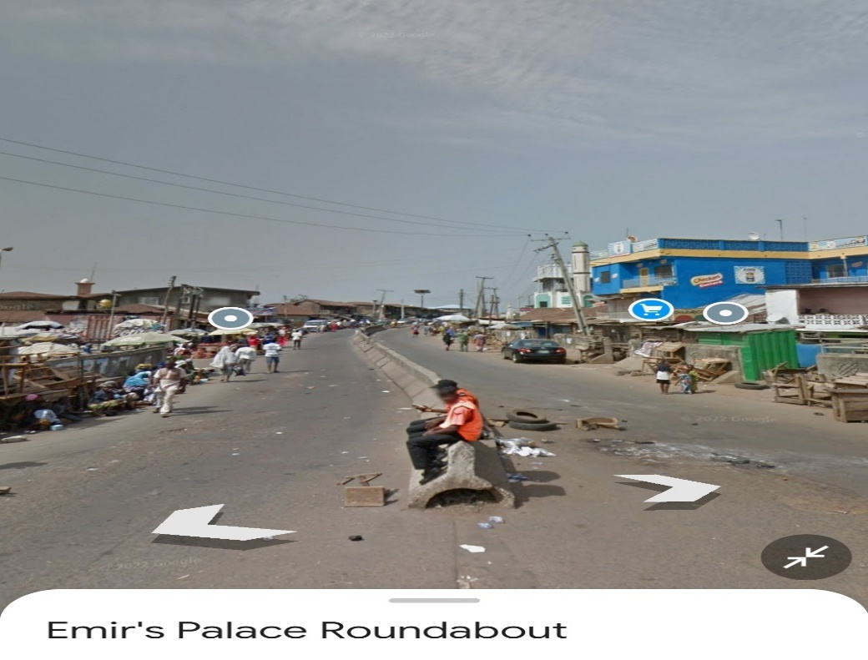

Picture 1: Showing the Exiting and Entry of AbdulAzeez Attah Lane

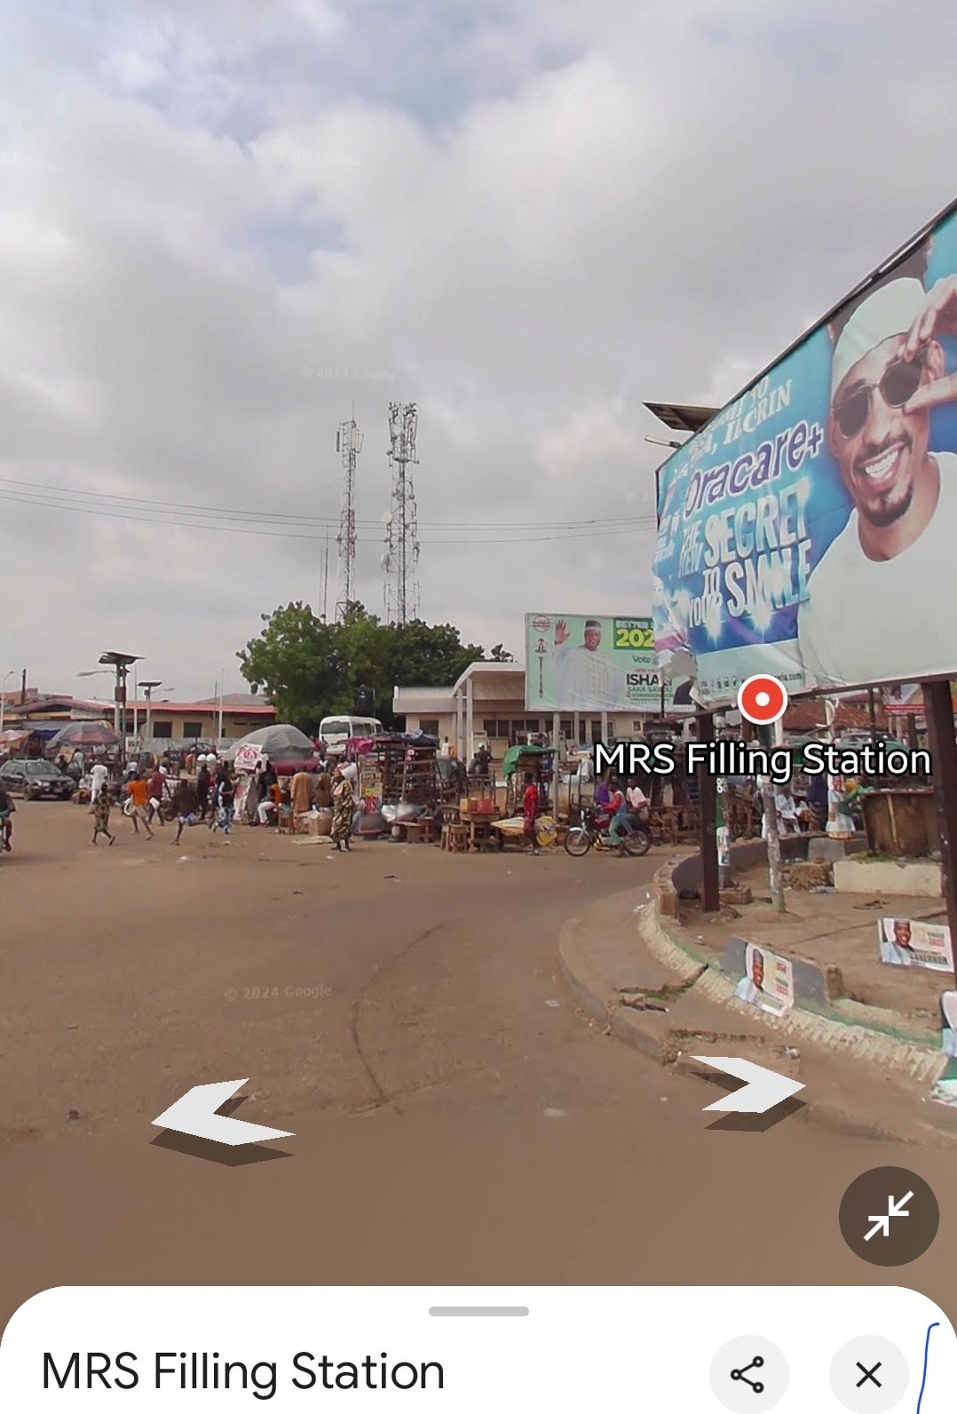

Picture 2: Showing the Entry Into Old Yidi Lane

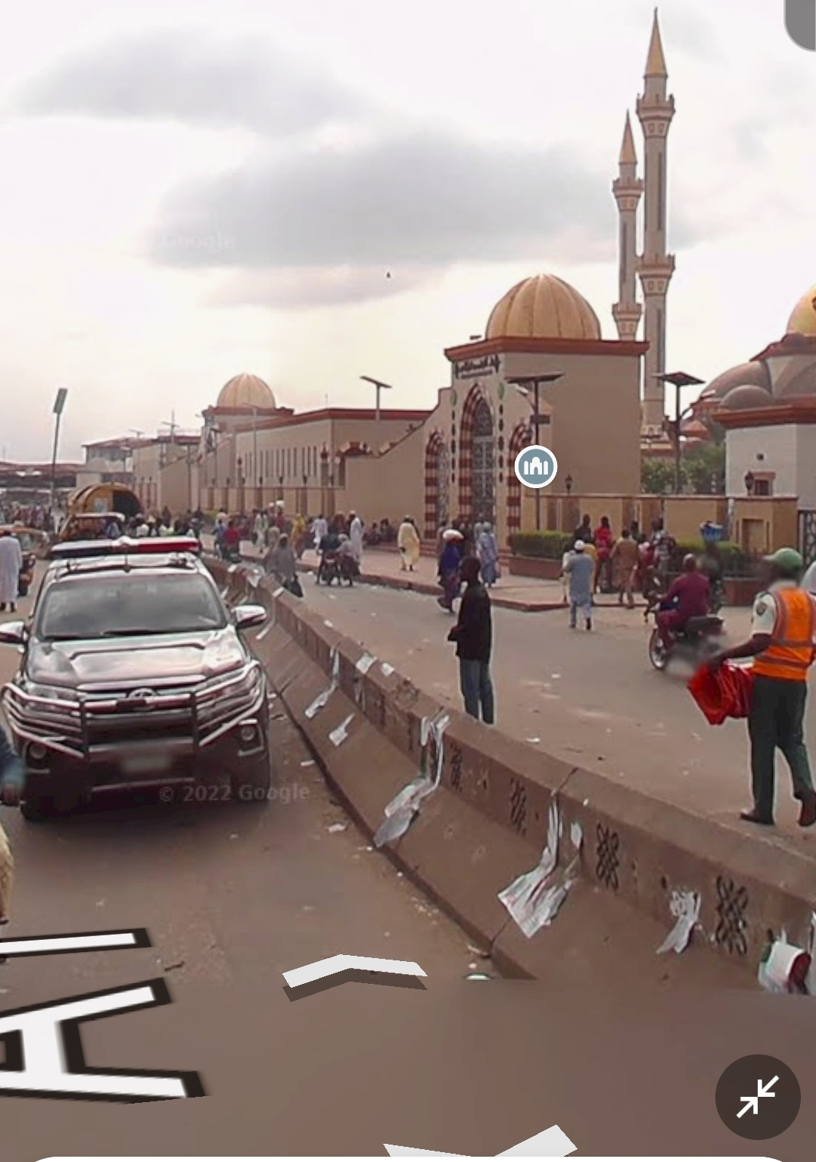

Picture 3: Showing the Exit and Entry Into Emir Palace Lane

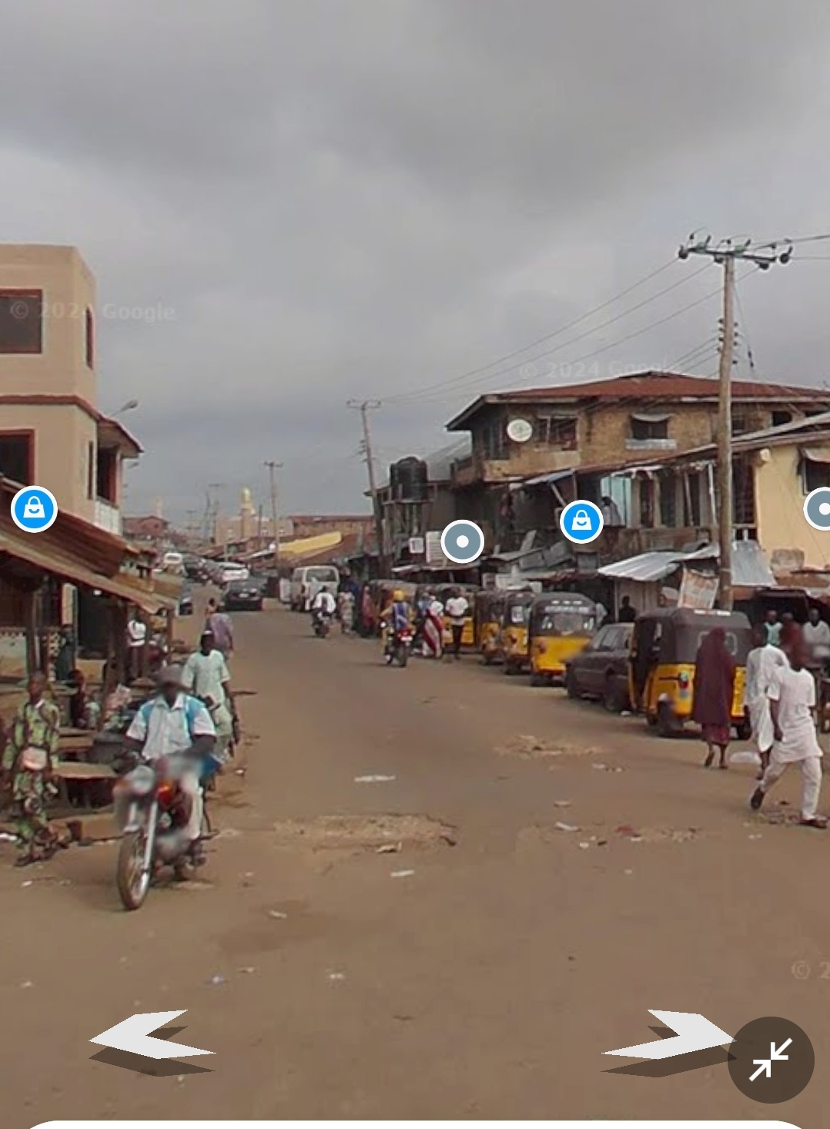

Picture 4: Showing the Entry From Pakata Lane

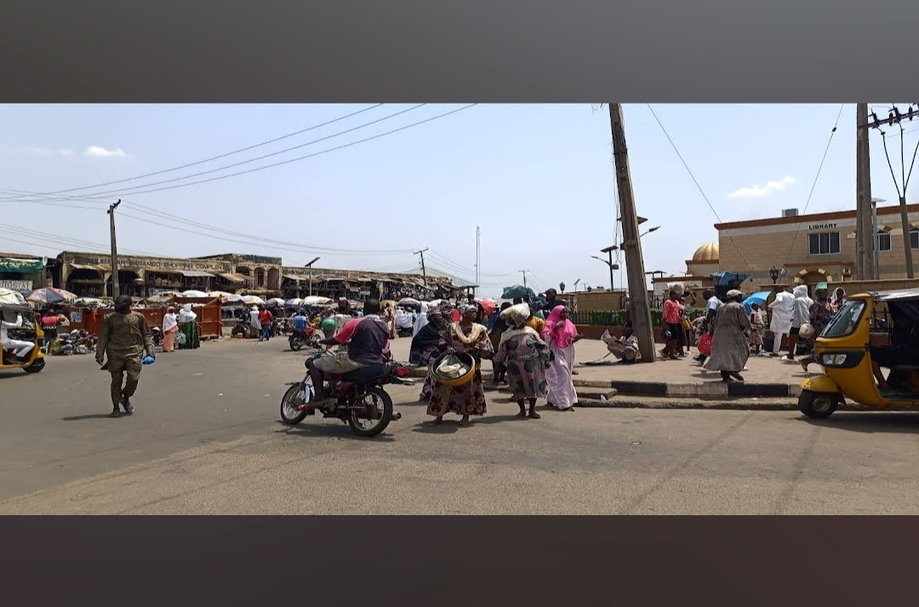

Picture 5: Showing the Entry and Exit from Emir Palace Lane

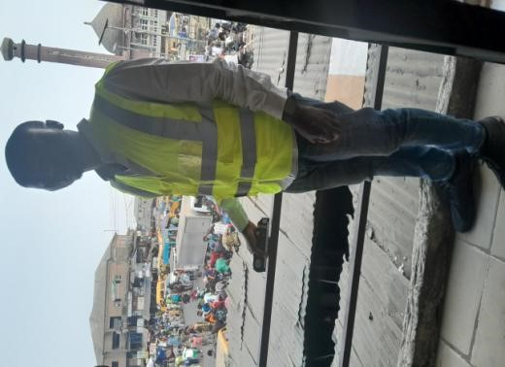 | 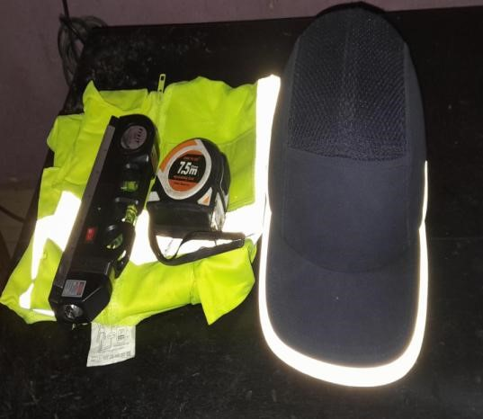
Picture 6: Showing the Field Assessment | Picture 7: Showing Safety gears and the instrument Used for the Field  Assessment

