CHAPTER THREE
METHODOLOGY

3.1 Description of the study area
The study area for this research is the Oja-Oba Roundabout, located in Ilorin, Nigeria. This 4-legged intersection is a critical node within the urban traffic network, known for experiencing significant vehicular congestion and delays. The roundabout serves as a junction for major roads, making it a vital point for assessing traffic flow and delay patterns.
The coordinates are 8.4960⁰ N and 4.5460⁰ E. The intersection has four arms. The
Approach 1 is the Abdul-Azeez Attah Road, the Approach 2 is the Old Yidi Road, and the Approach 3 is the Emir Palace Road while the Approach 4 is the Pakata Road. The study area has around it commercial, social and health, educational and administrative activities carried out in open space and buildings around it.

Table 3.1 Intersection and landmark

S/N | Intersection name | Intersection type | Landmark
1 | Oja-Oba Roundabout | Roundabout | Emir Palace Mosque

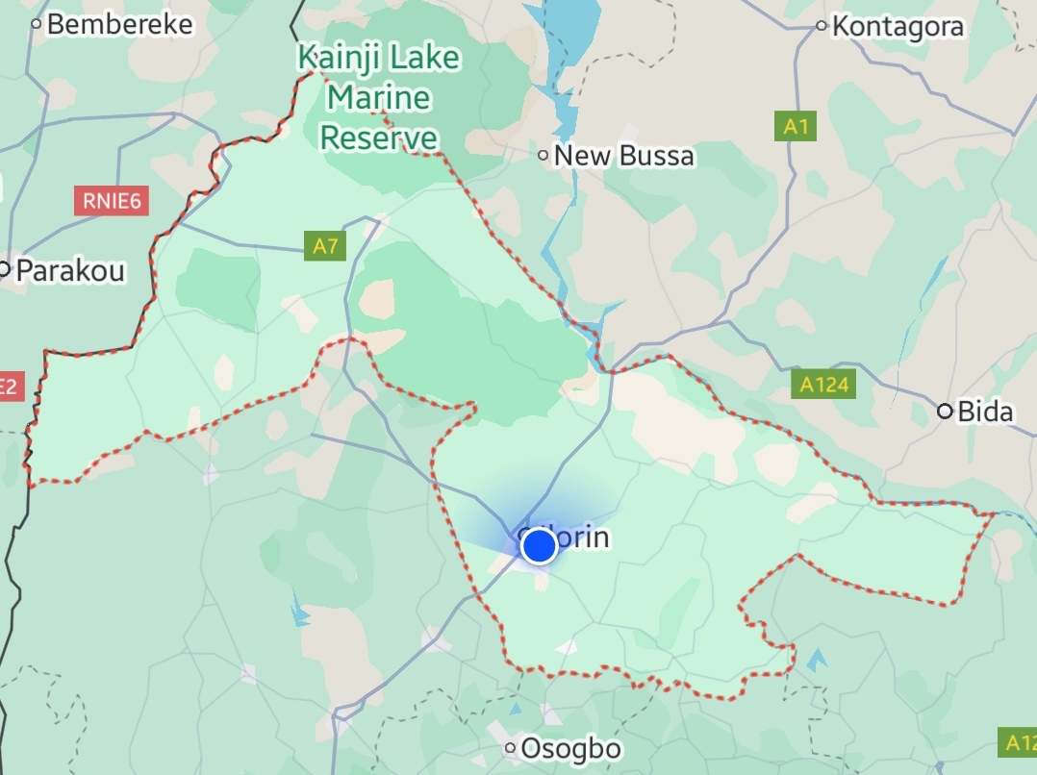
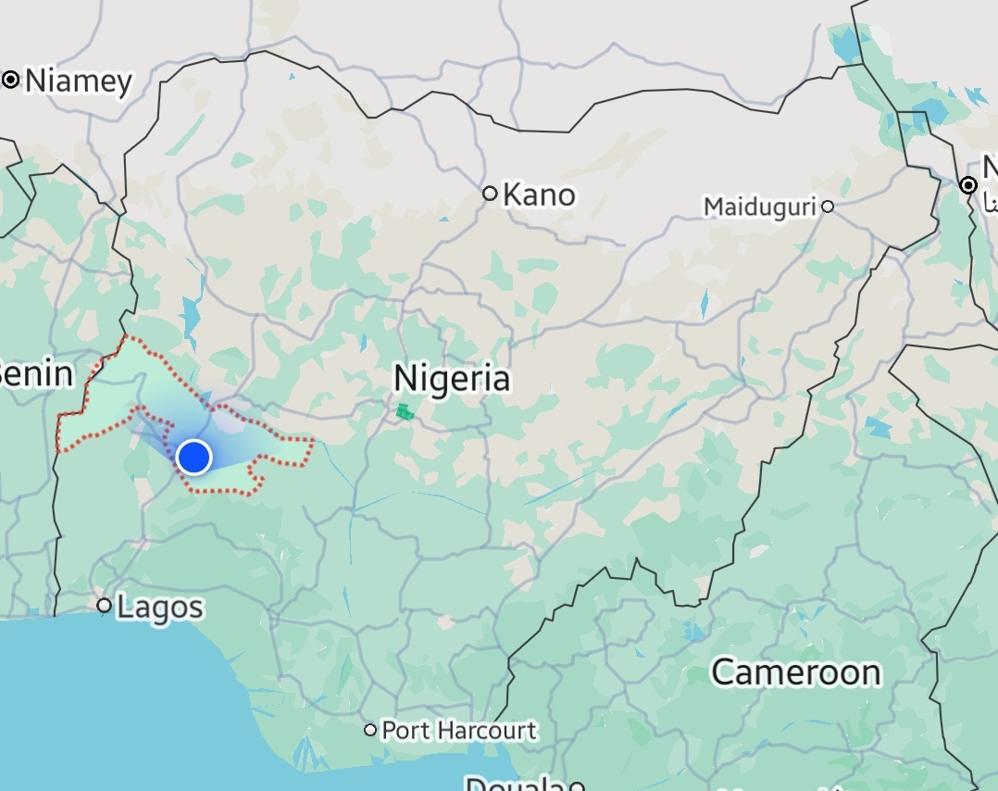

Figure 3.1: Map Showing Kwara, Nigeria
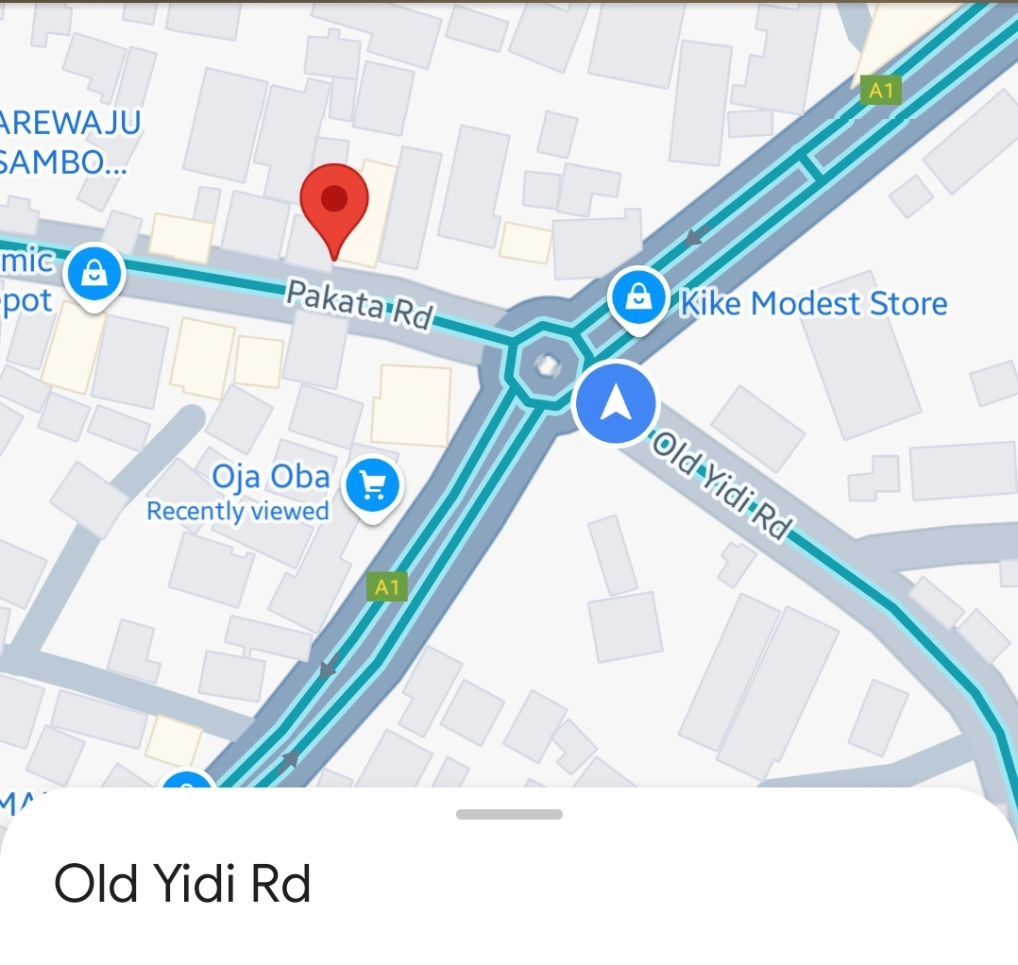

Figure 3.2: Boundary Roundabout, (Google Earth).

3.2 Data Collection
The collection of data involved the measurement of the geometric features and collection of traffic data for the intersection which is broken down below.

3.2.1 Geometric Features
Using a measuring tape, I measured the geometric features of the Oja-Oba Roundabout four legged intersection in Kwara State, Nigeria. The measuring tape gave me key values of features of the lanes such as entry width, approach half-width and average flare-width. The entry width is the distance across the roadway at the point where vehicles enter the intersection, measured by placing the tape perpendicular to the road edges. The approach half-width is the distance from the road’s center line to its edge as the road approaches the intersection. Finally, the average flare length is determined by measuring the distance over which the road widens as it nears the intersection, with multiple measurements taken if the widening is irregular to calculate an average length.

3.2.2 Traffic Data
With a camera I was able to determine the number of vehicles using the road. I positioned the camera at a high point to ensure a clear, unobstructed view of the entire area. I focused on capturing peak traffic hours (8:00 to 9:00 am in morning and 5:00 to 6:00 pm in the evening for 7 days) with high-resolution footage, ensuring every vehicle and pedestrian was clearly visible. To then extract the data, I manually counted and classified traffic. Then I went further to analyze the data to understand traffic volume, flow patterns, turning movements, delays, and queue lengths. Finally, I compiled these insights into a detailed report, complete with actionable recommendations to enhance traffic flow and safety.

3.2.3 Discharge traveling time at intersection
To determine the discharge travel time at a 4-legged intersection, I measured the time it took for a queue of vehicles to clear the intersection. This process involved recording the moment the first vehicle in the queue began to move and timing how long it took for the last vehicle in the queue to pass through the intersection. The discharge time can be influenced by several factors, including the length of the queue, the speed of the vehicles, and any delays caused by turning movements or interactions with pedestrians.

