CHAPTER TWO
LITERATURE REVIEW
2.1 INTRODUCTION
This chapter presents a comprehensive literature review on the development, functionality, and historical evolution of socket outlets, particularly extension boxes with USB outlets. It also explores the significance of the components employed in constructing such systems. As the demand for multipurpose power outlets increases, particularly in emerging markets where power supply inconsistencies persist, understanding the evolution and current advancements in socket design and integration becomes necessary.
2.2 HISTORY OF SOCKET OUTLETS
The development of socket outlets for portable appliances dates back to the 1880s. Initially, electricity was introduced primarily for lighting purposes. In those early years, appliances like vacuum cleaners and electric fans were often powered through light bulb sockets using lamp holder plugs (Thompson, 2015). These connections were both unsafe and inconvenient, necessitating the invention of safer alternatives.
In Britain, plug and socket systems started appearing in the mid-1880s. T.T. Smith was one of the pioneers in this field. He was granted British Patent 4162 in 1882 for a design that enabled flexible and safe electrical connections. A similar patent was registered in the United States in 1885 (Smith, 1885). These inventions marked a turning point in the accessibility and safety of electrical systems.
By 1903, Harvey Hubbell had introduced the first American designs for two-pin plugs and sockets. His inventions emphasized retention features that helped prevent accidental disconnections (Hubbell, 1903). Hubbell's design evolved further in 1912 with the introduction of parallel flat pins, which remain in use today in the NEMA 1-15 configuration. This form factor eventually became a de facto standard across the United States.

Between 1900 and 1920, several inventors and companies contributed to the proliferation of plug and socket designs. For example, Gustav Binswanger patented a coaxial plug and socket in 1895 under General Electric. These designs evolved based on user needs for convenience, safety, and compatibility (Mellanby, 1921).
In the early 20th century, earthed plug and socket systems began to emerge. George P. Knapp, working for the Harvey Hubbell Company, patented an earthed socket in 1915, with an extended grounding pin for enhanced safety (Knapp, 1915). Other inventors, like Philip F. Labre in 1928, further developed grounded systems that contributed to today’s safer and more reliable socket outlets (Labre, 1928).
The international community began standardizing plugs and sockets in the mid-20th century. The British Standard BS 546 introduced a three-pin configuration in the 1950s, which became widespread in many Commonwealth countries (IEC, 1986). The Schuko plug, introduced in Germany around 1925 by Albert Büttner, also became a popular standard in European countries for its robustness and grounding feature (VDE, 1993).
To facilitate global trade and travel, the International Electrotechnical Commission (IEC) formed Technical Committee TC 23 to promote harmonization. While the IEC 60884-1 standard provides general guidelines, individual countries still adopt their unique plug and socket configurations (IEC, 2002). For instance, the CEE 7/7 plug is compatible with several European sockets and has become a semi-universal solution in that region.
Recent years have seen an increase in the integration of USB ports in socket outlets. USB technology, first standardized in 1996, has become indispensable in modern devices such as mobile phones, tablets, and portable storage devices. The demand for USB-enabled extension boxes has increased significantly due to the convenience of charging without the need for adapters (USB Implementers Forum, 2020).

2.3 COMPONENTS USED FOR THE PROJECT
To achieve a functional extension box with an uninterruptible USB outlet, several electronic components are required. Each component plays a critical role in power regulation, safety, and overall system functionality. Some of these components includes;
- Capacitor
- Transistor
- Metal Oxide Semiconductor Field Effect Transistor (MOSFET)
- Transformer
- Switch
- Fuse
- Light emitting diode (LED)
- 13A sockets
- Rectifier
- Micro-controller
2.3.1 CAPACITORS
Capacitors are passive electrical components that store energy electrostatically in an electric field. They are vital in filtering, voltage regulation, and transient suppression. The two major types used in this project are ceramic and electrolytic capacitors (Horowitz & Hill, 2015).
2.3.2 CERAMIC CAPACITORS
Ceramic capacitors are non-polarized and constructed from ceramic dielectric material. They offer high stability and reliability at low cost, making them ideal for general-purpose applications (Mohan et al., 2018). Ceramic capacitors are the common types of capacitors used in most of the electrical instruments, as they are more reliable and cheaper manufacture.
2.3.3 ELECTROLYTIC CAPACITOR
These capacitors use an electrolyte to achieve higher capacitance values. They are polarized, meaning their terminals must be connected correctly. They are primarily used in power supply filtering (Millman & Halkias, 2011). An electrolyte is a liquid or gel containing a high concentration. Almost all-electrolytic capacitor are polarized, which means that the voltage on the positive terminal must always be greater than the voltage on the negative terminal.

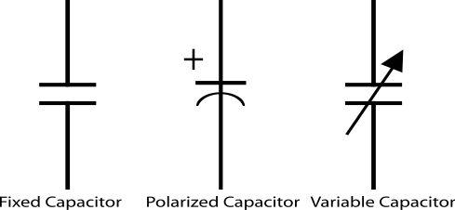
Fig.2.1 symbols of a capacitor

2.3.4 REGULATORS
A LM79805 regulator is a three terminal positive regulator with 5V fixed output voltage. The fixed regulator provides a local regulation, internal current limiting, thermal shut-down control, and safe area protection. Atypical diagram of a Regulator is shown in Fig. 2.3.
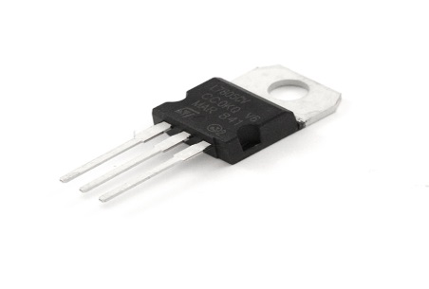
Fig. 2.2 A Regulator
2.3.5 RESISTORS
Resistors are passive elements used to oppose the flow of electricity in a circuit. The resistance of a resistor is measured in ohms. They are used to limit the current in the circuit and as a potential divider to achieve a specific value of voltage across a terminal. Resistors are either fixed or variable. A typical symbol of a resistor is shown in Fig. 2.3.

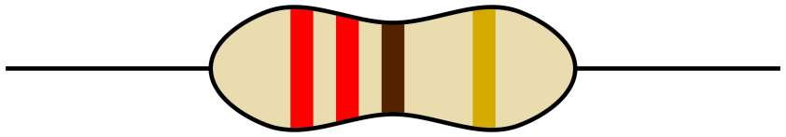
Fig. 2.3 Resistor
2.3.6 CRYSTAL OSCILLATOR
A crystal oscillator is an electronic circuit that uses the mechanical resonance vibrating crystal of piezoelectric material to create an electric signal with a precise frequency. This is often used to stabilize frequencies for radio transmitters and receivers. A typical diagram of crystal oscillator is shown in Fig. 2.4
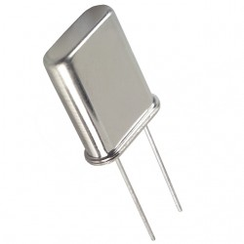
Fig. 2.4 Crystal Oscillator
2.3.7 TRANSFORMER
A current is a passive component that transfers electrical energy from one electrical circuit to another circuit, or multiple circuit. A varying current in any one coil of the transformer produces a varying magnetic flux in the transformer’s core, which induces a varying electromotive force across any other coils wound around the same core.
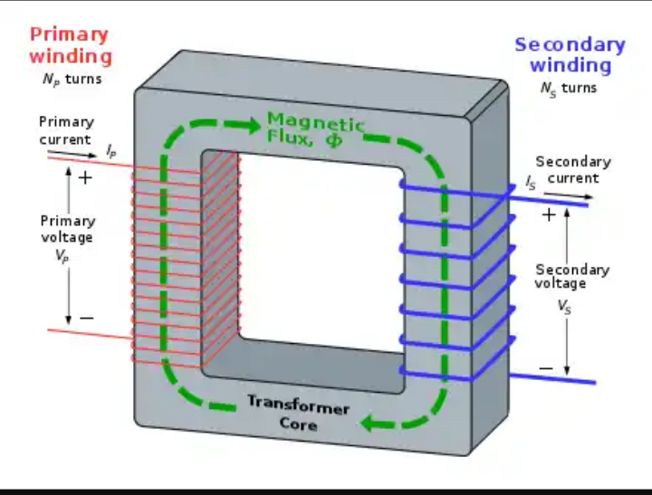
Fig. 2.5 Transformer winding

2.3.8 13A SOCKET
This is a standard socket in Nigeria and other countries that use BS 1363. It allows connection of appliances up to 3000W. It includes live, neutral, and earth pins for safety and functionality (BSI, 2019). It accommodates different electrical devices and aid their connection to the electricity before they can function properly. It helps in the connection of appliances rated between 700W and 3000W e.g dishwasher, microwave, kettle, toaster machine, Iron e.t.c
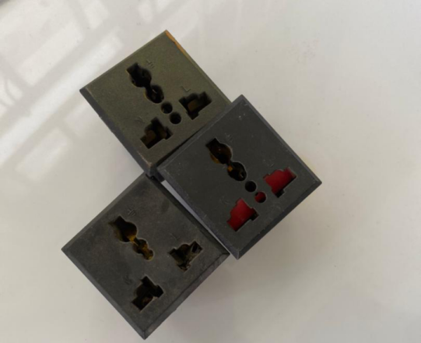
Fig. 2.6 13A Sockets

2.3.9 LIGHT EMITTING DIODE (LED)
This is a two lead semiconductor light source. It is a p-n junction diode that emits light when activated. When a suitable current is applied to the leads, electrons are able to recombine with electrons holes within the device, releasing energy in the form of photons. A typical diagram of a Led is shown in Fig 2.7
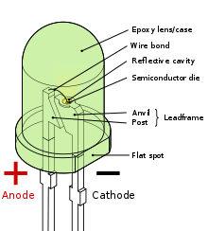
Fig. 2.7 light emitting diode (LED)

3.3.10 RELAY
Relays are electromechanical switches controlled by an electric signal. They enable the control of high-power devices with low-power logic circuits (Theraja & Theraja, 2010). it is an electromechanical switch composed of an electromagnet, an armature, a spring and a set of electrical constants. The electromagnetic switch is operated by a small electrical current that turns a larger current on or off by either releasing or retracting the armature constant, thereby cutting or completing the circuit.
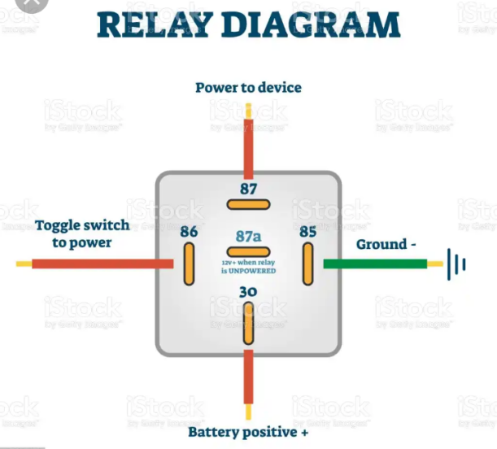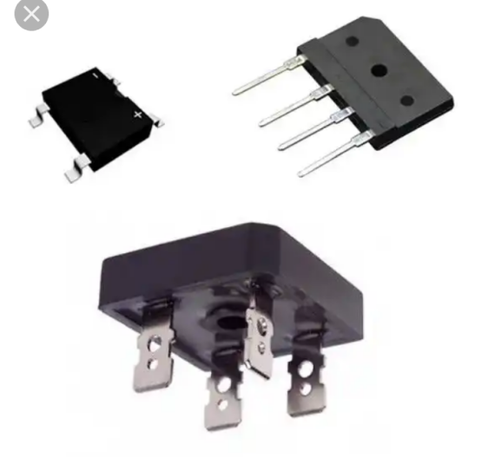
Fig. 2.8 Relay
3.3.11 TRANSISTOR
Transistors amplify and switch electronic signals. As the building blocks of integrated circuits, they are central to all electronic systems (Sedra & Smith, 2016). Transistor are active component of integrated circuits, or ‘microchips,’ which often contain billions of these minuscule devices etched into their shiny surfaces. Deeply embedded in almost everything electronic, transistors have become the nerve cells of the information Age.
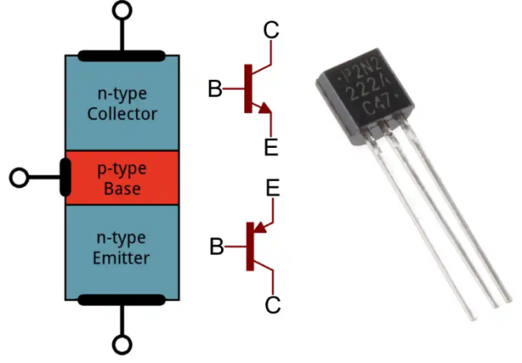 Fig. 2.9 Transistor

    - RECTIFIER
Rectifiers convert AC to DC. In this project, they ensure that USB outlets and control circuits receive DC power regardless of input type (Boylestad & Nashelsky, 2017). DC power is more expensive to produce. Therefore, a method of changing ac to dc is needed as an inexpensive dc source. AC power can be converted to DC power using rectifiers When ac power is converted to dc power using rectifiers, dc output contains un wanted alternating current components known as ripple. Many rectifier applications need that the ripple do not exceed a specified value. If the ripple exceeds the specified value, different unwanted effects appear in the system. Some of the unwanted effects are stray heating and audible noise. The ripple can be reduced using an output filter.
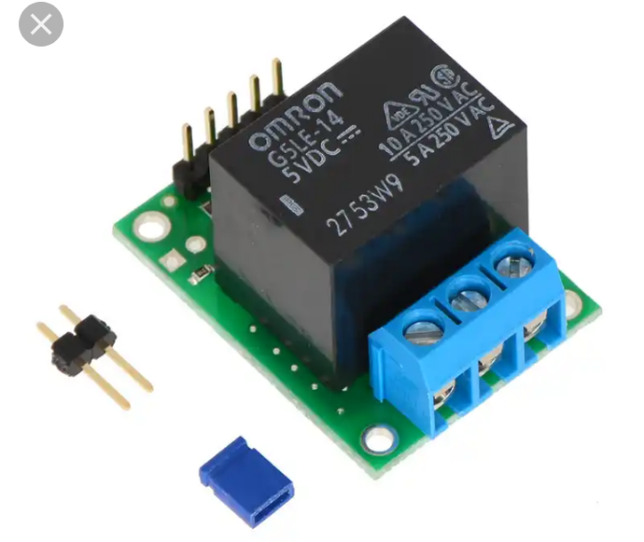
Fig. 2.10 Rectifier
2.3.12 THE MICRO-CONTROLLER
A microcontroller integrates a CPU, memory, and input/output peripherals. It acts as the brain of the system, executing programmed instructions to control switching, monitoring, and power management (Mazidi et al., 2014). A microcontroller is available in different word lengths like microprocessors (4bit,8bit,16bit,32bit,64bit and 128 bit microcontrollers are available today).
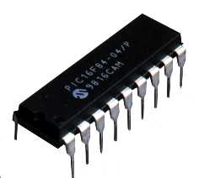
Fig. 2.11 The Micro-Controller Chip

