CHAPTER FOUR
TESTING ,RESULTSAND DISCUSSION
4.1 RESULTS AND DISCUSSION
Upon completing the design and construction of the extension box with uninterruptible USB ports, a series of performance tests were carried out to evaluate the effectiveness, efficiency, and reliability of the system. This chapter presents the detailed results obtained from those tests and offers a comprehensive discussion of the system's response under various load conditions. The focus was on how the system performs, especially when powered solely by the backup lithium battery during a power outage.
The central aspect of the evaluation involved subjecting the extension box to varying electrical loads to observe how long the lithium battery could sustain USB charging functionality under these load conditions. The system was configured to charge devices with different wattages, simulating real-life usage patterns in homes and offices. The results recorded in Table 4.1 provide insight into how power consumption affects the operational duration of the system.

Table4.1 Results Obtained from the Charging Time of Different Loads
S/N | LOADS (WATTAGE) | TIME (HOURS)
1 | 400 | 5.09
2 | 500 | 4.06
3 | 600 | 3.82
4 | 700 | 3.42
5 | 800 | 2.29
6 | 900 | 2.05
7 | 1000 | 1.45

From the table, it is evident that as the load increases, the available operating time decreases. This inverse relationship between load wattage and time duration can be attributed to the fact that higher loads draw more current, depleting the battery at a faster rate. The maximum endurance of 5.09 hours was observed at 400W, while the system could only sustain 1.45 hours of operation at a 1000W load.
This test validates the theoretical basis that the battery’s energy content (in watt-hours) is finite and any increase in the power consumption (wattage) of connected devices will proportionally reduce the duration for which the backup system can operate. The discharge rate aligns with Ohm's and Watt's Laws, where:

P = V x I
And
E = P x t
Where:
* P is the power (in watts)
* V is the voltage
* I is the current
* E is the energy capacity (in watt-hours)
* t is the time (in hours)

4.2 SYSTEM BEHAVIOR UNDER TEST CONDITIONS
The system was tested in real-life conditions involving a power outage. During the blackout, various devices were connected to the sockets and USB ports. Observations showed that:
- The 13A socket outlets maintained steady voltage across all terminals.
- The USB ports provided uninterrupted 5V DC, suitable for mobile phone and small gadget charging.
- The LCD voltage display remained active, continuously showing the real-time status of AC input, and displayed a blackout notification when the input was zero.
These observations confirmed that the system design was effective in providing seamless switching from grid to battery power. The microcontroller efficiently managed power routing, and the lithium battery backup system ensured continuous operation of critical USB-powered devices.

4.3 GRAPHICAL REPRESENTATION OF RESULTS
The graphical plot of power consumed (in watts) against time (in hours) is shown in Figure 4.1. The curve shows a non-linear downward trend, confirming the rapid drop in available usage time with increasing load demand.
Load (W)

Figure 4.1. The graph of “W” against “T”
It was observed from the results, that the more the loads added at a particular period of time, the reduction in the time of use.

4.4 DISCUSSION OF RESULTS
The successful operation of the extension box during power failure reveals several practical advantages:

1. Reliability: The extension box performed reliably under various load conditions. This indicates that the components used, including the battery, rectifier, transformer, and USB interface, were effectively integrated.
2. Scalability: While the system performed well under 1000W, it is advisable to consider using higher-capacity lithium batteries in future designs to extend the operation time or accommodate heavier loads.
3. Efficiency: The power conversion and regulation circuitry ensured minimal losses, maintaining efficiency in USB charging. The 5V DC USB output remained stable even as the battery level decreased.
4. Safety: No overheating, short circuits, or voltage irregularities were observed during the test period, indicating robust circuit protection.

4.5 LIMITATIONS OBSERVED
Despite the successful implementation, the project exhibited certain limitations:
- The 200mAh lithium battery had limited endurance under higher loads, lasting less than 2 hours for 900W and above.
- The recharge time for the battery was relatively long, especially after full depletion.
- The system does not yet include solar charging, which could improve off-grid resilience.

4.6 IMPLICATIONS OF FINDINGS
The findings demonstrate that such a system can be an effective solution for managing multiple electronic devices in areas with unstable power supply. The USB backup functionality can be particularly useful in emergency scenarios or in rural regions with limited electricity access. Furthermore, the concept can be adapted and scaled for SMEs, schools, and medical facilities where continuous access to mobile devices is critical.
These results also suggest that combining traditional socket functionality with battery-powered USB ports creates a hybrid solution capable of bridging the gap between convenience and necessity in power usage.

4.7 PICTORIAL DIAGRAM OF THE EXTENSION SOCKETS
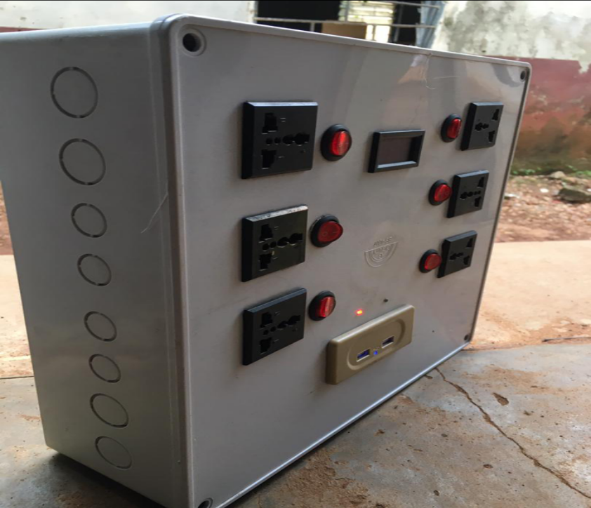
ADAPTABLE BOX
USB PORT
SWITCH
13A SOCKET
LCD
Figure 4.2. The final interface of the project.

